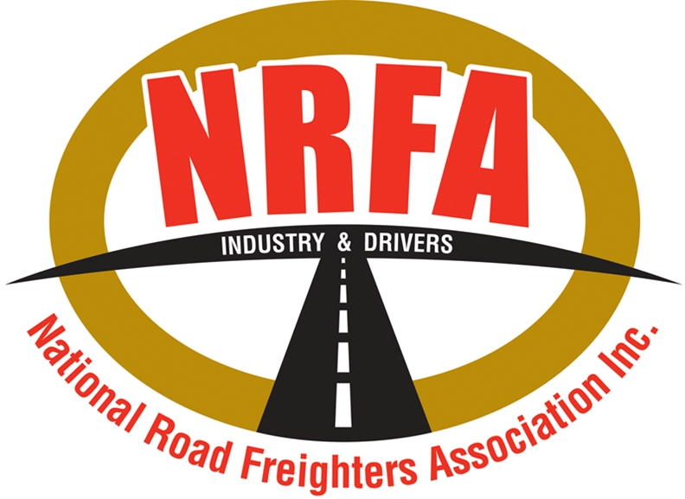

The National Road Freighters Association wishes to respond to the current NTC Proposal to increase the road user charge for heavy vehicles.

The first issue though, is the way it has been put to industry. The release and the intent to seek industry consultation cannot be seen to be even realistically aimed to succeed, given the time, the lack of industry press involvement and therefore the aim, from where we sit, must have been to put it out and hope no one saw it. This is a genuine concern, and we ask it be addressed and any such industry consultation be improved in the future.

Under the current pressures of high fuel costs, severely increased damage and wear and tear to vehicles caused by failed road infrastructure, increasing both costs to maintain and then to comply with vehicle inspection penalties and repair requirements, this cannot be justified on the following basis.

You are asking us to pay more for roads that have failed badly, yes, we recognise the additional damage from floods and storms. But if the roads were built and maintained to a suitable standard, much of these failures, or damage from patching instead of suitable actual repairs, would be reduced. Then there are bad building practices that see roads fail within months of being built, for example, many of the overtaking lanes being built on the Newell Highway being not only repaired within months of completion, but some rebuilt many times.

There is then also the cost of road projects badly constructed and built, e.g. how can one roundabout in Tamworth cost $20million? Until such time as we get better value for the funds spent, the road transport industry does not believe we should pay more for less.

Any such increase will certainly affect industry costs, will be yet another inflationary pressure and even more so on those who rely on road transport to deliver everything they use. Every community outside major cities are already reeling from increases from the cost of fuel, along with the lack of drivers, mechanics, and equipment to provide their transport needs. With rising interest rates to try and reduce inflation, this will only add to those pressures and multiply them.

We recognise roads must be built to carry traffic, trucks are not the only users of these roads and if they were built and maintained properly, not only would safety for all be improved, but transport costs could be reduced. Yet as a driver myself, I spend every minute avoiding potholes, road irregularities and have suffered not only increased damage, but increased fatigue and concentration levels due to bad roads, and not just those damaged in floods etc.

The NRFA believe a 3% increase per year is warranted, will not substantially increase inflation, and will give time to see better value provided. It would seem from discussions with road staff and crews, there is a lack of knowledge and experience in some road authorities and road building agencies and this, along with insufficient oversight, sees much of the lost value. Fixing roads must be a hot and slow job, but again, watching many crews patch one and miss four is one problem and the absolute waste of money on machines that spray on bitumen, without any actual or proper repair, only to have it gone after four vehicles drive over it is more like pouring money on the road rather than fixing it is another.

The other factor is the cycle of funds allocated being held, then when the next funding period is due, the money must be quickly spent or will not be allocated for the next period. This is not the best way to see roads properly repaired. If these issues can be addressed, not only will roads be safer, but the transport industry will welcome and recognise such improvements.

Rod Hannifey

NRFA President