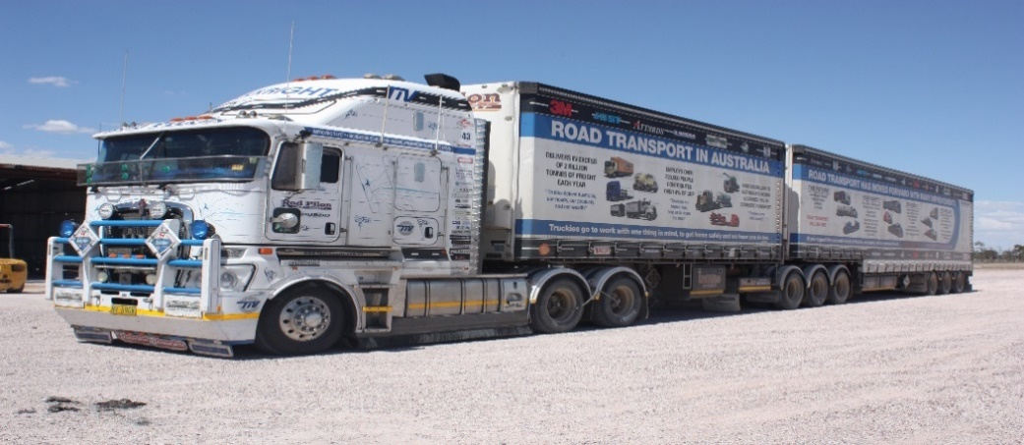

TRUCKRIGHT ABN 17426245866

***TRUCKRIGHT Industry Vehicle (TIV) Ten Years on the road, 2019.***

Rod Hannifey, Road Transport and Road Safety Advocate, TIV Driver and Operator. Telephone: 0428 120560 Email: [rod@truckright.com.au](mailto:rod@truckright.com.au) Website: [www.truckright.com.au](http://www.truckright.com.au)

TRUCKRIGHT Awarded Highly Commended, 3M ACRS Diamond Road Safety Awards 2015. Finalist 3M ACRS Diamond Road Safety Awards 2016, Awarded Churchill Fellowship 2016. Green Reflector Marking Informal Truck Bays, finally completed the Newell Highway 2019.

**Response to HVNL Review Paper 6 Assurance Models.**

Question 1: Have we covered the issues relating to assurance accurately and comprehensively? If not, what do we need to know?

Yes you have covered the issues.

Question 2: Is there evidence of third parties, such as site managers, customers or loaders, performing audits on heavy vehicle operators that duplicate certification audits? Can third parties be assured (by an accreditor or certifier, within the HVNL, or some other means) that their audits are unnecessary?

I am answering as a driver, therefore am not involved with company audits. But it seems to me that two problems affect drivers specifically. The first is the overpowering control by some who do know of and perhaps, understand COR, citing it as their need to require drivers to fill in more and more forms, with more and more complexity overtime, which not only duplicates what we are required to do for our own compliance, but often goes well beyond that. It may well be that this is a result of them seeing that the schemes in place are either not robust enough, or do not meet the legal requirements to off set their risk under COR.

For example, if I arrive at a site and had a TRUCKSAFE logo on the truck and TRUCKSAFE met all the legal requirements at the time (I recognise it does not now and some think it never has, but this is simply an example of how it could and should work) then that logo should be sufficient to allow the customer, whoever they may be, to accept I meet the legal requirements for COR and all they have to do is meet theirs. However, now it seems I must sign a multitude of forms or sometimes up to ten times on one form, that I am legal every which way from Sunday and both accept and are responsible for everything that might go wrong. This is ludicrous in the extreme.

The other side of this then, is that having filled in the form accepting all forms of liability, they then sit me there for hours!!!!!!!!!!!!!!!!!!!!!!!!!!!!!!!!!!!!!!!! Often not complying, no water, no shelter, no access to toilets, no ability to rest or sleep, as being in a que, I must continually move up. Not all are this bad and the degrees of failure varies, but there are some major Distribution Centres run by some major transport companies who seem to be the worst.

I have dealt with those employed as gatehouse staff who would do well in the KGB. It is their rules and if you don’t follow them, you are treated like a murderer, not like a truckie who has been held up in traffic and run 15 minutes late. “THOUGH SHALT NOT PASS” seems to be the motto for some. I have arrived 17 minutes before my allowed 15 minutes prior to time slot, to be told I am too early and must park over there out of the way. Of course, by the time I do that and walk back, I am accepted into the system. Then I qued for hours moving up each time a truck got onto a dock, finally leaving nearly 4 hours later.

Recently I arrived at 10 AM for a 10AM timeslot, was qued out into the street, got in the gate at 12.30 PM and on a dock to sit there for another hour and a half and got the first pallet off at 2.45 PM, then out at 3.30PM. Five and half hours on site and not once, was I or any of the other truckies I spoke with there out of the other 50 qued up, were we given a reason.

I can go on, but it seems we are still the only ones bearing the cost, loss of time, inconvenience signing away liability for much that we are not and never can be liable for, so why the bullshit in the first place? I know it is simply arse covering for the companies involved, but it is my time, I am not compensated for it in any way and it seems to all but me, my time and that of any truckdriver, is not valued or recognised in any way. This is where we lose so much time and then struggle to comply with driving laws.

This has extended to keeping me safe on site, where I must stand in a corner, loading takes hours longer and so if you are fifth in the que, five times the extra delay, all others are paid hourly, but WE ARE NOT! Customers must be held accountable, they are not currently and until such delays are charged for, my time will continue to be stolen, undervalued and I will then be punished for working too long to simply get somewhere to eat and or sleep to comply.

Question 3: Does the HVNL need an assurance scheme? Could the flexibility operators want be achieved simply through performance standards, or are some operators and operations sophisticated or specialised enough to need alternative compliance options? Does technology or vehicles or any other operational area need assurance under the HVNL?

Years ago the NTC did a report (seemingly nearly impossible to find now) which said the transport industry was too competitive for its own good. It is not only very competitive it has pressures from all parties in the logistics stream and each wants more for less. It is said by many, not only are we being paid less per pallet to deliver (yes, we have become much more productive) but it has gone too far so that costs rise, but companies still expect cheaper rates.

Drivers used to work 100 plus hours per week and made good money. We cannot do that now, nor should we be required to, but the hourly rate as such has if anything, dropped, we still do much for nothing, so the take home pay has dropped. Everytime I raise this issue with regulators, I am told, it is not their problem. Yet sticking your head in the sand, will not fix it.

I recognise there are two ways to pay drivers, hourly and per kilometre. Each has its merits and supporters. But until drivers are paid for all the work they do, we will both be under a pressure and an incentive to do more kilometres to get paid more and the more we do for nothing, the more we will be expected to.

This is nearly outside the scope of the question, but I offer it as another factor that from where I sit, there must be more than just laws and penalties for companies to keep me safe and pay me for what I do to a fair and reasonable level, given the life on the road and the risks of the job.

If any company cannot earn a return, then they will cut or cheat on maintenance and that will risk my life and those of others and then they will try and cheat me, simply to be competitive with others who are doing the same.

Question 4: Which of the models do you prefer? What should they assure and why? Do you have an alternative model? Who should perform the key roles in an HVNL assurance scheme?

The road transport industry fought long and hard to be treated fairly against government owned rail. It is a service industry for all, but it is very, if not too, competitive. Is it too easy to enter, perhaps, but will it continue to provide the service it does to all, if only big companies run it? In my experience as an employed driver, the bigger the company, the less the driver counts. They become just a means to make more money and so any driver costs, wages, better trucks, bunks, cab air conditioners, are simply not important. Therefore drivers safety becomes something said to be important. This has changed as drivers walk away in droves and few others are silly enough to be treated as those before them accepted.

I think an assurance scheme that allows all to participate evenly must be the aim. I think the NHVAS does not supply what is needed and that Trucksafe or any similarly audited scheme, should have the same attributes and acceptances, if it can show it can guarantee them to an acceptable standard.

Question 5: Fully developing a new assurance scheme could take a long time, even if writing it into law is relatively simple. What can we use from what we have, and how can we transition to the desired end-state?

I believe all trucks should be inspected at the least each year. I have been in a scheme where the trucks could be self-inspected and also where they needed state inspections. Yes much can go wrong in 12 months on the roads we have (they play an enormous role in the wear and tear and if we had a national standard for roads, then maintenance costs would be reduced and lives could be saved) but there is then not only an incentive to have it right for inspection, but to maintain it in case of roadside inspection. I am not a mechanic and with some years on the road, do get listened to when I have a problem, even if I can’t fully diagnose it.

One of the problems though, is the level and consistency of inspection. One week trailers will be failed for brakes with chassis cracks missed, the next week another fellow will look at lights or reflectors and ignore brakes. The brake efficiency tester can be finnicky too. Severe applications are when we want the brakes to work and more so when fully loaded, yet current inspections are done empty and the brakes must be applied slowly, or a false reading can occur. How does this really confirm the brakes are effective?

I want to be safe on the road. I want to drive a safe vehicle. I also want to be able to feed my family. How can we achieve all this with any system, when the overall aim is to make money? There must be some overview and it must be consistent and fair. Drivers time must be recognised as valuable. Until then, we will have a system that is patchy and does not fulfil its aim. Safety on the road for all.