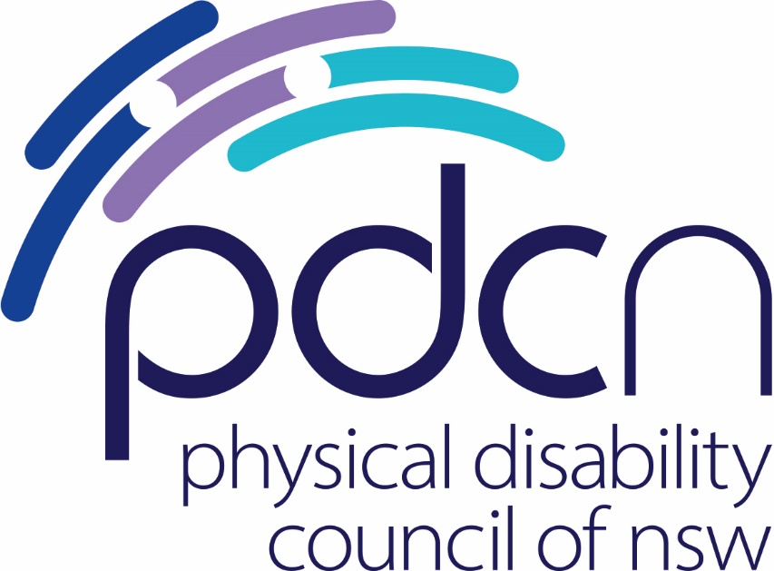

Submission to the National Transport Commission

Barriers to the safe use of motorised mobility devices

Discussion Paper

11 December 2019

Alice Dixon-Wilmshurst
Policy Officer

Physical Disability Council of NSW
3/184 Glebe Point Road, Glebe NSW 2037

02 9552 1606
www.pdcnsw.org.au
alice.wilmshurst@pdcnsw.org.au

Who is the Physical Disability Council of NSW?
The Physical Disability Council of NSW (PDCN) is the peak body representing people with physical disabilities across New South Wales. This includes people with a range of physical disability issues, from young children and their representatives to aged people, who are from a wide range of socio-economic circumstances and live in metropolitan, rural and regional areas of NSW.

Our core function is to influence and advocate for the achievement of systemic change to ensure the rights of all people with a physical disability are improved and upheld.

The objectives of PDCN are:
- To educate, inform and assist people with physical disabilities in NSW about the range of services, structure and programs available that enable their full participation, equality of opportunity and equality of citizenship.
- To develop the capacity of people with physical disability in NSW to identify their own goals, and the confidence to develop a pathway to achieving their goals (i.e.: self-advocate).
- To educate and inform stakeholders (i.e.: about the needs of people with a physical disability) so they are able to achieve and maintain full participation, equality of opportunity and equality of citizenship.

Introduction
The Physical Disability Council of NSW (PDCN) appreciates the opportunity to provide feedback to the National Transport Commission (NTC) on barriers to the safe use of motorised mobility devices (MMDs).
PDCN acknowledges and supports the work being done by both the NTC and Austroads to develop a nationally agreed framework for the safe use of motorised mobility devices (MMDs) on pedestrian infrastructure and roads. We believe the creation of national guidelines and the removal of regulatory barriers are constructive changes that can be made to increase the safety of both people with disability using these devices and the community. This submission will respond to the two questions raised in the discussion paper.

Question 1: Do you agree with aligning the maximum unladen mass with the Australian Technical Standard (ATS) or is there a more appropriate response to overcome the regulatory barriers identified?

PDCN agrees with aligning the maximum unladen mass for motorised mobility devices with the ATS in the Australian Road Rules (ARRs). We believe the current variations across jurisdictions is a barrier, preventing people with disability or impairment from having full access and inclusion in the community. Aligning the maximum unladen mass with the ATS is the most appropriate response to overcoming this barrier for several reasons that this submission will outline.

A nationally consistent framework would ensure the mobility and independence of people who rely on these devices to access the community is not restricted. They would be able to travel throughout Australia without concern that they would legally be able to use their device in all jurisdictions. A recent survey by PDCN of MMD users in NSW found that 69% of respondents were not aware that the current unladen mass limit differs across states (e.g. 110kg in NSW, 150kg in Queensland), suggesting that many people are unknowingly using an illegal device. 88% of respondents agreed there should be one national standard weight. Increasing the mass limit and making it nationally consistent would also allow for devices that may be heavier than the current limits to be legally used throughout Australia. PDCN believes that the current regulations are outdated and do not account for the variety of MMDs available for purchase in Australia, or in the variety of essential features on some MMDs. PDCN suggests that amending the ARRs should be combined with a comprehensive education and awareness campaign, to ensure all MMD users, pedestrians and other road users are aware of their rights and responsibilities.

A nationally consistent framework would increase choice and control for people who require MMDs, one of the fundamental principles of the National Disability Strategy (NDS), the NDIS Act and the NSW Disability Inclusion Act. MMDs perform an essential function for people with physical disability or mobility impairments and were the current weight limits and status quo to be maintained, it would put a number of people who already have a heavier device, or require a heavier device, at a disadvantage. It would also be in contradiction with the NDS, area 4, which states that ‘People with disability, their families and carers have access to a range of supports to assist them to live independently and actively engage in their communities’. The current weight limits do not take into consideration the various factors that impact on weight including larger individuals, complex needs, technological advances and clinical features (eg. sit to stand, power recline) that are now available. Maintaining these limits would impact on a person’s ability to choose a device that suits their needs. This was commonly reported in the recent survey conducted by PDCN. Participant responses included:

“It is essential that electric wheelchairs have no limit. 170kgs for scooters may be too low.” - survey respondent no. 1

“Users of power wheelchairs must use the chair prescribed - some clinically required features add considerable weight but are essential.” – survey respondent no. 2

“My unladen wheelchair weighs 176kg. Weights of chairs vary depending on the equipment installed on them. The higher the level of disability the greater the weight of the equipment installed on the chair.“ – survey respondent no. 149

“Some people who have medical issues causing obesity that places them over the current weight limit need them. This is discrimination against this group”. – survey respondent no. 172

In addition, the growing number of people with disability suggests there will be an increase in the need for MMDs. In 2010, the Disability Investment Group predicted the number of people with disability would grow from 1.4 million to 2.9 million over the next 40 years. This suggests that there will be greater demand for a broad range of MMDs, so that people with disability are not limited in their choices and are able to find a device that suits their individual needs. Consideration also needs to be given to people who live in rural and regional areas, as PDCN noted in its submission to the Senate inquiry in 2018, “…individuals may not be able to purchase larger devices suitable for travelling longer distances and rougher, uneven or hilly terrain if weight restrictions are introduced. This would disproportionately disadvantage people living in rural and regional areas of NSW for whom having a larger mobility device may be a necessity.”

Furthermore, aligning the maximum limit with the ATS will provide clarity and flexibility for suppliers importing MMDs. If weight limits were to be increased, it would open up the market, thereby reducing costs to suppliers, and ensuring choice and control for users.

Finally, PDCN would suggest that not increasing the maximum unladen mass limit could be seen as an infringement on people’s rights and in contravention of the CRPD article 20 – the right to mobility, as for some, heavier devices are essential and their only form of transport and access to the community. As a signatory to the UN CRPD, Australia has a responsibility to uphold this right in its laws, practices and regulations.

Acknowledging that this is out of the scope of this project, PDCN would like to say that while we support increasing unladen mass limits of MMDs, and the establishment of a nationally consistent framework, we believe it should be in conjunction with improvements to public infrastructure, and a comprehensive, nationwide education campaign.

PDCN does not want to see further rules and regulations that will restrict the rights of people with disability who rely on these devices to access their community, undertake paid work, or social engagements. PDCN acknowledges there are some safety risks involved with increasing mass limits, however we are aware that Austroads is working with the NTC on options for adopting other technical specifications in the ATS, and we would be happy to provide further comment should the opportunity arise. PDCN has already provided a submission to Austroads discussion paper on Motorised Mobility Devices, indicating our support for a nationally consistent framework.

Recommendation 1:
That the ARRs be amended to align with the ATS maximum unladen mass limits for motorised wheelchairs (no unladen limit) and mobility scooters (limit of 170kg).

Recommendation 2:
That the NTC, in partnership with Austroads and the relevant regulatory bodies in State and Territories, undertake a nationwide education campaign to ensure all MMD users are aware of their rights and responsibilities, and all other pedestrians and road users are aware of how to safely interact with MMD users, similar to the ‘Go Together’ campaign on bicycle safety.

Recommendation 3:
Investigate options for aligning the ARR road rules with the other aspects of the ATS, specifically requiring all devices to have a slow speed switch and a certification scheme for use on public transport.
Question 2: Do you agree with the proposed pedestrian classification? Is it appropriate that all MMD operators are required to follow the pedestrian road rules?

PDCN agrees with the proposed pedestrian classification for all MMDs and for persons who may be remotely controlling an MMD.

Currently, a device that can travel over 10km/h is classified as a vehicle, and a person using an MMD that cannot go over 10km/h is classified as a pedestrian. This is further confused because there is no stipulation as to whether a person using an MMD that can go over 10km/h, but is not traveling at over 10km/h, is a pedestrian. PDCN agrees that the ARRs should be amended so all users of MMDs are classified as pedestrians, regardless of the speed capability of the device. This is supported by PDCN’s members and other stakeholders (whom are MMD users), with 86% of survey respondents agreeing the ARRs should be amended to consider MMD users as pedestrians. Participant statements in support of this included:

“Yes. Given that MMDs are generally operated on footpaths and share the same space as pedestrians; it seems reasonable that the standards that pedestrians are expected to comply with should equally apply to MMD users as well.” - survey respondent no. 4

“I do believe we should be classed as pedestrians.” - survey respondent no. 17

“There should not be too many different rules as becomes confusing.” - survey respondent no. 23

“As far as I am concerned I am a pedestrian, I just happen to have wheels instead of feet to get around.” – survey respondent no. 54

“As most people use the footpaths then they should be classified as a pedestrian and comply with the pedestrian road rules.” – survey respondent no. 128

It should be noted, however that there was some push back against the idea of mobility scooters being classified as pedestrians, with one respondent commenting, “I don't think motorised scooters should be classed as pedestrians, because they have the ability to go faster than a person walking, & their size can be deadly.” – survey respondent no. 8

For some survey respondents there are differences between motorised wheelchairs and mobility scooters, and they felt that the two should be considered separately. PDCN acknowledges, however, that this project already separated MMDs from Personal Mobility Devices (PMDs) and it would be unreasonable at this point to further divide the project and consider mobility scooters separately to motorised wheelchairs.

The discussion paper also seeks views on amending the AARs so that MMDs that are required to travel on the road do not exceed a 10km/h speed limit. In responding to this, there is several considerations that need to be made, including location, reason for travelling at speed, type of device, and safety of the user. As the peak body for all people with physical disability, PDCN has a duty to represent the views of its members, and its recent survey indicated that while there is majority support (71% of respondents) for a speed limit of 10km/h, there are people (19%) who do not support imposing speed limits for a variety of reasons, including location issues, condition of footpath and discrimination against wheelchair users. Participant statements included:

“We should follow international conventions which are generally around 12-15kmph maximum speed.” – survey respondent no. 1

“I believe that having the option of going somewhat faster would be safer when crossing highways. Chugging across at 9-10km/hr sometimes puts me at risk, especially with turning vehicles who are disobeying the law about giving way to pedestrians. I do believe that it is a reasonable limit when there are other walking people on busy pathways (I go a lot slower in those circumstances). However we don't put a speed limit on joggers or bicycles, who can use footpaths. Why are wheelchair users singled out?” – survey respondent no. 17

“I should be able to travel at the speed I need and take responsibility for actions in the same way cyclists do! Limit all or don’t discriminate against me because I have a disability and use the power wheelchair.” – survey respondent no. 25

“I have clocked the speed of the average path user at between 7-9km/h and if people are able to move faster, i.e. fast walk or jog they exceed 10km/h. Why should people using a mobility device be restricted in their ability to move any more than they already are?” – survey respondent no. 56

“I have to travel long distances on paths where most times there isn't any other person. If you reduce the speed. It would make my life a lot harder and too long to get there and back. I dial my mobility scooter back to walking pace when in shopping centres or people on paths. It is common sense to be slow where you have to. Making it 10kph won’t stop accidents as that is too fast in crowded areas, and it will make life harder. Better to make walking pace in crowded areas.” – survey respondent no. 165

MMD users in rural or regional areas are often forced to travel on roads because public transport options are limited, and footpath infrastructure is non-existent. PDCN suggest that a 10km/h limit on roads is not a necessary safety consideration, and in fact would leave MMD users at risk and exposed to environmental factors such as extreme heat for longer periods than necessary. Participant statements in support of this included:

“In some rural or outer suburban areas, a higher speed could be allowed.” – survey respondent no 2

“From my experience I drove at full speed if there were no other road/footpath users. People in this country town go quite long distances and not see any other footpath users. Plus local govt has invested in extra wide quality footpaths and staggered crossings where there are median strips to cross. Let's make the footpaths and ramps to footpaths better. Don’t punish the riders. “– survey respondent no. 97

We believe it reasonable that people with a greater need, e.g. in regional or rural areas where public transport is limited and use of an MMD is their only means of independence, allowance must be given to an increase in speed - to a maximum of 12km/h so as not to impact on the user’s safety.

The recommended limit of 12km/h is to bring Australian standards in line with international standards and is also the speed limit of many devices, meaning they would not need to be modified when imported, thereby reducing costs for suppliers and consumers, and increasing choice for consumers. We also suggest a low speed setting of 6km/h for use on footpaths, and a national education and awareness raising campaign to ensure all MMD users, and other pedestrians and road users, are aware that there are speed limits on footpaths and other high pedestrian traffic areas.

Recommendation 4:
Amend the ARRs to state that MMDs – regardless of speed capability – are considered pedestrians and are to travel at a speed no greater than 10km/h on footpaths and roads with the following provisos:
- Are to travel at a speed of 6km/h in high pedestrian areas.
- Can travel at 12km/h on roads in situations where there is a clear need and there is no viable alternative.

Department of Social Services, National Disability Strategy 2010 – 2020, viewed on 27 November 2019, https://www.dss.gov.au/sites/default/files/documents/05_2012/national_disability_strategy_2010_2020.pdf
PriceWaterhouseCoopers, National Disability Insurance Scheme Final Report, Disability Investment Group, October 2009, viewed on 27 November 2019 https://www.dss.gov.au/sites/default/files/documents/05_2012/pwc_ndis_report_2009.pdf
Physical Disability Council of NSW, Submission to Senate Standing Committee on Regional and Rural Affairs and Transport, Inquiry into need for regulation of mobility scooters, also known as motorised wheelchairs, January 2019

