National Standard for Health Assessment of Rail Safety Workers
  - 2024

Foreword
The National Transport Commission is committed to ensuring the safety of our rail networks for all concerned, including those who work and travel within them, and for operators who provide this critical service to business and our community.
We have undertaken this Review of the National Standard for Health Assessment of Rail Safety Workers to ensure the Standard continues to meet its objectives in supporting rail transport operators to manage the risks posed by ill-health of rail safety workers.
The Standard continues to be informed by medical evidence and expert opinion, and we appreciate the significant commitment of specialist societies, individual professionals and researchers who have contributed their expertise. We also acknowledge the involvement of rail industry and union stakeholders who have provided the necessary context and real-world experience to ensure the Standard remains relevant to the Australian rail environment. In combination, these contributions have enabled a Standard that reflects contemporary best practice and is workable across our diverse rail system.
While the Review focused on the medical aspects of the Standard, we acknowledge that few aspects of the Standard operate in isolation. We therefore considered the rail operating environment, job requirements, changes in legal requirements and the findings of investigations into accidents and incidents that provided insight into any improvements necessary for the Standard and its implementation.
We are confident the Standard will deliver better outcomes for rail safety workers while also providing operators with the knowledge and parameters needed to keep our rail networks safe.
Carolyn Walsh
Chair

Contents
Foreword 2
Contents 3
List of tables 9
List of figures 10
Acknowledgements 11
Rail Health Advisory Group 11
Chief Medical Officers Council 14
Working groups 15
Cardiovascular working group 15
Diabetes working group 15
Hearing working group 16
Musculoskeletal working group 16
Neurodevelopmental disorders working group 18
Sleep disorders working group 18
Vision working group 19
Acronyms and abbreviations 20
Glossary 22
1. Introduction 26
1.1. Purpose and status 26
1.2. Scope of the Standard 27
1.3. Legislative basis and interfaces 28
1.3.1 Rail Safety National Law and National Regulations 28
1.3.2. Occupational health and safety and work health and safety legislation 28
1.3.3. Anti-discrimination legislation 29
1.3.4. Workers’ compensation legislation 30
1.3.5. Privacy legislation 30
1.4. Program interfaces 30
1.4.1. Drug and alcohol management programs 30
1.4.2. Fatigue management 31
1.4.3. Injury management, return to work and rehabilitation 32
1.4.4. Critical incident management 33
1.4.5. Psychometric testing 33
1.4.6. Employee assistance programs 33
1.4.7. Health surveillance 33
1.4.8. Health promotion 33
1.5. Roles, responsibilities and relationships 33
1.5.1. High-level implementation responsibilities 33
1.5.2. Responsibilities for the conduct and management of health assessments 34
1.6. Evidence base 39
1.7. Structure of the Standard 39
2. The health risk management approach 40
2.1. Health risk management approach 40
2.2. Features of the health risk management approach 41
2.2.1 Risk categories of rail safety workers 42
2.2.2. Health assessments matched to risk categories 44
2.2.3. Task-specific requirements 45
2.2.4. Functional and practical assessments 45
2.2.5. Drug and alcohol testing 47
2.2.6. Timing and frequency of health assessments 47
2.2.7. Validity of medical certificates and scheduling of health assessments 50
2.3. Standard reporting framework 51
2.3.1. Fit for Duty Unconditional 51
2.3.2. Fit for Duty Subject to Review 51
2.3.3. Temporarily Unfit for Duty 56
2.3.4. Permanently Unfit for Duty 56
2.4. Risk categorisation and health assessment requirements 56
2.4.1. Step 1: Define the context 58
2.4.2. Step 2: Identify rail safety tasks 59
2.4.3. Step 3: Analyse tasks 60
2.4.4. Step 4: Analyse safety controls 60
2.4.5. Step 5: Categorise tasks 60
2.4.6. Step 6: Identify task-specific health requirements 61
2.4.7. Step 7: Consider additional risk controls (non-medical) 66
2.4.8. Step 8: Confirm and document health assessment requirements 67
2.4.9. Step 9: Implement, monitor and review 67
2.5. Authorising health professionals 67
2.5.1. Who may perform health assessments under the Standard? 67
2.5.2. Qualifications, competencies and registration 68
2.5.3. Additional requirements for Track Safety Health Assessments (Category 3) 70
2.5.4. Quality control 70
2.6. Administrative systems and procedures 70
2.6.1. Scheduling and managing health assessments 70
2.6.2. Health assessment forms 72
2.6.3. Worker identification 74
2.6.4. Communicating with rail safety workers 74
2.6.5. Communicating with Authorised Health Professionals 75
2.6.6. Managing health information 76
2.7. Quality control 82
2.7.1. General requirements 82
2.7.2. Nature and extent of quality control system 83
2.7.3. Audit points 84
3. Procedures for Authorised Health Professionals 86
3.1. Appointments and documentation 88
3.1.1. Notification and making of appointments 88
3.1.2. Nature of the consultation 88
3.1.3. Forms and supporting information 88
3.1.4. Worker requirements 89
3.2. Test requirements and equipment 89
3.3. Orienting the worker 90
3.4. The examination 91
3.4.1. Overview 91
3.4.2. History including Health Questionnaire 93
3.4.3. Clinical assessments relevant to the worker’s risk category 94
3.4.4. Interpretation of the examination findings – general considerations 94
3.4.5. Temporary conditions 94
3.4.6. Undifferentiated illness 94
3.4.7. Multiple medical conditions 95
3.4.8. Drugs and rail safety work 95
3.5. Additional tests and referral 98
3.5.1. Functional and practical assessments 98
3.5.2. Psychometric, aptitude and neuropsychological tests 99
3.5.3. Specialist referrals and reports 99
3.5.4. Determining appropriate review periods 99
3.6. Reporting and record keeping 100
3.7. Communicating with the rail safety worker 100
3.8. Communicating with treating health professionals 101
References 101
4. Assessment and management of health conditions – Category 1 and 2 Safety Critical Workers 102
4.1. Blackouts 102
4.1.1. Relevance to Safety Critical Work 102
4.1.2. General assessment and management guidelines 102
4.1.3. Fitness for duty criteria for Safety Critical Workers 105
References and further reading - Blackouts 106
4.2. Cardiovascular conditions 107
4.2.1. Relevance to Safety Critical Work 107
4.2.2. General assessment and management guidelines 107
4.2.3. Fitness for duty criteria for Safety Critical Workers 119
References and further reading – Cardiovascular conditions 141
4.3. Diabetes 144
4.3.1. Relevance to Safety Critical Work 144
4.3.2. General assessment and management guidelines 144
4.3.3. Fitness for duty criteria for Safety Critical Workers 151
References and further reading – Diabetes 154
4.4 Hearing 156
4.4.1 Definitions of hearing loss and impacts on hearing experience 156
4.4.2. Relevance to Safety Critical Work 158
4.4.3. Risk assessment of Safety Critical Workers 159
4.4.4. General assessment and management guidelines 160
4.4.5. Fitness for duty criteria for Safety Critical Workers 166
References and further reading – Hearing 168
4.5. Musculoskeletal disorders 170
4.5.1. Relevance to Safety Critical Work 170
4.5.2. Risk assessment of Safety Critical Workers 170
4.5.3. General assessment and management guidelines 171
4.5.4. Fitness for duty criteria for Safety Critical Workers 172
References and further reading – Musculoskeletal disorders 173
4.6. Neurological conditions: general and dementia 174
4.6.1. Relevance to Safety Critical Work 174
4.6.2. Dementia 175
References and further reading – Dementia 178
4.7. Neurological conditions: seizures and epilepsy 180
4.7.1. Relevance to Safety Critical Work 180
4.7.2. General assessment and management guidelines 180
4.7.3. Fitness for duty criteria for Safety Critical Workers 185
References and further reading – Seizures and epilepsy 191
4.8. Neurological conditions: other 193
4.8.1. Relevance to Safety Critical Work 193
4.8.2. General assessment and management guidelines 193
4.8.3. Fitness for duty criteria for Safety Critical Workers 198
References and further reading – Other neurological conditions 205
4.9. Neurodevelopmental disorders 207
4.9.1. Relevance to Safety Critical Work 207
4.9.2. General assessment and management guidelines 208
4.9.3. Fitness for duty criteria for Safety Critical Workers 209
References and further reading – Neurodevelopmental disorders 211
4.10. Psychiatric conditions 213
4.10.1. Relevance to Safety Critical Work 213
4.10.2. General assessment and management guidelines 215
4.10.3. Fitness for duty criteria for Safety Critical Workers 221
References and further reading – Psychiatric conditions 223
4.11. Sleep disorders 224
4.11.1. Scope and interfaces 224
4.11.2. Relevance to Safety Critical Work 224
4.11.3. General assessment and management guidelines 226
4.11.4. Fitness for duty criteria for Safety Critical Workers 237
References and further reading – Sleep disorders 241
4.12. Substance misuse and dependence 246
4.12.1. Scope and definitions 246
4.12.2. Interface with drug and alcohol management programs 247
4.12.3. Relevance to Safety Critical Work 247
4.12.4. General assessment and management guidelines 251
4.12.5. Fitness for duty criteria for Safety Critical Workers 253
References and further reading – Substance misuse and dependence 256
4.13. Vision and eye disorders 259
4.13.1. Relevance to Safety Critical Work 259
4.13.2. Colour vision risk assessment for Safety Critical Workers 259
4.13.3. General assessment and management guidelines 262
4.13.4. Fitness for duty criteria for Safety Critical Workers 267
References and further reading – Vision 271
5. Assessment and management of health conditions – Category 3 workers 273
5.1. Introduction 273
5.2. Hearing 274
5.2.1. Relevance to safety around the track 274
5.2.2. General assessment and management guidelines 275
5.2.3. Fitness for duty criteria for Category 3 workers 275
5.3. Vision 276
5.3.1. Relevance to safety around the track 276
5.3.2. General assessment and management guidelines 276
5.3.3. Fitness for duty criteria for Category 3 workers 277
5.4. Musculoskeletal function 279
5.4.1. Relevance to safety around the track 279
5.4.2. General assessment and management guidelines 279
5.4.3. Fitness for duty criteria for Category 3 workers 279
5.5. Other conditions that may impact safety around the track 280
5.5.1. Relevance to safety around the track 280
5.5.2. General assessment and management guidelines 280
5.5.3. Fitness for duty criteria for Category 3 workers 281
6. Clinical tools, forms and transition arrangements 286
6.1. Clinical tools 286
6.1.1. Clarke hypoglycaemia awareness questionnaire 286
6.1.2. K10 questionnaire for anxiety and depression 289
6.1.3. Epworth Sleepiness Scale 292
6.1.4. STOP-Bang questionnaire 294
6.1.5. Alcohol Use Disorders Identification Test questionnaire 295
6.2. Model forms 300
6.2.1. Risk categorisation and health assessment requirements template 300
6.2.2. Request and Report Form 303
6.2.3. Worker Notification and Health Questionnaire 308
6.2.4. Record for Health Professional 320
6.3. Transition arrangements 332
6.3.1. Purpose of this section 332
6.3.2. Definitions 332
6.3.3. Assessments according to the Standard 332
6.3.4. Requirements for meeting the colour vision standard 332

List of tables
Table 1. Standard reporting framework 54
Table 2. Summary of hierarchy of control measures 66
Table 3. Competencies required of an Authorised Health Professional 69
Table 4. Audit points for quality control of rail safety health assessments 84
Table 5. Blackouts: Fitness for duty criteria for Safety Critical Workers 105
Table 6. Data collection for the Australian cardiovascular disease risk calculator 109
Table 7. Management of risk calculator scores for Category 1 Safety Critical Workers 113
Table 8. Minimum non-working periods for Category 1 Safety Critical Workers* 120
Table 9.Cardiovascular conditions: Fitness for duty criteria for Safety Critical Workers 123
Table 10. Diabetes management - Review frequency and input from GP or specialist 147
Table 11. Diabetes: Fitness for duty criteria for Safety Critical Workers 152
Table 12. Grades of hearing loss and related hearing experience 157
Table 13. Hearing: Fitness for duty criteria for Safety Critical Workers 167
Table 14. Musculoskeletal disorders: Fitness for duty criteria for Safety Critical Workers 172
Table 15. Dementia: Fitness for duty criteria for Safety Critical Workers 178
Table 16. Seizures and epilepsy: Fitness for duty criteria for Safety Critical Workers 186
Table 17. Neurological disorders: Fitness for duty criteria for Safety Critical Workers 199
Table 18. Neurodevelopmental disorders: Fitness for duty criteria for Safety Critical Workers 210
Table 19. Potential impairments associated with various psychiatric conditions 214
Table 20. Psychiatric conditions: Fitness for duty criteria for Safety Critical Workers 221
Table 21. Types of polysomnography (PSG) packages 233
Table 22. Sleep disorders: Fitness for duty criteria for Safety Critical Workers 238
Table 23. Substance misuse and dependence: Fitness for duty criteria for Safety Critical Workers 254
Table 24. Categories of colour vision 260
Table 25. Examples of colour vision requirements for rail safety workers 260
Table 26. Vision and eye disorders: Fitness for duty criteria for Safety Critical Workers 268
Table 27. Hearing: Fitness for duty criteria for Category 3 workers 276
Table 28. Vision and eye disorders: Fitness for duty criteria for Category 3 workers 278
Table 29. Musculoskeletal function: Fitness for duty criteria for Category 3 workers 280
Table 30. Fitness for duty criteria for Category 3 workers: other conditions likely to impact safety around the track 281

List of figures
Figure 1. The context of health assessments for rail safety workers 27
Figure 2. Legislative context 29
Figure 3. Examples of interfacing health and human resources programs 32
Figure 4. The ergonomics and health attributes required for rail safety work 41
Figure 5. Risk categories of rail safety workers* 43
Figure 6. Health assessments supporting fitness for duty of rail safety workers 49
Figure 7. Reporting framework (applied to newly identified medical conditions) 53
Figure 8. Steps in determining health assessment requirements for rail safety workers 58
Figure 9. Identifying rail safety tasks 59
Figure 10. Assessment of colour vision requirements (Safety Critical Workers)* 63
Figure 11. Assessment of hearing requirements (Safety Critical Workers) 65
Figure 12. Use of health assessment forms 73
Figure 13. Workplace reports relevant to health assessment and management 76
Figure 14. Relationships and information flow for rail safety worker health assessments 81
Figure 15. Conducting a health assessment for fitness for rail safety duty 87
Figure 16. The ergonomics and health attributes required for rail safety work 93
Figure 17. Management of blackouts and Safety Critical Work (Category 1 and Category 2) 104
Figure 18. Management of high blood pressure for Category 1 Safety Critical Workers 118
Figure 19. Clarke hypoglycaemia awareness questionnaire 150
Figure 20. Hearing and rail Safety Critical Work—risk assessment 159
Figure 21. Initial hearing assessment for Safety Critical Work 162
Figure 22. Overview of management of Safety Critical Workers following a seizure 182
Figure 23. Checklist for neurological disorders 194
Figure 24. K10 questionnaire 217
Figure 25. Definitions applied in the Standard – obstructive sleep apnoea and obstructive sleep apnoea syndrome 227
Figure 26. Sleep disorders - Initial assessment and management for Safety Critical Workers (Category 1 and 2) 228
Figure 27. Workplace reports relevant to assessment and management of sleep disorders 229
Figure 28. Epworth Sleepiness Scale questionnaire (included in Safety Critical Worker Health Questionnaire) 231
Figure 29. STOP-Bang questionnaire 232
Figure 30. Organisational and medical management of drug and alcohol misuse or dependence in Safety Critical Workers 249
Figure 31. Alcohol Use Disorders Identification Test (AUDIT) questionnaire 252
Figure 32. Colour vision risk assessment 262
Figure 33. Colour vision clinical assessment* 266
Figure 34. Clarke hypoglycaemia awareness questionnaire 288
Figure 35. K10 questionnaire 290
Figure 36. K10 scoring and management of Safety Critical Workers 291
Figure 37. Epworth Sleepiness Scale questions and scoring 293
Figure 38. STOP-Bang questionnaire 294
Figure 39. AUDIT questionnaire 297
Figure 40. Domains and item content of the AUDIT 298
Figure 41. AUDIT risk levels 298

Acknowledgements
The review of the National Standard for Health Assessment of Rail Safety Workers has involved extensive consultation across a range of stakeholders, including health professionals, jurisdictions, regulators, rail transport operators and unions.
The National Transport Commission gratefully acknowledges all contributors, including members of the Rail Health Advisory Group, Chief Medical Officers Council, various working groups, medical specialists and the project team and consultants.

Rail Health Advisory Group
Name | Title/Organisation | Stakeholder group
Jeremy Wolter (Chair) | Head of Legislative Reform, National Transport Commission | Project lead
Josie Thomas (Project Manager) | Principal Policy Advisor, National Transport Commission | Project lead
Fiona Landgren (Consultant) | Director, Project Health | Project lead
Dr Keith Adam | Chief Medical Officer and Senior Occupational Physician | Health professional
Peter Anderson | Associate Member, Association of Tourist and Heritage Rail Australia | Industry
Dr Dinesh Arya | Chief Health Officer and Chief Psychiatrist, ACT Health Directorate (Australian Capital Territory) | Health professional
Simon Bourke | General Manager Policy and Government Relations, Australasian Railways Association | Industry
Gina Campana | Senior Specialist Health and Wellbeing Mindfulness Facilitator, Vline | Rail transport operator
Dr Armand Casolin | Chief Medical Officer, Transport for NSW | Health professional
Karin Cooke | Manager (Safer Rail) Road and Rail Safety Policy, Department of Transport and Main Roads (Queensland) | Government
Catherine Dowe | Policy Officer, Office of the National Rail Safety Regulator | Regulator
Louisa Hackenberg | Team Leader Employee Wellbeing, Queensland Rail | Rail transport operator
Graham Jackson | General Manager Strategy and Stakeholder Engagement, Rail Industry Safety and Standards Board | Industry
Shayne Kummerfeld | Assistant National Secretary, Rail Tram and Bus Union | Union
Jacquie Lyons | Head of Health and Wellbeing, Metro Trains Melbourne | Rail transport operator
Patrick Maney | Occupational Health and Wellbeing Lead, KiwiRail (New Zealand) | Rail transport operator
Dr Maria Mazaheri | Chief Medical Officer, Aurizon | Health professional
Mitchell McDonald | Legislation and Regulation Manager (Rail), Australian Rail Track Corporation | Rail transport operator
Dan O’Neill | Senior Manager Occupational Health, Transport for NSW (New South Wales) | Government
Bill Reid | Manager Rail Compliance and Accreditation, Department for Infrastructure and Transport (South Australia) | Government
Guy Riley | Senior Policy Officer, Department of Infrastructure, Planning and Logistics (Northern Territory) | Government
Paul Salter | Chief Regulatory Economist, Department of Transport and Planning (Victoria) | Government
Anissa Thompson | Injury Management Advisor - Rail, Rio Tinto | Rail transport operator
Alicia Tong | Assistant Director, Department of Infrastructure, Transport, Regional Development, Communications and the Arts (Australian Government) | Government
Dr Stuart Turnbull | Chief Medical Officer, Metro Trains Melbourne | Health professional
Dr Chris Walls | Occupational medicine specialist (New Zealand) | Health professional
Kyle Waters | Manager Occupational Health and Safety, Public Transport Authority Western Australia (Western Australia) | Government

Chief Medical Officers Council
Name | Title/Organisation
Dr Armand Casolin (Chair) | Chief Medical Officer, Transport for NSW
Graham Jackson (co-ordinator) | General Manager - Strategy and Stakeholder Relations, Rail Industry Safety and Standards Board
Dr Keith Adam | Chief Medical Officer and Senior Occupational Physician, Sonic Health Plus
Dr Tim Drew | Jobfit Rail Specialist, Pacific National, QUBE Logistics
Dr Graeme Edwards | Chief Medical Officer, Australian Rail Track Corporation
Dr David Jones | Specialist Occupational Physician, Sonic Health Plus
Dr Maria Mazaheri | Chief Medical Officer, Aurizon
Dr Robert McCartney | Director, Resile / Occupational and Environmental Physician
Dr Joel Silbert | Occupational Physician, OSH Group
Dr June Sim | Occupational Physician, Simcon Office Services
Dr Mark Spearpoint | General Practitioner, Sonic Health Plus
Dr Stuart Turnbull | Chief Medical Officer, Metro Trains Melbourne
Dr Thang Vuong | Director, Corporate Health Group
Dr Chris Walls | Occupational Medicine Specialist (New Zealand)
Dr Craig White | Consultant Occupational Physician, Sonic Health Plus

Working groups

Cardiovascular working group
Name | Title/Organisation
Jeremy Wolter (Chair) | Head of Legislative Reform, National Transport Commission
Fiona Landgren (Consultant) | Director, Project Health
Dr Armand Casolin | Chief Medical Officer, Transport for NSW
Dr Maria Mazaheri | Chief Medical Officer, Aurizon
Dr Rajesh Puranik | Clinical Practice Advisor, Cardiac Society of Australia and New Zealand
Dr Stuart Turnbull | Chief Medical Officer, Metro Trains Melbourne

Diabetes working group
Name | Title/Organisation
Jeremy Wolter (Chair) | Head of Legislative Reform, National Transport Commission
Josie Thomas  (Project Manager) | Principal Policy Advisor, National Transport Commission
Fiona Landgren (Consultant) | Director, Project Health
A/Prof Sof Andrikopoulos | Chief Executive Officer, Australian Diabetes Society
Dr Armand Casolin | Chief Medical Officer, Transport for NSW
Clinical A/Prof Jane  Holmes-Walker | Clinical advisor on behalf of the Australian Diabetes Society
Dr Maria Mazaheri | Chief Medical Officer, Aurizon

Hearing working group
Name | Title/Organisation
Jeremy Wolter (Chair) | Head of Legislative Reform, National Transport Commission
Josie Thomas  (Project Manager) | Principal Policy Advisor, National Transport Commission
Fiona Landgren (Consultant) | Director, Project Health
Dr Keith Adam | Chief Medical Officer and Senior Occupational Physician, Sonic Health Plus
Ms Elissa Campbell | Advocacy and Policy Manager, Audiology Australia
Dr Armand Casolin | Chief Medical Officer, Transport for NSW
Dr Graeme Edwards | Chief Medical Officer, Australian Rail Track Corporation
Dr Maria Mazaheri | Chief Medical Officer, Aurizon
Dr Barbra Timmer | President, Audiology Australia
Dr Stuart Turnbull | Chief Medical Officer, Metro Trains Melbourne

Musculoskeletal working group
Name | Title/Organisation
Anthony Pepi (Chair) | Head of Legislative Reform, National Transport Commission
Fiona Landgren (Consultant) | Director, Project Health
Dr Keith Adam | Chief Medical Officer and Senior Occupational Physician, Sonic Health Plus
Peter Anderson | Associate Member, Association of Tourist and Heritage Rail Australia
Gina Campana | Senior Specialist Health and Wellbeing Mindfulness Facilitator, Vline
Dr Armand Casolin | Chief Medical Officer, Transport for NSW
Dr Tim Drew | Jobfit Rail Specialist, Pacific National, QUBE Logistics
Dr Graeme Edwards | Chief Medical Officer, Australian Rail Track Corporation
Louisa Hackenberg | Team Leader Employee Wellbeing, Queensland Rail
Shayne Kummerfeld | Assistant National Secretary, Rail Tram and Bus Union
Melanie Lee | Senior Occupational Health Advisor, Queensland Rail
Jacquie Lyons | Head of Health and Wellbeing, Metro Trains Melbourne (Victoria)
Patrick Maney | Occupational Health and Wellbeing Lead, KiwiRail (New Zealand)
Dr Maria Mazaheri | Chief Medical Officer, Aurizon
Fiona McHugh | Director People Safety, Health and Wellbeing, Vline
Dan O’Neill | Senior Manager Occupational Health, Transport for NSW (New South Wales)
Dr Stuart Turnbull | Chief Medical Officer, Metro Trains Melbourne
Dr Chris Walls | Occupational Medicine Specialist (New Zealand)
Kyle Waters | Manager Occupational Health and Safety, Public Transport Authority Western Australia

Neurodevelopmental disorders working group
Name | Title/Organisation
Jeremy Wolter (Chair) | Head of Legislative Reform, National Transport Commission
Josie Thomas (Project Manager) | Principal Policy Advisor, National Transport Commission
Fiona Landgren (Consultant) | Director, Project Health
Dr Armand Casolin | Chief Medical Officer, Transport for NSW
Dr Graeme Edwards | Chief Medical Officer, Australian Rail Track Corporation
Dr Nicola Gates | Clinical Neuropsychologist, APS College of Clinical Neuropsychologists

Sleep disorders working group
Name | Title/Organisation
Jeremy Wolter (Chair) | Head of Legislative Reform, National Transport Commission
Josie Thomas (Project Manager) | Principal Policy Advisor, National Transport Commission
Fiona Landgren (Consultant) | Director, Project Health
Dr Armand Casolin | Chief Medical Officer, Transport for NSW
Dr Tim Drew | Jobfit Rail Specialist, Pacific National, QUBE Logistics
Dr Graeme Edwards | Chief Medical Officer, Australian Rail Track Corporation
Dr Maria Mazaheri | Chief Medical Officer, Aurizon
Dr Linda Schachter | Respiratory and Sleep Physician, Australasian Sleep Association

Vision working group
Name | Title/Organisation
Jeremy Wolter (Chair) | Head of Legislative Reform, National Transport Commission
Fiona Landgren (Consultant) | Director, Project Health
Dr Maria Mazaheri | Chief Medical Officer, Aurizon
Dr Anne Weymouth | Optometrist and visual scientist, University of Melbourne

Acronyms and abbreviations
ADHD | attention deficit hyperactivity disorder
AHP | Authorised Health Professional
ASD | autism spectrum disorder
ATTP | Around The Track Personnel
BMI | body mass index
CABG | coronary artery bypass grafting
CCTA | coronary computed tomography angiogram
CDT | carbohydrate deficient transferrin
CMO | Chief Medical Officer
dB | decibel
DVT | deep vein thrombosis
EAP | employee assistance program
ECG | electrocardiograph
EchoCG | echocardiograph
ENT | ear, nose and throat
ESS | Epworth Sleepiness Scale
EtG | urinary ethyl glucuronide
HCM | hypertrophic cardiomyopathy
HDL | high-density lipoprotein
HLA | human leukocyte antigen
ICD | implantable cardiac defibrillator
LFT | liver function tests
MSLT | multiple sleep latency test
MUARC | Monash University Accident Research Centre
MWT | Maintenance of Wakefulness Test
NTC | National Transport Commission
OHS | occupational health and safety
ONRSR | Office of the National Rail Safety Regulator
OSA | obstructive sleep apnoea
PCI | percutaneous coronary intervention
PE | pulmonary embolus
PNES | psychogenic nonepileptic seizures
RISSB | Rail Industry Safety and Standards Board
RSNL | Rail Safety National Law
SMS | safety management system
WHO | World Health Organisation

Glossary
Term or title | Description
Around the Track Personnel | Workers who perform Non-Safety Critical Work tasks on or near the track. Also referred to as ATTP.
Authorised Health Professional | A health professional who is authorised according to the requirements of the Standard to conduct rail safety worker health assessments as defined under the Standard (refer to Section 2.5. Authorising health professionals).
Chief Medical Officer | A Chief Medical Officer is employed by a rail transport operator to advise them about a range of issues related to the health of rail safety workers and health risks associated with their rail operations.
Chief Medical Officers Council | The Chief Medical Officers Council is a governance group that operates under the auspices of RISSB for the rail industry and is responsible for providing medical expertise and advice on the implementation of the Standard.
civil infrastructure | Track formation and drainage (but excluding track) fixed structures beside, over or under the track, including supports for overhead electric traction equipment, and supports for signalling and telecommunications equipment, but excluding that equipment.
competence | Possession of skills and knowledge, and the application of them to the standards required in employment.
contractor | Person who is engaged by, or on behalf of, anybody who has been accredited under state or territory rail safety legislation to provide goods or services to such a body.
controlled environment | Rail workplace where a risk assessment has been performed to identify hazards and implement controls to ensure that any person working in or transiting the area is not placed at risk from moving rolling stock trains so far as is reasonably practicable.
electric traction infrastructure | Equipment and systems associated with the supply and reticulation of electricity for traction purposes but excluding elements of civil infrastructure supporting or otherwise associated with the equipment or systems.
employer | Rail transport operator that engages a rail safety worker, either as a paid worker or volunteer. The use of the term ‘employer,’ ‘operator’ and ‘rail transport operator’ and ‘subcontractor’ have the same meaning throughout the Standard.
ensure | Take all reasonable action insofar as controllable factors will allow.
Fit for Duty Subject to Review | This assessment category indicates that the worker does not meet the criteria for Fit for Duty Unconditional.
Fit for Duty Unconditional | This assessment category indicates that the worker meets all the criteria for Fit for Duty Unconditional in the Standard and is to be reviewed in line with the normal Periodic Health Assessment schedule.
Health Questionnaire | The self-administered questionnaire is a screening tool to help identify conditions that might affect the performance of rail safety work.
mainline | Line normally used for running trains through and between locations.
may | Existence of an option.
Non-Safety Critical Work/Worker | These are workers whose action or inaction due to ill-health will not lead directly to a serious incident affecting the public or the rail network. These workers require health assessments to ensure their own safety while working in or around the network.
on or near the track | 3 metres from the edge of the closest rail when measured horizontally, and at any level above or below the rail when measured vertically, unless in a position of safety.
Periodic Health Assessment | Periodic Health Assessments are conducted to identify health conditions that may affect safe performance of rail safety work. They should be conducted for Category 1, 2 and 3 rail safety workers according to defined frequencies in the Standard.
Permanently Unfit for Duty | This assessment category indicates that the worker has a permanent and/or progressive condition that is predicted to render them unfit for their current rail safety duties for 12 months or more.
Pre-placement or Change of Risk Category Health Assessment | Pre-placement or Change of Risk Category Health Assessments occur to determine a rail safety worker’s initial fitness to perform the full range of inherent job requirements and job demands of the rail safety position that they applied for or are transitioning to.
rail infrastructure manager | Person who is a rail infrastructure manager under the law specifically regulating rail safety in the place where the rail infrastructure is managed.
rail network | System of railways, whether interconnected or not.
rail safety worker | Worker undertaking rail safety work as defined in state or territory rail safety legislation and for the Standard includes an employee, contractor, subcontractor, or volunteer performing work on a railway or tramway system either:  - as a driver, second person, trainee driver, guard, conductor, supervisor, observer, or authorised officer; or  - as a signal operator, shunter or person who performs other work relating to the movement of trains or trams; or  - in repairs, maintenance, or upgrade of railway infrastructure, including for rolling stock or associated works or equipment; or  - in construction or as a look out for construction or maintenance; or  - any other work that may be included by regulation.
Record for Health Professional | This form guides the health professional through the assessment process and provides a standard clinical record.
Request and Report Form | The Request and Report Form is the key means of communication between the rail transport operator and the Authorised Health Professional.
Safety Critical Work/Worker | These are workers whose action or inaction due to ill-health may lead directly to a serious incident affecting the public or the rail network. These workers require health assessments to ensure ill-health does not affect their vigilance and attentiveness to the job, and therefore the safety of the public or the rail network. Safety Critical Workers’ tasks are distinguished from tasks that affect only individual worker safety.
serious incident | An accident or incident that affects the public or the rail network resulting in: any occurrence that results in significant property damage, a collision or derailment involving rolling stock that results in significant damage, incapacitating injury to a person, or death of a person.
Telemedicine | The use of electronic information and communications technologies to provide and support health care when distance separates the participants.
Temporarily Unfit for Duty | This assessment category indicates that the worker does not meet the criteria for Fit for Duty Unconditional or Fit for Duty Subject to Review and cannot presently perform current rail safety duties.
the Standard | National Standard for Health Assessment of Rail Safety Workers.
Track Safety Health Assessment | The Track Safety Health Assessment for ATTP (Category 3) focuses on medical conditions that could impact on a worker’s ability to detect and react quickly to an oncoming train or warnings.
Triggered Health Assessment | Triggered Health Assessments are additional health assessments undertaken earlier than the scheduled Periodic Health Assessment, because of concerns about an individual’s health, or because there is a requirement for more frequent monitoring of a medical condition.

1. Introduction
This section of the National Standard for Health Assessment of Rail Safety Workers (the Standard) explains the:
- purpose, status and scope of the Standard
- legislative basis of the Standard and the interfaces with other legislative requirements related to the health and safety of rail safety workers
- implementation of the Standard in relation to other interfacing programs
for the management of rail safety worker health
- process of development and maintenance
- broad roles and responsibilities for Standard implementation
- structure of the Standard document.

1.1. Purpose and status
Under the Rail Safety National Law (RSNL), rail transport operators are required to manage the risks posed by the ill-health of rail safety workers. The National Standard for Health Assessment of Rail Safety Workers provides practical guidance for rail transport operators to meet these obligations. This responsibility is an essential part of a rail transport operator’s rail safety management system which aims to minimise risks and protect the safety of:
- the public
- rail safety workers and their fellow workers
- the environment.
The Standard applies to all rail transport operators and to all rail safety workers nationally. The Standard recognises health assessments as one aspect of an integrated management system aimed at achieving a high level of safety throughout the rail network (Figure 1).
The Standard aims to support consistency in health management across the rail transport industry in Australia and is therefore called up in National Regulations under the RSNL. To this end, the RSNL National Regulations prescribe that rail transport operators must develop and implement a health and fitness program for their rail safety workers that complies with the Standard.
As part of a rail transport operator’s accreditation that shows risks to the safety of railway operations are appropriately managed, operators must demonstrate to the Office of the National Rail Safety Regulator (ONRSR) that the health and fitness of rail safety workers is sufficiently managed.
The Standard takes effect on Monday 11 November 2024. On it taking effect it will replace the National Standard for Health Assessment of Rail Safety Workers, June 2017.

Figure 1. The context of health assessments for rail safety workers
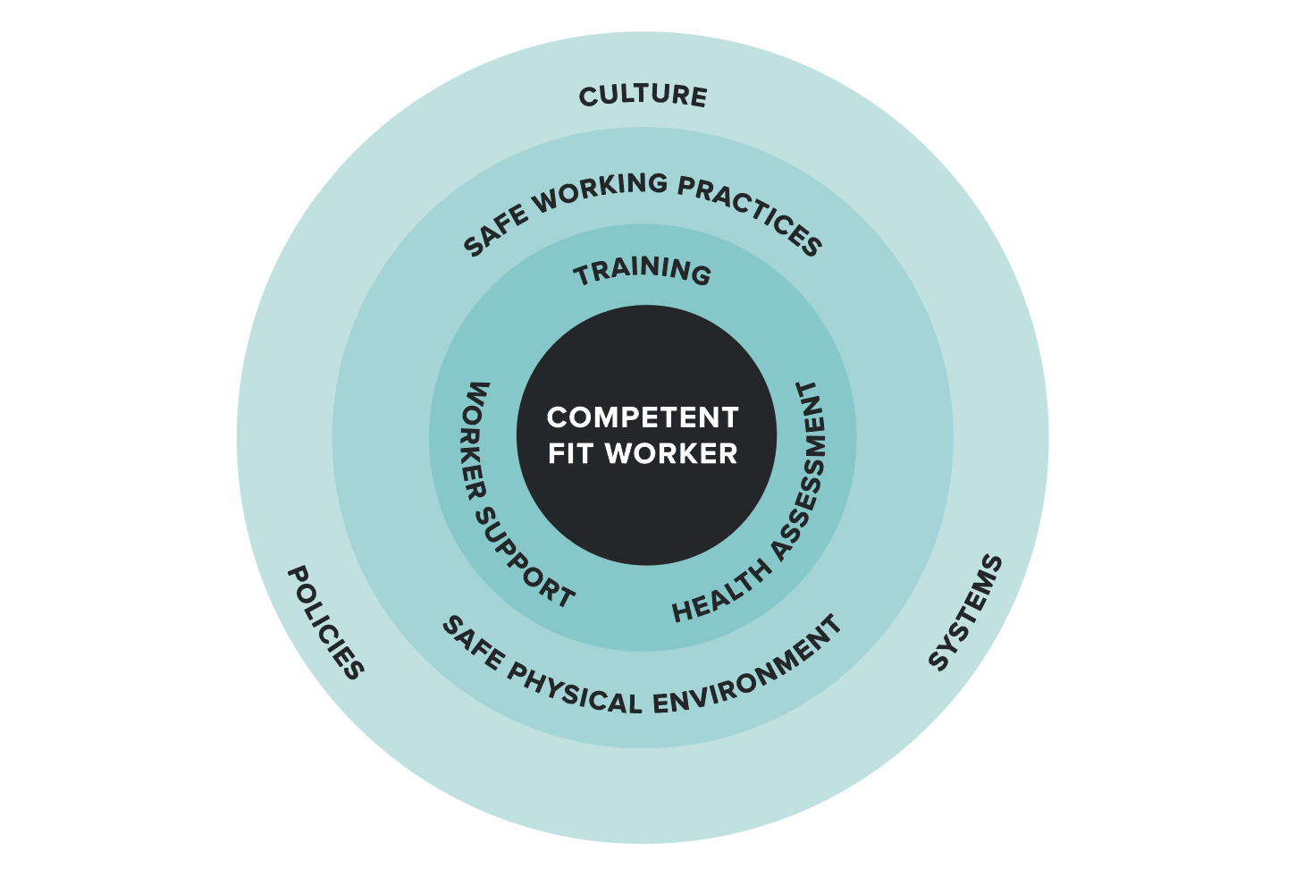

1.2. Scope of the Standard
The Standard relates to health assessments and procedures for monitoring and managing the health and fitness of workers in relation to their ability to perform rail safety duties.
Although the Standard does address individual worker safety on and about the track to some extent, it does not cover other occupational health and safety and work health and safety matters such as occupational exposure. It also does not cover fatigue management per se, however the implementation of the Standard interfaces closely with fatigue management programs through the identification and management of medical conditions that could affect sleep.
The Standard also does not include specific requirements for drug and alcohol testing, which is addressed through local requirements in each state or territory, or by individual rail transport operator policy. Such matters should be managed in conjunction with the Standard and are not superseded by it. The rail transport operator must address such issues and integrate them with the health assessments as appropriate (refer to Section 1.3. Legislative basis and interfaces).
The focus of the Standard is on risk management and achieving desirable outcomes. The provisions are described broadly so rail transport operators can implement systems and processes appropriate to their needs.
Should an agreement be reached at an enterprise level, the Standard does not preclude more comprehensive or frequent health assessments. However, those who do implement different methods should consider issues such as anti-discrimination laws and industry interfaces.

1.3. Legislative basis and interfaces

1.3.1 Rail Safety National Law and National Regulations
In December 2009, the Council of Australian Governments agreed to establish a national rail safety regulator and develop a national law that the regulator would administer. The National Transport Commission (NTC) developed the RSNL, based on the National Transport Commission Model Rail Safety Bill (2007) and Model Regulations (collectively, Model Law). The RSNL also addressed areas where states and territories had varied from the Model Bill and Regulations. Following extensive consultation with industry, governments and unions, a final version of the national law was submitted to and approved by infrastructure and transport ministers in November 2011. The RSNL was first enacted in South Australia in 2012. All other states and territories have adopted the RSNL.

Health and fitness management program
Under the National Regulations, Part 5 Rail safety workers, regulation 27, Health and fitness management program, a rail transport operator must have, and must implement, a health and fitness program for rail safety workers that complies with the Standard, as amended from time to time.

Drug and alcohol management program
Regulation 28 of the National Regulations outlines a number of requirements, including that rail transport operators must identify workers who have alcohol or other drug-related problems and, where appropriate, refer those workers to be assessed and treated, counselled or rehabilitated. The requirements include establishment of a drug and alcohol management program, implementation of systems and procedures for the provision of information and education to rail safety workers in respect of drugs and alcohol, as well as a drug and alcohol testing regime to be undertaken by rail transport operators.

Fatigue management
The RSNL and National Regulations also address the requirements in relation to fatigue management for rail safety workers. Safety management systems must address fatigue management through compliance with section 116 of the RSNL and regulation 29 of the National Regulations.

1.3.2. Occupational health and safety and work health and safety legislation
If a provision of the occupational health and safety legislation applies to railway operations, that provision continues to apply, and must be observed, in addition to the RSNL. Where a provision of the RSNL is inconsistent with a provision of the occupational health and safety legislation, the provision of the occupational health and safety legislation prevails to the extent of any inconsistency.
Occupational health and safety and work health and safety legislation impose a general duty of care on the rail transport operator and rail safety worker regarding risk management and integrates closely with the rail safety legislation and the Standard.
The scope of the Standard is confined to the assessment and management of health and fitness to perform rail safety work. Although the Standard does address individual worker safety on and around the track, it does not cover other occupational health and safety and work health and safety matters such as occupational exposure. Additional examinations required under occupational health and safety and work health and safety legislation (for example, occupational exposure to noise, lead or asbestos, or poor ergonomic design) are not covered by the Standard but should be addressed by the rail transport operator as required.

Case Study: Noise exposure
Rail safety workers’ hearing ability is assessed in accordance with the Standard to ensure they can work safely. In addition, state or territory regulations for hearing protection usually require audiometric testing at defined times for workers required to wear hearing protection due to exposure to certain noise levels. Thus, a 30-year-old worker may only require rail safety worker health assessments every 5 years but must have audiometric testing every 2 years if noise exposure warrants it. Rail transport operators must identify such overlaps and manage the process to ensure effective monitoring and management of risks and compliance with relevant legislation.
Figure 2. Legislative context
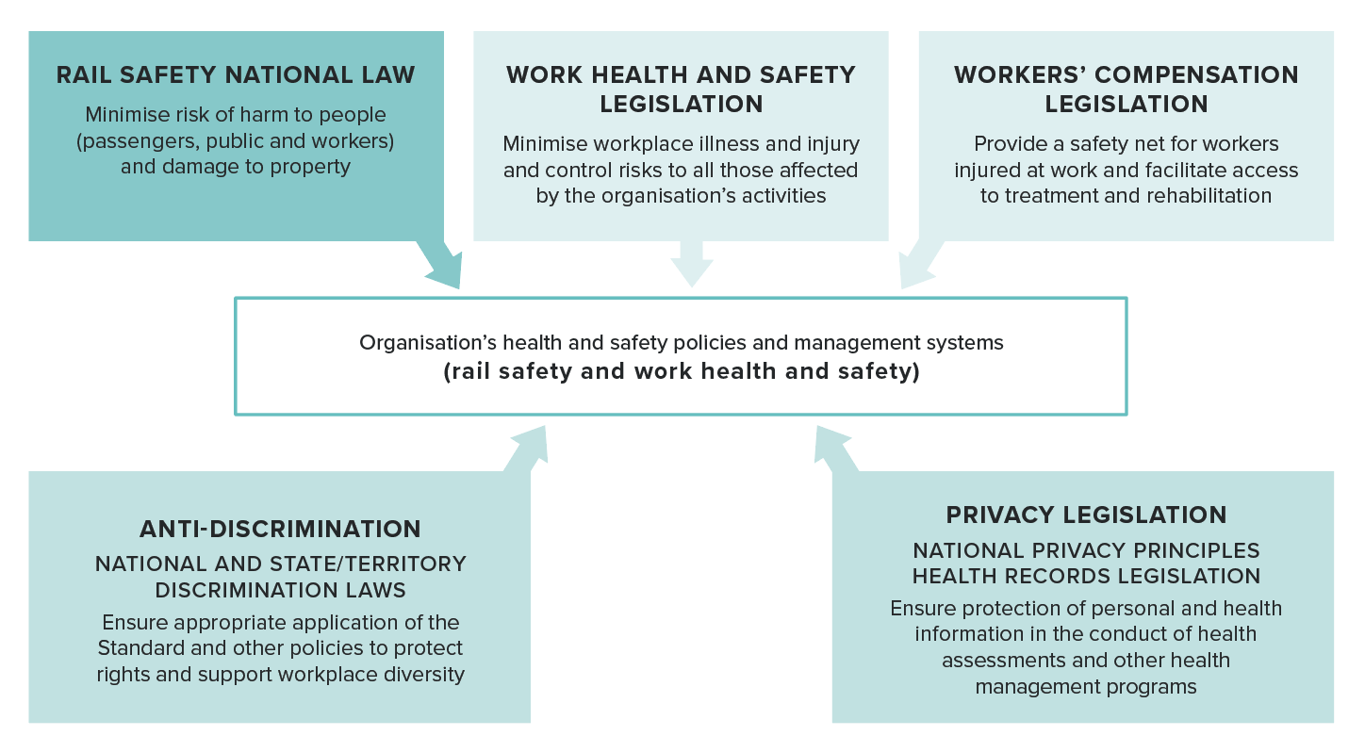

1.3.3. Anti-discrimination legislation
Anti-discrimination legislation has been considered in the development of the Standard and should be considered by rail transport operators when implementing health assessment systems:
- Health assessments must focus on inherent job requirements, not peripheral requirements. The risk assessment must guide the health assessment process (refer to Section 2.2.1. Risk categories of rail safety workers).
- In certain situations, it may be necessary to demonstrate that the condition prevents the worker from performing the required rail safety tasks—for example, through a functional or practical assessment of neurological conditions or musculoskeletal capacity (refer to Section 3.5.1. Functional and practical assessments).
- Any required tests should be valid, and the criteria must have a clear rationale—that is, the test must be a good predictor of serious illness regarding rail safety.
- If a standard must be met at entry, it should be maintained during employment and examined for periodically (refer to Section 2.2.6. Timing and frequency of health assessments).
- If a criterion is not met, a rail transport operator should consider reasonable adjustments to the workplace to accommodate the disability.
While public safety considerations take precedence over anti-discrimination, this does not exempt a rail transport operator from considering discrimination issues.

1.3.4. Workers’ compensation legislation
Workers’ compensation legislation is broadly relevant in terms of the concurrent management of compensation for work-related injury, the management of rehabilitation and return to work and the confirmation of fitness for duty under the Standard. Refer also to Section 1.4.3. Injury management, return to work and rehabilitation.

1.3.5. Privacy legislation
When administering the rail safety worker health assessments, rail transport operators must ensure compliance with the Australian Privacy Principles contained in privacy legislation and ensure that health records are managed and stored in line with the relevant health records legislation. Provisions for these specific requirements are described in Section 2.6.6. Managing health information.

1.4. Program interfaces
Implementation of the Standard will likely interface with a range of health and human resources policies and programs as shown in Figure 3. Interfaces should be identified and managed to optimise the effectiveness of the health assessment program, ensure consistent management of rail safety workers with respect to their health and reduce duplication.

1.4.1. Drug and alcohol management programs
The health assessments for rail safety workers should interface with drug and alcohol management programs, the requirements for which are defined under the RSNL, as described above.
Drug and alcohol testing conducted by rail transport operators in accordance with their drug and alcohol management program is a separate process to the health assessments conducted under the Standard, although Pre-placement (or change of risk category) Health Assessments may include a drug or alcohol test, depending on the state or territory’s legislation and the rail transport operator’s requirements. Periodic Health Assessments should not routinely include a drug or alcohol test.
The health assessment system provides a minimum mechanism and standard for managing workers who are identified with potential drug or alcohol problems but does not preclude rail transport operators from having additional testing or return-to-work requirements.
In addition, in cases where a Safety Critical Worker is diagnosed with chronic drug or alcohol issues, a more intensive individualised testing regime may be implemented as part of their management program upon return to work (refer to Section 4.12. Substance misuse and dependence).

1.4.2. Fatigue management
As described above, the RSNL requires that rail transport operators prepare and implement fatigue risk management programs for rail safety workers.
Health assessments have a role in identifying health problems as a possible cause of fatigue. The opinion of an Authorised Health Professional may be sought in appropriate cases by a triggered referral (refer to Section 2.2.6. Timing and frequency of health assessments).
Periodic Health Assessments may detect sleep apnoea syndrome, which manifests itself as a tendency to doze or lose concentration (or both) at inappropriate times. Assessments may also support sleep hygiene education (refer to Section 4.11. Sleep disorders).

Figure 3. Examples of interfacing health and human resources programs
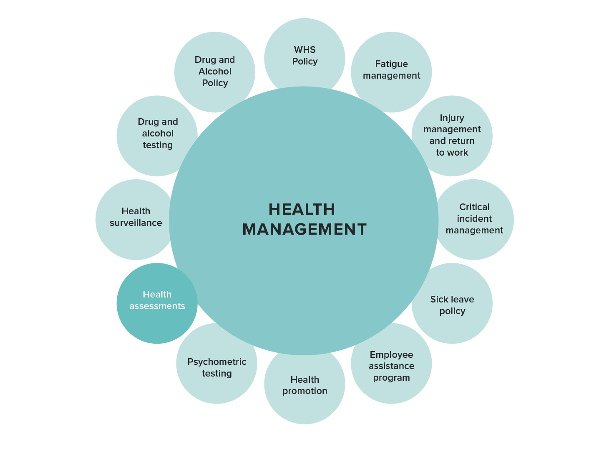

1.4.3. Injury management, return to work and rehabilitation
Injury management, return to work and rehabilitation also interface with rail safety worker health assessments and the Standard. For example, a worker on an injury management program should undergo a health assessment (Triggered Health Assessment) based on the Standard to determine fitness for their current rail safety duties or fitness for proposed alternative duties, including work in a different risk category.
The rail transport operator should ensure relevant providers of rehabilitation and return-to-work programs are aware of the Standard and assess rail safety workers accordingly for recommending fitness to return to work.

Case Study: Post-traumatic stress and return to work
A workplace injury is covered by accident compensation legislation. This means train drivers involved in traumatic events, such as suicides, receive counselling and monitoring as per organisational procedures. Depending on the time a driver is away from the workplace, they may undergo a health assessment to ensure they are fit to return to rail safety work (a Triggered Health Assessment). Rail transport operators must have defined programs for the return to work of rail safety workers.

1.4.4. Critical incident management
Most rail transport operators have counselling and support programs available for workers involved in fatalities, rail incidents and near misses. Periodic Health Assessments provide a further opportunity to review worker responses to critical incidents and to assess general psychological wellbeing. Informing the Authorised Health Professional of traumatic incident history, supports the effectiveness of the health assessment process and critical incident management overall. A Triggered Health Assessment may also be initiated by the rail transport operator as part of the return-to-work process or if there are ongoing concerns regarding a worker’s response to or recovery from a critical incident (refer to Section 4.10. Psychiatric conditions).

1.4.5. Psychometric testing
Some rail transport operators have introduced psychometric testing for recruitment and for promotion or change of risk category purposes. The health assessments described in the Standard do not include psychometric testing but may interface with these recruitment and selection tools where they exist. Psychometric testing may also be useful for assessing head injuries, as well as psychiatric, neurodevelopmental and neurological conditions (refer to Sections 4.4. Hearing, 4.5. Musculoskeletal disorders, 4.6. Neurological conditions: general and dementia, 4.7. Neurological conditions: seizures and epilepsy and 4.8. Neurological conditions: other).

1.4.6. Employee assistance programs
Personal and work-related issues can affect work performance. Employee Assistance Programs (EAP) help workers and their families resolve these issues via independent and confidential professional counselling. There is potential for referral to an EAP by the Authorised Health Professional (refer to Section 4.10. Psychiatric conditions).

1.4.7. Health surveillance
As previously noted, health screening undertaken as part of the Standard may interface with other health surveillance requirements, such as hearing testing for those working in environments that require hearing protection or surveillance required for other workplace exposures.

1.4.8. Health promotion
Rail safety worker health and fitness may be supported by health promotion programs, which may complement the health assessment program. For example, an Authorised Health Professional may refer a worker with increased risk factors for cardiac disease, such as smoking, to a health promotion program to assist risk factor modification.

1.5. Roles, responsibilities and relationships
This section describes the roles, responsibilities and relationships of organisations and individuals involved in the implementation of the Standard. It includes high-level responsibilities of organisations involved in Standard development and implementation, as well as the operational responsibilities and interactions between rail transport operators, health professionals and rail safety workers.

1.5.1. High-level implementation responsibilities
The NTC, ONRSR and Rail Industry Safety and Standards Board (RISSB) have responsibilities in overseeing Standard implementation and contributing to Standard development. These responsibilities are described below.

National Transport Commission
The NTC has an ongoing responsibility to ensure the Standard supports rail transport operators in managing the risks posed by ill-health of workers. The NTC reviews the Standard periodically to determine whether there have been medical, legal or social developments that need to be considered in applying the Standard. The NTC consults with stakeholders to review and implement changes to the Standard.
The NTC also plays a role in recommending and supporting changes to the RSNL and subordinate instruments.

Office of the National Rail Safety Regulator
ONRSR administers the RSNL and regulates rail transport operators across Australia. This includes monitoring compliance with the health and fitness requirements of the law through audits and investigations.
ONRSR is responsible for monitoring compliance with the Standard and consulting and advising on the application of the Standard.
ONRSR is consulted as a key stakeholder during the review of the Standard.

Rail Industry Safety and Standards Board
RISSB provides industry coordination of the Chief Medical Officers Council and the Authorised Health Professionals Program.
RISSB is consulted as a key stakeholder during reviews of the Standard.

Chief Medical Officers Council
The Chief Medical Officers Council (CMOC) is a governance group that operates under the auspices of RISSB for the rail industry and is responsible for providing medical expertise and oversight in the implementation of the Standard.
The CMOC contributes to quality assurance of the medical aspects of Standard implementation by assuring the development and content of the training program for Authorised Health Professionals and addressing quality issues and performance concerns that arise from audits.
The CMOC is consulted as a key stakeholder during reviews of the Standard.

1.5.2. Responsibilities for the conduct and management of health assessments
At an operational level, the effective implementation of health assessments for rail safety workers relies on a clear understanding of the various safety sensitive risks and responsibilities, as well as effective communication among the individuals or groups involved. Such communication, including management of health records, should be consistent with the provisions of relevant privacy and health records legislation as discussed in the previous section and in Section 2.6.6. Managing health information.

Rail transport operators
Rail transport operators have a legal responsibility to ensure that the health and fitness of workers is monitored and does not jeopardise rail safety, and that systems and processes to achieve this are developed in accordance with this Standard. This document uses the term ‘rail transport operator’ and ‘operator’ which also encompasses employers and sub-contractors and applies the same meaning.
Under the Standard, the rail transport operator is responsible for overseeing all aspects of Standard implementation within its organisation, including:
- Assessing the risks associated with ill-health for rail safety workers and implementing appropriate health assessments to address these risks.
- Ensuring rail safety workers meet the health assessment requirements and only work if they have a current fit for duty determination.
- Ensuring that health assessments for rail safety workers are conducted by Authorised Health Professionals as defined under the Standard (refer to Section 2.5. Authorising health professionals).
- Ensuring that Authorised Health Professionals who conduct health assessments for their organisation are informed about relevant operational requirements and policies.
- Implementing appropriate quality control measures to ensure consistency and quality of health assessments and appropriate management of worker’s health (refer to Section 2.7. Quality control).
- Managing worker health information in line with privacy and health records legislation.
- Accommodating the limitations on workers’ capabilities due to health issues through strategies such as job modifications, alternative duties or supervision, as appropriate (refer to Section 1.3.3. Anti-discrimination legislation).
- Communicating effectively with rail safety workers about:
  - The nature and purpose of health assessments conducted under the Standard.
  - The operator’s policies and procedures for worker health management.
  - How their health information will be managed in line with privacy and health records legislation.
  - Workers’ obligations and duties under the Standard including their obligation to report health concerns that may affect their ability to perform their work safely.
- Ensuring appropriate complaints and investigation processes are in place, including processes for reporting the outcomes to workers.
- Ensuring workers are advised about how to make a complaint regarding a health assessment decision.
- Participating in the resolution of complaints through the mechanisms described in the Standard (refer to Section 2.5.4. Quality control).
If employing contractors, the rail transport operator is required to inform them of their obligations to ensure appropriate health assessment systems are in place for their workers.
The final decision regarding fitness for duty or any restrictions rests with the rail transport operator and involves consideration of the advice of health professionals, including their Chief Medical Officer (see below), as well as anti-discrimination and retraining issues.

Contractors
A rail transport operator is responsible for managing its contractors and ensuring that contractors meet the health assessment requirements under the Standard and are certified fit for their current category of rail safety work according to the Standard.

Rail safety workers
Rail safety workers have a duty of care to themselves and others. They should understand the implications of their role on the safety of the public and the network, and the importance of their health and fitness to rail safety.
Rail safety workers may only conduct their rail safety duties if they have a current certificate indicating their fitness for that category of rail safety work. They must attend health assessments required under the Standard as directed by their rail transport operator or contracting organisation. At the assessment, they must provide complete and accurate information concerning their medical history to the assessing Authorised Health Professional. They must comply with any review requirements of the health assessment.
In between scheduled health assessments, rail safety workers have a responsibility to notify the rail transport operator of any temporary or ongoing health condition or change in health status that is likely to affect their ability to perform their work safely. They may request referral to an Authorised Health Professional if they are concerned about their ability to perform their work safely due to health reasons (refer to Section 2.2.6. Timing and frequency of health assessments).
If the rail safety worker works for more than one rail transport operator, they have a responsibility to ensure each operator is advised about any health condition that may affect their safe working ability.

Health professionals

Authorised Health Professionals
Only Authorised Health Professionals authorised according to the Standard may conduct health assessments for rail safety workers (refer to Section 2.5. Authorising health professionals). An exception to this requirement is strictly limited on a case-by-case basis to a circumstance whereby a Chief Medical Officer determines that lack of access to an Authorised Health Professional (such as in a remote location) precludes the timely medical certification of a rail safety worker (refer to Section 2.5. Authorising health professionals).
Under the Standard, Authorised Health Professionals are responsible for:
- Conducting health assessments in line with the procedures and fitness for duty criteria contained in this Standard (refer to Parts 3, 4 and 5). Note that, while measurements such as visual acuity, audiometry, body mass index (BMI), blood pressure and so on may be conducted by support personnel who are not Authorised Health Professionals, the clinical assessment and integration of information to make a fitness for duty decision is the responsibility of the Authorised Health Professional. Note also that telemedicine must not be used for the conduct of rail safety worker health assessments prescribed under the Standard except when specifically allowed under section 203 or 203A of the RSNL (for example, for emergency situations, such as in a pandemic) (refer to Section 3.1. Appointments and documentation).
- Collecting, disclosing and storing the worker’s health information in line with privacy and health records legislation (refer to Section 2.6.6. Managing health information).
- Liaising with the worker’s general practitioner and treating specialists, where appropriate, to clarify information relating to the worker’s current health status and fitness for rail safety duty.
- Communicating and consulting with all relevant providers to ensure the effective management of the worker’s health.
- Liaising with the rail transport operator’s Chief Medical Officer if applicable and as required.
- Communicating fitness for duty outcomes to rail transport operators in a timely way.
- Explaining fitness for duty outcomes to the worker.
- Advising how a worker may make a complaint regarding a health assessment decision.
- Participating in the resolution of complaints through the mechanisms described in the Standard (refer to Section 2.5.4. Quality control).
The ongoing treatment and management of medical conditions should be the responsibility of the worker’s general practitioner, treating specialist and other healthcare providers.
When a worker is already seeing a specialist, referrals for specialist opinion or further investigation for fitness for duty may be made to that specialist (see below for responsibilities of specialists).
The relationship between the health professional and the worker/patient is governed by the ethics of the relevant health profession and by privacy laws (refer to Section 2.6.6. Managing health information).

Chief Medical Officers
Some rail transport operators engage the services of a Chief Medical Officer whose role is to advise the rail transport operator about a range of issues related to the health of rail safety workers and health risks associated with their rail operations. The specific roles and responsibilities of each Chief Medical Officer will vary depending on the requirements of the rail transport operator.
In undertaking their role, the Chief Medical Officer must ensure that they practise ethically and in line with privacy requirements, being alert to any potential conflict of interest arising from their association with the rail transport operator or a health service provider, and always observing confidentiality of information.
All Chief Medical Officers are deemed to be Authorised Health Professionals on the basis of their skills and experience in conducting health assessments for rail safety workers. As a function of their role, they may or may not be available as Authorised Health Professionals to conduct assessments.
In relation to implementation of the Standard, a Chief Medical Officer’s role may include:
- Advising the rail transport operator about the implementation of the Standard within their organisation.
- Advising the rail transport operator about the health management and fitness for duty of individual rail safety workers.
- Advising the rail transport operator about engaging Authorised Health Professionals to conduct health assessments under the Standard as per Section 2.5. Authorising health professionals.
- Training health professionals about the Standard and the rail transport operator’s requirements, policies and so on.
- Providing oversight of fitness for duty recommendations made by Authorised Health Professionals to support consistency in application of the Standard.
- Liaising with Authorised Health Professionals as required to manage fitness for duty outcomes for rail safety workers, including requirements for specialist review or exceptional cases requiring consideration of individual risk.
- Implementing quality assurance activities associated with the Standard including auditing of Authorised Health Professional systems, processes and outputs.
- In emergency situations, such as a pandemic (where an exemption has been granted under section 203 or 203A of the RSNL), overseeing temporary modification of the health assessment process to avoid expiry of workers’ medical certification, as allowed. Refer to Section 3.5.3. Specialist referrals and reports for more information including the use of telemedicine.
In managing the fitness for duty process, it may be necessary for a Chief Medical Officer to issue an updated fitness for duty certificate, subsequent to an Authorised Health Professional's original determination. This may only occur, where there is medical evidence to support the change, such as from a treating specialist, or where there is further information from the workplace that is relevant to the health requirements, or where the assessment is not consistent with the requirements of the Standard. In making their decision, a Chief Medical Officer must take into consideration all medical evidence available to them. The most recent certificate must be available for the Authorised Health Professional when conducting subsequent assessments.
Rail safety workers should receive appropriate communication as to the reasons for any change in determinations as per Section 2.6.4. Communicating with rail safety workers and Section 3.7. Communicating with the rail safety worker.
The Chief Medical Officer may request a copy of the Record for Health Professional, the Health Questionnaire and/or other supporting clinical records from the Authorised Health Professional to ensure consistency and quality of health assessments for rail safety workers or to assist with management of a particular worker. When such records are accessed or retained by the Chief Medical Officer, their confidentiality must be assured, and systems must be in place to ensure records are not accessed by unauthorised personnel.
The Standard does not set out defined responses to quality issues associated with Authorised Health Professionals. If a Chief Medical Officer identifies issues with the quality of health assessments being conducted by an Authorised Health Professional providing services to their rail transport operator, this may be managed by actions including audit, further education or consultation with the Chief Medical Officers Council. Cancellation of the authorisation of a particular health professional may also result from a quality assurance process led by the Chief Medical Officer.

Medical specialists
For Safety Critical Workers diagnosed with or suspected of having a medical condition that may impact on their fitness for duty, specialist medical input is generally required to inform the decision about fitness for duty, to initiate and oversee treatment as required and to help monitor ongoing fitness for duty (Fit for Duty Subject to Review). Workers and their treating general practitioner should be involved in the selection of the medical specialist.
This Standard generally requires Safety Critical Workers who are assessed Fit for Duty Subject to Review to be seen by a specialist leading up to their review appointment with the Authorised Health Professional.
Medical specialists should be alerted to the requirements of the Standard and the nature and requirements of the rail safety worker’s job so that they can provide the relevant advice.
In certain circumstances, the Chief Medical Officer of a rail transport operator may determine that review by a worker’s treating general practitioner, or the Authorised Health Professional, is sufficient if there is an established pattern of compliance and a satisfactory response to treatment. The initial granting of Fit for Duty Subject to Review must be based on information provided by a specialist. These circumstances are identified in this Standard.
Refer to Section 3.5.3. Specialist referrals and reports for more information including the use of telemedicine. Refer also to Section 3.8. Communicating with treating health professionals.

1.6. Evidence base
The guidance and medical criteria contained in the Standard are based on published evidence of the impact of medical conditions on rail safety, including incident reports, where such evidence is available. Where such evidence is not available, the Standard draws on relevant evidence in the road environment, including crash risk and driver impairment associated with various medical conditions.
The review of the Standard has coincided with the conduct of a major literature review by the Monash University Accident Research Centre (MUARC). The report, Influence of chronic illness on crash involvement of motor vehicle drivers (3rd ed.), provides a comprehensive evidence base that is extrapolated as appropriate to fitness for rail safety work.
Where contributing professional organisations and experts have provided references to support changes to the Standard, these have been incorporated. Where evidence was lacking, expert opinion from members of specialist medical colleges and other health professional organisations provides the basis of the Standard.

1.7. Structure of the Standard
The Standard consists of 6 parts:
- Part 1. Introduction – This Part describes the purpose, scope and context of the Standard as well as roles and responsibilities of various parties involved in or subject to implementation of the Standard.
- Part 2. The health risk management approach – This Part outlines the system for managing rail safety worker fitness for duty under the Standard. It includes a framework for analysing and categorising the risks associated with rail safety tasks and assigning workers to a level of health assessment commensurate with the risks. It also includes procedural requirements for rail transport operators such as scheduling, communication, records management and the appointment of Authorised Health Professionals. Approaches for quality assurance and audit are also included.
- Part 3. Procedures for Authorised Health Professionals – This Part outlines the procedures relevant to Authorised Health Professionals in managing and conducting health assessments.
- Part 4. Assessment and management of health conditions – Category 1 and 2 Safety Critical Workers – This Part includes the fitness for duty criteria for fitness for duty for Safety Critical Workers, arranged alphabetically in sections addressing the main conditions affecting fitness for duty.
- Part 5. Assessment and management of health conditions – Category 3 workers – This Part includes the fitness for duty criteria for Non-Safety Critical Workers (Category 3).
- Part 6. Clinical tools, forms and transition arrangements – This Part includes supporting documentation including:
  - clinical tools such as health questionnaires
  - model forms for managing the health assessments
  - transition arrangements.

2. The health risk management approach
This section of the Standard explains:
- the features of the health risk management approach, including risk categorisation, timing and frequency of health assessments and the fitness for duty reporting framework
- the detailed task and worker risk categorisation process
- authorising health professionals, including the criteria for appointing Authorised Health Professionals
- administrative systems, including privacy laws and health assessment forms
- quality control, including systems and audit points.

2.1. Health risk management approach
The requirements for rail safety worker health assessments are to be determined by a health risk management approach based on a system of risk categorisation. This aims to ensure the level and frequency of health assessments conducted is commensurate with the risk associated with the tasks performed by rail safety workers.
Rail transport operators must establish systems and procedures to ensure rail safety workers receive the appropriate level and frequency of health assessment that corresponds with the risks associated with the tasks they perform.
Figure 4 shows the ergonomics of a typical rail safety job and provides a framework for understanding and applying a risk management approach to rail safety worker health assessments. It shows that information is gained about the rail system by the senses (mainly vision and hearing). The information is then processed by the brain (cognition, or ‘situational awareness’) and decisions are made that are then put into effect by the musculoskeletal system to alter the operation of the system. This cycle rapidly repeats. These processes take place within the operational environment of the rail transport operator.
The aim of a health risk management approach is to:
- identify what could go wrong in the case of physical or psychological ill-health
- assess the consequences
- establish appropriate controls for the risks associated with ill-health.
The health risk management approach focuses on a consideration of whether a worker’s physical or psychological health could contribute to a serious incident on the rail network that may result in any of the following:
- any other occurrence that results in significant property damage
- a collision or derailment involving rolling stock that results in significant damage
- incapacitating injury to a person
- the death of a person.
Health assessments are one approach to treating the risk of serious incidents and the risk to individual safety, thus a mix of engineering, administrative and health assessment measures is likely to be required. When determining the health assessment requirements of rail safety workers, it is important to consider the operational and engineering environment, since the existence or lack of appropriate controls will significantly determine the human attributes that are required for safety.
This interaction between technology and human capabilities has implications not only for the setting and application of health standards, but also for meeting diverse legal requirements. Health assessment standards cannot be simply set at the highest level for safety’s sake. They must be set and applied carefully to match the risks associated with the tasks to be consistent with anti-discrimination and privacy laws.
As the work environment significantly determines the skills and attributes required and the risk involved, a rail transport operator should determine its own health assessment requirements based on its own operating environment.

2.2. Features of the health risk management approach
The health risk management approach defined in the Standard features a number of key elements:
- Risk categorisation of rail safety workers – It is not practical to individualise health assessments for every worker or task, thus a system of risk categorisation forms the basis of the health risk management approach. This simplifies application of the health assessment requirements (refer to Section 2.2.1. Risk categories of rail safety workers and Section 2.4. Risk categorisation and health assessment requirements).
Figure 4. The ergonomics and health attributes required for rail safety work
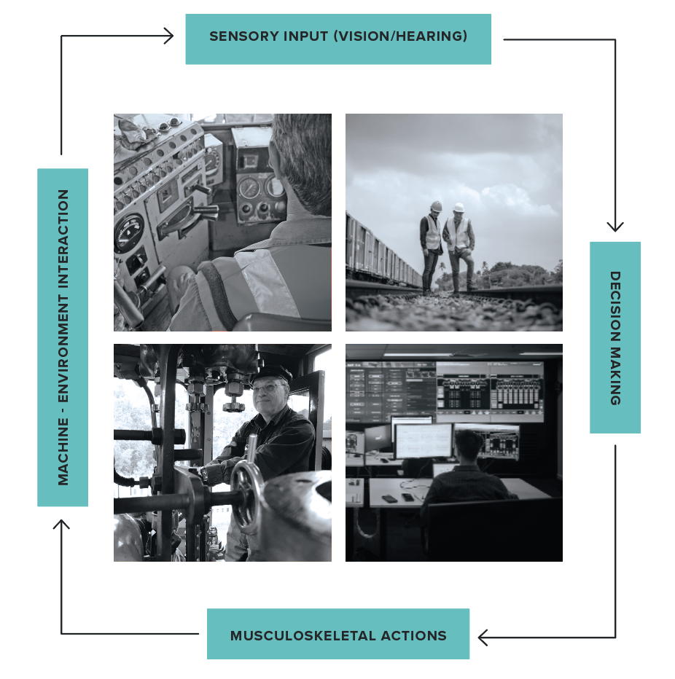
- Health assessments and fitness for duty criteria matched to the risk categories – Health assessments and fitness for duty criteria are defined in the Standard for each of the categories of work. This approach supports consistency of application. Health assessments are in turn based on a health risk management approach in which:
  - Rail safety workers are screened for health conditions that may impact on rail safety.
  - Identified health conditions are assessed and investigated to determine their potential impact on rail safety, both in the short and long term.
  - Rail safety workers are referred for appropriate treatment.
  - A program of monitoring and review is established to ensure risks to rail safety are minimised in line with the defined criteria of the Standard.
- Defined timing and frequency of health assessments – Timing and frequency of health assessments are defined to support early detection of health conditions and appropriate management to assist long-term fitness for duty.
- Standard reporting framework – A standard reporting framework for fitness for duty (or otherwise) supports consistency of application.

2.2.1 Risk categories of rail safety workers
This section provides an overview of the risk categories applied in the Standard. The process of defining the categories is summarised in Figure 5 overleaf. Further detail as to how workers are allocated to the respective categories is provided in Section 2.4. Risk categorisation and health assessment requirements.
In the first instance, category definition is based on a consideration of the key question:
For any aspect of the worker’s tasks, could action or inaction on the part of the worker due to ill-health lead directly to a serious incident affecting the public or the rail network?
This question is posed in the context of existing control measures such as vigilance systems and fail-safe mechanisms (refer to Section 2.4. Risk categorisation and health assessment requirements).
The response to this question leads to the definition of two main risk categories:
- Safety Critical Work/Workers – These are workers whose action or inaction due to ill-health may lead directly to a serious incident affecting the public or the rail network. Their vigilance and attentiveness to their job is crucial, and they are therefore the focus of the Standard. These workers require health assessments to ensure ill-health does not affect their vigilance and attentiveness to the job, and therefore the safety of the public or the rail network. Safety Critical Workers’ tasks are distinguished from tasks that affect only individual worker safety.
- Non-Safety Critical Work/Workers – These are workers whose action or inaction due to ill-health will not lead directly to a serious incident affecting the public or the rail network. These workers require health assessments to ensure their own safety while working in or around the network.
Safety Critical Work/Workers are then subdivided into Category 1 and Category 2 by applying a further test:
For any aspect of the worker's tasks, could sudden incapacity or collapse due to ill-health of the worker lead directly to a serious incident affecting the public or the rail network?
- Category 1 Safety Critical Work/Workers – Category 1 Safety Critical Workers are the highest level of Safety Critical Worker. These are workers who require high levels of attentiveness to their task and for whom sudden incapacity or collapse (for example, from a heart attack or blackout) may result in a serious incident affecting the public or the rail network. Single-operator train driving on the commercial network is an example of a Category 1 task.
- Category 2 Safety Critical Work/Workers – Category 2 Safety Critical Workers are those whose work also requires high levels of attentiveness, but for whom fail-safe mechanisms or the nature of their duties ensure sudden incapacity or collapse does not affect safety of the rail network. For example, in many cases signallers are categorised as Category 2 because fail-safe signal control systems protect the safety of the network in case of worker incapacity.
Note: The Category 3 standard should also be considered for Category 2 Safety Critical Workers who work on or near the track (see below).
Figure 5. Risk categories of rail safety workers*
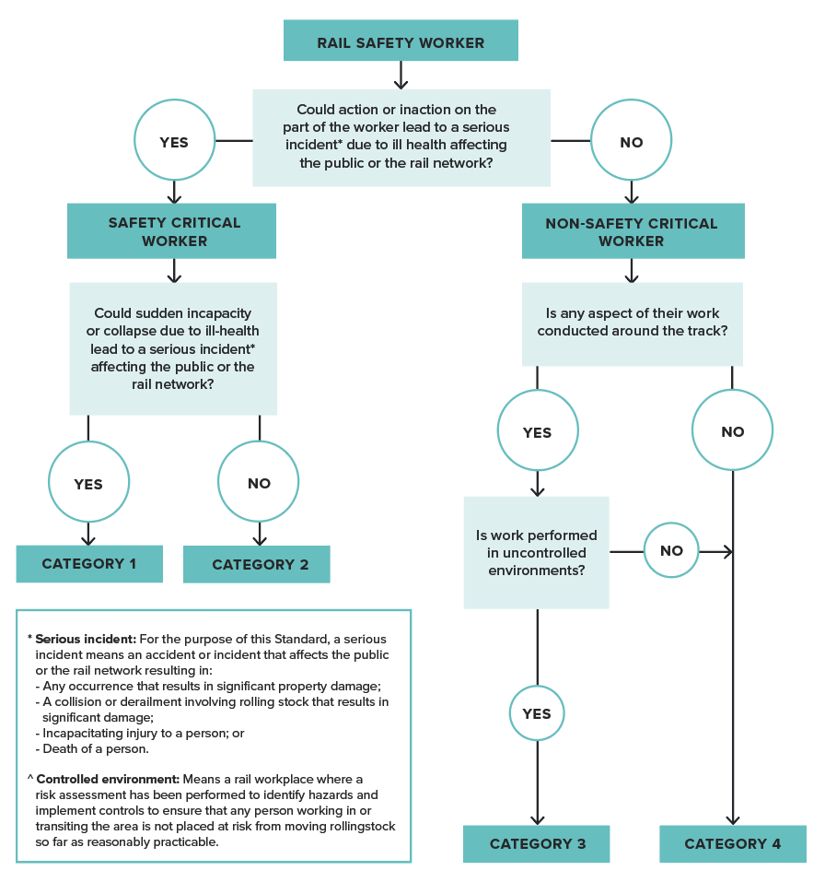
* Note that categorisation of the rail safety worker occurs in the context of existing control measures such as vigilance systems and failsafe mechanisms. Refer to Section 2.4. Risk categorisation and health assessment requirements for the steps in the full health risk assessment process.
Non-Safety Critical Work/Workers are further defined depending on whether they work on or near the track and whether they work in a ‘controlled environment’ where they are not at risk due to moving rolling stock. Around the Track Personnel (ATTP) is the term used to describe workers who perform Non-Safety Critical Work tasks on or near the track as defined.
- Category 3 Work/Workers – ATTP who operate in an uncontrolled environment may be at risk from moving rolling stock. They are categorised as Category 3 and are required to have health assessments to identify relevant health conditions that could affect their ability to detect an oncoming train and react to a warning and promptly move to a safe area.
- Category 4 Work/Workers – ATTP who operate in a controlled environment are categorised as Category 4 and are not required to have health assessments under the Standard. Workers who do not work around the track are not at risk from moving rolling stock and are also included in Category 4. A controlled environment is defined in the Standard as a rail workplace where a risk assessment has been performed to identify hazards and implement controls to ensure that any person working in or transiting the area is not placed at risk from moving rolling stock so far as is reasonably practicable.
When analysing the risk to ATTP and categorising the tasks into Categories 3 or 4, the features of a controlled environment need to be carefully considered regarding their adequacy. If workers may move between controlled and uncontrolled environments, then the higher level of risk assessment should be applied. Irregular visitors to the track, such as office workers, are not generally categorised as ATTP. When they do visit the track, their safety should be ensured by other means—for example, by escort. Further information about assessing controlled and uncontrolled environments is included in Section 2.4.5. Step 5: Categorise tasks.
Note that workers who access the track receive track safety awareness training on a regular basis, which is another key aspect of their ability to protect their own safety and that of fellow workers.

2.2.2. Health assessments matched to risk categories
A rail safety worker should receive the level of health assessment commensurate with their rail safety work risk category. These are briefly described in the following sections. The assessment procedures and fitness for duty criteria applicable to each of Categories 1, 2 and 3 are outlined in detail in Parts 3, 4 and 5.

Safety Critical Worker Health Assessments (Categories 1 and 2)
The health assessments for Safety Critical Workers aim to detect conditions that may impact on their vigilance and attentiveness to their work. These conditions include, for example, cardiovascular disease, diabetes, epilepsy, various other neurological conditions, neurodevelopmental disorders, sleep disorders, alcohol and drug dependence, and psychiatric conditions, as well as hearing and visual problems.
The assessment comprises a Health Questionnaire and clinical examination. The self-administered Health Questionnaire collects a general history and helps identify specific conditions that might affect rail safety task performance. The responses are reviewed by the Authorised Health Professional and details discussed as required to inform the clinical examination. The questionnaire is not diagnostic, and no decision can be made regarding fitness for duty until the clinical examination is completed.
The clinical examination assesses the key body systems to identify conditions that may affect rail safety task performance as described above. The examination may result in referral for further tests or opinion.

Additional assessment requirements for Category 1 Safety Critical Workers
Health conditions that may cause sudden incapacity or collapse are a particular risk for Category 1 Safety Critical Workers. They therefore have a cardiac risk level assessment to identify their risk of cardiovascular disease and predict the risk of cardiac events, such as heart attack or stroke. The clinical examination for Category 1 Safety Critical Workers also focuses on the identification of other health conditions that might result in sudden incapacity or collapse, including hypoglycaemia (in workers with diabetes), epilepsy and transient ischaemic attacks.

Track Safety Health Assessments (Category 3)
The Track Safety Health Assessment for ATTP (Category 3) focuses on medical conditions that could impact on a worker’s ability to detect and react quickly to an oncoming train or warnings.
The clinical assessment includes audiometry, testing of visual acuity and visual fields and a general musculoskeletal assessment. It is also acknowledged that health conditions that cause loss of attention or loss of consciousness can prevent a person from seeing, hearing or moving out of the path of an oncoming train (for example, blackouts, cardiovascular conditions, diabetes, and so on). Identification of these conditions at Pre-placement and Periodic Health Assessment is generally by worker self-report via the Health Questionnaire. Unlike Category 1 Safety Critical Workers, there is no active screening for these conditions other than by self-report.
In light of the above, and as for all rail safety workers, rail transport operators should ensure that Category 3 workers are advised to notify their supervisor or request a Triggered Health Assessment, or both, if they develop a condition that is listed in the Standard, including:
- a condition that could lead to collapse on a track
- serious injury or illness to their eyes, hearing or limbs
- a serious brain injury
- another serious condition that could affect track safety (refer to Part 4).
Substance abuse should also be declared in accordance with the operator’s drug and alcohol management program. Workers making such notifications should be referred for a Triggered Health Assessment to assess implications for safety around the track, and action taken accordingly, including job modification as required. Refer to Section 2.2.6. Timing and frequency of health assessments and Part 5.

2.2.3. Task-specific requirements
The risk categories and matching health assessments provide a general framework for defining health assessment needs. However, certain tasks will have specific requirements that are independent of the worker’s category, such as for colour vision, hearing or musculoskeletal attributes.
The health monitoring system implemented by the rail transport operator should ensure that the health assessment requirements reflect the specific health attributes required to undertake the rail safety tasks including, where appropriate, the frequency with which the tasks are performed.
Further guidance on defining the specific requirements is included in Section 2.4.6. Step 6: Identify task-specific health requirements.

2.2.4. Functional and practical assessments
In some situations, a clinical health assessment may need to be supplemented by a functional or practical test to confirm fitness for duty. This may occur at Pre-placement, Periodic or Triggered Health Assessments, including those conducted prior to return to work. For example, a functional assessment of some neurological conditions or of musculoskeletal capacity may be applied to confirm the worker’s ability to perform the particular tasks required of them.
Practical tests for colour vision or hearing, however, are not recommended because consistency of methodology, and thereby accuracy and applicability across all rail transport operators, cannot be ensured. Laboratory (clinical)-based tests of hearing or colour vision are standardised and therefore results are portable to all rail systems (refer to Section 4.4. Hearing and Section 4.13. Vision and eye disorders).
Practical tests are usually conducted in the typical work environment, whereas functional assessments are simulations of work in settings such as a gym or cab simulator. Such tests cannot override the fitness for duty criteria; they can only supplement the doctor’s decision about the ability to perform rail safety tasks where the Standard is imprecise.
Each rail transport operator should develop their own procedures and criteria for practical and functional assessments based on their system requirements. Assessments may also be designed and tailored to specific situations if needed.
The results of practical tests are not transferable to other operators or networks unless the work practices and work environments are very similar.
Practical or functional assessments of musculoskeletal function may be conducted by people appropriately trained in the test procedure and with experience of the tasks involved, such as an occupational therapist, a physiotherapist, a principal driver or other experienced staff. Such people should work in conjunction with the Authorised Health Professional.
A principal driver (or equivalent) is a senior driver with wide experience who is often involved in training other drivers. A worker with borderline impairment may be referred to a principal driver for a practical test to assess work performance. This is particularly relevant to musculoskeletal and neurological impairments. Similarly, other experienced staff may assist in assessing work performance of Safety Critical Workers in other jobs. Such an assessment should be arranged through the worker’s manager.
Rail transport operators and Authorised Health Professionals should consider the following limitations of functional and practical tests:
- They can never fully simulate the work environment—by nature, the test will always be a snapshot of the person’s functional capacity. They are limited in time and may not provide an indication that the individual will be capable of performing those tasks for a full working day.
- A test may place the person being tested at risk of injury. When ordering a functional or practical test, the examining doctor should be satisfied that the individual is fit to perform the test. If fitness to perform the test is questionable, then so is the person’s fitness for the role.
- A functional or practical test does not assess risk of injury. Where the health issue is one of recurrent injury, for example, an unstable knee, performing all of the elements of a test does not mean that the person is safe to perform those job demands day after day.
- A practical test is not standardised but is based on local requirements and equipment. Therefore, there is a potential problem in extrapolating the results to other systems if the worker transfers to another job or operator.
- A practical test is of limited use in situations where recurrent work performance or safety concerns have already been noted to occur on the job.

2.2.5. Drug and alcohol testing
The Rail Safety National Law (RSNL) requires rail transport operators to ensure that rail safety workers are not impaired by alcohol or drugs when performing their work. Rail safety workers themselves also have a duty not to perform rail safety work while impaired by alcohol or drugs.
Pre-placement (or change of risk category) Health Assessments may therefore include drug and alcohol testing, depending on the state or territory’s legislation and the rail transport operator’s requirements. Periodic Health Assessments should not routinely include a drug or alcohol test. However, testing may occur as part of a return-to-work program for a person with a substance misuse condition.
If a person declares drug or alcohol misuse, is suspected of being intoxicated by alcohol or drugs at the time of an examination or if the assessment is triggered due to drug or alcohol concerns, the Authorised Health Professional should assess them and enquire of possible reasons for their condition. Under these specific circumstances the doctor may conduct a drug and alcohol test or assessment. If drug or alcohol intoxication is suspected or confirmed, the Authorised Health Professional should categorise the worker as Temporarily Unfit for Duty and notify the rail transport operator (refer to Section 4.12. Substance misuse and dependence). Testing should be conducted in line with the relevant Australian standard.

2.2.6. Timing and frequency of health assessments
The timing and frequency of health assessments also supports a risk management approach. A rigorous health assessment approach should:
- confirm that the health and fitness of a rail safety worker candidate is suited to the tasks to be performed
- periodically monitor the rail safety worker’s health during employment to detect conditions that might affect rail safety
- enable monitoring of identified health conditions to ensure they are appropriately managed and do not present a risk to safety
- enable a timely response to concerns that may arise about a rail safety worker’s health.
The health assessment system should therefore comprise the three types of assessments described below and illustrated in Figure 6.

Pre-placement and Change of Risk Category Health Assessments
Rail safety workers categorised in Categories 1, 2 and 3 require health assessments at Pre-placement and before changing to a position involving tasks of a higher risk category. The assessments are aimed at determining a worker’s initial fitness to perform the full range of inherent job requirements and job demands of the rail safety position they have applied for and should match the risk category of the job they are entering.

Periodic Health Assessments
Periodic Health Assessments are conducted to identify health conditions that may affect safe performance of rail safety work. They should be conducted for Category 1, 2 and 3 rail safety workers according to the following defined frequencies.

Category 1 and 2: Safety Critical Workers
Periodic Health Assessments are conducted:
- at time of commencement (Pre-placement, as above), then
- every 5 years to age 50, then
- every 2 years to age 60, then
- every year.
For Category 1 and Category 2 Safety Critical Workers, despite anything to the contrary in the list, the worker must have a health assessment conducted within 2 years after turning 50 years of age, and within 1 year after turning 60 years of age.

Category 3: Around the Track Personnel in an uncontrolled environment
Periodic Health Assessments are conducted:
- at time of commencement (Pre-placement, as above), then
- every 5 years from the age of 40 years.
Category 3 workers who have had a full health assessment less than 5 years before turning 40 (for example, for Pre-placement), may have their next Periodic Health Assessment scheduled 5 years from that date.
When scheduling Periodic Health Assessments, rail transport operators may apply a fixed anniversary date, provided the assessment is conducted 2 months or less before the due date. If the assessment is conducted more than 2 months before the due date, the date of the assessment will become the new anniversary date. If the assessment is conducted after the due date (or the current medical report has expired), the date of the assessment will become the new anniversary date. Refer to Section 2.2.7. Validity of medical certificates and scheduling of health assessments.
The frequencies of Periodic Health Assessments are a minimum requirement based on evidence of rate of age-associated degenerative illness, the power of the assessment to detect rail safety workers at risk, and comparison with local and overseas standards. Rail transport operators may choose to implement more frequent Periodic Health Assessments should the need and rationale be identified.
Ongoing treatment of medical conditions should continue to be the responsibility of the worker’s general practitioner.
The program of comprehensive Periodic Health Assessments should be maintained even if more frequent Triggered Health Assessments are performed for an individual’s particular condition. Where a rail safety worker has an existing medical condition that warrants more frequent review between Periodic Health Assessments, the status of this condition should be specifically monitored at each Periodic Health Assessment.

Triggered Health Assessments
Triggered Health Assessments are additional health assessments undertaken earlier than the scheduled Periodic Health Assessment, because of concerns about an individual’s health, or because there is a requirement for more frequent monitoring of a health condition.
Triggered Health Assessments overlay the scheduled Periodic Health Assessments and enable early intervention, appropriate management and timely monitoring of health problems that are likely to affect safety.
Referral for a Triggered Health Assessment may be prompted by one of the circumstances listed below. These circumstances will determine the nature and extent of the health assessment required.

1. Assessments related to more frequent monitoring of a medical condition (Fit for Duty Subject to Review)
Where the rail safety worker has a medical condition which requires more frequent monitoring than that provided under the routine Periodic Health Assessments, for example, diabetes or a sleep disorder, a Triggered Health Assessment may be requested by the examining Authorised Health Professional or the rail transport operator’s Chief Medical Officer.
Figure 6. Health assessments supporting fitness for duty of rail safety workers
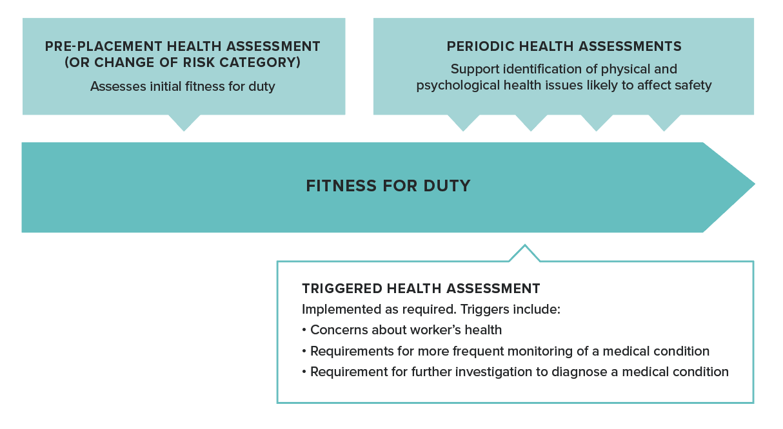
A health assessment will be triggered for an appropriate period as guided by the Standard (for example, annually). This will be noted on the report provided by the Authorised Health Professional and the rail safety worker will be categorised Fit for Duty Subject to Review.
The nature and extent of a Triggered Health Assessment will be determined by the examining Authorised Health Professional or the Chief Medical Officer and will depend on the nature of the medical conditions or health concerns. A full assessment (as required for Periodic Health Assessments) is not necessarily required. For example, for a worker with sleep apnoea, it may be sufficient for the Authorised Health Professional to review a printout of the worker’s continuous positive air pressure (CPAP) machine. Alternatively, review of reports from treating specialists may be sufficient. In other cases, a face-to-face medical assessment might be required.
The Authorised Health Professional will indicate that a Triggered Health Assessment is required by categorising that the individual is Fit for Duty Subject to Review and will indicate the type of review assessment required (while observing privacy), and when it will be required.

2. Assessments relating to further investigation to diagnose or treat a medical condition (Fit for Duty Subject to Review or Temporarily Unfit for Duty)
Resulting from a Periodic Health Assessment, it may be necessary for the Authorised Health Professional to arrange further investigations, or to request further reports from a treating doctor or specialist to determine fitness for duty.
If the condition does not pose an immediate risk to the safety of the individual or the rail system, and where permitted under the Standard, the worker may remain at work while the investigations are undertaken and while awaiting reports. The Authorised Health Professional will categorise the rail safety worker as Fit for Duty Subject to Review and will indicate the type of review assessment required and when it will be required, generally within three months.
If the condition is one that imposes an immediate risk, then the rail safety worker will be categorised Temporarily Unfit for Duty until their ongoing fitness can be determined after review of the additional medical information.

3. Health assessment triggered by concerns about a worker’s health
A Triggered Health Assessment may be requested by a rail transport operator where there is reason for concern that a health issue may be impacting the worker’s ability to perform their duties safely between Periodic Health Assessments.
Rail transport operators should be alert to indicators of ill-health, such as recurrent absenteeism, repeated incidents and recent traumatic events, and should discuss these with the rail safety worker. This may lead to a triggered referral for a health or neuropsychological assessment, retraining in competencies or referral to an EAP.
The worker themselves may also request a health assessment if they have concerns about their ability to work safely due to a medical condition, or due to treatment such as medication.
The nature and extent of the health assessment in these circumstances will depend on the presenting symptoms and circumstances and will be determined by the Authorised Health Professional or Chief Medical Officer. The rail transport operator should request a Triggered Health Assessment and provide sufficient information for the examining doctor to determine the assessment requirements. It is not the responsibility of the rail transport operator to determine the extent of the assessment required.

4. Triggered Health Assessments in relation to ongoing Periodic Health Assessments
Triggered Health Assessments do not forego the requirement for regular Periodic Health Assessments. Full Periodic Health Assessments should still be conducted according to the timeframes prescribed in the Standard.
Where a rail safety worker has an existing health condition that warrants more frequent review between Periodic Health Assessments, the status of this condition should be specifically monitored at each Periodic Health Assessment.
The Triggered Health Assessment process should not result in a change in the scheduling of the prescribed Periodic Health Assessments, unless the Triggered Health Assessment has comprised a full assessment as defined for Periodic Health Assessments, in which case the date of the next Periodic Health Assessment can be reset.

2.2.7. Validity of medical certificates and scheduling of health assessments
A rail safety worker without a current fitness for duty report cannot undertake rail safety work. All medical reports are deemed to expire at the end of the period noted on the report provided by the Authorised Health Professional. (The Authorised Health Professional must date and sign the report to represent the date the assessment was conducted.)
A Chief Medical Officer may, with the support of the rail transport operator, extend the period during which a medical report remains in force by up to 1 month, where the Chief Medical Officer is satisfied that extending the period will not adversely affect the safety of railway operations. The Chief Medical Officer must enter the new date on the medical report or provide the rail safety worker and the rail transport operator with a written notice setting out the period of the extension.
When scheduling Periodic Health Assessments, rail transport operators may apply a fixed anniversary date, provided the assessment is conducted 2 months or less before the due date. If the assessment is conducted more than 2 months before the due date, the date of the assessment will become the new anniversary date. If the assessment is conducted after the due date (or the current medical report has expired), the date of the assessment will become the new anniversary date.
In scheduling Triggered Health Assessments, consideration should be given to the date of the last specialist report.

2.3. Standard reporting framework
Rail transport operators should adopt standard terminology for reporting and managing rail safety workers’ fitness for duty.
The terminology provided below and illustrated in Figure 7 and Table 1 is used throughout the Standard and in the model forms in Section 6.2. Model forms.

2.3.1. Fit for Duty Unconditional
This assessment category indicates that the worker meets all the criteria for Fit for Duty Unconditional in the Standard and is to be reviewed in line with the normal Periodic Health Assessment schedule. It means the worker does not have a health condition or health risk that is likely to impact on their ability to undertake inherent requirements of the rail safety task now or in the foreseeable future. They are not subject to any restrictions or conditions, or more frequent review.
Note: Included in this category are rail safety workers who have stable visual impairments that are not associated with a progressive condition and who meet the vision fitness for duty criteria with the appropriate aids (corrective lenses). They must wear the appropriate aids when undertaking rail safety work. The suitability of these aids in meeting the fitness for duty requirements will be monitored by the Authorised Health Professional at each Periodic Health Assessment.

2.3.2. Fit for Duty Subject to Review
This assessment category indicates that the worker does not meet the criteria for Fit for Duty Unconditional; however, the condition or conditions are sufficiently controlled to permit current rail safety duties under certain conditions.

Monitoring of the worker’s health condition
Continuation of normal duties is conditional on the worker’s health condition being specifically monitored to confirm their ongoing fitness for duty. This may require more frequent assessments than prescribed under the normal Periodic Health Assessment schedule. For example, a Safety Critical Worker diagnosed with diabetes will require more frequent (annual) targeted health assessments to monitor their condition as well as general Periodic Health Assessments. Once they reach the age of 60, the annual review of their diabetes may be incorporated into their annual Periodic Health Assessment. The assessment should include a targeted evaluation of their diabetes as well as the general Periodic Health Assessment requirements.
The review period for Fit for Duty Subject to Review determinations are specified by the Standard. If the Standard does not specify a review period, this will be advised by the Authorised Health Professional based on their clinical assessment.

Job modification
Job modification may also be recommended by the Authorised Health Professional, following discussion with the rail transport operator, as a condition for the worker to meet the Fit for Duty Subject to Review requirements. This sub-category indicates that the worker does not meet the criteria for Fit for Duty Unconditional but could perform current rail safety duties if suitable modifications were made to the job. These modifications may include:
- modification of physical equipment
- roster changes
- worker supervision.
Job modifications are usually short term and subject to review in the context of the relevant health condition. Job modifications may not be practicable in various areas of rail safety work. Existing job modifications will be documented on the Request and Report Form issued by the rail transport operator. The Authorised Health Professional should report their findings relevant to any existing modifications.
Job modification should be distinguished from alternative duties, which are relevant to workers assessed as Unfit for Duty. Refer to Section 2.3.3. Temporarily Unfit for Duty.
Job modification recommendations will generally only apply to incumbent workers, not applicants.

Provisional categorisation
The Fit for Duty Subject to Review classification may also apply as a provisional classification for a newly diagnosed condition which does not pose an immediate risk to safety but requires further investigation. In this situation, workers must undergo prompt assessment to determine their ongoing status and be definitively categorised. The Authorised Health Professional will indicate ‘interim report’ on the report form.

Figure 7. Reporting framework (applied to newly identified medical conditions)
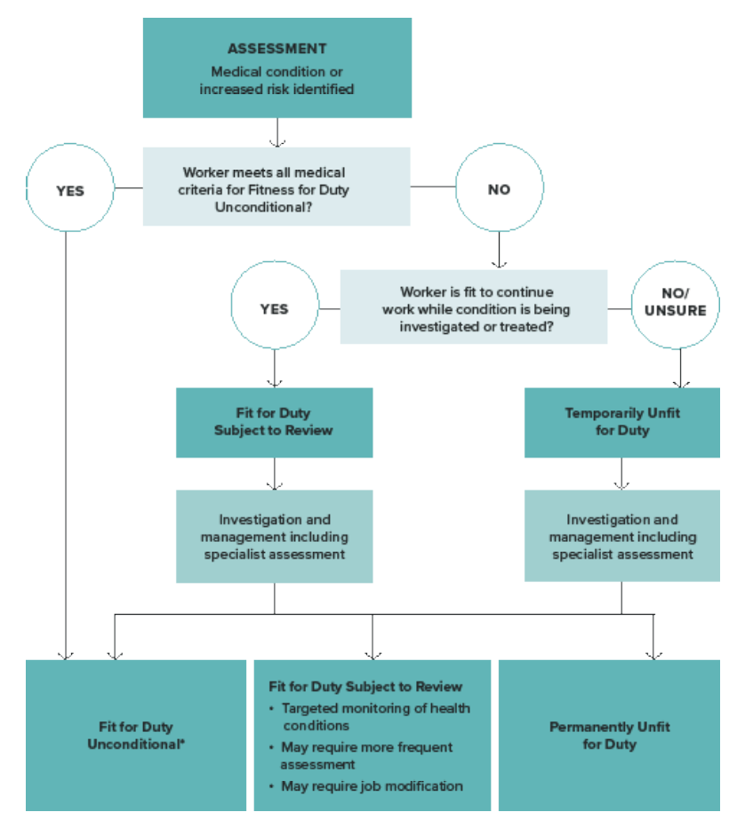
* Included in this category are rail safety workers who have stable visual impairments that are not associated with a progressive condition and who meet the vision fitness for duty criteria with the appropriate aids (corrective lenses).

Table 1. Standard reporting framework
Outcome category and definition | Application - Pre-placement (or change of risk category) | Application - Ongoing fitness for duty
Fit for Duty Unconditional  - The worker meets all the criteria for Fit for Duty Unconditional in the Standard.  - They are not subject to any restrictions or conditions (see below regarding use of aids for vision).  - They should be reviewed in line with the normal Periodic Health Assessment schedule.  Note: Included in this category are rail safety workers who have stable visual impairments that are not associated with a progressive condition and who meet the vision fitness for duty criteria with the appropriate aids (corrective lenses). | - Fit to undertake proposed rail safety duties – no restrictions or conditions except for wearing of appropriate aids for vision, as required. | - Fit to continue current rail safety duties – no restrictions or conditions except for wearing of appropriate aids for vision, as required.
Fit for Duty Subject to Review  - The worker does not meet the criteria for Fit for Duty Unconditional.  - The worker’s condition is sufficiently controlled to permit current rail safety duties under certain conditions.  - Continuation of normal duties is conditional on specific monitoring of the health conditions, which may require more frequent assessments than prescribed under the Periodic Health Assessment schedule (period specified by the Authorised Health Professional). More frequent assessment is not required if a condition is stable.  - This category may be applied in situations where a clear diagnosis has not yet been made but there is no immediate risk to rail safety.  - For incumbent workers, this category includes the sub-category Fit for Duty Subject to Job Modification. | - Fit to undertake proposed rail safety duties conditional upon specific monitoring of diagnosed health conditions, which may include more frequent assessment.  - Job modification is generally not applicable for applicants.  Note: For stable vision conditions these will be categorised as Fit for Duty Unconditional (as above). | - Fit to continue current rail safety duties conditional upon specific monitoring of diagnosed health conditions.  - Job modification may also be recommended. This does not include alternative duties. These apply if the worker is Unfit for Duty.  Note: For stable vision conditions these will be categorised as Fit for Duty Unconditional (as above).
Temporarily Unfit for Duty  - The worker does not meet the criteria for Fit for Duty Unconditional or Fit for Duty Subject to Review and cannot presently perform current rail safety duties.  - Their health situation is such that they may pose an immediate risk to safety and therefore should not continue current rail safety duties.  - They must undergo prompt assessment to determine their ongoing status and be definitively categorised.  - This category may be applied in situations where a clear diagnosis has not yet been made.  - The worker may be assessed as fit for alternative duties.  A worker may be judged fit for a lower category of rail safety work. | - Not fit to undertake proposed rail safety duties.  - May reapply when health issue is satisfactorily addressed. | - Not fit to continue current rail safety duties, pending appropriate management of health issue.  - Will be subject to targeted and more frequent health assessments (triggered) while health condition is being treated and managed.  - May be assessed as fit for alternative duties.  - May be assessed as fit for a role in another category (for example, Category 2 or 3).
Permanently Unfit for Duty  - The worker has a permanent or progressive condition that is predicted to render them unfit for their current rail safety duties for 12 months or more.  - This category may be applied to a worker diagnosed with a severe or unpredictably progressive condition such as epilepsy, macular degeneration, severe heart failure, severe chronic psychiatric conditions, and the like.  - A worker may be judged fit for a lower category of rail safety work.  Normal company policies such as redeployment may be considered. | - Not fit to undertake proposed rail safety duties. | - Not fit to continue current rail safety duties in the foreseeable future.  - A worker may be judged fit for a lower category of rail safety work (for example, Category 2 or 3).

Categorisation at pre-placement
An applicant may be categorised Fit for Duty Subject to Review at Pre-placement indicating that employment would be conditional on them attending targeted and potentially more frequent health assessments than required for a standard Periodic Health Assessment.

2.3.3. Temporarily Unfit for Duty
This assessment category indicates that the worker does not meet the criteria for Fit for Duty Unconditional or Fit for Duty Subject to Review and cannot presently perform the rail safety duties in the category being assessed. Their health situation is such that they may pose an immediate risk to safety and therefore should not continue current rail safety duties. They must undergo prompt assessment to determine their ongoing status and be definitively categorised.
A worker who is judged unfit for their current category of work may be judged fit to conduct work in a lower category. For example, a Category 1 Safety Critical Worker who is judged unfit to conduct their rail safety duties may be judged fit to conduct Category 2 or Category 3 work. This will be identified by the Authorised Health Professional on the report form.

Provisional categorisation
Temporarily Unfit for Duty may also be applied in situations where a clear diagnosis has not been made—for example, in the case of an undifferentiated illness where a worker is being investigated for blackouts. The worker may be assessed as fit for alternative duties.

2.3.4. Permanently Unfit for Duty
This assessment category indicates that the worker has a permanent or progressive condition that is predicted to render them unfit for their current rail safety duties for 12 months or more. This category may apply, for example, to a worker diagnosed with a severe or unpredictably progressive condition such as epilepsy, macular degeneration, severe heart failure, severe chronic psychiatric conditions, and the like. This category may also apply to a worker who has refused medical treatment for their condition and who will, therefore, not meet the medical criteria while they maintain that position. Normal company policies such as redeployment may be considered.

2.4. Risk categorisation and health assessment requirements
This section outlines the process for categorising rail safety workers, including identifying their risk category and their health assessment requirements. As previously described (refer Sections 1.3. Legislative basis and interfaces and 1.4. Program interfaces), consideration should be given to interfacing programs and health assessment requirements to meet other employer obligations. The risk assessment described in this Standard does not replace or forgo those obligations.
The risk categorisation process seeks to:
- identify the attributes needed to safely perform the activities
- identify what could go wrong in the case of ill-health
- assess the consequences
- establish appropriate controls for the risks associated with ill-health.
The steps are described in this section and summarised in Figure 8.
There are a number of guiding principles in undertaking this process:
- Focus on tasks – The process should focus on tasks, not on formal grades or job classifications. This is because workers often have to be multiskilled and perform various tasks. A risk categorisation should be assigned to a grade or job classification to match the task assessed as having the highest risk.
- Analysis – The process should involve the responsible manager, the workers who perform the tasks, and suitably qualified professional advisors (see below) so there is an accurate understanding of the nature of the tasks.
- Documentation – Documentation should be developed to record the categorisation process and provide a clear rationale for the risk categorisation and health assessment requirements. This may have legal significance in the future. The name of the person or persons who determined the risk categorisation and health assessment requirements should be recorded. Documentation can also be used to support the understanding of rail safety work by Authorised Health Professionals. A template to guide the collection and documentation of relevant data about the task analysis, health attributes and risk categorisation is also provided (refer to Section 6.2.1. Risk categorisation and health assessment requirements template).
- Expertise – The process should draw on appropriate expertise. Involvement of the Chief Medical Officer, an Authorised Health Professional or an occupational physician familiar with rail will help identify necessary health attributes for a task. In turn, the health professional is likely to develop a sound understanding of the work and associated risks.
- Review – The health risk management approach and effectiveness of non-medical controls should be kept under review. As a minimum, review should occur whenever there are changes to work practices or engineering controls.

Figure 8. Steps in determining health assessment requirements for rail safety workers
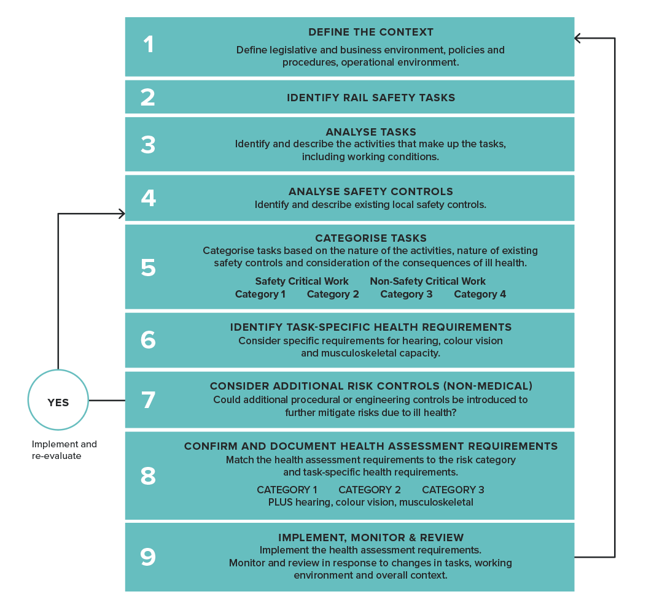

2.4.1. Step 1: Define the context
The first step is to define the context in which the rail safety work is performed. This includes considering:
- relevant legislative requirements
- organisation policies and procedures
- the business environment (for example, urban passenger train operations; freight operations, including dangerous goods; infrastructure maintenance or construction; light rail or tram operations; or tourist and heritage train or tram operations)
- the operational environment (for example, the type of safe-working systems, such as block signalling or staff-and-ticket systems; train protection systems, such as train stops or automatic train protection; and the maximum speed of operation).

2.4.2. Step 2: Identify rail safety tasks
The initial focus of the risk categorisation process should be on tasks, not on formal job classifications or grades. This is because workers are often required to be multiskilled and perform various tasks within one job. Once tasks have been identified and analysed, the risk categorisation process may then be applied to multiskilled positions, with the highest risk task determining the level of health assessment required.
For the purposes of the Standard:
- A job is the aggregation of tasks that go to make a multiskilled position (for example, driver).
- Tasks are the work required to be done (for example, driving an urban train, driving a non-urban train, conducting emergency procedures).
- Activities are the units of work done in carrying out the task (for example, scanning the track, moving controls, walking on ballast).
Following is a list of typical jobs and tasks that may comprise rail safety work for a rail transport operator.

Train driving:
- operation of a passenger train on an urban network
- operation of a freight train on a non-urban network.

Operation of signalling equipment

Train controlling

Infrastructure maintenance:
- driving of a road or rail vehicle
- track machine operation
- safe working protection party duties
- electrical systems maintenance.

Rolling stock maintenance:
- in a workshop or depot train examination.
Figure 9. Identifying rail safety tasks
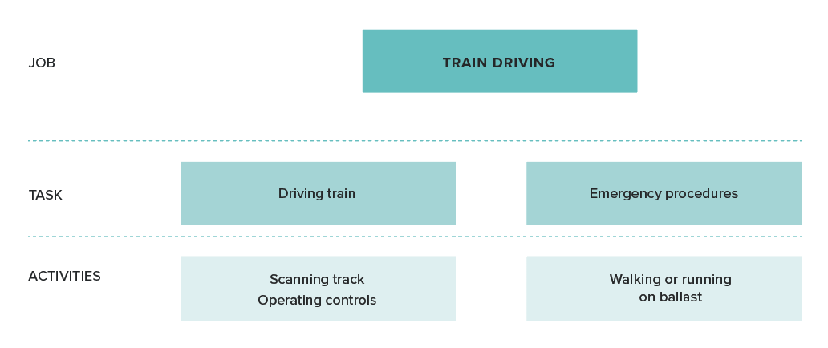

2.4.3. Step 3: Analyse tasks
Task analysis is the process of breaking down a job and tasks into its key activities. This should involve:
- a review of relevant job descriptions
- discussion and workshopping of job demands with subject matter experts and observation of the activities that comprise the tasks as well as the conditions under which the activities are performed, if needed (for example, shift work, working in extremes of heat and cold or terrain)
- identification of activities performed infrequently in response to an emergency situation.
All potential activities should be considered. Some activities may rarely or never occur during any one worker’s life experience but if it is predictable that they can occur, then they should be considered.
A thorough task analysis will assist in identifying the key requirements of the task and should be used to drive the risk categorisation process. It may assist in ensuring appropriate risk management strategies have been employed to manage risk. A template form is provided (refer to Section 6.2.1. Risk categorisation and health assessment requirements template).

2.4.4. Step 4: Analyse safety controls
The nature of the operational and engineering environment will, in part, determine the human attributes that are required for safety. This includes the operational or engineering controls that are intended to mitigate the risk associated with the task.
The next step, therefore, is to identify and describe the existing local safety controls for the rail safety tasks being analysed. For example:
- safe working rules and procedures
- fail-safe systems
- numbers of personnel in the working environment (such that other workers may identify worker incapacity and take up their task to ensure safety)
- driver support devices such as vigilance systems, train stops, the automatic warning system and automatic train protection.

2.4.5. Step 5: Categorise tasks
The previous steps provide the necessary inputs to categorise the rail safety worker tasks. This risk categorisation is best conducted in conjunction with people who are knowledgeable about the tasks and the existing control measures in question.
The first consideration is whether the task is Safety Critical Work or not. This is identified by applying the test (refer to Section 2.2.1. Risk categories of rail safety workers):
For any aspect of the tasks identified, could action or inaction due to ill-health on the part of the worker lead directly to a serious incident affecting the public or the rail network?
This question is posed in the context of existing control measures such as vigilance systems and fail-safe mechanisms (as per Step 4). Safety Critical Work tasks are then subdivided by applying a further test:
For any aspect of the tasks identified, could sudden incapacity or collapse due to ill-health of the worker lead directly to a serious incident affecting the public or the rail network?
Again, this question is posed in the context of existing control measures and with a consideration of whether there is a possibility of a serious incident resulting from worker incapacity. The test leads to a subdivision of Safety Critical Work tasks into Category 1 and Category 2 tasks as described in Section 2.2.1. Risk categories of rail safety workers.

Categorising Non-Safety Critical Work
Non-Safety Critical Work is categorised in a similar way, resulting in allocation to Category 3 or Category 4 based on a consideration of the requirements for maintaining the safety of the worker and fellow rail safety workers, and the adequacy of measures to create a controlled environment. When analysing the tasks of ATTP and categorising them into Categories 3 or 4, the method and adequacy of a controlled environment need to be carefully considered.
It is important to differentiate between risks posed by ill-health as distinct from lack of competency. The latter should be addressed through other control measures, such as training and initial worker selection.

Controlled environment
The determination of a Non-Safety Critical Worker, ATTP Category 4, depends on whether the work is performed in a controlled environment. When analysing the tasks of ATTP, the features of a controlled environment need to be identified and their adequacy carefully considered. The essential requirement of a controlled environment is that it must ensure that a person transiting the area is not placed at risk from moving rolling stock, so far as reasonably practicable.
In rail workplaces, such as sidings, rail yards or workshops, controls may include:
- provision of lock-out or warning devices
- barrier segregation from running lines
- permits to work.
These may be supplemented as identified by risk assessment by all or any of the following:
- warning signage
- special instructions
- use of designated pathways or access or transit routes
- supervision.
For special works, a running line may also be assessed as a controlled environment in certain circumstances, for example, in the case of:
- complete possession of all sections of track in the vicinity, including parallel lines
- a ‘non-train day’ on isolated historical railways with no active parallel running lines.
In all instances, consideration needs to be given to rolling stock and track machinery movements associated with the works.
Track Safety Health Assessments (Category 3) relate to the ability of a rail safety worker to see an oncoming train, hear warning sounds, and move from the path of rail vehicles. In the case of a worksite where rail vehicles are being moved, a Category 3 assessment should be applied.

2.4.6. Step 6: Identify task-specific health requirements
Some health attributes required for rail safety worker tasks under the Standard are independent of the risk categories described above – this includes requirements for colour vision, hearing and musculoskeletal capacity. Rail transport operators should therefore assess individual tasks with respect to these requirements and communicate the requirements to Authorised Health Professionals when requesting a health assessment.

Colour vision requirements for Safety Critical Workers
Rail transport operators should assess the colour vision requirements for Safety Critical Workers as per Figure 10 and communicate these requirements to the Authorised Health Professional.
Assessment of a job requires consideration of whether there is a need for colour differentiation. If so, is there redundancy of information that averts the need for colour vision (for example, semaphore arms)? If there is no redundancy, can the job be redesigned to eliminate the need for colour vision?
If red colour differentiation is required, consideration is then given to whether the task requires seeing colour as point sources (typically signals at a distance) or flat surfaces (typically flags or screens ‘colour defective safe B vision’). Jobs requiring seeing point sources may be further subdivided based on viewing conditions, with the most adverse requiring ‘normal colour vision’ (typically drivers) and lesser conditions requiring ‘colour defective safe A vision.’ Consideration may also be given to the consequences of different types of errors, for example, mistaking a red signal for green versus mistaking a green for yellow.
The following examples illustrate typical colour vision requirements, but they are not necessarily correct for any one network.
- Train drivers must be able to recognise colour signals. Positional cues are not always available because red–green lights often operate from a single lens signal; lights from a signal may have no background or illumination at night to help their identification; there may be dazzle from a low sun behind the signal; and red lights may be shone from a lantern in emergency situations requiring rapid reaction. Combinations of red–yellow–green signals are used to inform the train driver of a safe speed and routing.
- Heritage and tourist train drivers who are not on a main line may have a semaphore arm on a signal, which gives a positional cue (redundancy) as well as a red–green light. This only applies for daylight driving. The trains usually travel at low speed.

Figure 10. Assessment of colour vision requirements (Safety Critical Workers)*
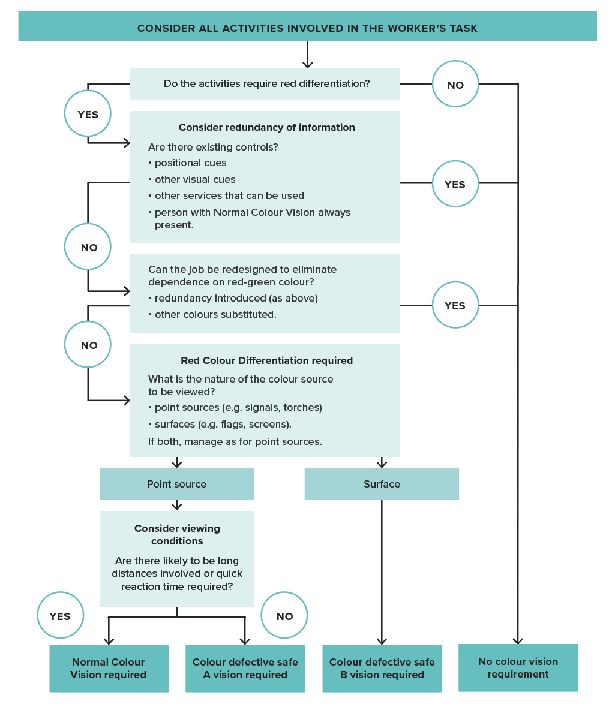
* While safety around the track does not require normal colour vision and is not assessed as part of the Category 3 health assessment under the Standard, there may be other aspects of the worker’s job that do require colour vision (for example, as a station attendant required to respond to coloured flags or signals in a Non-Safety Critical Work capacity). A Category 3 worker may therefore need to undergo assessment of colour vision in reference to the protocols contained in the Standard in certain circumstances (for example, at pre-employment).

Case Study:
A rolling stock maintenance company shunts suburban trains into a large shed before working on them. For safety, the trains are then isolated by placing a red flag on their front, so they are not moved while work is in progress. The need for staff to correctly distinguish red flags from other flags was recognised as requiring accurate colour vision. However, the need to introduce a colour vision test was averted by changing the procedure to state that a train should not be moved if any flag has been placed on the front, regardless of the flag’s colour.
Note: A Category 3 health assessment is required when a Non-Safety Critical Worker is required to go on track in an uncontrolled environment. While their safety around the track does not require normal colour vision and is not assessed as part of the Category 3 health assessment, there may be other aspects of their job that do require colour vision (for example, as a station attendant required to respond to coloured flags or signals in a non-safety critical capacity). A Category 3 worker may, therefore, need to undergo assessment of colour vision in reference to the protocols contained in the Standard in certain circumstances (for example, at pre-employment).

Hearing requirements for Safety Critical Workers
For Safety Critical Workers, the hearing requirements are also independent of the worker’s risk category.
Safety Critical Workers are commonly required to hear speech in order to accurately interpret safety critical information. The specific hearing requirements depend on whether the worker needs to hear:
- ‘speech in noise’ (for example, train driver in a noisy cab, shunters, site controllers, flagmen), or
- ‘speech in quiet’ (for example, train controller in a quiet control room).
The hearing requirements must therefore be determined individually (refer to Figure 11).
For the purposes of determining the requirement to hear speech in noise, a ‘noisy’ environment is defined as continuous or intermittent noise of 60 dB or more. This is differentiated from the noise level above which hearing protection is required (85 dB) (refer to Section 4.4. Hearing).
The task-specific hearing requirements should be communicated to the Authorised Health Professional when requesting an assessment (refer to Section 6.2.2. Request and Report Form).

Musculoskeletal requirements for Safety Critical Workers
It is not possible to make generic statements regarding the musculoskeletal capacity required for Safety Critical Work because the nature of such work can vary widely. All jobs, whether Category 1 or Category 2, need to be assessed regarding their inherent requirements and hence the musculoskeletal capacities required to perform them.
Most Category 1 Safety Critical Workers require soundness of limbs, neck and back and good balance. Category 2 tasks, such as train controlling, require only limited musculoskeletal capacity. The following are provided as examples and are not intended to be exhaustive for every task.
- Train driving requires good musculoskeletal capacity to:
  - sit and drive the train using the arms and legs
  - walk about the train on uneven track and ballast - a fault in a wagon may involve sustained effort for it to be shunted out of the train
  - join heavy couplings, bend and check bogies
  - enter and exit the cab to and from the ground routinely and in an emergency - in an emergency, there may be quite a drop between the lowest step and the ground
  - move rapidly from the path of an oncoming train.
- Flagman (hand signaller) duties require good musculoskeletal capacity to:
  - move quickly over uneven track and ballast
  - place detonators quickly and accurately on the track
  - signal to trains
  - move rapidly from the path of an oncoming train.
Figure 11. Assessment of hearing requirements (Safety Critical Workers)
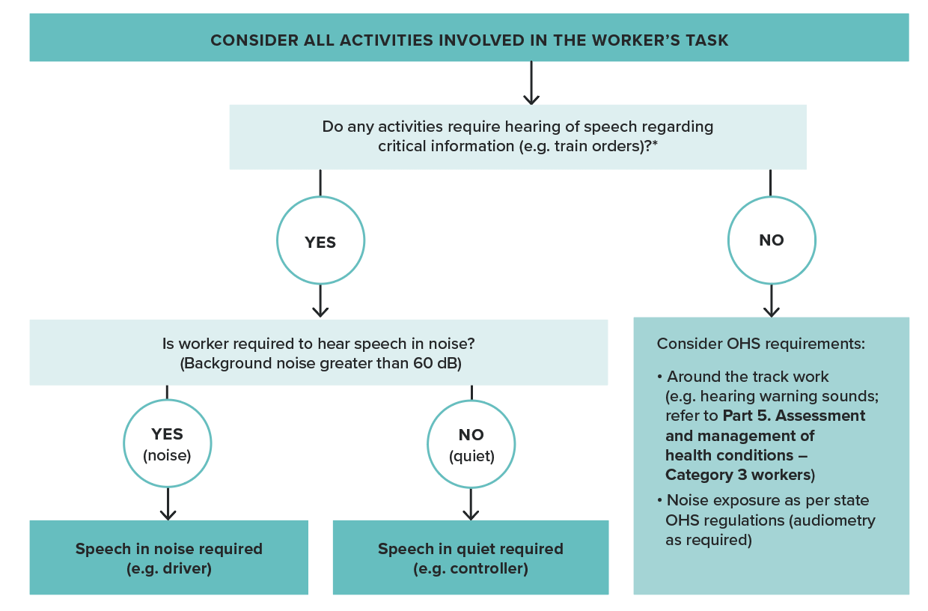
* The Standard assumes alignment with the principles and protocols outlined in the RISSB Code of Practice - Safety Critical Communications (2021) and any applicable voluntary protocols from the RISSB Safety Critical Communications Guideline (2018), including the use of closed-loop communication.
- Shunting requires good musculoskeletal capacity to:
  - move over uneven track and ballast
  - rapidly board or alight from trucks or carriages
  - open or close stiff, large coupling mechanisms
  - switch points
  - move rapidly from the path of an oncoming train.
- Train controlling requires only limited musculoskeletal capacity:
  - controllers typically work in an indoor environment and do not have to access the track
  - they require musculoskeletal capacity to work with computer screens and keyboards, paper records and telephones.
- Tram driving requires good musculoskeletal capacity to:
  - sit for long periods
  - operate master control
  - board and alight from tram for operational purposes including emergency situations.

2.4.7. Step 7: Consider additional risk controls (non-medical)
The health risk categorisation performed in Steps 5 and 6 is the basis of referral to a matched health assessment. However, an important interim step is to consider the other control options that might be introduced to mitigate the risk, such as additional administrative or engineering controls.
Table 2 summarises the hierarchy of control measures that should be applied to control safety risks.
Table 2. Summary of hierarchy of control measures
Eliminate risks (most effective) |  | Remove the hazard from the workplace
Reduce the risk through | Substitution | Substitute the hazard with a safer alternative
 | Isolation | Isolate people from the risk
 | Engineering controls | Reduce the risk through engineering changes or changes to systems of work
Apply administrative controls |  | Use administrative actions to minimise exposure and reduce the level of harm. Includes procedures, instruction, training, health assessments.
Use personal protective equipment (least effective) |  | Where no other controls can be applied or where they have limited effect.

Case Study:
A protection officer protecting a worksite needs to lay audible track warning devices or railway track signals after each train passes. However, if the protection officer collapses, the detonators will not be set and a train will enter a worksite at high speed and may strike heavy machinery and workers, causing a serious incident. One approach is to require Category 1 Safety Critical Worker health assessments for the protection officer to lessen the risk of collapse, but another is to alter the track working rules and provide the protection officer with a radio to contact the site controller after they have laid detonators so the site controller can then open the site.
This would be a safer work practice and change the categorisation of the job and the examination required to Category 2.
Controls such as elimination, substitution, isolation and engineering changes control the hazard itself. They are therefore more effective in reducing risk than controls that reduce the likelihood of the hazard, such as procedures, training or health assessments. A limitation with lower-level controls is that they can be more easily defeated. However, redundancy is helpful in safety, and the optimal treatment of risk may involve a mix of high-level controls and lower-level controls.
Higher level controls are generally preferred to health assessments because they provide more definitive protection. Such improvements should be implemented where possible and the task re-evaluated in terms of the health risk.

2.4.8. Step 8: Confirm and document health assessment requirements
After determining the final risk categories of rail safety worker tasks, the health assessments are matched to the categories—that is, Category 1 and Category 2 Safety Critical Workers have a similar assessment (except Category 1 Safety Critical Workers have a cardiac risk level assessment). Category 3 workers are required to have a Track Safety Health Assessment. These and the task specific requirements are confirmed and documented in the Risk categorisation and health assessment requirement template (refer to Part 6).

Occupational health, safety and welfare
Because of the crossover between rail safety and occupational health, safety and welfare, rail transport operators may elect to use the Standard to support obligations for health monitoring imposed by other legislation.
A robust assessment of the tasks performed by rail personnel should assist in capturing factors that may contribute to ill-health. Likewise, health assessments performed because of obligation under other legislation (for example, audiometry to monitor for noise-induced hearing loss) may give guidance to framing a health assessment under the obligations of rail safety legislation.

2.4.9. Step 9: Implement, monitor and review
Health risk management in relation to safety is a continuous improvement process and one that should respond to changes in the rail safety worker tasks and the working environment through a process of monitoring and review.

2.5. Authorising health professionals

2.5.1. Who may perform health assessments under the Standard?

General requirements
The Standard sets out requirements as to who can perform health assessments under the Standard. It does not cover contracting arrangements between Authorised Health Professionals and operators.
Only Authorised Health Professionals authorised according to the Standard may conduct health assessments for rail safety workers.
There are two types of Authorised Health Professionals:
- Those who are authorised to conduct all health assessments, including assessments for Safety Critical Workers (Category 1 and Category 2) and Track Safety Health Assessments (Category 3).
- Those who are authorised to conduct Track Safety Health Assessments (Category 3) only.
To become authorised, health professionals must be suitably qualified, complete approved training and be registered with the AHP Program (see Section 2.5.2. Qualifications, competencies and registration).
A nationally accepted list of Authorised Health Professionals is maintained via the AHP Program and is publicly available. Authorised Health Professionals on this list have met all the requirements outlined in the Standard (see below).
The list differentiates the two types of Authorised Health Professionals as above. Workers who require a rail health assessment can search the directory for their closest Authorised Health Professional to facilitate an examination that will be accepted by participating organisations.
The list is located at https://www.ahpprogram.com.au.
Note that, while screening tests such as visual acuity, audiometry, BMI, blood pressure and so on may be conducted by support personnel who are not Authorised Health Professionals, the clinical assessment and integration of information to make a fitness for duty decision is the responsibility of the Authorised Health Professional.
Practical on-site tests, such as tests for musculoskeletal capacity, may be performed by a person with appropriate qualifications and skills – they are not required to be an Authorised Health Professional. Such a person should liaise with an Authorised Health Professional or a Chief Medical Officer to ensure the issues of concern are addressed.

Exceptional circumstances
In a situation in which the services of an Authorised Health Professional are unable to be secured (such as in a remote location) and this precludes the timely medical certification of a rail safety worker, a Chief Medical Officer may approve a health professional who is not an Authorised Health Professional to conduct an assessment under the Standard.
- Such approval can be given only on a case-by-case basis and not as an ongoing arrangement.
- The Chief Medical Officer must specifically advise the nature and extent of the examination, including the task-specific requirements of the worker’s role and relevant information about existing health conditions and work performance.
- The health professional will not make a fitness for duty determination but will provide information to enable the Chief Medical Officer to determine the worker’s fitness for duty.
- The Chief Medical Officer must complete and sign off on the fitness for duty report and provide it to the rail transport operator and include the name and contact details of the health professional conducting the examination.

2.5.2. Qualifications, competencies and registration
To become authorised, health professionals must demonstrate certain qualifications and competencies, and must be registered as an Authorised Health Professional with the AHP Program.

Qualifications
In terms of professional qualifications:
- To be eligible for authorisation to conduct Safety Critical Worker health assessments for Category 1 and Category 2 workers, a health professional must be registered as a medical practitioner with the Australian Health Practitioner Regulation Agency (AHPRA).
- Health professionals seeking to be authorised to conduct Track Safety Health Assessments for Category 3 workers only are not required to be medically trained but should have appropriate health qualifications and professional registration — such as a registered nurse, occupational therapist or physiotherapist.

Training
In addition to their professional qualifications, health professionals must complete initial competency-based training through the AHP Program (available at https://www.ahpprogram.com.au). The competencies focus on the health professional’s knowledge and understanding of the safety sensitive activities within the rail industry, the risks associated with rail safety work, and the corresponding medical standard and clinical tests to be applied (refer to Table 3).

Registration
On completion of their initial training, Authorised Health Professionals are registered on the AHP Program database. To maintain their registration, they must participate in annual online re-accreditation.
Table 3. Competencies required of an Authorised Health Professional
Rail industry knowledge:
The health professional should demonstrate understanding of the rail industry environment, including the work performed and risks involved.
Standard:
The health professional should demonstrate familiarity with the National Standard for Health Assessment of Rail Safety Workers and a working knowledge of the assessment procedures and fitness for duty criteria set out in this Standard, including:
- Appreciation of the role of health assessments in rail safety.
- Familiarity with the risk management approach used to identify the level of health assessment required.
- Familiarity with the tasks involved in rail operations and with major tasks of Safety Critical Workers and/or Around the Track Personnel as appropriate.
- Knowledge of rail safety worker risk categories and the rationale for health assessments applied.
- Knowledge of the National Standard for Health Assessment of Rail Safety Workers and ability to perform the relevant health assessment.
- Understanding of the requirements and reporting options for fitness for rail safety duty.
- Knowledge of the administrative requirements, including form completion and record-keeping.
- Understanding of the ethical and legal obligations and the ability to conduct health assessments accordingly, including appropriate communication with the worker and the rail transport operator.
- Understanding of ethical issues in relationships with the treating doctor/general practitioner.
Interfacing policies and program:
The health professional should be able to demonstrate awareness of legislation, policies and programs that might interface with the health assessment or affect its performance — for example, drug and alcohol management programs, critical incident management programs, and anti-discrimination and privacy legislation.

2.5.3. Additional requirements for Track Safety Health Assessments (Category 3)
An Authorised Health Professional who is authorised to conduct Track Safety Health Assessments only (i.e., non-medically trained health professional) should conduct assessments under the supervision of a medically trained Authorised Health Professional.
Determination of fitness for duty for workers who declare medical conditions that may impact track safety (for example epilepsy, diabetes, cardiovascular disease, substance misuse as per Part 5), or those who are diagnosed with such conditions, should be made with direct oversight by a medically trained Authorised Health Professional, who should review reports from treating doctors and sign off on the fitness for duty report.

2.5.4. Quality control
The AHP Program manages complaints about Authorised Health Professionals. Concerns should be reported to the AHP Program administrator at contact@ahpprogram.com.au.
Inclusion of Authorised Health Professionals on the AHP Program list does not forego a rail transport operator’s responsibility to ensure the ongoing quality of work of the Authorised Health Professionals who conduct rail safety worker health assessments.
The rail transport operator should support a quality process by ensuring Authorised Health Professionals are kept up to date on changes to legislation, this Standard, and the rail transport operator’s policies and procedures. They should also ensure Authorised Health Professionals are provided with the necessary information to conduct the assessment, including task-specific requirements, previous reports and relevant workplace reports.
The rail transport operator should ensure that the performance of Authorised Health Professionals is subject to appropriate quality control measures including audit (refer to Section 2.7. Quality control). Refer also to the role of the Chief Medical Officer described in Section 1.5.2. Responsibilities for the conduct and management of health assessments.
Concerns about a health professional’s performance in conducting rail safety worker health assessments should be addressed by the rail transport operator through training and monitoring, or other corrective action as required.

2.6. Administrative systems and procedures
The rail transport operator should establish appropriate systems and procedures to support effective administration and implementation of the health management requirements of the Standard. This includes systems and procedures relating to:
- scheduling and managing health assessments
- using relevant forms to manage requests and outcomes
- managing worker identification
- communicating with rail safety workers and health professionals
- managing privacy of health information.
Administrative requirements for Authorised Health Professionals are detailed in Part 3 of the Standard.

2.6.1. Scheduling and managing health assessments

Health assessment database
The rail transport operator should establish an appropriate database to help administer health assessments. The database should identify the following:
- each rail safety worker’s health risk category, and the type of health assessment required
- the due date(s) for each worker’s health assessment(s), including Periodic Health Assessments and any additional Triggered Health Assessments associated with previous Fit for Duty Subject to Review determination
- any restrictions or conditions on the worker’s fitness for duty.
It should be managed in accordance with privacy requirements and so that timely reminders to supervisors and workers are issued and followed up.

Notification of workers
The health assessment system should be managed such that rail safety workers and supervisors are given reasonable notice of the health assessment requirements and receive appropriate follow up to facilitate timely management of fitness for duty status. The system should also ensure coordination to avoid conflict with leave and periods when workers are rostered off work.
For Periodic Health Assessments and non-urgent Triggered Health Assessments associated with a previous Fit for Duty Subject to Review determination, the minimum notice period is 10 working days, unless varied via mutual agreement between the operator and worker.
Where circumstances may preclude adequate notice or prevent the worker from attending the assessment on the prescribed date, there are provisions for a Chief Medical Officer, with support of the rail transport operator, to extend the period during which a medical report remains in force by up to 1 month, where the Chief Medical Officer is satisfied that extending the period will not adversely affect the safety of railway operations (refer Section 2.2.7. Validity of medical certificates and scheduling of health assessments).
Triggered Health Assessments may be requested because of sudden concerns about a worker's health, such as following an incident or an accident or a positive drug or alcohol test. These assessments are not subject to a minimum notice period. It is important in these circumstances that the worker's health is assessed as soon as possible.
The minimum notice period does not apply to Pre-placement Health Assessments.
In all cases, the rail transport operator is required to provide information about the reasons for the assessment (in Part A of the Worker Notification and Health Questionnaire).
Employers should also consider the needs of shift workers when scheduling appointments.

Information requirements for worker notification
The worker should receive written notice of their forthcoming health assessment requirements. The minimum information requirements are outlined below and are reflected in the model Worker Notification and Health Questionnaire form.
The notification should include but is not limited to:
- Purpose
  - the nature and purpose of the assessment
  - the consequences of not presenting for the assessment or not cooperating in the assessment process
  - the worker’s obligation to provide accurate information
- Appointment details
  - date, time, duration and location of the appointment and contact details for the practice
  - who will conduct the assessment
- Requirements for tests and reports
  - complete a Health Questionnaire before attending the appointment (this may not be required for Triggered Health Assessments)
  - undergo the required tests before the health assessment including an electrocardiograph (ECG) and a non-fasting blood test for cholesterol and HbA1c (diabetes) (for Category 1 Safety Critical Workers).
  - attend for audiometry
  - provide reports from treating doctors
- Other requirements to bring to the assessment
  - comfortable clothing
  - photo identification (ID) (also bring ID to any other tests)
  - glasses, hearing aids or other aids
  - current medication (or a list of it) (including prescription, over the counter and alternative medicines)
- Advice regarding information and report disclosure
  - who will receive the report
  - how health information will be managed
  - how the worker can access their health information.

Other considerations
In managing worker health assessments, the rail transport operator should consider language, cultural and other issues that may impact a worker’s ability to participate effectively in the health assessment. These may be addressed as appropriate and in collaboration with the Authorised Health Professional, including through an interpreter or support person.

2.6.2. Health assessment forms
Model forms have been developed to reflect the requirements of the health management approach and the specific requirements of health assessments. These model forms are provided in Part 6 as templates for rail transport operators to use as the basis for their administrative processes.
The forms may be used as provided or form the basis of electronic systems.
Administrative detail on the forms may be altered to make them consistent with a rail transport operator’s requirements. The provisions for the Authorised Health Professional to report to the rail transport operator, and the content of the Safety Critical Worker questionnaire, represent standardised data collection and should not be altered unless an assessment of workers’ fitness for additional job demands is required.
The model forms are consistent with privacy principles. The rail transport operator should ensure that any changes made to the forms are consistent with privacy and health records legislation. A health professional should not conduct an assessment without the appropriate forms.
Use of the forms is described in the following sections and in Figure 12.

Figure 12. Use of health assessment forms
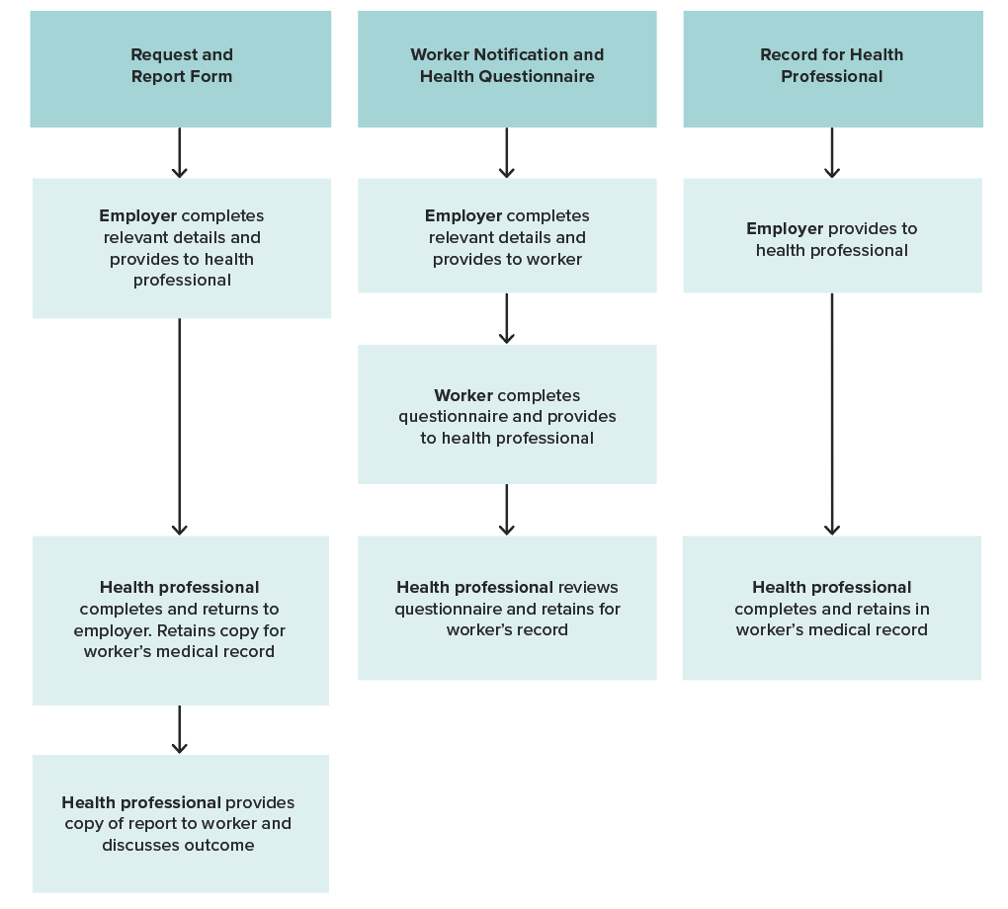

Request and Report Form
This form (refer to Section 6.2.2. Request and Report Form) facilitates communication between the rail transport operator and the Authorised Health Professional. The rail transport operator completes relevant details regarding the worker and the type of assessment that has been requested. The Authorised Health Professional summarises fitness for duty assessment findings on the form using the standard reporting terminology (refer to Section 2.3. Standard reporting framework) and returns the form to the rail transport operator. Medical data is not conveyed, only functional capacity (refer to Section 2.6.6. Managing health information).
As a general principle, the Authorised Health Professional should provide a copy of the report to the worker to facilitate discussion about the assessment. In exceptional circumstances, such as aggression from the worker, this step may be omitted.

Worker Notification and Health Questionnaire
This form (refer to Section 6.2.3. Worker Notification and Health Questionnaire) notifies the worker of the requirement to attend a health assessment. The form includes the reasons for the assessment and instructions for the worker. It also includes a Health Questionnaire. Workers should complete the Health Questionnaire before they attend their appointment. Authorised Health Professionals should review the responses during the appointment and record additional history as required.

Record for Health Professional
This form (refer to Section 6.2.4. Record for Health Professional) guides the Authorised Health Professional through the assessment process and provides a standard clinical record. The rail transport operator issues the form but because it will contain details of the clinical findings, it must not be returned to the rail transport operator. Instead, the Authorised Health Professional should retain the form (refer to Section 2.6.6. Managing health information).
If a rail transport operator employs the services of a Chief Medical Officer, the Chief Medical Officer may request a copy of the Record for Health Professional but must maintain confidentiality according to privacy legislation (refer to Section 2.6.6. Managing health information).

Risk categorisation and health assessment requirements template
The risk assessment template (refer to Section 6.2.1. Risk categorisation and health assessment requirements template) guides relevant parties through the process of risk assessment of rail safety tasks. It is recommended that a copy of the completed form be provided to the Authorised Health Professional.

2.6.3. Worker identification
The rail transport operator should establish systems to ensure that the rail safety worker can provide proof of identity for the purposes of health assessments, including pathology testing.
Proof of identity should include photo ID. The systems may include a record of the currency of health assessment and review requirements.

2.6.4. Communicating with rail safety workers

General requirements
The rail transport operator should communicate with workers about their obligations and protections under the Standard and relevant legislation. Supporting information and education regarding the Standard and the health assessment requirements may be available through the NTC and other stakeholders.
Specific communication mechanisms should be in place to alert workers about their health assessment requirements and status (refer to Section 2.6.1. Scheduling and managing health assessments).

After the assessment
If the worker is assessed as anything other than Fit for Duty Unconditional, the rail transport operator should discuss with the worker any implications for their work, and the policies or arrangements to be applied.
A record of such arrangements should be kept on the database, along with the fitness for duty outcome and any requirements for review assessments.
The Authorised Health Professional or the rail transport operator should provide the worker with a copy of the assessment report (refer to Section 6.2.2. Request and Report Form).

Complaints and disagreements with a health assessment process or outcome
A worker may disagree with the process undertaken in managing their health assessments or the conduct of the health assessment by the Authorised Health Professional or the outcome of the assessment. For example, a worker may feel a request made under the Standard is unreasonable (such as a request for a health assessment or request as a result of a health assessment).
While the Standard does not recommend a specific process for managing complaints and disagreements, all parties are advised to address this in their procedures relating to administration of the Standard.
Medical issues may be reasonably discussed with the examining Authorised Health Professional in the first instance. If this proves unsatisfactory, the worker may request a review by the Chief Medical Officer or the relevant rail transport operator. The Chief Medical Officers Council may also have a role in resolving these issues. This process will rely on input from the worker’s treating doctor or specialist or a second opinion from another Authorised Health Professional.
Complaints about Authorised Health Professionals may be lodged with the AHP Program at contact@ahpprogram.com.au (refer to Section 2.5.2. Qualifications, competencies and registration).
General complaints may also be directed to ONRSR at contact@onrsr.com.au or (08) 8406 1500.
Complaints about privacy breaches may be made to the relevant privacy commissioner (refer page 82).

2.6.5. Communicating with Authorised Health Professionals

Before the assessment
The Authorised Health Professional should not perform a health assessment of a rail safety worker without the appropriate forms (Authorised Health Professionals should also refer to Section 2.6.2. Health assessment forms and Section 3.1. Appointments and documentation).
The rail transport operator should provide the Authorised Health Professional with all forms and supporting information relevant to the worker’s health assessment.
In the case of Category 1 Safety Critical Workers, the examination should take place when the pathology results (namely, blood test results) to assess the cardiac risk levels are available. If the results are not available, the worker can be issued with a preliminary assessment of fitness or otherwise for duty, based on the clinical examination and other aspects of the assessment. The final assessment should be made as soon as possible, and the Authorised Health Professional should pursue the pathology results to ensure their timely completion. The Authorised Health Professional should contact the worker to explain the results.

Supporting information
For a Safety Critical Worker Periodic Health Assessment, relevant supporting information includes the previous health assessment report. This ensures continuity of the health assessment process and the capacity to assess fitness for duty.
In addition, the following information should be provided to the Authorised Health Professional, if relevant:
- any change in sick leave patterns
- relevant workers' compensation history
- critical incident history
- positive drug and alcohol assessments
- other relevant workplace reports (refer to Figure 13).
This information may be provided in summary and in any format that is administratively efficient and sufficiently comprehensive for the Authorised Health Professional.
In cases in which a Category 1 Safety Critical Worker refuses a blood test, or refuses to complete the assessment, the Authorised Health Professional should state that they were ‘unable to complete the assessment’ and refer back to the rail transport operator.
Figure 13. Workplace reports relevant to health assessment and management
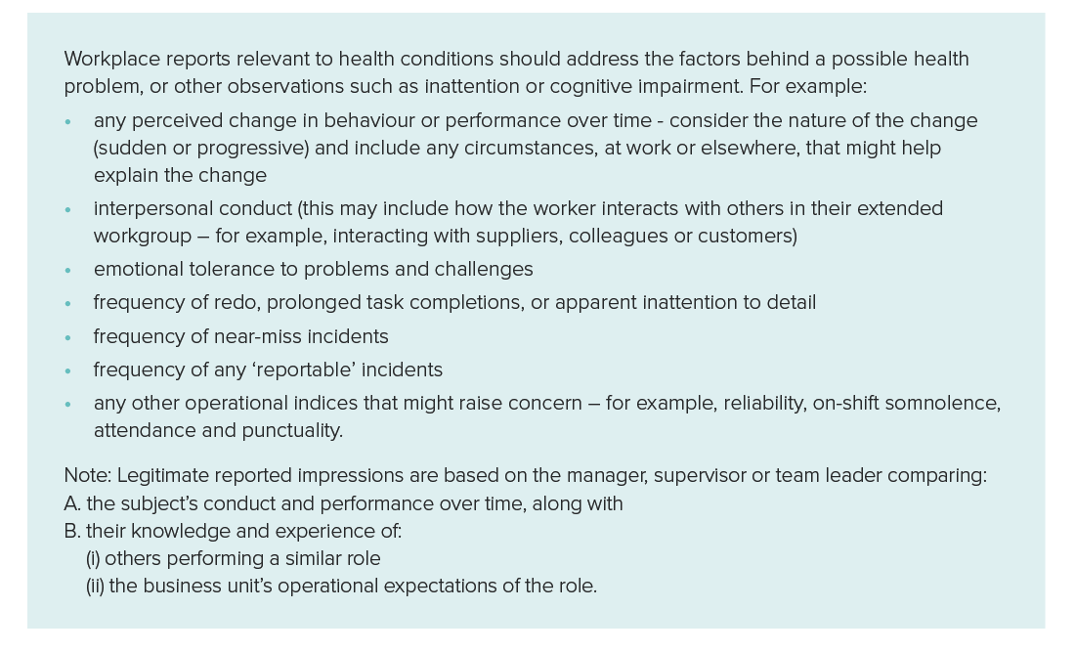

After the assessment
The Authorised Health Professional should immediately ring the rail transport operator if the worker is Unfit for Duty but should not reveal details of the worker’s medical condition without the worker’s consent (refer to Section 2.6.6. Managing health information).
The method of transmission of the report to the rail transport operator should ensure that confidentiality is maintained. The rail transport operator should keep all reports confidentially and securely in compliance with privacy and health records legislation (refer to Section 2.6.6. Managing health information).

2.6.6. Managing health information
In administering rail safety worker health assessments, rail transport operators and Authorised Health Professionals must comply with the Australian Privacy Principles contained in privacy legislation. Authorised Health Professionals should ensure that health records are managed and stored in line with relevant health records legislation, including with respect to archiving and destruction. Rail transport operators should consult the Australian Information Commissioner or the Privacy Commissioner in their state or territory if they are uncertain about local requirements, including requirements for privacy policies.

Primary purpose
A key concept to be understood in relation to the privacy principles is that of the ‘primary purpose’. The primary purpose of the health assessments conducted under the Standard is ‘to assess and manage rail safety workers fitness for duty'.
Thus, only information that is necessary to assess fitness for duty should be collected. The rail transport operator cannot ask an Authorised Health Professional to collect information that is not relevant to the health requirements of the rail safety worker’s task.
Similarly, information must only be used and disclosed for the primary purpose, or for a directly related purpose that could reasonably be expected by the rail safety worker, unless the rail safety worker gives their consent to use of the information for a secondary purpose. Thus, the rail transport operator cannot provide the Authorised Health Professional with information that is not relevant to the health assessment unless the rail safety worker gives their consent. Authorised Health Professionals cannot provide information back to the rail transport operator that is not relevant to the management of the rail safety worker and their fitness for duty.

Collection of health information
The Australian Privacy Principles require that when a rail safety workers’ health information is being collected, the rail safety worker must be clearly informed about the following:
- why the health information is being collected
- what information will be stored and where it will be stored
- the fact that they can access it
- to whom the information may be disclosed
- whether the information is required to be collected by law.
These requirements are detailed on the Worker Notification and Health Questionnaire form which the rail safety worker completes and signs if they agree to the terms of how their information will be managed.
Both the rail transport operator and Authorised Health Professionals have a role in ensuring that rail safety workers understand the management of their health information.

Use and disclosure of health information: the ‘need to know’
In keeping with the primary purpose, Authorised Health Professionals should only report a rail safety worker’s health information to the rail transport operator if the operator needs that information for the purpose of managing the rail safety worker and their fitness for duty.
The rail transport operator needs to know:
- how a rail safety worker’s ability to undertake their job might be affected by a health condition
- what controls (if any) must be put in place to mitigate against risks related to a health condition.
The rail transport operator usually does not need to know:
- the exact nature or details of the underlying medical conditions (for example, high blood pressure, anxiety state, diabetes)
- the exact nature of the treatment or management of the condition.
The Authorised Health Professional should not provide personal or medical information to the employer, unless specifically allowed by the worker. Only information regarding work capacity should be shared.
Within the rail transport operator, there are layers of disclosure that will need to be managed to ensure privacy. For example, it is possible that in seeking to manage a medical condition, such as during the rail transport operator’s discussions with the rail safety worker about alternative duties or job modification, the diagnosis may become evident. Careful consideration should be given to how privacy is maintained in this situation, including where information is recorded and who has access to this documentation.
As a further example, invoices for investigations and specialist referrals may need to be paid by the rail transport operator if the tests indicate a medical condition – such as a cardiac stress test, or a referral to a psychiatrist. Access to this information should be restricted to those who are involved in paying the supplier. The information should not be filed in the rail worker’s general personnel file.

Workers’ compensation and other legal requirements
The Australian Privacy Principles apply to workers compensation claims. By law, the nature of a rail safety worker’s injury will be disclosed to the rail transport operator and it must be included on any workers compensation claim form. Therefore, if an Authorised Health Professional is assessing a rail safety worker who has had a workers compensation injury regarding fitness for duty, the nature of that injury may be disclosed.
Health information may also be disclosed if permitted or authorised under another law, such as when a report is subpoenaed by a court of law during an investigation of an accident or incident, or when a notifiable disease is diagnosed. It may also be used and disclosed for auditing purposes.

Workers’ consent
Rail safety worker consent must be obtained before any private information including health information can be disclosed to a third party. Some exceptions are permitted by law — for example, audit and research purposes (see below).
When appropriate, it is helpful if the rail safety worker gives consent for disclosure in order to facilitate a sensible plan of health management.
If an Authorised Health Professional seeks information from a rail safety worker’s general practitioner or treating doctor to clarify the worker’s health status, such communication should occur with the written consent of the worker and should be limited to health issues that impact on the ability of the worker to undertake their job. This consent may be recorded on the Record for Health Professional.
The need for consent also applies in situations such as the recording or videoing of medical consultations.
Any consent process must address the following key elements:
- the individual gives consent voluntarily
- the individual is adequately informed before giving consent
- the consent is specific
- the consent is current
- the individual has the capacity to understand and communicate their consent.

Use and disclosure for quality and audit purposes
In circumstances in which a rail transport operator employs the services of a Chief Medical Officer, the Chief Medical Officer may request a copy of the Record for Health Professional, the Health Questionnaire or other clinical records from the Authorised Health Professional to ensure consistency and quality of health assessments for rail safety workers, to assist management of a particular worker, or to compile statistics. The confidentiality of such records must be assured, and systems must be in place to ensure that records are not accessed by others within the rail transport operator.
The same provisions apply for external auditors appointed by rail transport operators.

Portability of a health assessment report
If a rail safety worker has undertaken a health assessment for a rail transport operator, the health assessment report may be transferable to another rail transport operator only if the rail safety worker has given informed consent. The Request and Report form provides a vehicle to record this consent in relation to a particular health assessment report.
The rail transport operator that receives the health assessment report has a responsibility to confirm that:
- The level of health assessment performed by the original rail transport operator (that is, Category 1, 2 or 3) is equal to or greater than that required for the tasks performed by the rail safety worker in their operations.
- The specific health attributes required by the original rail transport operator (for example, colour vision, hearing, musculoskeletal) are equal to or greater than those required to complete the tasks in the worker’s position.
Practical tests, such as those for musculoskeletal capabilities, are generally specific to the particular rail environment. The results of such tests are not transferable to other rail transport operators unless the work practices and environment are very similar.
A rail safety worker who works for more than one rail transport operator has a responsibility to ensure that each operator is advised about conditions that may affect the worker’s safe working ability.

Retention and security of health information
Information should be kept up to date and protected from loss and unauthorised access, disclosure and modification. Records may be scanned and kept in electronic form. The rail safety worker’s signature on the completed Health Questionnaire is legally valid after scanning. This also applies to the Authorised Health Professional’s signature.
For continuity of records, a rail transport operator may establish a repository for rail safety worker health records if such records are accessible only to Authorised Health Professionals, the Chief Medical Officer and authorised personnel.
Figure 14 shows the flow of information that should take place during rail safety worker health assessments, based on privacy requirements.

Figure 14. Relationships and information flow for rail safety worker health assessments
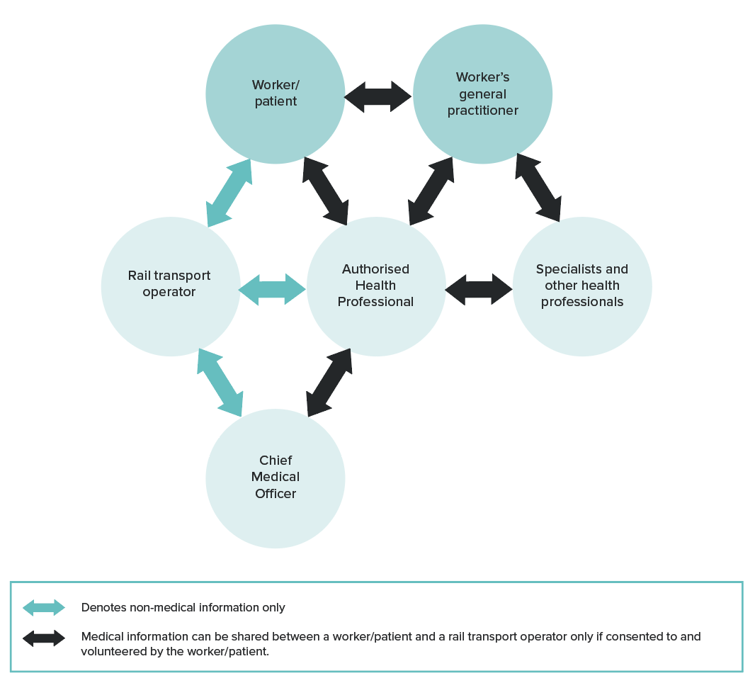

Worker access to health records
A person’s access to their health records is governed by Australian privacy law and health records legislation in each state and territory. Generally, this enables individuals to request access to their health records held by a health provider. Access may be refused in some circumstances — for example, if there is a risk to life, health or safety, or if access may impact on another person’s privacy, or if giving access is unlawful.
Rail safety workers should make a request for access to their health record through the relevant Authorised Health Professional.

Transfer of health records
If an Authorised Health Professional’s practice ceases to operate or ceases to perform rail safety health assessments, the rail transport operator may require the Authorised Health Professional to forward rail safety worker health records, including the Health Questionnaires, Record for Health Professional forms and other supporting clinical information, to the Chief Medical Officer or another designated Authorised Health Professional. Such arrangements are aimed at supporting continuity of records. Transfer of rail workers’ health records must comply with privacy principles.

Interstate considerations
If workers perform their roles across state or territory boundaries, information should only be transferred to other states or territories where privacy laws are similar.

Data breaches and complaints
Information about an individual’s health is classified as sensitive information under section 6(1) of the Privacy Act 1988 (Cth).
A data breach occurs when personal information an organisation holds is lost or subjected to unauthorised access or disclosure. For example, when:
- a device with a customer’s personal information is lost or stolen
- a database with personal information is hacked
- personal information is mistakenly given to the wrong person.
Under the Notifiable Breaches (NDB) scheme entities governed under the Privacy Act are required to notify individuals and the Office of the Australian Information Commissioner about data breaches that are likely to cause serious harm. Examples of serious harm may include: significant financial loss by the individual; loss of business or employment opportunities; humiliation, damage to reputation or relationships and workplace or social bullying or marginalisation. The likelihood of a particular harm occurring and the anticipated consequences for individuals are relevant considerations. The Notifiable Data Breach scheme includes a non-exhaustive list of ‘relevant matters’ that may assist entities to assess the likelihood of serious harm.
Complaints about privacy breaches may be directed to:
- the privacy commissioner in the relevant state or territory
- the health care complaints commissioner or ombudsman in the relevant state or territory
- AHPRA.

2.7. Quality control

2.7.1. General requirements
The adoption of quality control systems is essential for the effective implementation of the health assessments for rail safety workers, and thus for the safety of the rail network.
Quality control is important both for the conduct of the health assessments by the Authorised Health Professionals and for the management systems employed by the rail transport operators. Thus, all rail transport operators should implement a system of formal quality control to ensure that:
- rail safety workers are being appropriately categorised
- rail safety workers are receiving health assessments in accordance with the requirements of the Standard
- rail safety worker health assessments are being administered and managed in accordance with the requirements of the Standard, both within the organisation and by Authorised Health Professionals
- privacy of health information is maintained.
Where possible, rail transport operators should also establish that Authorised Health Professionals are correctly interpreting and applying the requirements of the Standard in terms of fitness or otherwise for duty, and appropriately managing rail safety workers according to the outcomes of the assessments. This role may be supported by the rail transport operator’s Chief Medical Officer if they have one (refer to Section 1.5.2. Responsibilities for the conduct and management of health assessments).

2.7.2. Nature and extent of quality control system
The Standard does not identify specific requirements for the quality control system but recognises that the nature and extent of the system will depend on the nature, size and complexity of the organisations, and the level of risk involved in their operations.
Systems may include elements such as:
- Internal or external audits – for example, audits of databases to ensure health assessments are being scheduled and completed as required.
- Document reviews – for example, reviews of procedures and documentation to ensure consistency with the Standard.
- Consultation and feedback – for example, through discussions with Authorised Health Professionals, internal staff managing the processes and rail safety workers.
Rail transport operators should establish a risk-based system founded on consideration of factors such as:
- The risk category of the workers – All categories of assessment should be included in the quality control system; however, the system may focus particularly on Category 1 and Category 2 Safety Critical Workers for whom, by definition, the risks are greatest.
- The experience of the health professionals conducting the health assessments – The system should involve all Authorised Health Professionals; however, the nature, extent and frequency of review or audit should consider factors such as the:
  - turnover of Authorised Health Professionals
  - relatively few assessments conducted by some practitioners
  - existence or otherwise of any routine checks conducted by the rail transport operator’s Chief Medical Officer (if they have one).
- The complexity of the organisation – Operators may risk ‘creep’ away from policies and procedures across diverse areas of the organisation and should consider this risk when scheduling audits or reviews and establishing the nature and extent of quality control measures.
The quality control system may change over time, particularly as health professionals and organisations become more familiar with the Standard. Rail transport operators should regularly review their requirements based on a health risk management approach. The system should be devised and implemented by those with appropriate experience both of the rail system and the Standard.

2.7.3. Audit points
To guide development of appropriate quality control systems, Table 4 describes possible points for audit or review of the health assessment systems of rail transport operators. Audit points are grouped under the headings of:
- task risk analysis and worker categorisation
- authorisation and management of Authorised Health Professionals
- performance and outcomes of health assessments by Authorised Health Professionals
- management of the health assessment process.
These points provide an indication of the potential scope of quality control systems and are not exhaustive.
Table 4. Audit points for quality control of rail safety health assessments
Audit points
1. Task risk analysis and worker categorisation
With respect to the task analysis and worker categorisation, rail transport operators should consider adopting audit or review processes that confirm:
- All rail safety worker tasks have been categorised according to the Standard.
- There is compliance with the categorisation methodology contained in the Standard, including compliance with the risk management processes outlined in Section 2.2. Features of the health risk management approach.
- There is appropriate documentation of categorisation processes and conclusions.
- The dates of review for risk categorisation have been scheduled and are flagged for reconsideration when job descriptions change.
2. Authorisation and management of Authorised Health Professionals
With respect to the authorisation and management of health professionals, rail transport operators should consider adopting audit or review processes that confirm:
- Up-to-date records are maintained by health professionals who are authorised by the rail transport operator.
- All health professionals who have conducted assessments either in part or in full (including nurses) are appropriately authorised.
- All Authorised Health Professionals have received initial training and refresher training if required, including receiving relevant updated information from the Office of the National Rail Safety Regulator or the National Transport Commission.
- Current procedures for conducting the health assessments for the particular rail transport operator are held by all Authorised Health Professionals.
- Authorised Health Professionals use current versions of forms.
- Appropriate systems are in place for regular communication with Authorised Health Professionals.
3. Performance and outcomes of health assessments by Authorised Health Professionals
With respect to health assessments performed by Authorised Health Professionals, the rail transport operator should consider audit or review processes that confirm:
- Authorised Health Professionals maintain suitable systems and procedures for managing and conducting health assessments, including the use of the appropriate forms.
- There is timely conduct of various aspects of health assessments from initial assessment to reporting and follow-up as required.
- There is continuity of assessment from a medical viewpoint, including the number of different Authorised Health Professionals involved.
- Health assessments are conducted according to the requirements of the Standard.
- There is appropriate decision-making in terms of fitness for duty.
- There is appropriate interaction with the rail transport operator.
- There is appropriate interaction with the rail safety worker.
4. Management of the health assessment process
With respect to management of the health assessment process, rail transport operators should consider adopting audit or review processes that confirm:
- There are adequate internal procedures in line with the Standard.
- Rail safety workers hold current medical certification.
- The recall and monitoring systems adequately identify when health assessments are due, and adequately monitor assessment status.
- There is timely reporting by Authorised Health Professionals.
- The recall and monitoring systems are effective in managing workers with temporary medical certificates (requiring follow-up investigation) and those found Temporarily Unfit for Duty.
- Interactions between Authorised Health Professionals and the rail transport operator (for example, compliance with privacy requirements).

3. Procedures for Authorised Health Professionals
This section of the Standard explains:
- the procedures associated with conduct of the health assessments for rail safety workers (summarised in Figure 15)
- the relationships, use of forms and flow of information between Authorised Health Professionals and rail transport operators
- the nature of the tests required for Pre-placement and Periodic Health Assessments
- the equipment requirements
- general considerations for conducting the assessments
- considerations for communicating with rail safety workers, other health professionals and rail transport operators
- considerations for record keeping.

Figure 15. Conducting a health assessment for fitness for rail safety duty
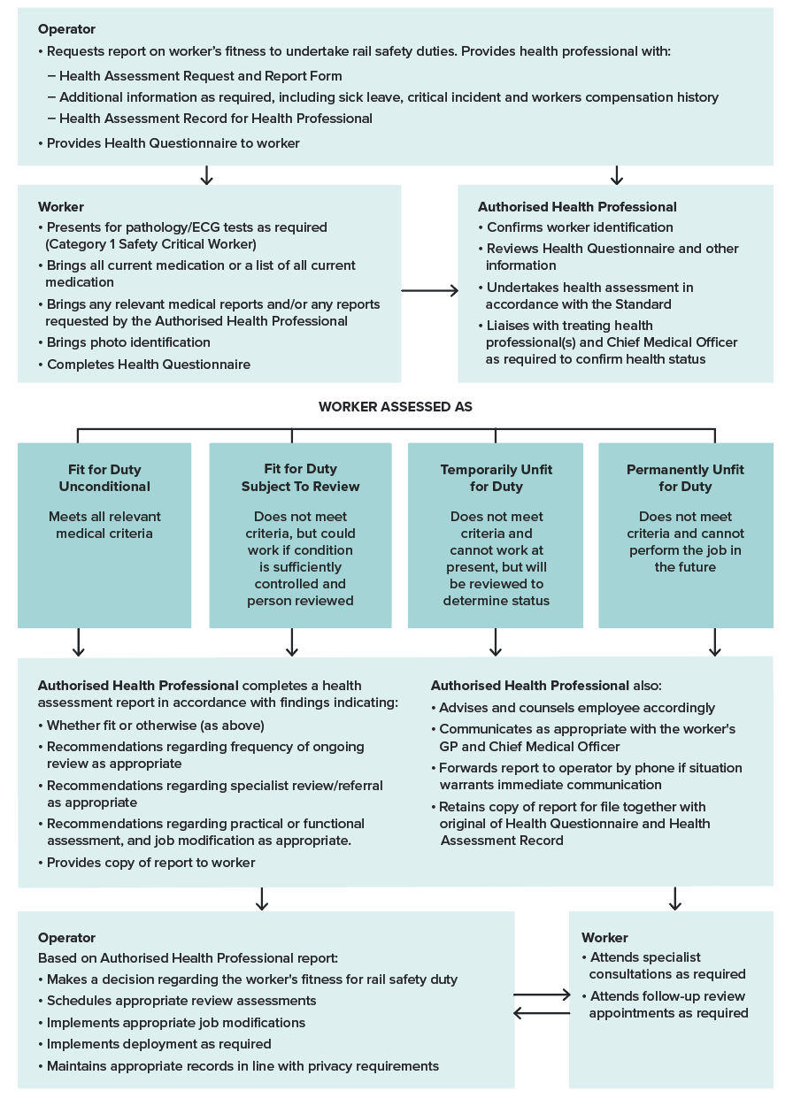

3.1. Appointments and documentation

3.1.1. Notification and making of appointments
The rail transport operator will notify rail safety workers of their health assessment requirements, including when they are due for their Periodic Health Assessment or when they are required to undertake a Triggered Health Assessment.
An appointment for an assessment can be made by the rail transport operator or the worker.

3.1.2. Nature of the consultation
Except in very limited circumstances, health assessments for rail safety workers must be conducted in person.
Telemedicine must not be used for the conduct of rail safety worker health assessments prescribed under the Standard except when specifically allowed under section 203 or 203A of the RSNL (for example, for emergency situations, such as in a pandemic).
Where appropriate and available, the use of telemedicine may facilitate access to specialist opinion for Fit for Duty Subject to Review assessments. This should be on agreement with the Authorised Health Professional (refer to Section 3.5.3. Specialist referrals and reports).
Teleaudiology may be utilised for hearing testing and assessment under certain circumstances (refer to Section 4.4.4. General assessment and management guidelines).

3.1.3. Forms and supporting information
Before the appointment, the rail transport operator will forward the relevant forms and documentation to the Authorised Health Professional (also refer to Section 2.6.2. Health assessment forms and Section 6.2. Model forms). This will include:
- Request and Report Form – this will indicate the nature of the worker’s job and the level (for example, Category 1, Category 2, Category 3) and type of health assessment required (for example, Pre-placement, Periodic or Triggered). This form will also identify task-specific requirements for hearing, colour vision and musculoskeletal capacity. It will also indicate the nature of tests required.
- Record for Health Professional – this guides the clinical examination and provides a convenient standardised template for recording a general assessment of fitness for rail safety duty. This form is generally not suitable for a Triggered Health Assessment, which will likely focus on a specific health issue.
The Authorised Health Professional should not conduct the assessment without the appropriate forms. The Authorised Health Professional should not initiate the forms.
Supporting documentation will include a copy of the Health Assessment Report (that is, Part B of the Request and Report Form) from the previous health assessment. Additional information should also be included, for example:
- summary reports of sick leave and workers compensation claims
- notifiable incident history
- indication of a positive alcohol or drug test, or self-declaration.
The Authorised Health Professional may seek further relevant information from the rail transport operator or from previous Authorised Health Professionals if required and consistent with privacy principles.

3.1.4. Worker requirements
For Pre-placement and Periodic Health Assessments, workers should bring to the assessment:
- the completed Health Questionnaire
- all medications they are currently taking
(or a list of them)
- corrective lenses if usually worn at work
- hearing aids if usually worn at work
- copies of any medical reports or test results that are available or that have been requested by the Authorised Health Professional
- photo identification (ID).
For Triggered Health Assessments, the requirements are similar; however, rail safety workers may not need to complete the Health Questionnaire.

3.2. Test requirements and equipment
For Pre-placement (or change of risk category) and Periodic Health Assessments, the following tests are required:
- resting electrocardiograph (ECG) (Category 1)
- non-fasting blood test for cholesterol (total and HDL) (Category 1)
- non-fasting blood test for HbA1c (Category 1)
- glucose urine test (Category 2) – conducted at the time of the assessment
- audiometry (all categories).
Drug and alcohol testing may also be requested for all categories of workers at Pre-placement (or change of risk category) Health Assessments.
Other clinical measures and assessments are described in the relevant chapters and in the Record for Health Professional.
Note that, while measurements such as visual acuity, audiometry, BMI, blood pressure and so on, may be conducted by support personnel who are not Authorised Health Professionals, the clinical assessment and integration of information to make a fitness for duty decision is the responsibility of the Authorised Health Professional.
Note that the blood tests for cholesterol and HbA1c are required at Pre-placement and all Periodic Health Assessments for Category 1 Safety Critical Workers to enable monitoring of individual cardiovascular risk factors and existing diabetes. These data are applied to the calculation of the cardiovascular risk score only for workers 30 years and over and as per the procedures outlined in Section 4.2.2. General assessment and management guidelines.
Results of the tests should be available to the Authorised Health Professional for consideration during the appointment. If the results are not available, the worker can be issued with a preliminary assessment of fitness for duty, based on the clinical examination and other aspects of the assessment. The final assessment should be made as soon as possible, and the Authorised Health Professional should actively pursue the pathology results to ensure their timely completion. The Authorised Health Professional should contact the worker to explain the results whether they are normal or abnormal.
Testing requirements for Triggered Health Assessments will be determined by the Authorised Health Professional or the Chief Medical Officer.
The examination room should be well lit, quiet, offer privacy and be accessible.
Equipment for the health assessment should include:
- distant visual acuity test (Snellen chart or equivalent)
- audiometer
- sphygmomanometer
- Farnsworth D15 Panel
- ECG machine
- test kit for glycosuria
- breathalyser (AS3547:2019)
- urine test kit for drug testing
- Ishihara plates (12 plates from 24 plate edition) for colour vision test
- computer or tablet for recording data and calculating cardiac risk score.

3.3. Orienting the worker
In performing the health assessment, the Authorised Health Professional should accommodate any special requirements relating to the worker's gender, culture or language.
Before starting the assessment, the Authorised Health Professional should:
- Explain the purpose of the health assessment to the worker and that the results will be discussed with them.
- Explain how their health information will be collected, used, disclosed and stored in line with privacy principles, in particular that:
  - Only information relevant to the assessment of their fitness for rail safety duty will be collected.
  - All clinical and health information will remain confidential and will not be forwarded to the rail transport operator without the worker’s consent but may be discussed with the Chief Medical Officer.
  - The report provided to the rail transport operator will be in functional terms (rather than diagnostic ones) in relation to their fitness to perform rail safety duties, as indicated on the report form.
- Request the worker to sign the declaration and disclosure statements indicating that they:
  - understand how their health information will be managed
  - attest that the information they provide to the Authorised Health Professional is complete and correct
  - give their consent for the Authorised Health Professional to contact their treating health professionals if necessary to establish information necessary to determine their fitness for duty.
- Check the worker’s photo ID.
If the worker refuses to sign the disclosure or the declaration that the information they have provided is complete and correct, the Authorised Health Professional should:
- abandon the assessment
- notify the rail transport operator that the examination has not been conducted
- class the worker as Temporarily Unfit for Duty.

3.4. The examination

3.4.1. Overview
In general terms, the assessment of rail safety workers under the Standard involves:
- identification of health issues
- assessment to determine the impact of health conditions on rail safety work, including referral for investigation or specialist assessment
- application of fitness for duty criteria
- management in terms of directing the worker for appropriate treatment, monitoring and review.
The detailed assessment processes, fitness for duty criteria and general management guidelines for various health conditions and body systems are contained in Part 4 (Category 1 and Category 2 Safety Critical Workers) and Part 5 (Category 3 workers) of the Standard. The information is arranged in chapters alphabetically according to body system or condition. Each chapter provides general information about the body system or condition and its effects on safety, and then provides advice about the assessment of the body system or condition and management, where appropriate. The table in each chapter sets out the criteria to be met for fitness for duty.
The focus of the assessment is on identifying and managing serious conditions that would impact the ability to perform rail safety duties. The criteria emphasise function in relation to the job rather than being based on diagnosis or impairment per se.
It is not possible to cover the complete range of conditions that may need to be considered. A generic approach may be applied in situations where conditions or symptoms are encountered which are not covered in the Standard. This approach also applies to the situation where there are multiple minor conditions where concern may arise regarding their net effect on safety. This may occur, for example, in the setting of degenerative disease or multiple traumas after a motor car crash (refer to Section 3.4.7. Multiple medical conditions).
The basic principle in such assessments is to be mindful of the inherent requirements of the rail safety worker’s job as per Figure 16. Clinical judgement is then required in assessing the severity of the condition in relation to the demands of performing the job safely. It is desirable that the Authorised Health Professional has first-hand understanding of the job requirements to make this assessment with insight. Where necessary, additional tests may be required or discussions with the worker’s treating doctors or others may be helpful.
The examination of rail safety workers seeks to identify significant conditions likely to affect fitness for duty. This includes:
- blackouts
- cardiovascular conditions
- diabetes mellitus
- hearing
- musculoskeletal disorders
- neurological conditions (seizures and epilepsy, dementia, vestibular disorders and other neurological disorders)
- neurodevelopmental disorders
- psychiatric conditions
- sleep disorders
- substance abuse
- vision (including colour vision requirements).
The nature and extent of the assessment is determined by the risk assessment and worker categorisation and is guided by the Record for Health Professional (refer to Section 6.2.4. Record for Health Professional).
For Category 3 workers, the assessment focuses on conditions that affect track safety, including hearing, vision, mobility and the conditions listed in the Category 3 Health Questionnaire which may impact safety around the track by affecting the worker’s ability to detect an oncoming train, respond to warnings and move safety out of the way, for example, by potentially causing sudden incapacity (refer to Part 5).
The examination proceeds via the conventional steps of:
- taking a patient history using the Health Questionnaire as the basis
- performing the clinical examination and considering pathology results, other tests and medical reports using the Record for Health Professional to guide the assessment and record results.
- interpreting the findings in light of the Standard to determine fitness for duty status.
For Periodic Health Assessments the steps will also be informed by previous health assessment outcomes and supporting information provided by the rail transport operator.
For Triggered Health Assessments, the steps will be focused on the triggering factors such as a monitoring a particular health condition. The steps are outlined in further detail in the following sections.

Figure 16. The ergonomics and health attributes required for rail safety work
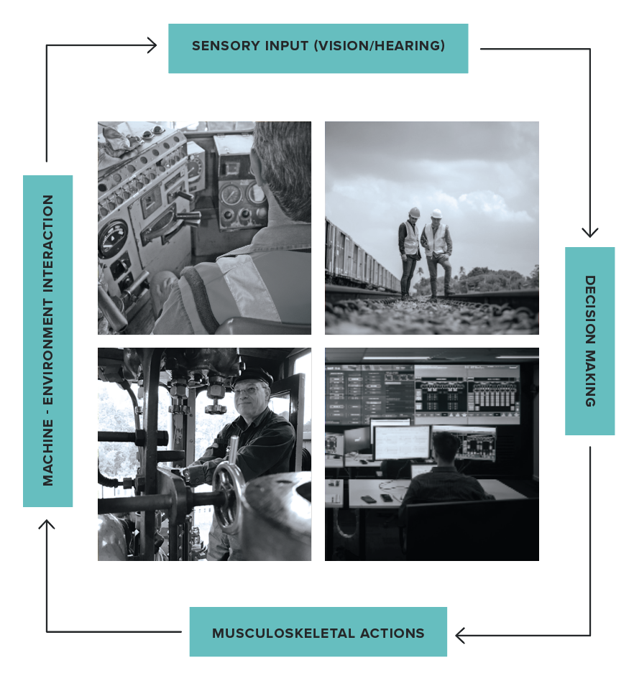

3.4.2. History including Health Questionnaire
All workers (Categories 1, 2 and 3) attending for a Pre-placement or Periodic Health Assessment should bring a completed Health Questionnaire. The questionnaire for the Track Safety Health Assessment (Category 3) is not as comprehensive as the Category 1 and Category 2 questionnaire, but still seeks to establish any serious health condition that might impact on track safety. The assessment should not proceed until the Health Questionnaire has been completed. The Authorised Health Professional should review the worker’s responses to the questionnaire, elicit further information as required and record the history in detail for all declared conditions.
The Authorised Health Professional should clarify and discuss aspects of the questionnaire as required to establish the history, including any changes or incidents since the worker’s previous assessment.
They should ask the worker to sign the declaration that the information they have provided is accurate and truthful, then countersign and date. If this is refused, then proceed as set out in Section 3.6. Reporting and record keeping.
For Triggered Health Assessments, which usually focus on a specific health condition, completion of the Health Questionnaire is not usually required.

3.4.3. Clinical assessments relevant to the worker’s risk category
When examining a worker to assess their fitness for duty, the functionality of various body systems should be addressed as outlined in Parts 4 and 5.
As outlined in those sections, additional tests or referral to a specialist may be required to determine fitness for duty if the history and clinical examination raises the possibility of potentially significant problems. It may be necessary to contact the treating doctor to clarify information regarding the worker’s health. This must be done with the worker’s consent. Such consent may be recorded on the Record for Health Professional form.
The assessment is guided by the Record for Health Professional and specific assessment protocols outlined in the relevant chapters in Parts 4 and 5.
In the case of hearing, colour vision and musculoskeletal capacity for Category 1 and Category 2 Safety Critical Workers, specific risk assessments and fitness for duty criteria are required in relation to each job.
Depending on the circumstances, a Triggered Health Assessment may require a targeted or more comprehensive assessment than that prescribed for the Periodic Health Assessment and will be individually determined. This should be advised by the Authorised Health Professional (refer to Section 2.2.6. Timing and frequency of health assessments).

3.4.4. Interpretation of the examination findings – general considerations
The findings should be recorded on the form Record for Health Professional, which aims to guide systematic thinking about the findings. It requires documentation of any abnormalities found, their interpretation in regard to the Standard and the action taken (refer to Section 6.2.4. Record for Health Professional). The form may be audited to assist in quality assurance.
The information should be interpreted in light of the guidance and fitness for duty criteria outlined in Parts 4 and 5.
Category 1 and Category 2 Safety Critical Workers have differing fitness for duty criteria due to the added emphasis on risk of collapse for Category 1 Safety Critical Work. Both categories, however, share the need for cognitive competence and other faculties. Each section in Part 4 clearly differentiates the requirements for Category 1 and Category 2 Safety Critical Workers, as appropriate.
The fitness for duty criteria for Category 3 workers differ again, reflecting the requirements for their worker’s own safety around the track, as distinct from safety of the network.

3.4.5. Temporary conditions
The Standard does not deal with the many conditions that may affect health on a short-term basis, and for which a rail safety worker may be referred for assessment regarding fitness to resume duty. Such conditions may include post-major surgeries, severe migraines, limb fractures or acute infections.
Clinical judgement is usually required on a case-by-case basis, although the text in each section gives some advice on the clinical issues to be considered.

3.4.6. Undifferentiated illness
A rail safety worker may have clinical symptoms that could have implications for their job, but the diagnosis is not clear. Referral and investigation of the symptoms will mean that there is a period of uncertainty before a health professional can make a definitive diagnosis, and confidently advise the worker and rail transport operator. Each situation will need to be assessed individually, with due consideration being given to the probability of a serious disease that will affect rail safety work.
Generally, a Safety Critical Worker who presents with symptoms of a potentially serious nature—for example, chest pains, impaired consciousness, confusional states, memory loss or dizzy spells—should be assessed as Temporarily Unfit for Duty until their condition can be adequately assessed. However, they may be assessed as fit for non-safety critical alternative duties. Fit for Duty Subject to Review may be used to categorise workers who require prompt investigation, but whose condition is unlikely to pose a safety risk (refer to Section 2.3.2. Fit for Duty Subject to Review).

3.4.7. Multiple medical conditions
Where a worker has a systemic disorder or a number of medical conditions, there may be additive or cumulative detrimental effects on judgement and overall function. For example, there may be a combination of impaired vision, hearing and locomotor dysfunction, or combinations of physical and mental illness, and associated medication.
If these or other clinical conditions are not adequately covered in the Standard, the Authorised Health Professional should consider the nature of the worker’s tasks and the worker’s capacity to perform the duties safely. The general principles of the ergonomics of rail safety work should be borne in mind (refer to Figure 16).
The key issue to consider is whether the conditions in combination could do any of the following:
- affect sensory processes (vision, hearing and balance)
- affect cognition (situational awareness)
- lead to sudden collapse
- affect musculoskeletal performance.
If any of the above could occur, consider whether this could affect the safety of the rail network. If so, then consider:
- modifying the tasks or environment to accommodate a person’s condition without compromising their efficiency or the health and safety of others or incurring unreasonable expense
- providing additional information through functional or practical assessments (refer to Section 3.5.1. Functional and practical assessments).

3.4.8. Drugs and rail safety work

Requirements under the RSNL
Health and safety implications associated with alcohol and drugs (including illicit, prescription and over-the-counter drugs) are managed by the application of the RSNL.
Under Section 128(1) of the RSNL, a rail safety worker must not carry out or attempt to carry out rail safety work while there is any presence in their system of alcohol or a ‘prescribed drug’. Under the RSNL, these are banned substances even if prescribed legally, such as may be the case for medicinal cannabis (see below).
Prescribed drugs include:
- delta-9-tetrahydrocannabinol (THC)
- methylamphetamine (methamphetamine)
- 3,4-methylenedioxymethylamphetamine (MDMA) and
- any other substance declared by the national regulations to be a prescribed drug for the purposes of this section.
Rail safety workers may be tested for drugs and/or alcohol by a rail transport operator, or an authorised person appointed by the Regulator. Rail transport operators undertake drug and alcohol testing under their Drug and Alcohol Management Program. ONRSR may also undertake testing at any time.
Drug testing may identify the ‘prescribed drugs’ noted above as well as a range of other drugs and metabolites. Prescription medications likely to result in a positive/non-negative test result include benzodiazepines and opiates (see below).
In addition, under the RSNL it is an offence to carry out rail safety work while under the influence of alcohol or a drug. Rail transport operators also have a duty to ensure rail safety workers do not carry out work if they are impaired by alcohol or any drugs, prescribed or otherwise.

Medically prescribed medicines — general considerations
Any drug that acts on the central nervous system has the potential to adversely affect a rail safety worker’s functioning. Central nervous system depressants, for example, may reduce vigilance, increase reaction time and impair decision-making in a very similar way to alcohol. In addition, drugs that affect behaviour may exaggerate adverse behavioural traits and introduce risk-taking behaviours.
Rail safety workers are asked to record all current prescription and over-the-counter medication on the Health Questionnaire when attending a health assessment. This provides an opportunity for the Authorised Health Professional to consider potential impacts and advise accordingly.
In determining a rail safety worker’s fitness for duty and advising rail safety workers and their employers, the Authorised Health Professional should consider:
- The indication for the medication, the severity of the condition and the individual response to treatment, including how medication may help to control or overcome aspects of a health condition that may impact on working safely and the implications of not treating the condition (refer to the relevant chapters in the Standard).
- The rail safety worker’s insight and understanding of their condition and the implications for compliance.
- Whether medication side effects may affect working safely, including risk of sedation, impaired reaction time, impaired motor skills, blurred vision, hypotension or dizziness. This includes the added risks or potential impacts of:
  - combining two or more drugs capable of affecting cognitive function, including the intermittent consumption of alcohol
  - sleep deprivation (due to impacted cognitive functions and fatigue), which is particularly relevant to shift workers
  - changing medications or changing dosage
  - the cumulative effects of medications
  - intermittent (as required) medications, such as for pain control. Such regimes may be incompatible with safety critical work unless the use requirements are regularly reviewed, and a management plan is in place for those occasions on which the medication is used.
- The presence of other medical conditions that may combine to adversely affect the rail safety worker’s ability to perform Safety Critical Work.
- Other factors that may exacerbate risks, such as known history of alcohol or drug misuse.
- Whether medication may result in a positive or non-negative result on a random drug test.

The effects of specific drug classes
The potential effects of specific drug classes are well documented but can vary between individuals. While the impact on safety in the rail environment has not been systematically studied, evidence in relation to road vehicle driving performance and crash risk provides an indication of the potential risk. While many drugs have effects on the central nervous system, most, except for benzodiazepines and THC, tend not to pose a significantly increased driving crash risk when the drugs are used as prescribed and once the patient is stabilised on the treatment.
Benzodiazepines: Benzodiazepines are well known to increase the risk of a crash/incident. If a hypnotic is needed, a shorter acting drug is preferred. Tolerance to the sedative effects of the longer-acting benzodiazepines used in the treatment of anxiety gradually reduces their adverse impact on driving skills.
Benzodiazepine use will be identified in a random drug test (urine test) and rail safety workers should be advised accordingly.
Antidepressants: Although antidepressants are one of the more commonly detected drug groups in fatally injured drivers, this tends to reflect their wide use in the community. The ability to impair is greater with sedating tricyclic antidepressants, such as amitriptyline and dothiepin, than it is with the less sedating serotonin and mixed re-uptake inhibitors such as fluoxetine and sertraline. However, antidepressants can reduce the psychomotor and cognitive impairment caused by depression and return mood towards normal. This can improve driving and work performance.
Antipsychotics: This diverse class of drugs can improve performance if substantial psychotic-related cognitive deficits are present. However, most antipsychotics are sedating and have the potential to adversely affect driving skills (work performance) by blocking central dopaminergic and other receptors. Older drugs such as chlorpromazine have strong sedation effects due to their additional actions on the cholinergic and histamine receptors. Some newer drugs are also sedating, such as clozapine, olanzapine and quetiapine, while others, such as aripiprazole, risperidone and ziprasidone, are less sedating. Sedation may be a particular problem early in treatment and at higher doses.
Opioids: Opioid analgesics are central nervous system depressants and as such can suppress cognitive and psychomotor responses. While cognitive performance is reduced early in treatment (largely due to their sedative effects), neuroadaptation is rapidly established. This means that patients on a stable dose of an opioid may not have a higher risk of a crash. Working at night may be a problem due to the persistent miotic effects of these drugs, which reduce peripheral vision.
Opioid use will be identified in a random drug test (urine or oral fluid test) and rail safety workers should be advised accordingly.
Medicinal cannabis: Medicinal cannabis products contain the cannabinoids cannabidiol (CBD) and delta-9-tetrahydrocannabinol (THC), the latter being the psychoactive component and a ‘prescribed drug’ under section 128 of the RSNL as noted above. No products containing THC can be used legally by rail safety workers.
THC consumption may be identified in a random drug test (urine or oral fluid test) and rail safety workers should be advised accordingly.
Psychedelics: At the time of publication, use of psychedelics for medicinal purposes is approved in Australia under very limited and strictly controlled circumstances. They remain ‘prescribed’ drugs under the RSNL.
Stimulants used to treat ADHD: The stimulant medications prescribed to treat ADHD (amphetamines) are unlikely to result in impairment unless there is abuse. They will however likely be detected in a random drug test and rail safety workers should be advised accordingly.
For instances in which medication is relevant to the overall assessment of fitness for Safety Critical Work in the management of specific conditions, such as cardiovascular, diabetes, epilepsy and psychiatric conditions, the circumstances are covered in the relevant sections.

3.5. Additional tests and referral
To further assist in assessment, there are some additional tests and rail-specific resources to be aware of and these are discussed in the following sections.

3.5.1. Functional and practical assessments
The role of functional and practical assessments in relation to the overall health assessment system is described in Section 2.2.4. Functional and practical assessments, including considerations for rail transport operators.
A clinical health assessment may need to be supplemented with a functional or practical test to confirm fitness for duty. For example, a functional assessment of some neurological conditions or musculoskeletal capacity may be applied to confirm the worker’s ability to perform the particular tasks required of them. Practical tests are usually conducted in the typical work environment, while functional assessments are simulations of work in settings such as a clinic gym or a cab simulator. Such tests cannot override the fitness for duty criteria; they can only supplement the doctor’s decision about the ability to perform rail safety tasks where the Standard is imprecise.
Authorised Health Professionals should consider the following limitations of such tests:
- These tests can never fully simulate the work environment. By their nature, the test will always be a snapshot of the person’s functional capacity. They are limited in time and may not provide an indication that the individual will be capable of performing those tasks for a full working day.
- The test may place the person being tested at risk of injury. When ordering a functional or practical test, the examining doctor should be satisfied that the individual is fit to perform the test. If fitness to perform the test is questionable, then so is the person’s fitness for the role.
- A functional or practical test does not assess risk of injury. Where the health issue is one of recurrent injury—for example, an unstable knee—performing all of the elements of a test does not mean that the person is safe to perform those job demands day after day.
As with ordering any test, the doctor should first consider how a positive, negative or inconclusive result will affect their ultimate decision-making.
Practical tests for colour vision or hearing are not recommended because consistency of methodology, and thereby accuracy and applicability across all rail transport operators, cannot be ensured.

3.5.2. Psychometric, aptitude and neuropsychological tests
Psychometric and aptitude tests to assess cognitive capacity and aptitude for various types of rail safety worker may be used at recruitment.
Neuropsychological tests may also be used for assessment of rail safety workers who have had an injury or condition affecting mental processes to help gauge the severity, the extent of recovery, if applicable, and suitability for work.
Neuropsychological tests should be applied by a psychologist or neuropsychologist experienced in using such tests and should be interpreted in light of relevant criteria contained in the Standard.

3.5.3. Specialist referrals and reports
The worker’s condition may warrant referral to a specialist to assess fitness for duty and to advise or initiate appropriate treatment. Workers and their treating general practitioner should be involved in the selection of the medical specialist. Where a worker is already seeing a relevant specialist, the referral should be made to that specialist. The Authorised Health Professional should explain to the specialist, the nature of the rail safety tasks involved and the concerns regarding health status.
The specialist’s report should be sent to the Authorised Health Professional, not to the rail transport operator. The Authorised Health Professional should also request that a copy of the correspondence and test results be sent to the worker’s general practitioner and other treating doctors.
When a worker is assessed as Fit for Duty Subject to Review, they will generally be required to be seen by their treating specialist leading up to their review appointment with the Authorised Health Professional and to provide a report accordingly. Exceptions to this are detailed in the Standard where applicable for certain conditions.
Where appropriate and available, the use of telemedicine may facilitate access to specialist opinion for Fit for Duty Subject to Review assessments.
Use of telemedicine should be on agreement with the Authorised Health Professional.

3.5.4. Determining appropriate review periods
The Standard generally specifies review periods for conditions for which the worker is categorised Fit for Duty Subject to Review. Where the period is not specified, the Authorised Health Professional is required to make a recommendation based on the nature of the condition, the response to treatment and the nature of the rail safety work.
The review period may therefore change as treatment is established and the worker’s condition stabilises. In circumstances where the condition is considered cured, the Authorised Health Professional may recommend that more frequent review is not required, and the worker’s condition can be monitored at their Periodic Health Assessment. Progress of the condition will need to be specifically monitored at that assessment and a report from the treating doctor may be required.

3.6. Reporting and record keeping
Fitness for duty should be reported using the Standard fitness for duty classifications (refer to Section 2.3. Standard reporting framework):
- Fit for Duty Unconditional
- Fit for Duty Subject to Review
- Temporarily Unfit for Duty
- Permanently Unfit for Duty.
Should the worker be assessed as unfit for duty either temporarily or permanently, the Authorised Health Professional should notify the rail transport operator immediately by phone to discuss the implications of the assessment and to allow the rail transport operator to make appropriate arrangements. The Authorised Health Professional should not discuss specific clinical information, only recommendations in terms of fitness for duty, including any necessary job modifications.
In all cases, the Authorised Health Professional should complete the report section of the Request and Report Form. This report should not include any clinical information. Only the functional assessment of fitness for duty or otherwise, any recommendations regarding specialist review or job modifications, and any tests that need to be ordered by the rail transport operator for future Triggered Health Assessments, for example, audiogram, HbA1c, should be reported to the operator.
The Health Questionnaire and Record for Health Professional should not be returned to the rail transport operator.
For each worker, appropriate records should be maintained by the Authorised Health Professional, including:
- completed Health Questionnaire
- completed Record for Health Professional
- copy of the Health Assessment Report (that is, Part B of the Request and Report Form) sent to the rail transport operator
- copies of relevant support information
- any additional clinical notes.
In addition, and in accordance with legislation:
- The worker’s medical records should be made available to the worker on request.
- The worker’s medical records are subject to confidentiality.
- Records may be scanned and kept in electronic form. The employee’s signature on the completed Health Questionnaire is legally valid after scanning.

3.7. Communicating with the rail safety worker
The Authorised Health Professional should advise the worker of the results of the assessment and, where relevant, about the ways in which their condition may impair their ability to conduct rail safety work. As part of this process, the worker can become better informed about the nature of their condition, the extent to which they can maintain control over their condition, the importance of regular medical review and the need for medication, where appropriate. The worker should be provided with a copy of the report to facilitate the discussion.
If the worker is found to be unfit for duty, the Authorised Health Professional should take a conciliatory and supportive role while fully explaining the risks posed by the worker’s condition with respect to rail safety work.

3.8. Communicating with treating health professionals
The Authorised Health Professional should ensure an ethical relationship with the worker’s general practitioner and other treating professionals and ensure continuity of care is maintained.
Reference to the general practitioner should be made for ongoing treatment requirements, for management of lifestyle issues and to discuss issues such as medication causing impairment. The Authorised Health Professional should also request that specialist reports and investigation results be copied to the worker’s general practitioner.
The Authorised Health Professional should obtain the worker’s consent should they need to contact the worker’s general practitioner or treating specialist to clarify information about the worker’s health condition.
The final decision regarding fitness for duty or any restrictions rests with the rail transport operator and involves consideration of the advice of health professionals as well as anti-discrimination and retraining issues.

References
Australian and New Zealand College of Anaesthetists (2020) Faculty of Pain Management: Statement regarding the use of opioid analgesics in patients with chronic non-cancer pain.
Austroads Ltd and NTC (National Transport Commission) (2022) Assessing Fitness to Drive 2022: for commercial and private vehicle drivers.
Brubacher JR, Chan H, Erdelyi S, Zed PJ, Staples JA and Etminan M (2021) ‘Medications and risk of motor vehicle collision responsibility in British Columbia, Canada: a population-based case-control study’, Lancet Public Health, 6(6):e374-e385.
Cameron-Burr KT, Conicella A and Neavyn MJ (2021) ‘Opioid use and driving performance’, Journal of Medical Toxicology, 17(3):289-308.
Drummer OH and Yap S (2016) ‘The involvement of prescribed drugs in road trauma’, Forensic Science International, 265:17-21.
Leon SJ, Trachtenberg A, Briscoe D, Ahmed M, Hougen I, Askin N, Whitlock R, Ferguson T, Tangri N, Rigatto C and Komenda P (2022) ‘Opioids and the risk of motor vehicle collision: a systematic review’, Journal of Pharmacy Technology, 38(1):54-62.
Parekh V (2019) ‘Psychoactive drugs and driving’, Australian Prescriber, 42(6):182-185.
Schumann J, Perkins M, Dietze P, Nambiar D, Mitra B, Gerostamoulos D, Drummer OH, Cameron P, Smith K and Beck B (2021) ‘The prevalence of alcohol and other drugs in fatal road crashes in Victoria, Australia’, Accident Analysis & Prevention, 153:105905.
Verster JC, Pandi-Perumal SR, Ramaekers JG and de Gier JJ (2009) Drugs, driving and traffic safety, Birkhauser Verlag AG, Basel-Boston-Berlin.

4. Assessment and management of health conditions – Category 1 and 2 Safety Critical Workers
This section of the Standard applies to Category 1 and Category 2 Safety Critical Workers and explains the:
- rail safety risks associated with specific medical conditions and their treatments
- approach to assessment and management of these conditions, including screening tools and investigations
- fitness for duty criteria and review requirements.
Note that it is impossible to cover all conditions or combinations of conditions that may affect safety. A generic approach may be applied in situations where conditions or symptoms are not covered in the Standard or where there are concerns about the net effect of multiple minor conditions (refer to Section 3.4.7. Multiple medical conditions).

4.1. Blackouts

4.1.1. Relevance to Safety Critical Work
Unpredictable, spontaneous loss of consciousness is incompatible with Category 1 Safety Critical Work. The Standard is therefore primarily applicable to those workers. However, blackouts or presyncope may indicate an underlying medical condition (for example, seizures, diabetes, a cardiovascular condition, a sleep disorder), which may have implications for those performing Category 2 Safety Critical Work and that will require management as per the appropriate section of the Standard.
For the purposes of the Standard, a syncopal event is defined as a loss of consciousness (blackout) arising from a cardiovascular cause.

4.1.2. General assessment and management guidelines

General considerations
Blackouts may occur due to a range of mechanisms including:
- vasovagal syncope or ‘faint,’ which accounts for more than 50 per cent of blackouts and may be due to factors such as hot weather, emotion or venepuncture but may also be due to more serious causes that may recur
- syncope due to other cardiovascular causes such as structural heart disease, arrhythmias or vascular disease
- epileptic seizure, which accounts for less than 10 per cent of blackouts
- other causes, including metabolic causes (for example, hypoglycaemia), psychiatric (for example, hyperventilation, psychosomatic states, psychogenic non-epileptic seizures), drug intoxication or a sleep disorder.
Blackouts should be managed as per Figure 17. Although blackout is of principal concern for Category 1 Safety Critical Workers, both Category 1 and Category 2 Safety Critical Workers should be assessed as Temporarily Unfit for Duty until the cause of the blackout is established. The underlying cause may adversely affect Category 2 work (for example, diabetes or a sleep disorder). The Category 3 standard should also be considered for Category 2 Safety Critical Workers who work on track.
Determination of the cause of blackouts may be difficult and require extensive investigation and specialist referral. The cause may remain unknown despite extensive investigation.
Some conditions causing blackout are temporary (for example, fainting in hot weather) and do not impact on fitness for duty.

Vasovagal syncope
The most common cause of transient loss of consciousness is vasovagal syncope (‘fainting’). Where this has been triggered by a well-defined provoking factor or a situation that is unlikely to recur while working (for example, prolonged standing, overheating, venepuncture or emotional situation), it is not necessary to restrict work. However, vasovagal syncope may also result from other causes that are not so benign. In such cases, fitness for Safety Critical Work should be assessed according to the fitness for duty criteria for syncope (refer to Section 4.2. Cardiovascular conditions).

Blackouts due to medical causes not covered in the Standard
If the cause of the blackout is determined to be due to a medical condition not covered in the Standard, then first principles regarding fitness for duty should be applied (refer to Section 3.4.1. Overview). Considerations include the likelihood of recurrence of blackout and the treatability of the condition, as well as the nature of the safety critical task. There should also be an appropriate review period.

Figure 17. Management of blackouts and Safety Critical Work (Category 1 and Category 2)
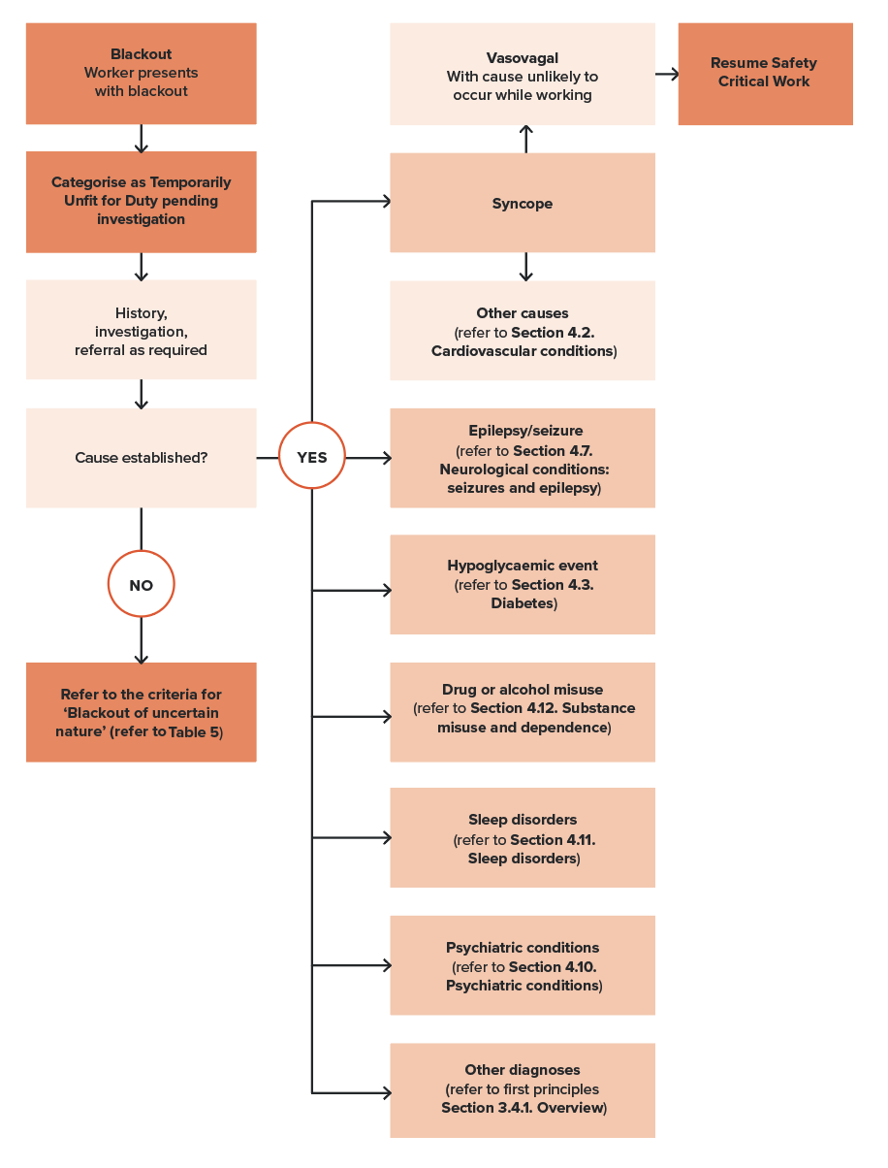

Blackouts of undetermined mechanism
If, despite extensive investigation, the mechanism of a blackout cannot be determined, fitness for duty should be assessed according to Table 5. The fitness for duty criteria for blackout of undetermined mechanism are similar to those for seizure.

4.1.3. Fitness for duty criteria for Safety Critical Workers
Where a firm diagnosis has been made, the criteria appropriate to the condition should be referred to elsewhere in the Standard. For recurrent blackouts that are not covered elsewhere in the Standard, refer to Table 5.
It is important that health professionals familiarise themselves with both the general information previously described and the tabulated fitness for duty criteria before assessing a person’s fitness for duty.
Table 5. Blackouts: Fitness for duty criteria for Safety Critical Workers
Condition | Criteria
Blackouts: episode(s) of impaired consciousness of uncertain nature | Category 1 Safety Critical Workers  A person is not Fit for Duty Unconditional:  - if the person has experienced blackouts that cannot be diagnosed as syncope, seizure or another condition.  If there has been a single blackout or more than one blackout within a 24-hour period, Fit for Duty Subject to Review may be determined, subject to at least annual review, taking into account information provided by an appropriate specialist as to whether the following criterion is met:  - there have been no further blackouts for at least 5 years.  If there have been 2 or more blackouts separated by at least 24 hours, Fit for Duty Subject to Review may be determined, subject to at least annual review, taking into account information provided by an appropriate specialist as to whether the following criterion is met:  - there have been no further blackouts for at least 10 years.  Category 2 Safety Critical Workers  Category 2 Safety Critical Workers experiencing blackouts of uncertain nature should be individually assessed in terms of the likely impact on their work.  Category 2 Safety Critical Workers who work around the track should be assessed as per the Category 3 worker criteria – refer Part 5.
Exceptional cases | Category 1 and Category 2 Safety Critical Workers  Where a person with one or more blackouts of undetermined mechanism does not meet the above criteria, Fit for Duty Subject to Review may be determined, based on consideration of the nature of the task and subject to annual review:  - if, in the opinion of the treating specialist and in consultation with the Authorised Health Professional and the rail transport operator’s Chief Medical Officer (or an occupational physician experienced in rail), the risk to the network caused by blackout is acceptably low.
Temporary illnesses. The Standard does not deal with the many conditions that may affect health on a short-to-medium-term basis and for which a Safety Critical Worker may be referred for assessment regarding fitness to resume duty. Clinical judgement is usually required on a case-by-case basis, although the text in each section gives some advice on the clinical issues to be considered.
Undifferentiated illness. A Safety Critical Worker may present with symptoms that could have implications for their job, but the diagnosis is not clear. Referral and investigation of the symptoms will mean that there is a period of uncertainty before a definitive diagnosis is made, and before the worker and employer can be confidently advised. Each situation will need to be assessed individually, with due consideration being given to the probability of a serious disease that will affect Safety Critical Work. Generally, workers presenting with symptoms of a potentially serious nature should be categorised as Temporarily Unfit for Duty until their condition can be adequately assessed. However, they may be suitable for alternative duties, including duties at a lower risk category (for example, Category 2 or Category 3). Workers who are fit to continue work while being investigated should be categorised as Fit for Duty Subject to Review.
Specialist review. The Standard generally requires Safety Critical Workers who are assessed as Fit for Duty Subject to Review to be seen by a specialist leading up to their review appointment with the Authorised Health Professional. Exceptions are specifically described in the Standard where appropriate.

References and further reading - Blackouts
Austroads Ltd and NTC (National Transport Commission) (2022) Assessing Fitness to Drive 2022: for commercial and private vehicle drivers.
Brignole M, Moya A, de Lange FJ, Deharo JC, Elliott PM, Fanciulli A, Fedorowski A, Furlan R, Kenny RA, Martín A, Probst V, Reed MJ, Rice CP, Sutton R, Ungar A and van Dijk JG (2018) ‘2018 ESC Guidelines for the diagnosis and management of syncope’, European Heart Journal, 39(21):1883-1948.
Shen WK, Sheldon RS, Benditt DG, Cohen MI, Forman DE, Goldberger ZD, Grubb BP, Hamdan MH, Krahn AD, Link MS, Olshansky B, Raj SR, Sandhu RK, Sorajja D, Sun BC and Yancy CW (2017) ‘ACC/AHA/HRS guideline for the evaluation and management of patients with syncope: A report of the American College of Cardiology/American Heart Association task force on clinical practice guidelines and the Heart Rhythm Society’, Circulation, 136(5):e60– e122.
Sorajja D, Nesbitt GC, Hodge DO, Low PA, Hammill SC, Gersh BJ and Shen WK (2009) ‘Syncope while driving: clinical characteristics, causes, and prognosis’, Circulation, 120(11):928-34.

4.2. Cardiovascular conditions

4.2.1. Relevance to Safety Critical Work

Effects of cardiovascular conditions on Safety Critical Work
Cardiovascular conditions may affect the ability to perform Safety Critical Work due to sudden incapacity, such as from a heart attack or an arrhythmia. This is particularly relevant to Category 1 Safety Critical Workers. These conditions may also affect concentration and the ability to control machinery due to onset of chest pain or palpitations, or dyspnoea, which is relevant to both Category 1 and Category 2 Safety Critical Workers.
Cardiovascular conditions may be asymptomatic leading up to an event such as acute myocardial infarction, cardiac arrest or stroke, and this poses a significant risk to rail safety for Category 1 Safety Critical Workers. Predication of cardiac risk and active investigation and management of Category 1 Safety Critical Workers found to be at high risk is therefore an important aspect of the Standard.
Cardiovascular disease also may have end-organ effects, such as on the brain (stroke), extremities (vasculature) and vision. The relevant sections should be referred to for advice on assessment of these effects.

Effects of Safety Critical Work on the heart
A further problem in those who have established ischaemic heart disease is that situations experienced while performing Safety Critical Work, such as responding to an emergency, may lead to a faster heart rate and fluctuation in blood pressure, which could theoretically trigger angina or even infarction.

4.2.2. General assessment and management guidelines

General considerations
The Standard seeks to identify, assess and manage workers with cardiovascular disease that may impact rail safety. In addition, for Category 1 Safety Critical Workers, it seeks to proactively identify and manage workers at risk of future cardiovascular disease associated events such as heart attack and stroke.
A further consideration is the return to work and ongoing management of workers who experience acute cardiac events or are subject to cardiac interventions during their employment.
In terms of existing cardiovascular conditions, workers are required to self-declare current and past history, symptoms and treatment via the Health Questionnaire at Pre-placement and Periodic Health Assessments. A resting electrocardiogram (ECG) is routinely conducted for Category 1 Safety Critical Workers to screen for potential arrythmias and inherited or acquired cardiac disease.
Category 1 Safety Critical Workers also undergo routine pathology testing of lipids and HbA1c and blood pressure assessment at Pre-placement and Periodic Health Assessments.
This information guides the clinical assessment including evaluation of:
- past history
- current symptoms, including chest pain, palpitations or irregular heartbeat, shortness of breath, syncope and pre-syncope that may cause distraction from Safety Critical Work, as well as being a harbinger of possible collapse
- indicators of inherited cardiac disease, such as first-degree relatives having cardiovascular events in midlife
- comorbidities such as obesity, inactivity, obstructive sleep apnoea, chronic kidney disease, alcohol use, depression and hypertensive complications in pregnancy
- work factors such as exposure to climatic extremes in the course of work.
Note that family history of premature cardiovascular disease is defined as coronary heart disease or stroke in a first-degree female relative aged under 65 years or a first-degree male relative aged under 55 years. The unexpected death of a family member under the age of 50 may also be an indicator of an inherited arrhythmic condition.
Note also, recent evidence suggests an interrelationship between COVID-19 and cardiovascular disease, with COVID-19 potentially increasing the risk of cardiovascular disease as well as contributing to worse outcomes in individuals with pre-existing disease such as myocarditis, acute coronary syndrome, heart failure, thromboembolic complications and arrythmias., The risk is elevated acutely with infection but remains elevated for 12 months thereafter.
All information should be used in assessing fitness for duty for Category 1 and Category 2 Safety Critical Workers. Clinical judgement may be needed to determine if a person is Fit for Duty Unconditional, Fit for Duty Subject to Review or Temporarily Unfit for Duty while being further assessed, including referral as appropriate for specialist cardiology opinion. Conditions identified should be managed as per the criteria in this chapter.

Cardiac risk level for Category 1 Safety Critical Workers aged 30 years and over
The assessment for Category 1 Safety Critical Workers incorporates the cardiac risk level as a tool for predicting risk of a cardiovascular event during a five-year period. The Australian Cardiovascular Disease Risk Calculator should be used to calculate cardiovascular risk (the calculator has been updated as of July 2023).
The calculator estimates 5-year cardiovascular disease risk, expressed as a percentage representing the person’s probability of dying or being hospitalised due to myocardial infarction, angina, other coronary heart disease, stroke, transient ischaemic attack, peripheral vascular disease, congestive heart failure or other ischaemic cardiovascular disease-related conditions within the next 5 years. While the calculator has not been developed as a workplace risk assessment tool, it helps to identify workers at risk of sudden incapacity and guide their management.
The cardiac risk level should be calculated at Pre-placement Health Assessments for Category 1 Safety Critical Workers without known cardiovascular disease who are 30 years of age or over.
Conduct of the risk assessment at Periodic Health Assessment and Triggered Health Assessment will depend on whether and when the risk assessment has been previously conducted and the outcome (see below).
The calculator is not applied to workers who are already at high risk due to moderate to severe kidney disease or familial hypercholesterolaemia. These workers should be managed as per the high-risk category as described below.
Authorised Health Professionals should refer to the comprehensive guidelines accompanying the calculator for application and interpretation of the results and subsequent management, noting that a Category 1 Safety Critical Worker who is asymptomatic but found to have an increased likelihood of cardiovascular event should be assessed more fully than an ordinary patient because of the risks they pose to public safety.

Data collection
The information required for the cardiac risk level calculator is shown in Table 6, together with commentary regarding the data fields, including optional fields. The data should be recorded in the Record for Health Professional form.
Table 6. Data collection for the Australian cardiovascular disease risk calculator
Data for risk calculator | Comment
Clinically determined high risk*  Clinical conditions that automatically confer high risk.  Moderate-severe chronic kidney disease  Familial hypercholesterolaemia  Neither present | If either of these apply, the user will be redirected to management for the high-risk category.
Age*  yrs | Note: Only ages between 30 and 79 can be entered.
Sex at birth*  Female  Male | Note: Sex at birth is specified
Smoking status*  Never smoked  Previously smoked (ceased >1 year ago)  Currently smokes (or ceased ≤1 year ago) | Note: This now clarifies that the risk diminishes 1 year after ceasing smoking.
Systolic blood pressure*
/.
Ratio of total cholesterol to HDL cholesterol*  Ratio  OR enter  Total mmol/L  HDL mmol/L | Note: There is the option of entering the ratio, OR the individual values.
Use of CVD medicines within last 6 months*  Blood pressure-lowering medicines  Lipid-modifying medicines  Antithrombotic medicines  None | Note: Workers are required to bring or provide a list of all medications in the Health Questionnaire. The Authorised Health Professional should ask about these types of medications specifically.
History of atrial fibrillation  No  Yes | Optional question. The response may be gained from self-report in the Health Questionnaire or direct questioning.
Postcode | Optional question designed to identify socioeconomic disadvantage.
Diabetes  No  Yes | A worker is considered to have diabetes if they are under treatment for diabetes or if diabetes is confirmed on HbA1c testing (refer to Section 4.3.2. General assessment and management guidelines)  If Yes is selected, the following subset of questions will open.
If Yes  Provide additional diabetes details  Continue without providing additional details | Note: All of the following fields must be completed if ‘Provide additional diabetes details’ is selected.*
Additional information for diabetics
Years since diabetes diagnosis*  yrs | Note that some of the information in this section is not routinely collected as part of the Category 1 assessment, however if the information is available (for example, from specialist or GP reports or directly from the worker), this aspect of the calculator is valuable for informing management of risk for patients with diabetes.
Glycated haemoglobin (HbA1c)*
mmol/mol or %
uACR *
mg/mmol
eGFR *
mL/min/1.73 m² or eGFR≥90
Body mass index (BMI) *
Weight Kg; Height Meters
Use of insulin within last 6 months *
No
Yes
*Mandatory fields once ‘Provide additional diabetes details’ is selected.

Determine risk level and category
The calculator produces a risk estimate expressed as a percentage probability of dying or being hospitalised due to cardiovascular disease-related conditions in the next 5 years. Based on the resulting score, workers can be placed into one of 3 risk categories, which will determine the management approach:
- Low – less than 5 per cent
- Intermediate – 5 per cent to less than 10 per cent
- High – 10 per cent or greater
Workers with moderate-to-severe chronic kidney disease and those with confirmed familial hypercholesterolaemia should be assessed as being at high risk and managed accordingly.
In addition to the variables included in the calculator itself, there are a number of ‘reclassification factors’ that may help refine risk classification. These are most useful when the person’s risk lies close to a risk threshold. These are flagged in the online tool and include:
- ethnicity
- chronic kidney disease
- coronary artery calcium score
- family history of premature cardiovascular disease
- severe mental illness.

Initial risk management and reassessment interval
The categories of risk are managed as follows and summarised in Table 7.

High risk – greater than or equal to 10 percent
Workers, who are assessed as having a high risk of an event in the next 5 years (greater than or equal to 10 per cent) should be referred for cardiologist assessment. Depending on their overall clinical picture, they may be categorised Fit for Duty Subject to Review or Temporarily Unfit for Duty while medical management is initiated and investigations undertaken, as appropriate. Advice and support regarding risk factor management and referral to the worker’s general practitioner should also be provided.
All investigations will be initiated at the discretion of the cardiologist, who will also advise regarding treatment and review requirements.
Formal reassessment of cardiovascular risk is generally not required for this group as they will be under clinical management. Subsequent reviews (Fit for Duty Subject to Review) will involve specialist report as to the effectiveness of that management.

Intermediate risk – from 5 per cent to less than 10 per cent
Workers at intermediate risk (5 per cent to less than 10 percent) should be categorised Fit for Duty Subject to Review and referred for assessment by their general practitioner, including establishing the absence of concerning cardiac symptoms, risk factor management and pharmacotherapy as appropriate.
This group should be reassessed every two years if they are not currently receiving pharmacotherapy to reduce cardiovascular disease risk, or more frequently if they are close to the high-risk threshold, if cardiovascular disease risk factors worsen or if new risk factors develop.

Low risk – less than 5 per cent
Workers with a low risk (less than 5 per cent) should be referred for risk factor management as appropriate, providing there is an absence of concerning cardiac symptoms. They should be reassessed every 5 years or sooner if they are closer to the intermediate threshold, if risk factors worsen or if new risk factors are identified.
For First Nations people, the guidelines accompanying the cardiac risk calculator recommend more frequent reassessment based on the higher incidence rates of cardiovascular disease compared to non-indigenous peoples, the earlier onset of risk factors such as diabetes and chronic kidney diseases, and the limited literature on population-specific risk transition to and progression of cardiovascular disease. The guidelines recommend review of risk factors for those over 18 years. This should be taken into consideration in the assessment and ongoing management of workers who identify as First Nations people.
Table 7 summarises the approach to fitness for duty categorisation, referral and investigation and repeat risk assessment.
Table 7. Management of risk calculator scores for Category 1 Safety Critical Workers
 | Probability of cardiovascular event in the next 5 years
 | ≥ 10% (High risk) | ≥ 5 and < 10% (Intermediate risk) | < 5% (Low risk)
Initial categorisation | Temporarily Unfit for Duty or Fit for Duty Subject to Review pending investigation | Fit for Duty Subject to Review | Fit for Duty Subject to Review or Fit for Duty Unconditional
Investigation and referral | Refer for cardiologist assessment.  Cardiologist to advise review requirements as below. | Assess overall risk including risk factors such as obesity, physical activity, and family history.  Refer to general practitioner or cardiologist. | Assess overall risk including risk factors such as obesity, physical activity, and family history.  Refer to general practitioner if required.
Subsequent review | No repeat cardiac risk score required as under clinical management.  Specialist or general practitioner review annually (unless otherwise recommended by cardiologist).  Manage confirmed cardiovascular disease and comorbidities as per standard. | Reassess risk every 2 years if not receiving pharmacotherapy unless cardiologist or treating doctor advises otherwise.  Assess sooner if close to high-risk threshold, if risk factors worsen, or new risk factors identified. | Reassess risk every 5 years.  Assess sooner if close to intermediate risk threshold, if risk factors worsen, or new risk factors are identified.

Investigations
Specific investigations are at the discretion of the cardiologist. Where there is absence of concerning cardiac symptoms, these may include the following tests.

Coronary computed tomography angiogram
Coronary computed tomography angiogram (CCTA) provides anatomical information on coronary circulation, specifically enabling the exclusion of clinically significant proximal coronary stenoses to support risk stratification of patients and inform preventative strategies.

Stress electrocardiogram and stress echocardiogram
Stress ECG and echocardiography provide functional information on the coronary circulation and are best utilised in people in whom there are exertional symptoms. The yield from this form of testing in asymptomatic individuals is lower than CCTA.

Coronary artery calcium score
Coronary artery calcium can be considered when risk factor treatment decisions are uncertain such as when the risk of cardiovascular events is assessed as low or intermediate when using the calculator and other risks concerns are present that are not accounted for by the calculator. For example, a higher score may lead to earlier use of statin therapy.

Management of risk factors
Where risk factors are identified, the worker should be referred to their general practitioner and other appropriate programs. The worker should be reviewed to monitor management of their risk factor profile – the frequency will depend on the overall risk, including consideration of other fitness for duty criteria in the Standard, such as for hypertension or diabetes.
If, during the course of the examination, a Category 2 Safety Critical Worker is found to have raised cardiovascular risk factors, there are no specific actions regarding fitness for duty since the major risk is in relation to sudden incapacity. However, if raised cardiovascular risk factors are found, the worker should be referred to their general practitioner.

Ischaemic heart disease and related interventions
In individuals with ischaemic heart disease, the severity, rather than the mere presence of ischaemic heart disease, should be the primary consideration when assessing fitness for duty. For Category 1 and Category 2 Safety Critical Workers, the Authorised Health Professional should consider any symptoms of sufficient severity to be a risk to attentiveness while working. For Category 1 Safety Critical Workers, the risk of sudden collapse is a further consideration. Those who have had a previous myocardial infarction or similar event are at greater risk of recurrence than the normal population, thus cardiac history is an important consideration.
Return to work following an acute myocardial infarction will be on the advice of the treating specialist, with a minimum non-working period of 4 weeks (Temporarily Unfit for Duty) for Category 1 Safety Critical Workers. They must demonstrate adequate medical management, participate in a management program designed to achieve National Heart Foundation targets for secondary prevention and have minimal symptoms relevant to performing their Category 1 Safety Critical Work. These are requirements for ongoing review (Fit Subject to Review) at least annually, with exercise testing conducted if clinically indicated.
Requirements for return to work, ongoing fitness and review periods for Category 2 Safety Critical Workers will depend on the nature of the work and the advice of the treating specialist.

Suspected angina pectoris
If chest pains or shortness of breath of uncertain origin are reported by the Safety Critical Worker, these should be investigated. Generally, it would be wise to class the worker as Temporarily Unfit for Duty, particularly if they are at increased cardiovascular risk, until cardiovascular or other serious disease are excluded, particularly for Category 1 Safety Critical Workers. If the tests indicate ischaemic heart disease, or the person remains symptomatic and requires anti-anginal medication for the control of symptoms, the requirements listed for proven angina pectoris apply.

Cardiac surgery (open chest)
Cardiac surgery may be performed for various reasons, including valve replacement, excision of atrial myxoma or correction of septal defects. In some cases, the stabilisation of the condition will support ongoing fitness for duty in the long term, although the worker should be categorised Temporarily Unfit for Duty post-operatively (refer to Table 8).
In other cases, the condition may not be stabilised and the effect on Safety Critical Work needs to be individually assessed. In addition, all cardiac surgery patients should be advised regarding safety of working in the short term as for any other post-surgery patient (for example, considering the limitation of chest and shoulder movements after sternotomy).

Disorders of rate, rhythm and conduction
A resting ECG is routinely conducted for Category 1 Safety Critical Workers to screen for potential arrythmias and inherited or acquired cardiac disease.
There is a wide diversity of ECG changes and a diversity of consequences arising from these changes. Sometimes palpitations, and hence loss of attentiveness, may occur. Occasionally there is a risk of collapse. Each case needs to be individually assessed as to the potential consequences and impacts on the work being undertaken.
Some examples of relevant conditions that can be screened include hypertrophic cardiomyopathy, Long QT syndrome, Brugada syndrome, coronary ischemia and pre-excitation or Wolff Parkinson White syndrome.
Initial categorisation will depend on the nature of the ECG changes and the potential impacts. Workers with recurrent arrhythmias causing syncope or presyncope are usually not fit for duty while being investigated. If a person has a significant ECG abnormality, such as left bundle branch block, pre-excitation syndrome, prolonged QT interval (greater than 500 ms) or changes suggestive of myocardial ischaemia or previous myocardial infarction, they should also be categorised Temporarily Unfit for Duty while being investigated by a cardiologist. Those with suspected left ventricular hypertrophy or right bundle branch block may be categorised Fit for Duty Subject to Review while being investigated.
A classification of Fit for Duty Subject to Review may be considered after appropriate treatment and a non-working period (refer to Table 8).
For Category 1 Safety Critical Workers, an implantable cardioverter defibrillator (ICD) is acceptable only for primary prevention and under strict conditions as per Table 9.
Category 2 Safety Critical Workers should be individually assessed based on the nature of their work and the underlying condition.

Electromagnetic interference
Pacemakers, defibrillators and other electronic medical devices may be susceptible to interference from electromagnetic fields. This is particularly relevant for individuals working in close proximity to high voltage transmission lines and generation equipment. Workers should be advised to inform their cardiologist of the nature of their work. The likely impact and management approach should be determined individually based on information from the device manufacturer, the treating cardiologist or an occupational physician.

Vascular disease

Aneurysms
Thoracic aortic aneurysms are largely asymptomatic until a sudden and catastrophic event occurs, such as rupture or dissection. Such events are rapidly fatal in a large proportion of patients and are therefore relevant to Category 1 Safety Critical Workers. Risk varies with the type and size of aneurysm. The Standard is set differently for atherosclerotic aneurysms or aneurysms associated with tri-leaflet versus bicuspid aortic valve.
If the aneurysm is associated with untreated or uncontrolled hypertension (consistently or frequently greater than 150/90 mmHg), the worker should be categorised Temporarily Unfit for Duty while treatment is established, and control is demonstrated.
Some inherited aortopathies may not be compatible with Category 1 Safety Critical Work, for example Marfan syndrome with risk factors or familial aortic aneurysm or dissection (including non syndromic). A cardiologist’s opinion should be sought.
Aneurysms are unlikely to affect attentiveness as required in Category 2 Safety Critical Workers.

Deep vein thrombosis and pulmonary embolism
Although deep vein thrombosis (DVT) may lead to an acute pulmonary embolus (PE), there is little evidence that such an event affects safety. Therefore, there is no Standard for either DVT or PE per se, although non-working periods (Temporarily Unfit for Duty) are advised (refer to Table 8). If long-term anticoagulation treatment is prescribed, the Standard for anticoagulant therapy should be applied (refer to Other cardiovascular conditions below).

Valvular disease
Valvular disease may present with diverse symptoms including exertional dyspnoea, palpitations, angina, syncope, cardiac arrest or heart failure. It may also be asymptomatic and found on examination. The symptoms, if severe, may cause distraction from work and as such are relevant to both Category 1 and Category 2 Safety Critical Workers. The risk of collapse is particularly relevant to Category 1 Safety Critical Workers.
Generally, those who are asymptomatic and with mild valvular disease may continue working Fit Subject to Review and more frequent review may not be required. Those with moderate disease will require annual review to monitor development of symptoms, progression and function. Those with severe disease will require surgical or percutaneous intervention. Return to work will be determined by the treating specialist (minimum 3-months). Ongoing follow-up will be annually, including specialist report as clinically indicated.
Specific criteria are set for the complications of cardiac arrest, heart failure and implanted devices (refer to Table 9).

Myocardial disease
The dilated and hypertrophic cardiomyopathies may present with diverse symptoms, including exertional dyspnoea, palpitations, angina, syncope, cardiac arrest or heart failure. They may also be asymptomatic and found on examination. The symptoms, if severe, may cause distraction from work and as such are relevant to both Category 1 and Category 2 Safety Critical Workers. The risk of collapse is particularly relevant to Category 1 Safety Critical Workers. Specific criteria are set for the complications of cardiac arrest, heart failure and implanted devices (refer to Table 9).
There are several other causes of myocardial disease. These may be managed using the principles for the cardiomyopathies or by consideration of the basic principles regarding Safety Critical Work.

Other cardiovascular conditions

Long-term anticoagulant therapy
Long-term anticoagulant therapy may be used to lessen the risk of embolism in disorders of cardiac rhythm, following valve replacement, for deep venous thrombosis and so on. If not adequately controlled, there is a risk of bleeding that may acutely affect Category 1 Safety Critical Work, such as an intracranial bleed, particularly for warfarin.
A person is not Fit for Duty Unconditional if they are on long-term anticoagulant therapy. Those on warfarin require annual review in light of the higher risk of haemorrhage. Novel non-vitamin K antagonist oral anticoagulants (NOACs) present a lower risk of haemorrhage. These workers should be reviewed as required for their underlying condition.

High blood pressure (hypertension)
For Category 1 Safety Critical Workers the concerns about high blood pressure relate to:
- exceedingly high levels (≥ 200/≥ 110) where acute incapacity due to events such as stroke are a concern, and the blood pressure is managed as a risk factor per se; and
- moderately raised blood pressure (≥ 170/≥ 100) where blood pressure is managed, along with other risk factors, as a contributor to cardiovascular events.
Category 1 Safety Critical Workers with blood pressure levels greater than or equal to 170/100 should be managed as per Figure 18 and Table 9.
There are no specific criteria for Category 2 Safety Critical Workers; however, their blood pressure should still be measured as part of the assessment. If it is raised, they should be referred to their general practitioner.

Figure 18. Management of high blood pressure for Category 1 Safety Critical Workers
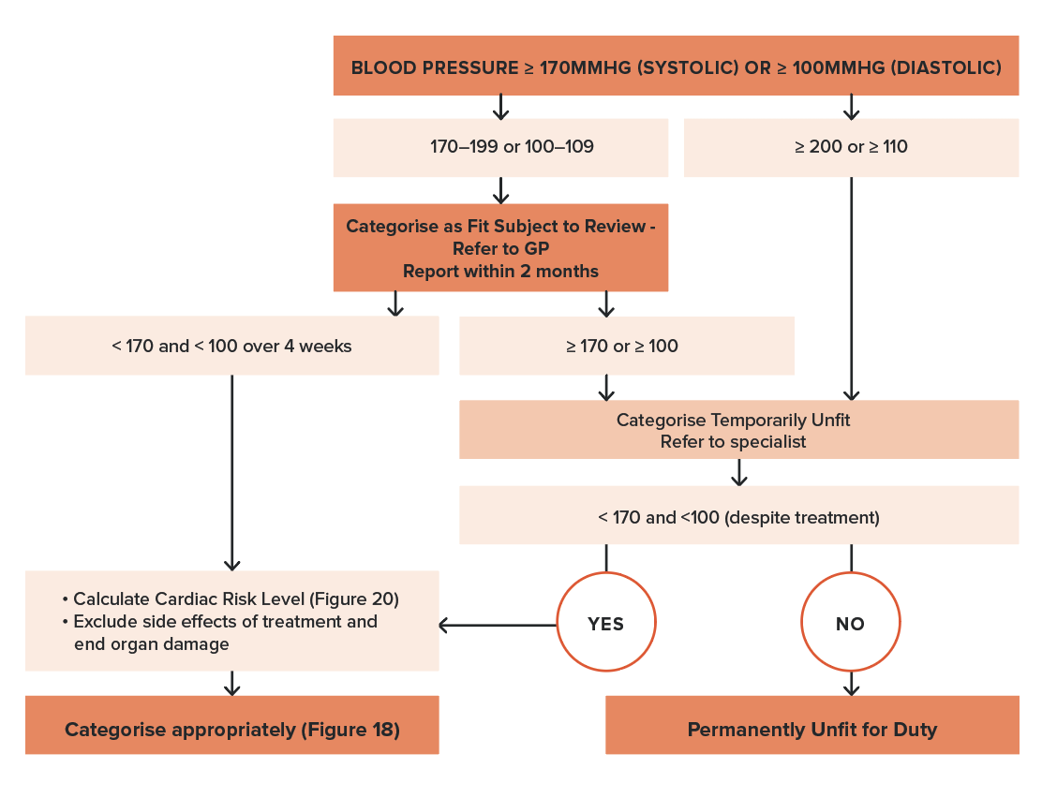

Syncope
If an episode of syncope is vasovagal in nature with a clear-cut precipitating factor (for example venesection), and the situation is unlikely to occur while performing Category 1 Safety Critical Work, the person may generally resume work within 24 hours.
With syncope due to other cardiovascular causes, a person should not perform Category 1 Safety Critical Work for at least 3 months, after which time their ongoing fitness for duty should be assessed. In cases where it is not possible to be certain that an episode of loss of consciousness is due to syncope or some other cause, refer to Section 4.1. Blackouts.

Congenital disorders
The impact of congenital heart disorders on Safety Critical Work relates to the effects of the congenital lesion on ventricular function, associated valve lesions, shunting, cyanosis, development of pulmonary vascular disease and complicating arrhythmias.
Some congenital conditions are likely to be incompatible with Category 1 Safety Critical Work, for example:
- congenital heart disorders (repaired or unrepaired) associated with severe pulmonary vascular disease (including Eisenmenger syndrome or pulmonary vascular resistance over 8 wood units)
- cyanotic congenital heart disorder (unoperated or untreated) with resting oxygen saturation below 80%
- Fontan circulation
- univentricular heart (including double inlet left/right ventricle, tricuspid/mitral atresia, hypoplastic left heart syndrome, and any other anatomic abnormality with a functionally single ventricle)
- severe stenotic valve disease if unrepaired (see also below).
For other congenital heart disorders, fitness for duty will depend on the haemodynamic impacts and symptoms relevant to Safety Critical Work as advised by the treating specialist.
The relevant sections on atrial fibrillation, paroxysmal arrhythmias, implantable cardioverter defibrillators, cardiac pacemaker and heart failure may also apply to workers with congenital heart disease.

4.2.3. Fitness for duty criteria for Safety Critical Workers
As alluded to in previous sections, there are 3 aspects to the management of fitness for duty and therefore the fitness for duty criteria for cardiac conditions and Safety Critical Work. They include:
- management of the risk of sudden incapacity due a cardiovascular event such as heart attack or stroke, based on the cardiac risk score, with categorisation and review periods dependent on the level of risk (Category 1 Safety Critical Workers without known cardiac disease)
- management following an acute event or intervention in terms of the non-working period (Temporarily Unfit for Duty)
- management of longer-term fitness for duty for chronic cardiac conditions.

Criteria for cardiovascular risk
The criteria for managing various levels of risk are shown in Table 7. Initial fitness for duty will depend on the risk level. Ongoing fitness for duty will depend on the findings of investigations and management of the condition identified.

Non-working periods following acute events or interventions
A number of cardiovascular incidents and procedures have implications for both short-term and long-term fitness for duty—for example, acute myocardial infarction and cardiac surgery. Minimum non-working periods (Temporarily Unfit for Duty) are prescribed for Category 1 Safety Critical Workers as shown in Table 8. Non-working periods for Category 2 Safety Critical Workers should be determined individually on clinical grounds based on whether the worker has symptoms (chest pain, syncope, palpitations, breathlessness) that may impair performance of the task. If there is uncertainty, the advice of an occupational physician with rail industry experience should be sought regarding a risk assessment of the job.

Table 8. Minimum non-working periods for Category 1 Safety Critical Workers*
Event or procedure | Minimum non-working period
Ischaemic heart disease
Acute myocardial infarction | 4 weeks
Angioplasty | 4 weeks
Coronary artery bypass grafts | 3 months
Disorders of rate, rhythm, and conduction
Cardiac arrest | 6 months
ICD insertion (primary prevention only – see text) | 6-months
Generator change of an ICD | 2 weeks
ICD therapy associated with symptoms of haemodynamic compromise | ICD not permitted for Category 1  unless for primary prevention
Cardiac pacemaker insertion | 4 weeks
Vascular disease
Deep vein thrombosis | 2 weeks
Pulmonary embolism | 6 weeks
Aneurysm repair | 3 months
Valvular replacement (including treatment with MitraClipsTM and transcutaneous aortic valve replacement) | 3 months
Other
Heart or lung transplant | 3 months
Syncope (due to cardiovascular causes) | 3 months
* Non-working periods for Category 2 Safety Critical Workers should be determined individually on clinical grounds based on whether the worker has symptoms (chest pain, syncope, palpitations, breathlessness) that may impair performance of the task. If there is uncertainty, the advice of an occupational physician with rail industry experience should be sought regarding a risk assessment of the job.
The variation in non-working periods reflects the varying effects of these conditions, including the time needed for recovery from discomfort of an intervention to resume necessary musculoskeletal work, as well the time needed to assess stabilisation of the condition or a device.
These exclusion periods are minimum advisory periods only and are based on expert opinion. The classification of Fit for Duty Subject to Review should be considered once the condition has stabilised and safe working capacity can be assessed, as outlined in this section. The non-working periods for Category 2 Safety Critical Workers are generally individually assessed based on the nature of the task.

Criteria for long-term fitness for duty including review periods
Most cardiac conditions require long term management, even when stabilised. The criteria for fitness for duty outlined in Table 9 are applied once the condition is confirmed and under treatment. Initial categorisation while a person’s symptoms are being investigated are covered in the text.
In general, the review interval should not exceed 12 months for Category 1 Safety Critical Workers with diagnosed cardiac disease (as distinct from raised risk factors). However, where a condition has been effectively treated and there is minimal risk of recurrence, the review period may be extended on the advice of a specialist. These circumstances are identified in Table 9.
It is important that health professionals familiarise themselves with both the general information above and the tabulated fitness for duty criteria before assessing a person’s fitness for duty.
Requirements for safe working are included in Table 9 for the following conditions:
- Ischaemic heart disease
  - acute myocardial infarction
  - angina
  - coronary artery bypass grafting
  - percutaneous coronary intervention
- Disorders of rate, rhythm and conduction
  - arrhythmia
  - cardiac arrest
  - cardiac pacemaker
  - implantable cardioverter defibrillator
  - ECG changes
- Vascular disease
  - aneurysms (abdominal and thoracic)
  - deep vein thrombosis
  - pulmonary embolism
  - valvular heart disease
- Myocardial diseases
  - dilated cardiomyopathy
  - hypertrophic cardiomyopathy
- Other conditions and treatments
  - anticoagulant therapy
  - congenital disorders
  - heart failure
  - heart transplant
  - hypertension
  - syncope.
Table 9.Cardiovascular conditions: Fitness for duty criteria for Safety Critical Workers
Condition | Criteria
Cardiac risk level (Refer to Table 7) | Category 1 Safety Critical Workers  Refer to Table 7.  Refer to related criteria as required (e.g., hypertension and diabetes).  Category 2 Safety Critical Workers  There are no specific criteria for fitness for duty for Category 2 Safety Critical Workers since the major risk is in relation to sudden incapacity. However, if during the examination, raised cardiovascular risk levels are found the worker should be referred to their general practitioner.
Ischaemic heart disease
Acute myocardial infarction  Refer also to percutaneous coronary intervention (PCI)  Refer also to coronary artery bypass grafting (CABG) | Category 1 Safety Critical Workers  A person should be categorised Temporarily Unfit for Duty for at least 4 weeks following an acute myocardial infarction.  A person is not Fit for Duty Unconditional:  - if the person has had an acute myocardial infarction.  After the prescribed non-working period, Fit for Duty Subject to Review may be determined, subject to at least annual review, taking into account the nature of the work and information provided by the treating specialist as to whether the following criteria are met:  - there is adequate adherence and compliance with recommended medical management; and  - there is an ejection fraction of ≥ 40%; and  - the worker is in a management program designed to achieve National Heart Foundation targets for secondary prevention relevant to the condition; and  - there are minimal symptoms relevant to performing Safety Critical Work (chest pain, palpitations, breathlessness); and  - where clinically recommended, there is adequate performance with exercise testing.  Category 2 Safety Critical Workers  The non-working period (Temporarily Unfit for Duty) should be determined on clinical grounds.  A person is not Fit for Duty Unconditional:  - if the person has had an acute myocardial infarction; and  - they have symptoms (chest pain, palpitations, breathlessness) that may impair performance of the task.  Fit for Duty Subject to Review may be determined, with the review period being determined by the Authorised Health Professional, taking into account the nature of the work and information provided by the treating specialist.
Angina and myocardial ischaemia | Category 1 Safety Critical Workers  A person is not Fit for Duty Unconditional:  - if the person is subject to angina pectoris or has confirmed myocardial ischaemia.  Fit for Duty Subject to Review may be determined, subject to at least annual review, taking into account the nature of the work and information provided by the treating specialist as to whether the following criteria are met:  - there is adequate adherence and compliance with recommended medical management; and  - the worker is in a management program designed to achieve National Heart Foundation targets for secondary prevention relevant to the condition; and  - there are minimal symptoms relevant to performing Safety Critical Work (chest pain, palpitations, breathlessness); and  - where clinically recommended, there is adequate performance with exercise testing.  Where surgery or percutaneous coronary intervention (PCI) is undertaken, the requirements listed for surgery or PCI apply (see below).  Category 2 Safety Critical Workers  A person is not Fit for Duty Unconditional:  - if the person is subject to angina pectoris or has confirmed myocardial ischaemia; and  - they have symptoms (chest pain, palpitations, breathlessness) that may impair performance of the task.  Fit for Duty Subject to Review may be determined, with the review period determined by the Authorised Health Professional, taking into account the nature of the work and information provided by the treating specialist.
Coronary artery bypass grafting (CABG) | Category 1 Safety Critical Workers  A person should be categorised as Temporarily Unfit for Duty for at least 3 months following coronary artery bypass grafting.  A person is not Fit for Duty Unconditional:  - if the person requires or has had coronary artery bypass grafting.  Following the prescribed non-working period, Fit for Duty Subject to Review may be determined, subject to at least annual review, taking into account the nature of the work and information provided by the treating specialist as to whether the following criteria are met:  - there is a satisfactory response to treatment; and  - the worker is in a management program designed to achieve National Heart Foundation targets for secondary prevention relevant to the condition; and  - there are minimal symptoms relevant to performing Safety Critical Work (chest pain, palpitations, breathlessness); and  - where clinically recommended, there is adequate performance with exercise testing; and  - there is minimal residual musculoskeletal pain after the chest surgery.  Category 2 Safety Critical Workers  The non-working period (Temporarily Unfit for Duty) should be determined on clinical grounds.  A person is not Fit for Duty Unconditional:  - if the person requires or has had coronary artery bypass grafting; and  - they have symptoms (chest pain, palpitations, breathlessness) that may impair performance of the task.  Fit for Duty Subject to Review may be determined, with the review period determined by the Authorised Health Professional, taking into account the nature of the work and information provided by the treating specialist.
Percutaneous coronary intervention (PCI)(e.g., angioplasty) | Category 1 Safety Critical Workers  A person should be categorised Temporarily Unfit for Duty for at least 4 weeks after percutaneous coronary intervention (PCI).  A person is not Fit for Duty Unconditional:  - if the person requires or has had PCI.  Following the prescribed non-working period, Fit for Duty Subject to Review may be determined, subject to at least annual review, taking into account the nature of the work and information provided by the treating specialist as to whether the following criteria are met:  - there is a satisfactory response to treatment; and  - the worker is in a management program designed to achieve National Heart Foundation targets for secondary prevention relevant to the condition; and  - there are minimal symptoms relevant to performing Safety Critical Work (chest pain, palpitations, breathlessness); and  - where clinically recommended, there is adequate performance with exercise testing.  Category 2 Safety Critical Workers  The non-working period (Temporarily Unfit for Duty) should be determined on clinical grounds.  A person is not Fit for Duty Unconditional:  - if the person requires or has had PCI; and  - they have symptoms (chest pain, palpitations, breathlessness) that may impair performance of the task.  Following the prescribed non-working period, Fit for Duty Subject to Review may be determined, with the review period determined by the Authorised Health Professional, taking into account the nature of the work and information provided by the treating specialist.
Disorders of rate, rhythm, and conduction
Atrial fibrillation | Category 1 Safety Critical Workers  The non-working period (Temporarily Unfit for Duty) will depend on the method of treatment (see below).  A person is not Fit for Duty Unconditional:  - if the person has a history of recurrent or persistent arrhythmia, which may result in syncope or incapacitating symptoms.  Following the prescribed non-working period, Fit for Duty Subject to Review may be determined, subject to at least annual review*, taking into account the nature of the work and information provided by the treating specialist as to whether the following criteria are met:  - there is a satisfactory response to treatment; and  - there are minimal symptoms relevant to performing Safety Critical Work (chest pain, syncope, palpitations, breathlessness); and  - subject to appropriate follow-up.  * Where the condition is considered stable, the requirement for periodic review may be reduced or waived based on the advice of the treating specialist.  The person should not perform Safety Critical Work for at least:  - 4 weeks following percutaneous intervention  - 4 weeks following initiation of successful medical treatment  - 3 months following open chest surgery.  If the person is taking anticoagulants, refer to the Long term anticoagulant therapy section, below.  Category 2 Safety Critical Workers  The non-working period following treatment (Temporarily Unfit for Duty) should be determined on clinical grounds.  A person is not Fit for Duty Unconditional:  - if the person has a history of recurrent or persistent arrhythmia, and  - they have symptoms (chest pain, syncope, palpitations, breathlessness) that may impair performance of the task.  Following the prescribed non-working period, Fit for Duty Subject to Review* may be determined, with the review period determined by the Authorised Health Professional, taking into account the nature of the work and information provided by the treating specialist.  * Where the condition is considered stable, the requirement for periodic review may be reduced or waived based on the advice of the treating specialist.
Paroxysmal arrhythmias (e.g., supraventricular tachycardia [SVT] atrial flutter, idiopathic ventricular tachycardia) | Category 1 Safety Critical Workers  A person should be categorised as Temporarily Unfit for Duty for at least 4 weeks following initiation of treatment.  A person is not Fit for Duty Unconditional:  - if there was near or definite collapse.  Following the prescribed non-working period, Fit for Duty Subject to Review may be determined, subject to at least annual review*, taking into account the nature of the work and information provided by the treating specialist as to whether the following criteria are met:  - there is a satisfactory response to treatment; and  - there are normal haemodynamic responses at a moderate level of exercise; and  - there are minimal symptoms relevant to performing Safety Critical Work (chest pain, syncope, palpitations, breathlessness).  * Where the condition is stable, the requirement for periodic review may be reduced or waived based on the advice of the treating specialist.  The person should not perform Safety Critical Work for:  - at least 4 weeks following percutaneous intervention  - at least 4 weeks following initiation of successful medical treatment.  If the person is taking anticoagulants, refer to the Long term anticoagulant therapy section (see below).  Category 2 Safety Critical Workers  The non-working period (Temporarily Unfit for Duty) following treatment should be determined on clinical grounds.  A person is not Fit for Duty Unconditional:  - if the person has a history of paroxysmal arrhythmias; and  - they have symptoms (chest pain, syncope, palpitations, breathlessness) that may impair performance of the task.  Following the prescribed non-working period, Fit for Duty Subject to Review* may be determined, with the review period determined by the Authorised Health Professional, taking into account the nature of the work and information provided by the treating specialist.  * Where the condition is considered stable, the requirement for periodic review may be reduced or waived based on the advice of the treating specialist.
Cardiac arrest | Category 1 Safety Critical Workers  A person should be categorised as Temporarily Unfit for Duty for at least 6 months following a cardiac arrest.  A person is not Fit for Duty Unconditional:  - if the person has suffered a cardiac arrest.  Following the prescribed non-working period, Fit for Duty Subject to Review may be determined, subject to at least annual review, taking into account the nature of the work and information provided by the treating specialist as to whether the following criteria are met:  - a reversible cause is identified, and recurrence is unlikely; and  - there are minimal symptoms relevant to performing Safety Critical Work (chest pain, syncope, palpitations, breathlessness).  Category 2 Safety Critical Workers  The non-working period (Temporarily Unfit for Duty) should be determined on clinical grounds.  A person is not Fit for Duty Unconditional:  - if the person has suffered a cardiac arrest; and  - they have symptoms (chest pain, syncope, palpitations, breathlessness) that may impair performance of the task.  Following the prescribed non-working period, Fit for Duty Subject to Review may be determined, with the review period determined by the Authorised Health Professional, taking into account the nature of the work and information provided by the treating specialist.
Cardiac pacemaker | Category 1 Safety Critical Workers  A person should be categorised as Temporarily Unfit for Duty for at least 4 weeks after insertion of a pacemaker.  A person is not Fit for Duty Unconditional:  - if a cardiac pacemaker is required or has been implanted or replaced.  Following the prescribed non-working period, Fit for Duty Subject to Review may be determined, subject to at least annual review, taking into account the nature of the work and information provided by the treating specialist as to whether the following criteria are met:  - the relative risks of pacemaker dysfunction have been considered; and  - there are normal haemodynamic responses at a moderate level of exercise; and  - there are minimal symptoms relevant to performing Safety Critical Work (chest pain, syncope, palpitations, breathlessness).  Category 2 Safety Critical Workers  The non-working period (Temporarily Unfit for Duty) should be determined on clinical grounds.  A person is not Fit for Duty Unconditional:  - if a cardiac pacemaker is required, or has been implanted or replaced; and  - they have symptoms (chest pain, syncope, palpitations, breathlessness) that may impair performance of the task.  Following the prescribed non-working period, Fit for Duty Subject to Review may be determined, with the review period determined by the Authorised Health Professional, taking into account the nature of the work and information provided by the treating specialist.
Implantable cardiac defibrillator (ICD) | Category 1 Safety Critical Workers  Pending the non-working period and meeting the fitness for duty criteria below, Category 1 Safety Critical Workers may perform Category 1 Safety Critical Work if they have had an ICD implanted for primary prevention of ventricular arrhythmias. Other applications are not compatible with Category 1 Safety Critical Work (i.e., secondary prevention).  A person should be categorised Temporarily Unfit for Duty for at least 6 months after the ICD is implanted.  Following the prescribed non-working period, a person may be categorised Fit for Duty Subject to Review, subject to annual review, taking into account the nature of the work and information provided by the treating specialist as to whether the following criteria are met:  - the ICD was implanted for primary prevention; and  - the person participates in routine surveillance of the device (6-monthly), which shows;  - there are no episodes of sustained arrhythmia  - there are no discharges from the defibrillator  - there is no evidence of anti-tachycardic pacing; and  - there is an ejection fraction of ≥ 40%; and  - there are minimal symptoms relevant to performing Safety Critical Work (chest pain, syncope, palpitations, and breathlessness); and  - where clinically recommended, there is adequate performance with exercise testing.  Category 2 Safety Critical Workers  Following the prescribed non-working period, fitness for duty for Category 2 Safety Critical Workers should be individually assessed based on the nature and stability of the underlying condition.
ECG changes | Category 1 Safety Critical Workers  The non-working period (Temporarily Unfit for Duty) should be determined on clinical grounds.  A person is not Fit for Duty Unconditional:  - if the person has an ECG abnormality, such as left bundle branch block, pre-excitation syndrome, prolonged QT interval, Brugada syndrome, left ventricular hypertrophy, or changes suggestive of myocardial ischaemia or previous myocardial infarction.  Fit for Duty Subject to Review may be determined, subject to at least annual review*, taking into account the nature of the work and information provided by the treating specialist as to whether the following criteria are met:  - if the condition has been treated medically or follow-up investigation has excluded underlying cardiac disease; and  - there are minimal symptoms relevant to performing Safety Critical Work (chest pain, syncope, palpitations, breathlessness).  * Where the condition is stable or the ECG abnormality is assessed as not significant, the requirement for periodic review may be reduced or waived based on the advice of the treating specialist.  Category 2 Safety Critical Workers  The non-working period (Temporarily Unfit for Duty) following initiation of treatment should be determined on clinical grounds.  A person is not Fit for Duty Unconditional:  - if the person has an ECG abnormality, and  - they have symptoms (chest pain, syncope, palpitations, breathlessness) that may impair performance of the task.  Fit for Duty Subject to Review* may be determined, with the review period determined by the Authorised Health Professional, taking into account the nature of the work and information provided by the treating specialist.  * Where the condition is stable or the ECG abnormality is assessed as not significant, the requirement for periodic review may be reduced or waived based on the advice of the treating specialist.
Vascular disease
Aneurysms (abdominal and thoracic) | Category 1 Safety Critical Workers  A person should be categorised as Temporarily Unfit for Duty for at least 3 months following repair of the aneurysm.  A person is not Fit for Duty Unconditional:  - if the person has an unrepaired aortic aneurysm, thoracic or abdominal.  Following the prescribed non-working period, Fit for Duty Subject to Review may be determined, subject to at least annual review, taking into account the nature of the work and information provided by the treating specialist as to whether the relevant criteria are met:  - in the case of a repaired aneurysm, the response to treatment is satisfactory, according to the treating vascular surgeon; or  - in the case of atherosclerotic aneurysm or aneurysm associated with the bicuspid aortic valve, the aneurysm diameter is less than 55 mm; or  - for all other aneurysms, the diameter is less than 50 mm; and  - in the case of all unrepaired aneurysms, blood pressure is consistently below 150/90 mmHg.  Category 2 Safety Critical Workers  The non-working period (Temporarily Unfit for Duty) should be determined on clinical grounds.  A person is not Fit for Duty Unconditional:  - if, following repair of aneurysm, the person has symptoms that may impair performance of the task.  Following the prescribed non-working period, Fit for Duty Subject to Review may be determined, with the review period determined by the Authorised Health Professional, taking into account the nature of the work and information provided by the treating specialist.
Deep vein thrombosis (DVT) | Category 1 and Category 2 Safety Critical Workers  A Category 1 Safety Critical Worker should be categorised as Temporarily Unfit for Duty for at least 2 weeks after a DVT.  The non-working period (Temporarily Unfit for Duty) for a Category 2 Safety Critical Worker should be determined on clinical grounds.  There are no specific criteria for long-term fitness for duty for DVT.  For long-term anticoagulation refer to Long term anticoagulant therapy (see below). Also refer to text.
Pulmonary embolism (PE) | Category 1 and Category 2 Safety Critical Workers  A Category 1 Safety Critical Worker should be categorised as Temporarily Unfit for Duty for at least 6 weeks after a PE.  The non-working period (Temporarily Unfit for Duty) for a Category 2 Safety Critical Worker should be determined on clinical grounds.  There are no specific criteria for long-term fitness for duty for PE.  For long-term anticoagulation refer to Long term anticoagulant therapy (see below). Also refer to text.
Valvular heart disease (Including treatment with Mitra Clips and Transcutaneous Aortic Valve Replacement) | Category 1 Safety Critical Workers  A person should be categorised as Temporarily Unfit for Duty for at least 3 months following valve repair.  A person is not Fit for Duty Unconditional:  - if the person has any history or evidence of valve disease, with or without surgical repair or replacement, associated with symptoms or a history of embolism, arrhythmia, cardiac enlargement, abnormal ECG, high blood pressure, or  - if the person is taking long-term anticoagulants (refer to Long term anticoagulant therapy treatment below).  Following the prescribed non-working period, Fit for Duty Subject to Review may be determined, subject to at least annual review, taking into account the nature of the work and information provided by the treating specialist as to whether the following criteria are met:  - the person’s cardiological assessment shows valvular disease at a level of haemodynamic significance that is unlikely to impact on Safety Critical Work; or  - there is no evidence of ventricular dysfunction; and  - the person participates in an appropriate cardiac surveillance program; and  - there are minimal symptoms relevant to performing Safety Critical Work (chest pain, palpitations, breathlessness); and  - there is minimal residual musculoskeletal pain after chest surgery.  Category 2 Safety Critical Workers  The non-working period (Temporarily Unfit for Duty) following treatment should be determined on clinical grounds.  A person is not Fit for Duty Unconditional:  - if the person has valvular disease; and  - they have symptoms (chest pain, palpitations, breathlessness) that may impair performance of the task.  Following the prescribed non-working period, Fit for Duty Subject to Review may be determined, with the review period determined by the Authorised Health Professional, taking into account the nature of the work and information provided by the treating specialist.
Myocardial diseases
Dilated cardiomyopathy (Refer also heart failure) | Category 1 Safety Critical Workers  A person is not Fit for Duty Unconditional:  - if the person has a dilated cardiomyopathy.  Fit for Duty Subject to Review may be determined, subject to at least annual review, taking into account the nature of the work and information provided by the treating specialist as to whether the following criteria are met:  - there is an ejection fraction of ≥ 40%; and  - there are minimal symptoms relevant to performing Safety Critical Work (chest pain, palpitations, breathlessness); and  - the person is not subject to haemodynamically significant arrhythmias.  Category 2 Safety Critical Workers  A person is not Fit for Duty Unconditional:  - if the person has dilated cardiomyopathy; and  - they have symptoms (chest pain, palpitations, breathlessness) that may impair performance of the task.  - Fit for Duty Subject to Review may be determined, with the review period determined by the Authorised Health Professional, taking into account the nature of the work and information provided by the treating specialist.
Hypertrophic cardiomyopathy (HCM) | Category 1 Safety Critical Workers  A person is not Fit for Duty Unconditional:  - if the person has hypertrophic cardiomyopathy.  Fit for Duty Subject to Review may be determined, subject to at least annual review, taking into account the nature of the work and information provided by the treating specialist as to whether the following criteria are met:  - the left ventricular ejection fraction is ≥ 40%; and  - there is absence of all of the following:  - a history of syncope  - severe left ventricle hypertrophy  - significant LV outflow tract gradient  - ventricular arrhythmia on Holter testing  - a family history of sudden death; and  - there are minimal symptoms relevant to performing Safety Critical Work (chest pain, palpitations, breathlessness); and  - where clinically recommended, there is adequate performance with exercise testing.  Category 2 Safety Critical Workers  A person is not Fit for Duty Unconditional:  - if the person has hypertrophic cardiomyopathy; and  - they have symptoms (chest pain, palpitations, breathlessness) that may impair performance of the task.  Fit for Duty Subject to Review may be determined, with the review period determined by the Authorised Health Professional, taking into account the nature of the work and information provided by the treating specialist.
Other cardiovascular diseases
Long term anticoagulant therapy | Category 1 Safety Critical Workers  A person is not Fit for Duty Unconditional:  - if the person is on long-term anticoagulant therapy.  For those on warfarin, Fit for Duty Subject to Review may be determined, subject to at least annual review, taking into account the nature of the work and information provided by the treating specialist as to whether the following criterion is met:  - anticoagulation is maintained at the appropriate degree for the underlying condition; and  - there is a low risk of haemorrhage.  Those on non-Vitamin K antagonist oral anticoagulants should be categorised Fit for Duty Subject to Review and reviewed as required for their underlying condition.  Category 2 Safety Critical Workers  - There are no specific criteria for fitness for duty for Category 2 Safety Critical Workers since the major risk is in relation to sudden incapacity.
Congenital disorders | Category 1 Safety Critical Workers  A person should be categorised as Temporarily Unfit for Duty:  - for at least 3 months following surgical treatment for congenital heart disease  - for at least 4 weeks following percutaneous intervention for congenital heart disease.  A person is not Fit for Duty Unconditional:  - if the person has a congenital heart disorder.  Fit for Duty Subject to Review may be determined subject to at least annual review*, taking into account the nature of the work and information provided by the treating specialist as to whether the following criteria are met:  - there is a minor congenital heart disorder of no haemodynamic significance; or  - there has been surgical/percutaneous correction of the disorder; and  - there are minimal symptoms relevant to Safety Critical Work (chest pain, syncope, palpitations, breathlessness).  * If the disorder is considered stable and there are minimal symptoms likely to affect performance of safety critical tasks, a reduced frequency of review may be determined based on the advice of the treating specialist.  Category 2 Safety Critical Workers  The non-working period (Temporarily Unfit for Duty) following treatment should be determined on clinical grounds.  A person is not Fit for Duty Unconditional:  - if the person has a congenital heart disorder; and  - they have symptoms (chest pain, syncope, palpitations, breathlessness) that may impair performance of the task.  Fit for Duty Subject to Review* may be determined, with the review period determined by the Authorised Health Professional taking into account the nature of the work and information provided by the treating specialist.  * Where the condition is considered stable, the requirement for periodic review may be reduced or waived based on the advice of the treating specialist.
Heart failure | Category 1 Safety Critical Workers  A person is not Fit for Duty Unconditional:  - if the person has heart failure.  Fit for Duty Subject to Review may be determined, subject to at least annual review, taking into account the nature of the work and information provided by the treating specialist as to whether the following criteria are met:  - there is a satisfactory response to treatment; and  - there is an ejection fraction of ≥ 40%; and  - the underlying cause of the heart failure is considered; and  - there are minimal symptoms relevant to performing Safety Critical Work (chest pain, palpitations, breathlessness); and  - where clinically recommended, there is adequate performance with exercise testing.  Category 2 Safety Critical Workers  A person is not Fit for Duty Unconditional:  - if the person has heart failure; and  - they have symptoms (chest pain, palpitations, breathlessness) that may impair performance of the task.  Fit for Duty Subject to Review may be determined, with the review period determined by the Authorised Health Professional, taking into account the nature of the work and information provided by the treating specialist.
Heart transplant | Category 1 Safety Critical Workers  A person should be categorised Temporarily Unfit for Duty for at least 3 months after transplant.  A person is not Fit for Duty Unconditional:  - if the person requires or has had a heart or heart and lung transplant.  Following the prescribed non-working period, Fit for Duty Subject to Review may be determined, subject to at least annual review, taking into account the nature of the work and information provided by the treating specialist as to whether the following criteria are met:  - there is a satisfactory response to treatment; and  - there is an exercise tolerance of ≥ 90% of the age/sex predicted exercise capacity according to the Bruce protocol (or equivalent exercise test protocol); and  - there is no evidence of severe ischaemia (i.e., < 2 mm ST segment depression on an exercise ECG, or a reversible regional wall abnormality on an exercise stress EchoCG, or absence of a large defect on a stress perfusion scan); and  - there is an ejection fraction of > 40%; and  - there are minimal symptoms relevant to performing Safety Critical Work (chest pain, palpitations, breathlessness).  Category 2 Safety Critical Workers  The non-working period (Temporarily Unfit for Duty) should be determined on clinical grounds.  A person is not Fit for Duty Unconditional:  - if the person requires or has had a heart or heart/lung transplant; and  - they have symptoms (chest pain, palpitations, breathlessness) that may impair performance of the task.  - Following the prescribed non-working period, Fit for Duty Subject to Review may be determined, with the review period determined by the Authorised Health Professional, taking into account the nature of the work and information provided by the treating specialist.
Hypertension | Category 1 Safety Critical Workers  A person is not Fit for Duty Unconditional:  - if the person has blood pressure consistently ≥ 170 mmHg systolic or ≥ 100 mmHg diastolic (treated or untreated).  Management of the person and subsequent categorisation will depend on the:  - level of blood pressure  - response to treatment  - cardiac risk level  - effects of medication relevant to Safety Critical Work, and  - presence of end organ damage relevant to Safety Critical Work.  For blood pressure between 170-199mmHg systolic or 100-109mmHg diastolic:  - The person should be categorised Fit for Duty Subject to Review and referred to their general practitioner for appropriate investigation and treatment. A report should be provided within 2 months.  - If the person’s blood pressure is < 170 mmHg systolic and < 100 mmHg diastolic after 4 weeks of treatment, they should have their cardiac risk level calculated based on the new level of blood pressure and they should be managed and categorised accordingly (refer to High blood pressure (hypertension)), including whether they meet the following criteria:  - there are no side effects from the medication that will impair Safety Critical Work; and  - there is no evidence of damage to target organs relevant to Safety Critical Work.  - If the person’s blood pressure remains ≥ 170/100 after 4 weeks of treatment, they should be categorised Temporarily Unfit for Duty and referred to an appropriate specialist for investigation and treatment. Categorisation will subsequently depend on response to treatment, the cardiac risk score and meeting of other criteria as above.  - If blood pressure remains ≥ 170 mmHg systolic or ≥ 100 mm Hg diastolic despite treatment, the person should be categorised Permanently Unfit for Duty.  For blood pressure ≥ 200 mmHg systolic or ≥ 110 mmHg diastolic:  - The person should be categorised Temporarily Unfit for Duty and referred to an appropriate specialist for investigation and treatment.  - If the person’s blood pressure is < 170 mmHg systolic and < 100 mmHg diastolic after 4 weeks of treatment, they should have their cardiac risk level calculated based on the new level of blood pressure and they should be managed and categorised accordingly (refer to High blood pressure (hypertension)), including whether they meet the following criteria:  - there are no side effects from the medication that will impair Safety Critical Work; and  - there is no evidence of damage to target organs relevant to Safety Critical Work.  If blood pressure remains ≥ 170 mmHg systolic or ≥ 100 mmHg diastolic despite treatment, the person should be categorised Permanently Unfit for Duty.  Category 2 Safety Critical Workers  - There are no specific criteria for Category 2 Safety Critical Workers; however, their blood pressure should still be measured as part of the assessment and if found raised referred to their general practitioner.
Stroke | Refer to Section 4.6. Neurological conditions: general and dementia.
Syncope due to hypotension  Refer also to Section 4.1. Blackouts | Category 1 Safety Critical Workers  The person could resume Safety Critical Work within 24 hours if the episode was vasovagal in nature with a clear-cut precipitating factor (e.g., venesection) and the situation is unlikely to occur while performing Safety Critical Work.  A person should be categorised Temporarily Unfit for Duty for at least 3 months after syncope due to other cardiovascular causes.  A person is not Fit for Duty Unconditional:  - if the condition is severe enough to cause episodes of loss of consciousness without warning.  Following the prescribed non-working period, Fit for Duty Subject to Review may be determined, subject to at least annual review, taking into account the nature of the work and information provided by the treating specialist as to whether the following criteria are met:  - the underlying cause has been identified; and  - satisfactory treatment has been instituted; and  - the person has been symptom-free throughout the non-working period.  Category 2 Safety Critical Workers  A person is not Fit for Duty Unconditional:  - if the person has symptoms of pre-syncope that may impair performance of the task.  Fit for Duty Subject to Review may be determined, with the review period determined by the Authorised Health Professional, taking into account the nature of the work and information provided by the treating specialist.

Temporary illnesses. The Standard does not deal with the many conditions that may affect health on a short-to-medium-term basis and for which a Safety Critical Worker may be referred for assessment regarding fitness to resume duty. Clinical judgement is usually required on a case-by-case basis, although the text in each section gives some advice on the clinical issues to be considered.
Undifferentiated illness. A Safety Critical Worker may present with symptoms that could have implications for their job, but the diagnosis is not clear. Referral and investigation of the symptoms will mean that there is a period of uncertainty before a definitive diagnosis is made, and before the worker and employer can be confidently advised. Each situation will need to be assessed individually, with due consideration being given to the probability of a serious disease that will affect Safety Critical Work. Generally, workers presenting with symptoms of a potentially serious nature should be categorised as Temporarily Unfit for Duty until their condition can be adequately assessed. However, they may be suitable for alternative duties, including duties at a lower risk category (e.g., Category 2 or Category 3). Workers who are fit to continue work while being investigated should be categorised as Fit for Duty Subject to Review.
Specialist review. The Standard generally requires Safety Critical Workers who are assessed as Fit for Duty Subject to Review to be seen by a specialist leading up to their review appointment with the Authorised Health Professional. Exceptions are specifically described in the Standard where appropriate.

References and further reading – Cardiovascular conditions
Atherton JJ, Sindone A, De Pasquale CG, Driscoll A, MacDonald PS, Hopper I, Kistler PM, Briffa T, Wong J, Abhayaratna W, Thomas L, Audehm R, Newton P, O'Loughlin J, Branagan M and Connell C (2018) ‘National Heart Foundation of Australia and Cardiac Society of Australia and New Zealand: Guidelines for the prevention, detection, and management of heart failure in Australia 2018’, Heart, Lung and Circulation, 27(10):1123-1208.
Austroads Ltd and NTC (2022) Assessing Fitness to Drive 2022: for commercial and private vehicle drivers.
Bagnall RD, Weintraub RG, Ingles J, Duflou J, Yeates L, Lam L, Davis AM, Thompson T, Connell V, Wallace J, Naylor C, Crawford J, Love DR, Hallam L, White J, Lawrence C, Lynch M, Morgan N, James P, du Sart D, Puranik R, Langlois N, Vohra J, Winship I, Atherton J, McGaughran J, Skinner JR and Semsarian C (2016) ‘A prospective Study of Sudden Cardiac Death among Children and Young Adults’, New England Journal of Medicine, 374:2441-2452.
Bruce RA, Kusumi F and Hosmer D (1973) ‘Maximal oxygen intake and nomographic assessment of functional aerobic impairment in cardiovascular disease’, American Heart Journal, 85: 546-62.
Canadian Cardiovascular Society (2014) ‘Canadian Cardiovascular Society Position Statement on the Management of Thoracic Aortic Disease’, Canadian Journal of Cardiology, 30(6):577-589.
Canadian Cardiovascular Society and Canadian Heart Rhythm Society (2016) ‘Implantable Cardioverter-Defibrillator Guidelines’, Canadian Journal of Cardiology, 33(2):174-188.
Charlton JL, Di Stefano M, Dow J, Rapoport MJ, O’Neill D, Odell M, Darzins P and Koppel S (2021) Influence of chronic illness on crash involvement of motor vehicle drivers: 3rd Edition, Monash University Accident Research Centre.
Chee JN, Simpson C, Sheldon RS, Dorian P, Dow J, Guzman J, Raj SR, Sandhu RK, Thiruganasambandamoorthy V, Green MS, Krahn AD, Plonka S and Rapoport MJ (2021) ‘A systematic review of the risk of motor vehicle collision in patients with syncope’, Canadian Journal of Cardiology, 37: 151–161.
Driver Licensing Authority, United Kingdom (2022) Assessing Fitness to Drive – a guide for medical professionals.
Hanke JS, Riebandt J, Wahabzada M, Nur F, Wahabzada A, Dogan G, Feldmann C, Haverich A, Popov AF, Zimpfer D and Schmitto JD (2018) ‘Driving after left ventricular assist device implantation’, Artificial Organs, 42: 695–699.
Jennings GLR, Audehm R, Bishop W, Chow CK, Liaw S, Liew D and Linton SM (2021) ‘National Heart Foundation of Australia: position statement on coronary artery calcium scoring for the primary prevention of cardiovascular disease in Australia’, Medical Journal of Australia, 214(9):434-439.
Lovibond SW, Odell M and Mariani JA (2020) ‘Driving with cardiac devices in Australia. Does a review of recent evidence prompt a change in guidelines?' Internal Medicine Journal, 50: 271–277.
Moya A, Sutton R, Ammirati F, Blanc JJ, Brignole M, Dahm JB, Deharo JC, Gajek J, Gjesdal K, Krahn A, Massin M, Pepi M, Pezawas T, Ruiz Granell R, Sarasin F, Ungar A, van Dijk JG, Walma EP and Wieling W (2009) ‘Guidelines for the diagnosis and management of syncope (version 2009)’, European Heart Journal, 30(21):2631-71.
Nguyen DD, Spertus JA, Alexander KP, Newman JD, Dodson JA, Jones PG, Stevens SR, O'Brien SM, Gamma R, Perna GP, Garg P, Vitola JV, Chow BJW, Vertes A, White HD, Smanio PEP, Senior R, Held C, Li J, Boden WE, Mark DB, Reynolds HR, Bangalore S, Chan PS, Stone GW, Arnold SV, Maron DJ and Hochman JS, on behalf of the ISCHEMIA Research Group (2023), ‘Health Status and Clinical Outcomes in Older Adults With Chronic Coronary Disease: The ISCHEMIA Trial’, Journal of the American College of Cardiology, 81:1697-709.
Rowe SL, Leder K, Dyson K, Sundaresan L, Wollersheim D, Lynch BM, Abdullahi I, Cowie BC, Stephens N, Nolan T, Sullivan S, Sutton B and Cheng AC (2022) ‘Complications Following SARS-CoV-2 Infection in Victoria, Australia: A Record Linkage Study’, SSRN website. http://dx.doi.org/10.2139/ssrn.4025054.
Shen WK, Sheldon RS, Benditt DG, Cohen MI, Forman DE, Goldberger ZD, Grubb BP, Hamdan MH, Krahn AD, Link MS, Olshansky B, Raj SR, Sandhu RK, Sorajja D, Sun BC and Yancy CW (2017) ‘ACC/AHA/HRS guideline for the evaluation and management of patients with syncope: a report of the American College of Cardiology/American Heart Association task force on clinical practice guidelines and the Heart Rhythm Society’, Circulation, 136(5):e60– e122.
Singhvi A and Trachtenberg B (2019) ‘Left ventricular assist devices 101: shared care for general cardiologists and primary care’, Journal of Clinical Medicine, 8(10):1720.
Slaughter MS, Rogers JG, Milano CA, Russell SD, Conte JV, Feldman D, Sun B, Tatooles AJ, Delgado RM 3rd, Long JW, Wozniak TC, Ghumman W, Farrar DJ and Frazier OH (2009) ‘Advanced heart failure treated with continuous flow left ventricular assist device’, New England Journal of Medicine, 361:2241-51.
Watanabe E, Abe H and Watanabe S (2017) ‘Driving restrictions in patients with implantable cardioverter defibrillators and pacemakers’. Journal of Arrhythmia, 33: 594–601.
Xie Y, Xu E, Bowe B and Al-Aly Z (2022) ‘Long-term cardiovascular outcomes of COVID-19’, Nature Medicine, 28:583-590.

4.3. Diabetes
(Refer also to Sections 4.2. Cardiovascular conditions, 4.6. Neurological conditions: general and dementia, 4.7. Neurological conditions: seizures and epilepsy and 4.8. Neurological conditions: other, 4.11. Sleep disorders and 4.13. Vision and eye disorders).

4.3.1. Relevance to Safety Critical Work
Diabetes may affect a person’s ability to perform Safety Critical Work, either through impairment or loss of consciousness in a hypoglycaemic episode associated with treatment, or from end-organ effects on relevant functions, including effects on vision, the heart, the brain, the peripheral nerves and vasculature of the extremities, particularly the feet. Sleep apnoea is also more common in people with type 2 diabetes (refer to 4.11. Sleep disorders).
Hypoglycaemia causing collapse is particularly important in Category 1 Safety Critical Workers; however, the associated confusional state may affect judgement, which is relevant to both Category 1 and Category 2 Safety Critical Workers. The Standard is therefore applicable to both categories of workers.
There is also evidence that ‘tighter control‘, as measured by the HbA1c, may be associated with increased crash risk. This has implications for the management of Safety Critical Workers with diabetes in terms of targets for satisfactory control.
Severe hyperglycaemia may change an individual’s behaviour and decision-making processes and may increase fatiguability.
Newer technologies, such as continuous glucose monitoring and insulin pumps, have a role in mitigating risk for Safety Critical Workers. Note that the use of these devices requires Bluetooth connection to a smart device which needs to be considered in overall risk management.

4.3.2. General assessment and management guidelines
For the purposes of the Standard an appropriate medical specialist is an endocrinologist or a consultant physician specialising in diabetes.

Screening for diabetes
For Category 1 Safety Critical Workers, diabetes may be diagnosed on history or on HbA1c testing on non-fasting blood,.
A HbA1c result less than 6.5% suggests that the person does not have diabetes mellitus. Those who have symptoms suggestive of diabetes mellitus should have diabetes confirmed by measurement of blood glucose. Screening should be conducted as follows:
- If the initial test shows HbA1c is less than 48 mmol/mol (6.5%), regard as not having diabetes and review as per normal Periodic Health Assessment schedule.
- If the initial test shows HbA1c is equal to or greater than 53 mmol/mol (7%) regard as having diabetes.
- If the initial test shows HbA1c is 48 mmol/mol (6.5 %) or greater but less than 53 mmol/mol (7%) arrange a repeat (confirmatory) test.
- If the repeat (confirmatory) HbA1c is 48 mmol/mol (6.5%) or greater, diagnosis of diabetes is confirmed.
- If the repeat test is less than 48mmol/L (6.5%), regard as not having diabetes and review as per normal Periodic Health Assessment schedule.
Note: any condition that leads to a shortened red cell survival time can interfere with the HbA1c assay. This includes the haemoglobinopathies, therapeutic venesection, anaemia, haemolysis, recent transfusion, and chronic renal failure and dialysis. In this situation fasting blood glucose should be used with oral glucose tolerance testing as required.
For Category 2 Safety Critical Workers, diagnosis of diabetes is by self-report via the Health Questionnaire plus a urine glucose test conducted at the time of the health assessment. A raised glucose level should trigger a referral to the worker’s general practitioner. The worker should be categorised Fit for Duty Subject to Review. If diabetes is confirmed, monitor as per the criteria for diabetes.

Satisfactory control of diabetes
When assessing if workers with diabetes are fit to perform Safety Critical Work:
- Individualised assessment of control is important.
- HbA1c is a reasonable indicator of control, however the general goal of HbA1c of less than 7.0% may not be applicable or safe for Safety Critical Workers, due to increased risk of hypoglycaemia associated with tight control. If the HbA1c is between 9.0% and 10.0%, the Authorised Health Professional should usually refer the person to their treating doctor or specialist for review of their diabetes management. The worker may be categorised Fit for Duty Subject to Review unless there are immediate concerns about fitness for duty. If the HbA1c is greater than 10.0%, the worker should be assessed as Temporarily Unfit for Duty as there is a greater risk of hospitalisation with intercurrent illness at this level. Return to Safety Critical Work will be advised by the treating specialist based on the effectiveness of a management plan to achieve target (up to 6 months).
- For people on insulin treatment, blood glucose monitoring and other related records should be reviewed. The worker should keep a diary of blood glucose levels, taking rosters into account, as agreed with the examining doctor. This is partly so the worker knows they are safe for work and partly so that control of their diabetes can be readily checked at their review. In general, at least the last 3 months of blood glucose monitoring records should be reviewed. Workplace reports may be helpful in assessing if hypoglycaemia is interfering with safety critical decisions (refer to Figure 13).

Review frequency and input from treating doctor or specialist (refer to Table 10)
When assessing a worker with diabetes, a report from the person’s treating doctor (general practitioner or specialist) is generally required to determine fitness for duty, except where the condition is managed effectively with diet and exercise alone. The report should include details of general health, indication of satisfactory diabetes control (as above) and freedom from severe complications. The reporting and review requirements vary depending on the treatment and the worker’s health status and reflect the risks to rail safety as shown in Table 10. For example:
- Workers with diabetes controlled by diet and exercise alone, do not require more frequent review and they are generally categorised Fit for Duty Unconditional unless assessed otherwise based on their general risk profile. The Authorised Health Professional should review at the worker’s Periodic Health Assessment and may determine fitness status based on HbA1c. They may request a report from the treating general practitioner.
- Workers treated with metformin alone require annual review and a report from their treating general practitioner. If the diabetes is satisfactorily controlled, the Authorised Health Professional may be able to determine fitness status based on HbA1c and they may determine that less frequent review is adequate. They may request a report from the treating general practitioner.
- For workers treated with other oral agents or injectables other than insulin, at least annual review and a specialist report is generally required. Where a worker has demonstrated satisfactory control and is being managed by their general practitioner, a report from the general practitioner may be accepted by the Authorised Health Professional.
- For workers treated with insulin, ongoing fitness for duty is assessed at least annually and requires a report from the treating specialist.
Where appropriate and available, the use of telemedicine technologies such as videoconferencing is encouraged as a means of facilitating access to specialist opinion.
In all cases, the worker should be instructed to request a Triggered Health Assessment if their condition deteriorates or their treatment changes.

Table 10. Diabetes management - Review frequency and input from GP or specialist
 | Controlled by diet and exercise alone | Treated with metformin alone | Treated with other oral agents alone | Treated with injectables other than insulin | Treated with insulin
Fitness for duty category (if Fitness for duty criteria met per Table 10) | Fit for Duty Unconditional | Fit for Duty Subject to Review | Fit for Duty Subject to Review | Fit for Duty Subject to Review | Fit for Duty Subject to Review
Frequency of review | As per Periodic Health Assessment | Annual review or less if determined by Authorised Health Professional | At least annual review | At least annual review | At least annual review
Initial reporting requirements | Treating GP | Treating GP | Specialist | Specialist | Specialist
Subsequent reporting requirements (pending satisfactory control)* | Authorised Health Professional review at Periodic Health Assessment based on HbA1c | Authorised Health Professional review based on HbA1c | Treating GP | Treating GP | Specialist
* The worker should be instructed to request a Triggered Health Assessment if their condition deteriorates or their treatment changes.

Hypoglycaemia

Definition: severe hypoglycaemic event
For the purposes of this document, a ‘severe hypoglycaemic event’ is defined as an event of hypoglycaemia of sufficient severity such that the person is unable to treat the hypoglycaemia themselves, and thus requires an outside party to assist with or administer treatment. It includes hypoglycaemia causing loss of consciousness. Episodes occurring during working time or at any other time of the day or night are relevant to the assessment in relation to the Standard.
A severe hypoglycaemic event is particularly relevant to Safety Critical Work because it affects brain function and may cause impairment of perception, motor skills or consciousness. It may also cause abnormal behaviour. A severe hypoglycaemic event is to be distinguished from mild hypoglycaemic events, with symptoms such as sweating, tremulousness, hunger and tingling around the mouth, which are common occurrences in the life of a person with diabetes treated with insulin and some hypoglycaemic agents.

Potential causes of hypoglycaemia
Hypoglycaemia may be caused by many factors, including non-adherence or alteration to medication, unexpected exertion, alcohol intake or irregular meals and reduced awareness (see below). Irregular meals and variability in medication administration may be an important consideration for long-distance train driving or for those operating on shifts. Impairment of consciousness and judgement can develop rapidly.

Managing a ‘severe hypoglycaemic event’, including non-working period
Safety Critical Workers with diabetes should be advised to cease safety critical duties if a ‘severe hypoglycaemic event’ is experienced while working or at any other time. Such an event should result in a Triggered Health Assessment. The worker should be categorised Temporarily Unfit for Duty and not work for a significant period of time until cleared to return to work by a specialist in diabetes.
The minimum period of time before returning to Safety Critical Work is generally 6 weeks because it often takes many weeks for patterns of glucose control and behaviour to be re-established and for any temporary ‘lack of hypoglycaemia awareness’ to resolve. The non-working period will depend on factors such as identifying the reason for the episode, specialist opinion and the nature of the work.
Specialist support of a return to Safety Critical Work should be based on patient behaviour and objective measures of glycaemic control (documented blood glucose) over a reasonable time interval, and usage of continuous glucose monitoring with low and high glucose alerts.

Reducing the risk of hypoglycaemia: advice to Safety Critical Workers
Workers with diabetes should be advised to take appropriate precautionary steps to help avoid a severe hypoglycaemic event, for example, by:
- self-monitoring blood glucose levels before working and at work (every 2 hours, as reasonably practical, taking into account the history of control)
- not working if their blood glucose is less than 5 mmol/L or, if using a continuous or flash glucose monitor, the predicted glucose level is showing downward trends into hypoglycaemia range (measured when not working)
- wearing a continuous or flash glucose monitor, preferably with an active hypoglycaemia and hyperglycaemia alert or alarm. Note that the use of these devices requires Bluetooth connection to a smart device which needs to be considered in overall risk management
- not delaying or missing a main meal
- carrying adequate glucose for self-treatment
- treating mild hypoglycaemia if symptoms occur while working, including:
  - ceasing work as practical
  - self-treating the low blood glucose
  - checking the blood glucose levels 15 minutes or more after the hypoglycaemia has been treated and ensuring it is above 5 mmol/L
  - not recommencing working until feeling well and until at least 30 minutes after the blood glucose is above 5 mmol/L
- complying with specified medical review requirements (general practitioner or specialist).
Workers should be instructed to request a Triggered Health Assessment if their condition deteriorates or their treatment changes.

Impaired hypoglycaemia awareness
Impaired hypoglycaemic awareness exists when a person does not regularly sense the usual early warning symptoms of mild hypoglycaemia such as sweating, tremulousness, hunger, tingling around the mouth, palpitations and headache. It markedly increases the risk of a severe hypoglycaemic event occurring and is therefore a risk for rail safety.
Rates of severe hypoglycaemia may be up to seven times higher compared to those who retain hypoglycaemia awareness. Impaired hypoglycaemia awareness occurs in 20 to 25 per cent of people with type 1 diabetes and about 10 per cent of those with type 2 diabetes. Prevalence is higher in older people and in those with a longer duration of diabetes.
Impaired hypoglycaemic awareness may be screened for using the Clarke Hypoglycaemia Awareness Questionnaire (Figure 19), which may be particularly useful for people with insulin-treated diabetes of longer duration (more than 10 years) or following a severe hypoglycaemic event or after an incident. When impaired hypoglycaemia awareness develops in a person who has experienced a severe hypoglycaemic event, it may improve in the subsequent weeks and months if further hypoglycaemia can be avoided. For more information about the Clarke Questionnaire refer to Section 6.1.1. Clarke hypoglycaemia awareness questionnaire.
The use of devices such as continuous or flash glucose monitors do not replace the need for a person to be able to sense the warning signs of hypoglycaemia or to compensate for impaired hypoglycaemia awareness.
A person with impaired hypoglycaemia awareness should be under the regular care of a medical practitioner with expert knowledge in managing diabetes (for example, endocrinologist or diabetes specialist), who should be involved in assessing their fitness for duty. Any worker who has a lack of hypoglycaemia awareness is generally not fit for duty unless their ability to experience early warning symptoms returns.
In managing impaired hypoglycaemic awareness, the treating medical practitioner should focus on aspects of the person’s self-care to minimise a severe hypoglycaemic event occurring while working. In addition, self-care behaviours that help to minimise severe hypoglycaemic events in general should be a major ongoing focus of regular diabetes care. This requires attention by both the treating medical practitioner and the person with diabetes to diet and exercise programs, insulin regimens and blood glucose testing protocols.

Hyperglycaemia
Severe hyperglycaemia may change the individual’s usual behaviour and decision-making processes and increase fatiguability. An HbA1c greater than 9% is a level at which medical intervention is warranted. If the level is greater than 10%, the worker should be categorised Temporarily Unfit for Duty.
Each person with diabetes should be counselled about management of their diabetes during days when they are unwell and should be advised not to work if they are acutely unwell with metabolically unstable diabetes.

Electromagnetic interference
Electronic medical devices such as continuous glucose monitors and insulin pumps may be susceptible to interference from electromagnetic fields. This is particularly relevant for individuals working in close proximity to high voltage transmission lines and generation equipment. Workers should be advised to inform their treating doctor of the nature of their work. The likely impact and management approach should be determined individually based on information from the device manufacturer, the treating doctor or an occupational physician.
Figure 19. Clarke hypoglycaemia awareness questionnaire
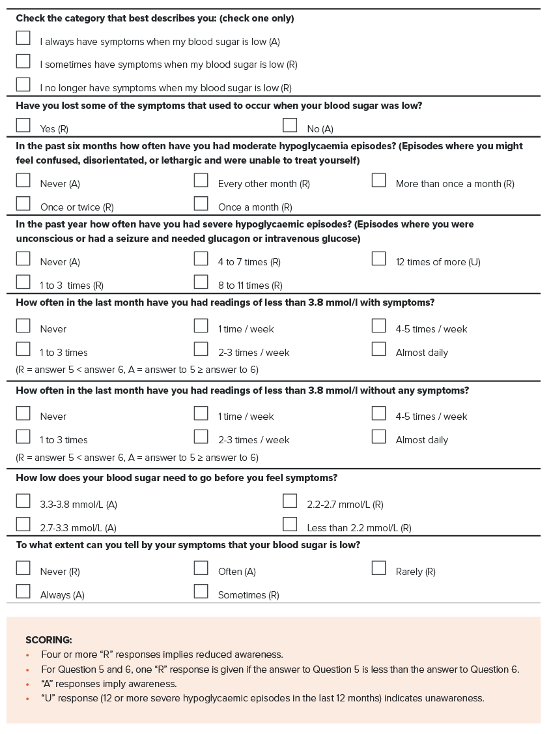

Comorbidities and end-organ complications
Assessment and management of comorbidities is an important aspect of managing people with diabetes with respect to their fitness for Safety Critical Work. This includes but is not limited to the following.
- Vision – Visual acuity should be tested annually. Retinal screening should be undertaken every second year if there is no retinopathy, or more frequently if at high risk. Visual field testing is not required unless clinically indicated. Refer to Section 4.13. Vision and eye disorders.
- Neuropathy and foot care – Although it can be difficult to be prescriptive about neuropathy in the context of Safety Critical Work, it is important that the severity of the condition is assessed. Adequate sensation is required for the operation of foot controls and adequate stability is necessary for walking on ballast, climbing in and out of trains, and so on (refer to Sections 4.6. Neurological conditions: general and dementia, 4.7. Neurological conditions: seizures and epilepsy and 4.8. Neurological conditions: other and 4.5. Musculoskeletal disorders).
- Sleep apnoea – Sleep apnoea is a common comorbidity affecting many people with type 2 diabetes and has substantial implications for rail safety. The treating health professional should be alert to potential signs (for example, BMI greater than 35, neck circumference greater than or equal to 40cm) and symptoms, and apply tests such as the STOP-Bang questionnaire and Epworth Sleepiness Scale as appropriate (refer to Section 4.11. Sleep disorders).
- Cardiovascular – Diabetes is an important risk factor in assessing the cardiac risk level (refer to Section 4.2. Cardiovascular conditions).
Additional information on the use, administration and scoring of the Clarke questionnaire is available in Section 6.1.1. Clarke hypoglycaemia awareness questionnaireonnaire.

4.3.3. Fitness for duty criteria for Safety Critical Workers
Fitness for duty criteria are outlined in Table 11.
It is important that health professionals familiarise themselves with both the general information above and the tabulated fitness for duty criteria before assessing a person’s fitness for duty.

Table 11. Diabetes: Fitness for duty criteria for Safety Critical Workers
Condition | Criteria
Screening for diabetes | Category 1 Safety Critical Workers  Diabetes may be diagnosed on history or on HbA1c testing on non-fasting blood (refer to Section 4.3.2. General assessment and management guidelines for screening process).  - If HbA1c is confirmed as equal to or greater than 48 mmol/mol (6.5%) regard as having diabetes and manage as below.  Category 2 Safety Critical Workers  Diagnosis of diabetes is by self-report via the Health Questionnaire and urine glucose test. A person with a positive urine screen should be referred to their general practitioner and categorised Fit for Duty Subject to Review. If diabetes is confirmed manage as below.
Diabetes controlled by diet and exercise alone | Category 1 and Category 2 Safety Critical Workers  A person with diabetes controlled by diet and exercise alone may perform Safety Critical Work without restriction. More frequent reviews may not be necessary.  They should be reviewed by their treating doctor periodically regarding progression of diabetes. The Authorised Health Professional may determine fitness for duty at Periodic Health Assessment based on HbA1c and clinical assessment. They may request a report from the treating doctor.  The worker should be instructed to request a Triggered Health Assessment if their condition deteriorates or their treatment changes.
Diabetes treated by glucose-lowering agents other than insulin (oral agents and other agents, e.g., injectable) | Category 1 and Category 2 Safety Critical Workers  A person is not Fit for Duty Unconditional:  - if the person has non-insulin-treated diabetes mellitus and is being treated with glucose-lowering agents other than insulin.  Fit for Duty Subject to Review may be determined, subject to at least annual review*, taking into account the nature of the work and information provided by a specialist (endocrinologist or consultant physician specialising in diabetes)* on whether the following criteria are met:  - the condition is satisfactorily controlled (refer to Section 4.3.2. General assessment and management guidelines) and the person is compliant with treatment; and  - there is no history of a severe hypoglycaemic event during recent years as assessed by the specialist; and  - the person experiences early warning symptoms (awareness) of hypoglycaemia (refer to Section 4.3.2. General assessment and management guidelines); and  - the person is following a treatment regimen that minimises the risk of hypoglycaemia; and  - there is an absence of end-organ effects that may affect working as per the Standard.  * Following are exceptions to the above requirements, including review periods and specialist review  For workers treated with metformin alone:  - the initial determination of fitness for duty may be made based on a report from the treating doctor or general practitioner (specialist report not required).  - if the person’s diabetes is satisfactorily controlled, subsequent reviews may be conducted by the Authorised Health Professional based on HbA1c.  - the Authorised Health Professional may recommend an appropriate review period (less frequently than annual review) if the person’s diabetes is satisfactorily controlled.  For workers treated with other oral agents or injectables other than insulin:  - the initial determination of fitness for duty must be made based on a report from a specialist (endocrinologist or consultant physician specialising in diabetes).  subsequently, a report from the treating general practitioner may be acceptable where a worker has demonstrated a significant period of satisfactory control.
Insulin-treated diabetes | Category 1 and Category 2 Safety Critical Workers  A person is not Fit for Duty Unconditional:  - if the person has insulin-treated diabetes.  Fit for Duty Subject to Review may be considered, taking into account the nature of the work and information provided by a specialist in endocrinology or diabetes on whether the following criteria are met, subject to at least annual review:  - the condition is satisfactorily controlled (refer to Section 4.3.2. General assessment and management guidelines) and the person is adherent with treatment; and  - there is no history of a severe hypoglycaemic event in the last 12 months as assessed by the specialist; and  - the person experiences early warning symptoms (awareness) of hypoglycaemia (refer to Section 4.3.2. General assessment and management guidelines); and  - the person is following a treatment regimen that minimises the risk of hypoglycaemia; and  - there is an absence of end-organ effects that may affect working as per the Standard.

Temporary illnesses. The Standard does not deal with the many conditions that may affect health on a short-to-medium-term basis and for which a Safety Critical Worker may be referred for assessment regarding fitness to resume duty. Clinical judgement is usually required on a case-by-case basis, although the text in each section gives some advice on the clinical issues to be considered.
Undifferentiated illness. A Safety Critical Worker may present with symptoms that could have implications for their job, but the diagnosis is not clear. Referral and investigation of the symptoms will mean that there is a period of uncertainty before a definitive diagnosis is made, and before the worker and employer can be confidently advised. Each situation will need to be assessed individually, with due consideration being given to the probability of a serious disease that will affect Safety Critical Work. Generally, workers presenting with symptoms of a potentially serious nature should be categorised as Temporarily Unfit for Duty until their condition can be adequately assessed. However, they may be suitable for alternative duties, including duties at a lower risk category (for example, Category 2 or Category 3). Workers who are fit to continue work while being investigated should be categorised as Fit for Duty Subject to Review.
Specialist review. The Standard generally requires Safety Critical Workers who are assessed as Fit for Duty Subject to Review to be seen by a specialist leading up to their review appointment with the Authorised Health Professional. Exceptions are specifically described in the Standard where appropriate.

References and further reading – Diabetes
Australian Diabetes Society Position Statement (2023) Medical Certification of Persons with Insulin-treated Diabetes in the Aviation Industry.
Living Evidence for Diabetes Consortium (2020) Australian Evidence-based Clinical Guidelines for Diabetes.
Australian Diabetes Society, Royal College of Pathologists of Australasia, Australasian Association of Clinical Biochemists (2012) ‘The role of HbA1c in the diagnosis of diabetes mellitus in Australia’, The Medical Journal of Australia, 197(4):220-1.
Australian Type 1 Diabetes Guidelines Expert Advisory Group (2011) National evidence based clinical care guidelines for type 1 diabetes in children, adolescents, and adults.
Austroads Ltd and NTC (2022) Assessing Fitness to Drive 2022: for commercial and private vehicle drivers.
Charlton JL, Di Stefano M, Dow J, Rapoport MJ, O’Neill D, Odell M, Darzins P and Koppel S (2021) Influence of chronic illness on crash involvement of motor vehicle drivers: 3rd Edition, Monash University Accident Research Centre.
Clarke WL, Cox DJ, Gonder-Frederick LA, Julian D, Schlundt D and Polonsky W (1995) ‘Reduced awareness of hypoglycemia in adults with IDDM. A prospective study of hypoglycemic frequency and associated symptoms’, Diabetes Care, 18(4):517-22.
Cox DJ, Ford D, Gonder-Frederick L, Clarke W, Mazze R, Weinger K and Ritterband L (2009) ‘Driving mishaps among individuals with type 1 diabetes: a prospective study’, Diabetes Care, 32(12):2177-80.
d’Emden M (2014) ‘Glycated haemoglobin for the diagnosis of diabetes’, Australian Prescriber, 37:98–100.
Geddes J, Wright RJ, Zammitt NN, Deary IJ and Frier BM (2007) ‘An evaluation of methods of assessing impaired awareness of hypoglycemia in type 1 diabetes’, Diabetes Care, 30:1868-70.
Høi-Hansen T, Pedersen-Bjergaard U and Thorsteinsson B (2010) ‘Classification of hypoglycemia awareness in people with type 1 diabetes in clinical practice’, Journal of Diabetes and its Complications, 24:392-7.
Redelmeier DA, Kenshole AB and Ray JG (2009) ‘Motor vehicle crashes in diabetic patients with tight glycemic control: a population-based case control analysis’, PLOS Medicine, 6(12):e1000192.
Royal Australian College of General Practitioners (2020) Management of type 2 diabetes: a handbook for general practice.
Schopman JE, Geddes J and Frier BM (2010) ‘Prevalence of impaired awareness of hypoglycaemia and frequency of hypoglycaemia in insulin-treated type 2 diabetes’, Diabetes Research and Clinical Practice, 87(1):64-8.

4.4 Hearing
(Refer also to Section 4.8. Neurological conditions: other)
Important
The Standard should be applied to Category 1 and Category 2 Safety Critical Workers based on a risk assessment of their safety critical tasks (refer to Section 2.4.6. Step 6: Identify task-specific health requirements).
The Standard assumes alignment with the principles outlined in the Rail Industry Safety and Standards Board (RISSB) Code of Practice - Safety Critical Communications (2021) and voluntary protocols in the RISSB Safety Critical Communications Guideline (2018), including the use of closed-loop communication.
The Standard is designed to identify and manage workers with hearing loss that may affect safety on the network and should be distinguished from audiometric monitoring required for workers who frequently use personal hearing protectors as a control measure for noise that exceeds the exposure standard (background noise greater than 85 dB (averaged over 8 hours), or any sound greater than 140 dB). The interface between these programs should, however, be managed by the rail transport operator and, as appropriate, by the examining Authorised Health Professional, to optimise hearing conservation.
Workers who work around the track and who require hearing only for their own safety should meet the criteria as set out for Track Safety Health Assessment (Part 5 of the Standard). However, track workers who wear personal protective equipment to protect themselves from the noise of machinery cannot be expected to hear warning sounds such as train horns. They should be under the immediate supervision of a team leader who directs them to stop work and clear the track when appropriate.

4.4.1 Definitions of hearing loss and impacts on hearing experience
The World Health Organization (WHO) has established an international grading system for hearing loss, which defines levels of hearing loss in terms of hearing thresholds, as well as in terms of the likely functional impacts on hearing experience (refer to Table 12).
The validated system defines moderate (disabling) hearing loss as averaged hearing thresholds at 500 Hz, 1000 Hz, 2000 Hz and 4000 Hz in the better hearing ear of 35 dB or greater, and ‘mild’ hearing loss as hearing thresholds between 20 dB and 34 dB.
It also highlights that hearing loss presents differently in quiet and noisy environments. For example, while mild hearing loss typically has little impact on speech understanding in quiet environments, a person with mild hearing loss may have difficulty following conversation in noisy environments. This is a consideration for the assessment and management of rail safety workers who are required to hear and respond to safety critical information in noisy environments.
The WHO system defines a noisy environment based on standard speech discrimination in noise testing (60 dB). This is materially different to the definition of what comprises a noisy working environment, which is based on the daily noise dose and the nature of the work. According to Safe Work Australia, ideally, workplace noise levels should be lower than 50 dB if the work involves high concentration or significant amounts of conversation, and lower than 70 dB, if the work is routine, fast-paced and demands attentiveness and the ability to verbally communicate with others. This also differs from the definition of noise levels requiring hearing conservation programs and hearing protection under various jurisdictional work health and safety regulations.
For the purposes of the Standard and based on expert advice, a ‘noisy’ environment is considered one in which the noise level is greater than 60 dB consistent with the WHO recommendations.
Table 12. Grades of hearing loss and related hearing experience
Grade | Hearing threshold* in better ear | Hearing experience in a QUIET environment for most adults | Hearing experience in a NOISY environment for most adults
Normal hearing | Less than 20 dB | Has no problem hearing sounds | Has no or minimal problem hearing sounds
Mild hearing loss | 20 dB to less than 35 dB | Has no problem hearing conversational speech | May have difficulty hearing conversational speech
Moderate hearing loss | 35 dB to less than 50 dB | May have difficulty hearing conversational speech | Has difficulty hearing and taking part in conversation
Severe hearing loss | 50 dB to less than 65 dB | Does not hear most conversational speech; may have difficulty hearing and understanding raised voices | Has extreme difficulty hearing speech and taking part in conversation
Profound hearing loss | 65 dB to less than 80 dB | Has extreme difficulty hearing raised voices | Cannot hear conversational speech
Complete or total hearing loss/deafness | 95 dB or greater | Cannot hear speech and most environmental sounds | Cannot hear speech and most environmental sounds
Unilateral | Less than 20 dB in the better and greater than 35 dB in the worse ear | May not have a problem unless sound is near the poorer hearing ear. May have difficulty in locating sounds | May have difficulty hearing speech and taking part in conversation and in locating sounds
* 'Hearing threshold' refers to the minimum sound intensity that an ear can detect as an average of values at 500 Hz, 1000 Hz, 2000 Hz and 4000 Hz in the better ear.
Source: World Health Organisation (2021) World Report on Hearing.

4.4.2. Relevance to Safety Critical Work

Effects of hearing loss on Safety Critical Work
Hearing loss may affect the ability to perform Safety Critical Work due to the inability to communicate or failure to hear sounds indicating a hazard. The ability to hear radio communication is particularly important for the communication of train orders, as well as for managing emergency situations.
Closed-loop communication, whereby the essence of a message is repeated back to the sender to ensure correct reception, is a key risk management approach and is recommended for use throughout the rail industry together with a range of other protocols designed to support safety critical communication., While the RISSB protocols in some settings are voluntary, the Standard assumes closed loop communication is in place. The ability to amplify radio communications may be an additional mitigating factor that should be considered in the risk assessment. It is the responsibility of the transport operator to provide suitable and appropriately maintained communication equipment.
The hearing requirements of safety critical tasks vary and are independent of whether the task is Category 1 or Category 2. For example:

Train drivers
Drivers need to be able to hear radio communication from central control, as well as alarm systems and track detonators. The background noise in train cabs varies but is commonly ‘noisy’. Binaural hearing is helpful in distinguishing speech in a noisy environment. Most radios in engine cabs can be amplified to help hearing against the background noise. Drivers also exit the cab from time to time and are required to be on track, and thus need to hear oncoming trains and other warning sounds.

Tram drivers
For tram drivers, the main safety requirement is to hear other traffic on the road, including emergency vehicles or other warning horns, bells or sirens, as well as signals from passengers regarding stopping. They may also be required to use radio communications.

Other Safety Critical Workers
Train controllers are required to hear and respond to spoken safety-critical information, generally in the quiet environment of a control room. Shunters are also required to hear and respond to spoken safety-critical information, but generally in a noisy environment. Any rail safety worker who is working in yards or near tracks (for example, shunters, flagmen) needs to be able to hear warning sounds such as train horns, whistles or verbal warnings for their own safety. The hearing requirements of Safety Critical Workers who are not required to hear speech but work around the track are outlined in Section 5.2. Hearing.

Setting the hearing thresholds for Safety Critical Workers and managing the interface with hearing conservation and worker health outcomes
The Standard and the fitness for duty criteria are focused on the identification and management of Safety Critical Workers whose hearing loss may present a risk on the rail network. In the absence of incident data relating to hearing loss, and considering the safety protocols for communication in the rail industry, the threshold at which these workers are considered unfit for duty is set at the mid-range of moderate hearing loss (greater than or equal to 40 dB), where an individual is likely to experience difficulty hearing conversation. It is acknowledged that some individuals are likely to have sought hearing support prior to reaching this level of hearing loss and may already wear hearing aids.
It is also acknowledged that workers required to hear speech in noise may experience difficulty in hearing communication at hearing loss thresholds below 40 dB. The Standard therefore identifies the management approach for lower levels of hearing loss, taking into consideration self-reported hearing impairment or difficulties with communication together with workplace reports.
In applying the Standard, consideration is also to be given to the need to support hearing conservation more generally, including minimising the potential impacts of uncorrected hearing impairment, which may affect fitness for duty in the long term, as well as quality of life more generally. The Standard therefore recommends that workers with any degree of hearing loss (hearing loss threshold greater than or equal to 20 dB) be counselled regarding hearing conservation measures, advised to discuss their hearing with their general practitioner and managed as per the rail transport operator’s hearing conservation program.

4.4.3. Risk assessment of Safety Critical Workers
All Safety Critical Work tasks should be assessed in relation to their individual hearing requirements. Rail transport operators should assess the hearing requirements based on the flow chart shown in Figure 20, and communicate these requirements to the Authorised Health Professional (refer also to Section 2.4.6. Step 6: Identify task-specific health requirements).
Figure 20. Hearing and rail Safety Critical Work—risk assessment
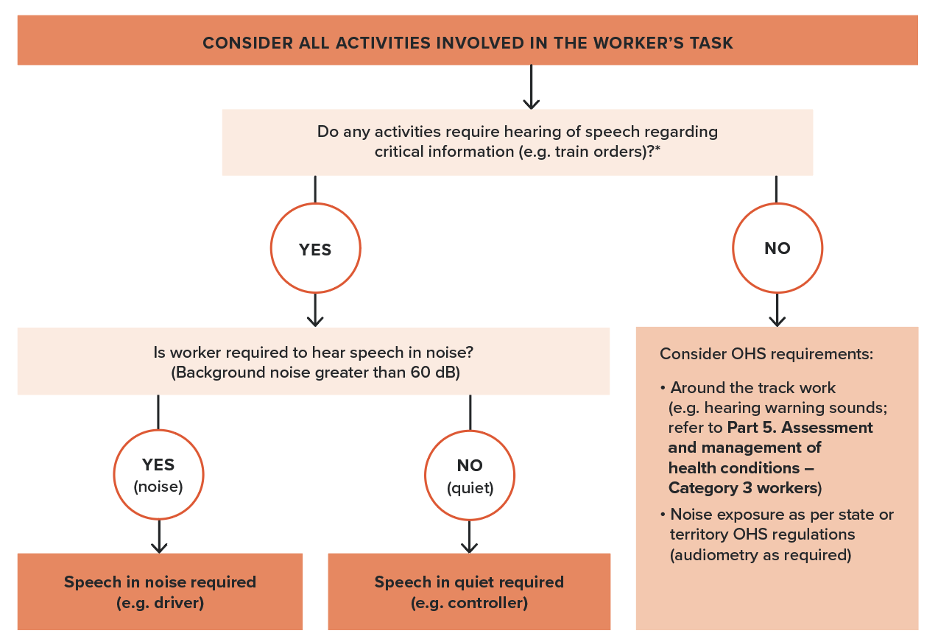
* The Standard assumes alignment with the principles and protocols outlined in the RISSB Code of Practice - Safety Critical Communications (2021) and any applicable voluntary protocols from the RISSB Safety Critical Communications Guideline (2018), including the use of closed-loop communication.
The risk assessment is based on a determination of whether the task requires ‘hearing speech in quiet’, which occurs where hearing takes place in a quiet background (typically indoors such as in a control room); or ‘hearing speech in noise’ which occurs where hearing of safety critical speech is required against a continuously or intermittently noisy background (60 dB or more), for example, typically drivers in a train cab, or shunters, site controllers, flagmen, and so on.
Category 1 or Category 2 Safety Critical Workers who are not required to hear speech regarding safety-critical information but are required to work around the track should have their hearing assessed and managed as per the Standards for Category 3 workers (Section 5.2. Hearing).

4.4.4. General assessment and management guidelines
The requirements for assessment of Safety Critical Workers are summarised in Figure 21.

Initial assessment (Pre-placement and Periodic Health Assessments) – all workers who are required to hear speech
All Safety Critical Workers who are required to hear speech, whether in quiet or noise, should be screened at Pre-placement and Periodic Health Assessments using pure tone audiometry. This includes those who already using hearing aids. Hearing aids should not be worn during pure tone audiometry.
Audiometry should be conducted at 500 Hz, 1000 Hz, 1500 Hz, 2000 Hz, 3000 Hz, 4000 Hz, 6000 Hz and 8000 Hz as per Australian Standard AS/ISO 8253:2009 Parts 1-3. The audiometry results at 500 Hz, 1000 Hz, 2000 Hz and 4000Hz in the better ear should be averaged to obtain the hearing loss threshold.
Remote testing
Teleaudiology may be utilised where in-person audiometry and audiological assessment is not available, such as in remote locations, and where an appropriate provider of such services is able to be accessed. Audiology Australia has developed guidelines for hearing health care practitioners to support safe and effective delivery of hearing services through teleaudiology, including pure tone audiometry, testing for hearing aid users and digit in noise testing.
In addition to audiometry, workers are required to self-declare via the Health Questionnaire both:
- whether they have had any workplace incidents
- whether they:
  - have hearing loss or deafness
  - have tinnitus sufficient to affect their hearing
  - have had an ear operation
  - are using a hearing aid.
The rail transport operator may also provide a report in relation to incidents or other problems related to communication at work.
The outcomes of the assessment should be managed based on a consideration of the audiometry results, whether the person currently wears hearing aids, self-reported difficulties with hearing or communication and workplace reports as follows (refer to Figure 21).

Figure 21. Initial hearing assessment for Safety Critical Work
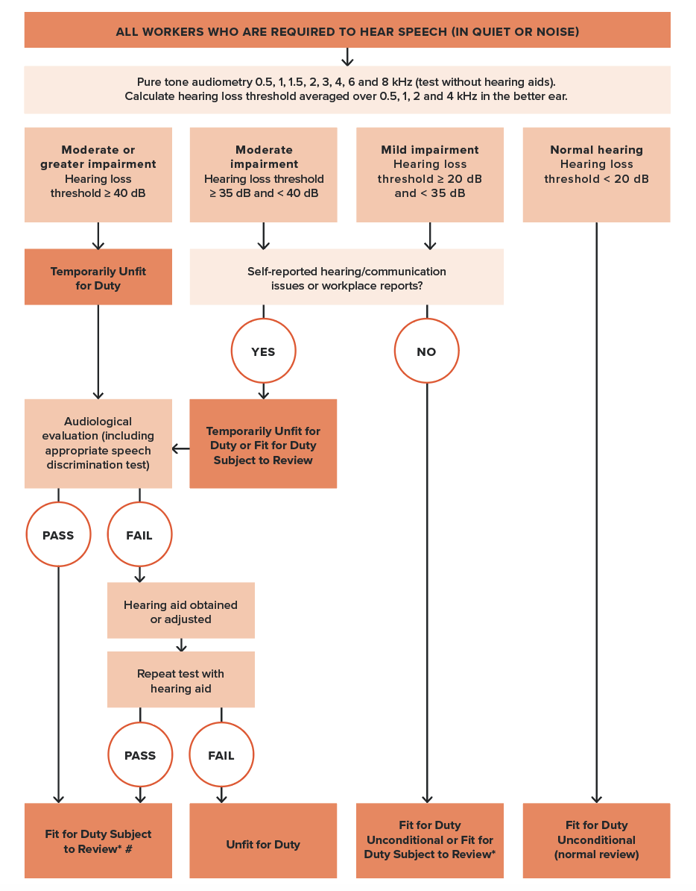
* Workers with any level of hearing loss should be managed according to rail transport operator’s hearing conservation program.
# Workers must wear prescribed hearing aids while undertaking Safety Critical Work.

For workers not currently wearing hearing aids:
- Hearing loss threshold greater than or equal to 40 dB
  - Workers with an averaged hearing loss threshold of 40 dB or greater who do not currently wear hearing aids should be referred for audiological evaluation including the appropriate speech discrimination test (see below).
  - The worker should be categorised Temporarily Unfit for Duty while awaiting this evaluation unless they have previously passed a speech discrimination test and their hearing threshold has not declined by more than 5 dB (indicated by a 5 dB or more additional loss measured by the four-frequency average), in which case they may be categorised Fit for Duty Subject to Review.
- Hearing loss threshold of 35 dB to less than 40 dB
  - Workers with an averaged hearing loss threshold of 35 dB to less than 40 dB who do not report hearing loss issues and for whom workplace reports do not identify problems with communication may be categorised Fit for Duty Subject to Review. They may be reviewed in line with their rail transport operator’s hearing conservation program or at the normal age-based review periodicity with a specific indicator for serial assessment of their hearing.
  - Workers who identify problems with hearing or communication or for whom workplace reports indicate an issue should be referred for further audiological evaluation, including speech discrimination testing as appropriate (see below). They may be categorised Fit for Duty Subject to Review or Temporarily Unfit for Duty while awaiting results, based on the impact to safety-critical communication as assessed by the Authorised Health Professional.
- Hearing loss threshold of 20dB to less than 35 dB
  - Workers with an average hearing loss threshold of 20 dB to less than 35 dB who do not report hearing loss issues and for whom workplace reports do not identify problems with communication may be categorised Fit for Duty Unconditional.
  - If the worker identifies problems with hearing at work or there are concerns regarding communication in the workplace, the Authorised Health Professional should refer the worker for further audiological evaluation including speech discrimination testing as required (see overleaf). The worker may be categorised Fit for Duty Subject to Review while awaiting test results.
- Hearing loss threshold less than 20 dB
  - Workers with an average hearing loss threshold of less than 20dB may be categorised Fit for Duty Unconditional and subject to the usual age-based periodic review in relation to their hearing.
All workers with any degree of hearing loss (hearing loss threshold greater than 20 dB) should be counselled regarding hearing conservation measures and advised to discuss their hearing with their general practitioner. Concerns regarding the impact of workplace exposure to noise should be communicated to the rail transport operator in the Health Assessment Report (that is, Part B of the Request and Report Form) so that the worker can be managed under their hearing conservation program.
Workers who are assessed as requiring further audiological evaluation and who do not currently wear hearing aids should be referred to an audiologist, audiometrist or ear, nose and throat (ENT) specialist.
The evaluation should include:
- diagnostic test of hearing sensitivity
- conduct of a speech in quiet or noise test, as required and as determined by the risk assessment, and according to the protocols (Box 1. Speech discrimination in quiet test, Box 2. Speech discrimination in noise test) overleaf (this is mandatory for workers with hearing loss thresholds of 40 dB or above)
- an evaluation of whether mitigating strategies such as radio amplification and closed loop communication may enable the worker to undertake safety-critical communications consistently and effectively
- an evaluation of whether hearing aids would enable the worker to meet the hearing criteria and an assessment of whether the aids are suitable for work in the rail environment.
If a worker has previously passed the relevant speech discrimination test, a repeat test is only required if their base audiometry has worsened (indicated by a 5 dB or more additional loss measured by the four-frequency average).
The audiologist or ENT report should guide treatment (refer Hearing aids below) recommendations for the individual (refer Hearing aids below) and inform ongoing monitoring by the rail transport operator. The Authorised Health Professional should recommend a review period, based on the audiologist or ENT report and taking into consideration the degree of hearing loss and likely progression.

Workers who currently wear hearing aids
Safety Critical Workers with established hearing loss of greater than or equal to 40 dB and who already have hearing aids will be required to undergo speech in noise or quiet testing at their initial assessment (for example, Pre-placement or change of risk category). Speech discrimination testing for hearing loss levels below 40 dB should be conducted on the advice of the audiologist or ENT specialist or where the history, or workplace reports, indicate difficulty with communication.
For subsequent reviews, speech in noise or quiet will only be required if their base audiometry has worsened (indicated by a 5 dB or more additional loss measured by the four-frequency average). They should undertake the testing while wearing the hearing aids and the testing should reflect the usual working environment. The testing should be conducted with hearing aid features active.
Note: Testing of speech in noise for workers who wear hearing aids requires the audiologist to have calibrated, free field speech in noise testing facilities. This should be ascertained before a worker attends a clinic for testing. See also considerations for remote access to testing below.
Workers who meet the criteria with hearing aids should undergo periodic review of their hearing and the function of their hearing aid (Fit for Duty Subject to Review). Frequency of review should be determined based on the nature and degree of hearing loss, the potential impact of noise exposure and the advice of the treating audiologist. Generally, hearing aids may be expected to have a five-year life span and can accommodate a degree of progression in hearing loss with reprogramming by the treating audiologist.
Box 1. Speech discrimination in quiet test
- Speech discrimination in quiet is assessed using phonemically balanced monosyllabic word lists (PBMs). These are 25-word lists, plus 5 practice items.
- As the work environment involves binaural listening to speech in quiet, the test should be binaural free-field PBMs.
- The presentation level should be 70 dB via a calibrated single speaker stationed at 0 degrees azimuth with the candidate seated at approximately one metre from the speaker.
- Scoring for PBMs is calculated as: score = percentage words correctly identified, excluding practice items. Therefore, the number of words correct multiplied by 4 = percentage correct.
- A pass score should be set at 70 per cent of words accurately identified. The Standard assumes closed-loop communication is practised.
- In jobs where use of hearing aids is permitted, they may be used as long as they are self-contained and fit within or behind the ear.
- Workers using hearing aids must provide evidence from an accredited audiologist using functional-gain or real-ear measurements that the hearing aids meet the stipulated manufacturer’s standards.
- Workers using a hearing aid must have aided free-field speech discrimination testing in quiet.
- Workers should be categorised as Fit for Duty Subject to Review and reviewed at periods determined by the prognosis of the underlying pathology.

Box 2. Speech discrimination in noise test
- Speech discrimination ability in noise will be assessed using phonemically balanced monosyllabic word lists in noise (PBNs). These are 50-word lists. PBN wordlists are embedded in noise (at a +10 signal:noise ratio, that is 70:60 dB for a presentation level of 70 dB).
- The work environment involves binaural listening to speech in background noise; therefore, the test should be binaural free-field PBNs.
- The presentation level should be 70 dB via a calibrated single speaker stationed at 0 degrees azimuth with the candidate seated at approximately 1 metre from the speaker.
- Scoring for PBNs is calculated as: score = percentage words correctly identified. Therefore, number of words correct multiplied by 2 = percentage correct.
- A pass score should be set at 50 per cent of words accurately identified. The Standard assumes closed-loop communication is practised.
- In jobs where use of hearing aids is permitted, they may be used as long as they are self-contained and fit within or behind the ear (refer to Hearing aids).
- Workers using hearing aids must provide evidence from an accredited audiologist using functional-gain or real-ear measurements that the hearing aids meet the stipulated manufacturer’s standards.
- Workers using a hearing aid must have aided free-field speech discrimination testing in noise.
- Workers should be categorised Fit for Duty Subject to Review and reviewed at periods determined by the prognosis of the underlying pathology.

Hearing aids
Note: Hearing technology is a rapidly evolving field. Advice about the options and suitability of hearing aids for Safety Critical Workers must be sought from an audiologist who is familiar with the rail transport environment and the hearing requirements of the specific worker. The worker should be educated about correct use.
The prescription and fitting of hearing aids for Safety Critical Workers should be undertaken by the audiologist with due consideration to the individual needs of the worker, the safety critical nature of their work and the nature of the working environment.
Use in noisy environments or where warning sounds need to be heard warrants particular consideration. An initial report from the audiologist should demonstrate specific understanding of the circumstances of use and the mitigation of any risks to the Safety Critical Worker or the rail environment.
Hearing aids worn in quiet surroundings (for example, by a train controller) require no specific characteristics. They should be set for optimal hearing in the relevant environment.
Workers who use hearing aids should be advised of the following:
- They should wear the aid at all times at the recommended settings.
- They should report the development of any medical condition that may temporarily worsen hearing or reduce efficient function of the hearing aid (for example, severe middle ear infection), or if a hearing aid fails or is lost. Monaural aid use, when binaural hearing loss is present, results in reduced ability to localise warning sounds and discriminate speech against background noise.
- They should have their hearing assessed and their hearing aid serviced annually.
- In the event of replacement or upgrading of hearing aids, or further deterioration in hearing, speech discrimination in noise or quiet should be re-examined.
- They are encouraged to carry a supply of batteries or ensure their hearing aid is recharged overnight.

Cochlear implants
Workers with cochlear implants should be assessed on an individual basis by an ENT specialist or audiologist, who should consider the:
- characteristics of the implant, including the risk of sudden device failure
- nature of the relevant background noise
- nature of the duties of Safety Critical Workers, including the need for efficient and reliable use of communication devices, such as mobile phones and radio communication devices, and the need to reliably detect emergency alarms against background noise.
A speech discrimination test in noise or quiet, as appropriate to their job risk assessment, must be passed.
Please note that the presence of a cochlear implant may be a contraindication to some rail industry jobs working with or in close proximity to high-voltage power supplies and overhead wiring, where strong magnetic fields and induced currents may present a risk to workers.

4.4.5. Fitness for duty criteria for Safety Critical Workers
Fitness for duty criteria are outlined in Table 13.
It is important that health professionals familiarise themselves with both the general information above and the tabulated fitness for duty criteria before making an assessment of a person’s fitness for duty.
Table 13. Hearing: Fitness for duty criteria for Safety Critical Workers
Condition | Criteria
Hearing  Safety Critical Workers required to hear speech in quiet or in noise | Compliance with the Standard should be initially assessed by audiometry without hearing aids.  Safety Critical Workers who are required to hear speech, whether in quiet or noise, are not fit for duty:  - if hearing loss is ≥ 40 dB averaged over 0.5 kHz, 1 kHz, 2 kHz and 4 kHz in the better ear.  Fit for Duty Subject to Review may be determined, subject to periodic review, taking into account the opinion of an audiologist or ENT specialist and the nature of the work:  - if the person passes an appropriate speech discrimination test with or without hearing aids.  If hearing aids are required to meet the Standard, they must be worn while working.  The use of cochlear implants should be assessed on an individual basis by an ENT specialist or audiologist. An appropriate speech discrimination test must be passed.  Safety Critical Workers with hearing loss less than 40 dB should be managed as per the text and Figure 21, depending on self-reported hearing difficulties, workplace reports and audiological evaluation as required.
Hearing—tram drivers  If hearing speech is required, tram drivers should be managed as per above | Compliance with the Standard should be initially assessed by audiometry without hearing aids.  Tram drivers are not fit for duty:  - if hearing loss is ≥ 40 dB averaged over 0.5 kHz, 1 kHz, 2 kHz and 4 kHz in the better ear.  Fit for Duty Subject to Review may be determined, subject to periodic review, taking into account the opinion of an audiologist or ENT specialist and the nature of the work:  - if the person meets the Standard with a hearing aid.  If hearing aids are required to meet the Standard, they must be worn while working.  The use of cochlear implants should be assessed on an individual basis by an audiologist or ENT specialist.  Workers with hearing loss less than 40 dB should be managed as per the text and Figure 21, depending on self-reported hearing difficulties, workplace reports and audiological evaluation as required.

Temporary illnesses. The Standard does not deal with the many conditions that may affect health on a short-to-medium-term basis and for which a Safety Critical Worker may be referred for assessment regarding fitness to resume duty. Clinical judgement is usually required on a case-by-case basis, although the text in each section gives some advice on the clinical issues to be considered.
Undifferentiated illness. A Safety Critical Worker may present with symptoms that could have implications for their job, but the diagnosis is not clear. Referral and investigation of the symptoms will mean that there is a period of uncertainty before a definitive diagnosis is made, and before the worker and employer can be confidently advised. Each situation will need to be assessed individually, with due consideration being given to the probability of a serious disease that will affect Safety Critical Work. Generally, workers presenting with symptoms of a potentially serious nature should be categorised as Temporarily Unfit for Duty until their condition can be adequately assessed. However, they may be suitable for alternative duties, including duties at a lower risk category (for example, Category 2 or Category 3). Workers who are fit to continue work while being investigated should be categorised as Fit for Duty Subject to Review.
Specialist review. The Standard generally requires Safety Critical Workers who are assessed as Fit for Duty Subject to Review to be seen by a specialist leading up to their review appointment with the Authorised Health Professional. Exceptions are specifically described in the Standard where appropriate.

References and further reading – Hearing
Audiology Australia (2022) Teleaudiology Guidelines.
Austroads Ltd and NTC (2022) Assessing Fitness to Drive 2022: for commercial and private vehicle drivers.
Hearing Care Industry Association (2017) The social and economic cost of hearing loss in Australia.
Dineen R (2007) Hearing standards for rail safety workers: a report to the National Transport Commission.
Gates GA, Schmid P, Kujawa SG, Nam B and D'Agostino R (2000) ‘Longitudinal threshold changes in older men with audiometric notches’, Hearing Research, 141(1-2):220-8.
Humes LE (2018) ‘The World Health Organization’s hearing-impairment grading system: an evaluation for unaided communication in age-related hearing loss’, The International Journal of Audiology.
Olusanya BO, Neumann KJ, and Saunders JE (2014) ‘The Global Burden of Disabling Hearing Impairment: A Call to Action’, Bulletin of the World Health Organization, 92(5):367–373.
RISSB (2018) Safety Critical Communications Guideline.
RISSB (2021) Code of Practice - Safety Critical Communications.
Safe Work Australia (2020) Managing noise and preventing hearing loss at work: Code of Practice.
World Health Organization (2021) World report on hearing.

4.5. Musculoskeletal disorders

4.5.1. Relevance to Safety Critical Work
Musculoskeletal disorders may affect the ability to perform Safety Critical Work due to the inability to carry out the prescribed work tasks or respond appropriately to emergency situations, thus placing the network at risk.
Chronic impairment of musculoskeletal functions may arise from numerous disorders and trauma (for example, amputations, arthritis, ankylosis, deformities and chronic lower back pain). Issues related to muscle tone, spasm, sitting tolerance and endurance, as well as the effects of medications, may also need to be considered (refer to Section 3.4.8. Drugs and rail safety work).
Acute and chronic pain associated with musculoskeletal disorders may also impact the cognitive aspects of Safety Critical Work, with evidence that it affects attention and concentration, as well as emotional responses. This is an important consideration for the overall management of Safety Critical Workers with musculoskeletal disorders.
The Standard is not designed for meeting a duty of care regarding the work health safety of workers.

4.5.2. Risk assessment of Safety Critical Workers
It is not possible to make generic statements regarding the musculoskeletal capacity required for Safety Critical Work because the nature of such work can vary widely. All jobs, whether Category 1 or Category 2, need to be assessed regarding their inherent requirements and hence the necessary musculoskeletal capacities to do them.
Most Category 1 Safety Critical Workers require soundness of limbs, neck, back and good balance. For example:
- Train driving requires good musculoskeletal capacity to:
  - sit and drive the train using the arms and legs
  - walk about the train on uneven track and ballast. A fault in a wagon may involve sustained effort for it to be shunted out of the train
  - join heavy couplings, bend over to check bogies and braking systems
  - enter and exit the cab to and from the ground routinely and in an emergency. In an emergency, there may be quite a drop between the lowest step and the ground
  - move rapidly from the path of an oncoming train
- Protection officer duties require good musculoskeletal capacity to:
  - move quickly over uneven track and ballast
  - place detonators quickly and accurately on the track
  - signal to trains using hand signals, lamps and flags
  - move rapidly from the path of an oncoming train
- Shunting requires good musculoskeletal capacity to:
  - move over uneven track and ballast
  - rapidly board or alight from trucks or carriages
  - open or close stiff, large coupling mechanisms
  - switch points
  - move rapidly from the path of an oncoming train
- Train controlling requires only limited musculoskeletal capacity:
  - controllers typically work in an indoor environment and do not have to access the track
  - to work with computer screens and keyboards, paper records and telephones
- Tram driving requires good musculoskeletal capacity to:
  - sit for long periods
  - operate the master controller board and alight from the tram for operational purposes, including emergency situations.

4.5.3. General assessment and management guidelines
The aim of the health assessment is to detect those Safety Critical Workers who may have difficulty in performing their duties due to a musculoskeletal condition, or who may be at increased risk of injury, and to identify those workers who would benefit from job modification. The assessment should therefore be individualised based on their defined functional requirements, together with the associated impacts of their condition and treatment.
The examining doctor should take a thorough history, noting information such as:
- the person’s day-to-day functional capacity
- their performance in other roles
- their history of injuries, including the circumstances of any injuries, the severity and recovery time.
The examination should evaluate the following in regard to the anticipated tasks as per risk assessment for the job:
- gait—the ability to walk on flat and uneven surfaces
- spine—the strength and range of movement of the cervical and lumbar–sacral spine
- limbs—the power and range of movement of the upper and lower limbs
- balance—the person’s sense of balance, which may be assessed using the Romberg test
- pain—the presence of musculoskeletal pain that may impede movement, concentration or attention and its adequacy of treatment
- the potential impairment from prescription medications balanced against the worker’s improvement in function and health more generally
- the likely progression of the condition or disability
- the person’s current use of adaptive strategies and equipment, including impacts on functionality and outcomes such as endurance on safety critical task
- exacerbating and relieving factors and risk of injury or exacerbation
- the impact of comorbidities and age-related change.
In some cases, the treating doctor may also be contacted to discuss the worker’s condition and fitness.
The clinical examination may need to be supplemented by a functional assessment or practical demonstration that the worker can meet particular requirements (refer to Section 3.5.1. Functional and practical assessments). Such practical assessment tasks cannot override the medical standards, they can only supplement the doctor’s decision about the ability to perform rail safety tasks where the Standard is imprecise.

Chronic pain associated with musculoskeletal disorders
Assessment and management of chronic pain should consider the functional and cognitive impacts on Safety Critical Work. This includes whether pain or pain treatments are likely to affect attention, concentration or decision-making, or the person’s ability to respond appropriately in the working environment. The functional and cognitive impacts may fluctuate. Refer also Section 3.4.8. Drugs and rail safety work.
Fitness for duty will depend on the demands of the task and whether these can be managed or modified. It will also depend on self-management and compensatory strategies and the worker’s insight into the impact of their chronic pain. A practical or functional assessment may assist in some cases to evaluate the impact of chronic pain on Safety Critical Work (refer to Section 3.5.1. Functional and practical assessments).

Job modification
Fit for Duty Subject to Job Modification may be determined (as a subcategory of Fit for Duty Subject to Review), taking into consideration the nature of the work (refer to Section 2.3. Standard reporting framework). However, modification to cabs and other equipment is usually impractical because operators may be expected to drive different trains on different shifts. The decision on whether a proposed job modification can be accommodated rests with the rail transport operator. A worksite visit or functional assessment may also be considered (refer to Section 3.5.1. Functional and practical assessments).

4.5.4. Fitness for duty criteria for Safety Critical Workers
Fitness for duty criteria for Safety Critical Workers are outlined in Table 14. It is not possible to detail in the Standard all the tasks of Safety Critical Workers and the musculoskeletal criteria to be met. The Authorised Health Professional should be familiar with the job, or at least be provided with a position description, task analysis or job dictionary so as to conduct the examination with insight when matching demands and musculoskeletal capacities, such as given in the examples above.
A rail transport operator may develop its own standards appropriate to the risk assessment of a job and with advice from an occupational physician. Such standards may incorporate functional assessments that are based on the job demands of the position in question.
It is important that health professionals familiarise themselves with both the general information above and the tabulated fitness for duty criteria before assessing a person’s fitness for duty.
Table 14. Musculoskeletal disorders: Fitness for duty criteria for Safety Critical Workers
Condition | Criteria
Musculoskeletal disorders | Category 1 and Category 2 Safety Critical Workers  A person is not Fit for Duty Unconditional:  - if lack of range of movement, pain, weakness, instability or another impairment from a musculoskeletal condition results in either of the following:  - inability to perform the inherent job requirements of the rail safety work in question  - increased risk of exacerbation of a pre-existing injury.  The person may be determined to be Fit for Duty Subject to Review, if, after taking into account the opinion of the treating doctor and the nature of the work:  - the condition can be adequately treated, and function can be restored; and  - treatments do not impair capacity for safe working.  Conditions that are stable, such as amputations, do not need to be reviewed more frequently than the usual Periodic Health Assessment.  The person may be determined Fit for Duty Subject to Review, taking into consideration the nature of the work. Recommendations for job modification may be made. It is the operator's decision as to whether any job modifications can be accommodated. A functional assessment or practical assessment at the workplace may also be considered.

Temporary illnesses. The Standard does not deal with the many conditions that may affect health on a short-to-medium-term basis and for which a Safety Critical Worker may be referred for assessment regarding fitness to resume duty. Clinical judgement is usually required on a case-by-case basis, although the text in each section gives some advice on the clinical issues to be considered.
Undifferentiated illness. A Safety Critical Worker may present with symptoms that could have implications for their job, but the diagnosis is not clear. Referral and investigation of the symptoms will mean that there is a period of uncertainty before a definitive diagnosis is made, and before the worker and employer can be confidently advised. Each situation will need to be assessed individually, with due consideration being given to the probability of a serious disease that will affect Safety Critical Work. Generally, workers presenting with symptoms of a potentially serious nature should be categorised as Temporarily Unfit for Duty until their condition can be adequately assessed. However, they may be suitable for alternative duties, including duties at a lower risk category (for example, Category 2 or Category 3). Workers who are fit to continue work while being investigated should be categorised as Fit for Duty Subject to Review.
Specialist review. The Standard generally requires Safety Critical Workers who are assessed as Fit for Duty Subject to Review to be seen by a specialist leading up to their review appointment with the Authorised Health Professional. Exceptions are specifically described in the Standard where appropriate.

References and further reading – Musculoskeletal disorders
Austroads Ltd and NTC (2022) Assessing Fitness to Drive 2022: for commercial and private vehicle drivers.
Charlton JL, Di Stefano M, Dow J, Rapoport MJ, O’Neill D, Odell M, Darzins P and Koppel S (2021) Influence of chronic illness on crash involvement of motor vehicle drivers: 3rd Edition, Monash University Accident Research Centre.
Vaezipour A, Oviedo-Trespalacios O, Horswill M, Rod JE, Andrews N, Johnston V and Delhomme P (2022) ‘Impact of chronic pain on driving behaviour: a systematic review’, Pain, 163(3):e401-e416.

4.6. Neurological conditions: general and dementia

4.6.1. Relevance to Safety Critical Work
Safety Critical Work requires a number of intact neurological functions in order to maintain ‘situational awareness’ and respond appropriately in an emergency situation. Depending on the job, these neurological functions may include:
- visuospatial perception
- insight
- judgement
- attention and concentration
- reaction time
- memory
- sensation
- muscle power (refer to Section 4.5. Musculoskeletal disorders)
- coordination
- balance
- vision (refer to Section 4.13. Vision and eye disorders).
Impairment of any of these capacities may be caused by neurological disorders and thus affect safe working ability. In addition to these deficits, some neurological conditions produce seizures.
This section provides guidance and fitness for duty criteria for the following conditions:
- dementia
- seizures and epilepsy (refer to Section 4.7. Neurological conditions: seizures and epilepsy)
- vestibular disorders (refer to Section 4.8. Neurological conditions: other)
- other neurological conditions (refer to Section 4.6. Neurological conditions: general and dementia), including:
  - unruptured intracranial aneurysms and other vascular malformations
  - cerebral palsy
  - head injury
  - neuromuscular disorders
  - Parkinson’s disease
  - multiple sclerosis
  - stroke
  - transient ischaemic attacks
  - subarachnoid haemorrhage
  - space-occupying lesions, including brain tumours.
The focus of this section is mainly on long-term or progressive disorders affecting safe working ability, but some guidance is also provided regarding short-term fitness to work—for example, following a head injury.
Neurodevelopmental disorders are addressed separately in Section 4.9. Neurodevelopmental disorders.
Where people experience musculoskeletal, visual or psychological symptoms, the relevant fitness for duty criteria should also be considered. Refer to Section 4.5. Musculoskeletal disorders, 4.10. Psychiatric conditions and 4.13. Vision and eye disorders.

4.6.2. Dementia
This section focuses on dementia, which —for the purposes of the Standard— is defined as a progressive deterioration of cognitive function due to degenerative conditions of the central nervous system.
Other causes of fluctuating or permanent cognitive impairment or delirium, such as hepatic, renal or respiratory failure, may be managed according to general principles. Substance misuse is covered in Section 4.12. Substance misuse and dependence.

Relevance to Safety Critical Work

Effects of dementia on Safety Critical Work
Dementia is characterised by significant loss of cognitive abilities such as memory capacity, psychomotor abilities, attention, visuospatial functions and executive functions, all of which are required for Safety Critical Work. The Standard is therefore applicable to workers performing Category 1 and Category 2 Safety Critical Work.
Dementia may arise due to numerous causes, including Alzheimer’s disease, Huntington’s disease, fronto-temporal dementia and vascular dementia. Alzheimer’s disease is the most common cause, accounting for 50 to 70 per cent of cases. It mainly affects people over the age of 70 and is of some relevance in the rail industry due to an ageing workforce. It may occur prematurely.
Dementia may affect safe working ability in a number of ways, including:
- memory loss
- limited concentration or ‘gaps’ in attention, such as failing to see or respond to signals (signals passed at danger)
- errors in judgement
- confusion when making choices
- poor decision making or problem solving
- poor insight and denial of deficits
- errors with navigation, including forgetting details of routes
- slowed reaction time, including failure to respond in a timely fashion to instructions
- poor hand-eye coordination.

Evidence of crash risk
Based on studies of road accidents, a diagnosis of dementia is associated with a moderately high risk of collision compared with matched controls.

Assessment
Dementia is most likely to become evident during a Triggered Health Assessment initiated by a rail transport operator in response to behavioural or performance issues or incidents observed in the workplace. Assessment of suspected dementia requires specialist referral.
The level of impairment varies widely; each person will experience a different pattern and timing of impairment as their condition progresses. This presents challenges for both diagnosis and management.
The following points may be of assistance in assessing a person:
- Work history – Have they been involved in any incidents? Have they been referred for assessment by a supervisor?
- Vision – Can they see things coming straight at them or from the sides? (Refer to Section 4.13. Vision and eye disorders).
- Hearing – Can they hear speech and warning sounds? (Refer to Section 4.4. Hearing)
- Reaction time – Can they respond to signals and train orders?
- Problem solving – Do they become upset and confused when more than one thing happens at the same time?
- Coordination – Have they become clumsy or started to walk differently because their coordination is affected?
- Praxis – Do they have difficulty using their hands and feet when asked to follow motor instructions?
- Alertness and perception – Are they aware and do they understand what is happening around them? Do they experience hallucinations or delusions?
- Insight – Are they aware of the effects of their dementia? Is there denial?
Because of the lack of insight and variable memory abilities associated with most dementia syndromes, the person may minimise or deny any difficulties with working. Workplace reports, and feedback from supervisors or co-workers may be a useful source of information regarding overall coping and safety decision making skills (refer to Figure 13).

Preclinical dementia
Preclinical dementia is increasingly being identified using modern diagnostic techniques. The dementia-related pathology is diagnosed in advance of the clinical manifestations of dementia itself, including symptoms that impair Safety Critical Work (for example, preclinical Alzheimer’s disease). A person diagnosed in this manner, who has no clinically significant symptoms of dementia, can be considered Fit for Duty Subject to Review to monitor disease progression and development of dementia symptoms.

Mild cognitive impairment
Mild cognitive impairment, which incorporates the prodromal stage of dementia, causes a slight but measurable decline in cognitive abilities, that is, a decline from baseline levels but the person is still within age norms. A Safety Critical Worker with this diagnosis can be categorised Fit for Duty Subject to Review and monitored accordingly if there are no existing safety or work performance concerns.

Fitness for duty criteria for Safety Critical Workers
Fitness for duty criteria are outlined in Table 15.
Due to the usually progressive nature of dementia, a person first diagnosed with suspected dementia should be categorised as Temporarily Unfit for Duty and referred for specialist assessment.
A Safety Critical Worker with a diagnosis of dementia will generally not meet the fitness for duty criteria (Permanently Unfit for Duty). In some situations, a classification of Fit for Duty Subject to Review may be determined subject to careful assessment by an appropriate specialist. Information relating to work performance and safety breaches or near misses, should also be considered.
It is important that health professionals familiarise themselves with both the general information above and the tabulated fitness for duty criteria before assessing a person’s fitness for duty.

Table 15. Dementia: Fitness for duty criteria for Safety Critical Workers
Condition | Criteria
Dementia (including preclinical and prodromal forms) | Category 1 and Category 2 Safety Critical Workers  A person is not Fit for Duty Unconditional:  - if the person has a diagnosis of dementia, including the preclinical, prodromal or mild cognitive impairment stages of the disease.  Fit for Duty Subject to Review may be determined, subject to at least annual review, taking into account:  - the nature of the work and workplace reports; and  - information provided by an appropriate specialist regarding the likely progression of the condition; and  - information provided by an appropriate specialist about the level of impairment of any of the following: visuospatial perception, insight, judgement, attention, reaction time or memory.

Temporary illnesses. The Standard does not deal with the many conditions that may affect health on a short-to-medium-term basis and for which a Safety Critical Worker may be referred for assessment regarding fitness to resume duty. Clinical judgement is usually required on a case-by-case basis, although the text in each section gives some advice on the clinical issues to be considered.
Undifferentiated illness. A Safety Critical Worker may present with symptoms that could have implications for their job, but the diagnosis is not clear. Referral and investigation of the symptoms will mean that there is a period of uncertainty before a definitive diagnosis is made, and before the worker and employer can be confidently advised. Each situation will need to be assessed individually, with due consideration being given to the probability of a serious disease that will affect Safety Critical Work. Generally, workers presenting with symptoms of a potentially serious nature should be categorised as Temporarily Unfit for Duty until their condition can be adequately assessed. However, they may be suitable for alternative duties, including duties at a lower risk category (for example, Category 2 or Category 3). Workers who are fit to continue work while being investigated should be categorised as Fit for Duty Subject to Review.
Specialist review. The Standard generally requires Safety Critical Workers who are assessed as Fit for Duty Subject to Review to be seen by a specialist leading up to their review appointment with the Authorised Health Professional. Exceptions are specifically described in the Standard where appropriate.

References and further reading – Dementia
Alzheimer’s Australia website, https://alzheimersresearch.org.au.
Austroads Ltd and NTC (2022) Assessing Fitness to Drive 2022: for commercial and private vehicle drivers.
Charlton JL, Di Stefano M, Dow J, Rapoport MJ, O’Neill D, Odell M, Darzins P and Koppel S (2021) Influence of chronic illness on crash involvement of motor vehicle drivers: 3rd Edition, Monash University Accident Research Centre.
Zoer I, Sluiter JK and Frings-Dresen MHW (2014) ‘Psychological work characteristics, psychological workload and associated psychological and cognitive requirements of train drivers’, Ergonomics, 57(10):1473-1487.

4.7. Neurological conditions: seizures and epilepsy
(Refer also to Sections 4.1. Blackouts, 4.2. Cardiovascular conditions and 4.3. Diabetes)

4.7.1. Relevance to Safety Critical Work

Effects of seizures on Safety Critical Work
Epilepsy refers to the tendency to experience recurrent seizures. Not all people who experience a seizure have epilepsy.
Seizures vary considerably, some being purely subjective experiences (for example, some focal seizures), but the majority involve some impairment of consciousness (for example, absence and complex partial seizures) or loss of voluntary control of the limbs (for example, focal motor and complex partial seizures). Convulsive (tonic–clonic) seizures may be generalised from onset or secondarily generalised with focal onset. Seizures associated with loss of awareness, even if brief or subtle, or loss of motor control, have the potential to impair the ability to perform both Category 1 and Category 2 Safety Critical Work.
The seizure-free periods outlined in the Standard are applicable to workers performing Category 1 Safety Critical Work. Category 2 Safety Critical Workers should be individually assessed for various seizure types as discussed in this section.
In addition, sleep deprivation is a common provoking factor in epilepsy and may be experienced in shift work.

Evidence of safety risk
Although evidence of accident or incident risk is limited, it is apparent that symptoms that are common to epilepsy, such as potential spontaneous loss of consciousness, are deleterious to safety on the rail network.

4.7.2. General assessment and management guidelines
An overview of the management of Safety Critical Workers who have had a seizure is shown in Figure 22.
The specific criteria outlined in this section relate to Category 1 Safety Critical Workers, for which sudden collapse is likely to pose a serious risk for the rail network. The impact of seizures for Category 2 Safety Critical Workers is less clear. By definition, sudden collapse will not lead to a serious incident; however, the variable impacts of the condition, including the impact on attentiveness, will need to be considered in light of the individual requirements of the worker’s job.
Given the unpredictable nature of epilepsy and the potential serious impact on rail safety, incumbent Category 1 Safety Critical Workers experiencing a seizure will generally be Permanently Unfit for Duty, unless there are exceptional circumstances.
Incumbent Category 2 Safety Critical Workers experiencing a seizure should be categorised Temporarily Unfit for Duty and be managed on an individual basis, with input from a specialist in epilepsy, to determine the type and severity of the epilepsy, the possible consequences for the safety of the network (and the worker’s own safety) and the response to treatment.
Category 2 Safety Critical Workers who are required to work around the track should also meet the criteria for Category 3 workers as per Part 5 of the Standard.
Applicants for safety critical roles who declare a history of seizures or epilepsy will need to be carefully assessed and would not be considered fit to take on these roles unless the criteria outlined in this section can be confidently established, including the required seizure-free periods. Where the reliability of relevant clinical information is not clear (for example, unreported seizures likely due to the person not recognising the occurrence of seizures or deliberately not reporting seizures), the person is not fit for duty.

Category 1 default fitness for duty criteria (all cases)
Given the considerable variation in seizures and their potential impact on Safety Critical Work, a hierarchy of standards has been developed that provides a logical and fair basis for decision-making regarding fitness for duty.
The ‘default criteria’ apply to all Category 1 Safety Critical Workers who have (ever) had a seizure. It requires a seizure-free period of 10 years before commencing or returning to Safety Critical Work. This will render an incumbent worker Permanently Unfit for Duty.
The default criteria apply in all but a number of defined situations that are associated with a lower risk of a seizure-related crash or incident. Only in these situations may work be resumed after a shorter period of seizure freedom. However, the need for adherence to medical advice and at least annual review still apply.
If a seizure has caused a crash, incident or near miss within the preceding 12 months, the required period of seizure freedom may not be reduced below that required under the default criteria (10 years) and the person will be Permanently Unfit for Duty.
Anti-epileptic medication is not to be withdrawn in Category 1 Safety Critical Workers (refer to Table 16 for details).

Variations to the default criteria for Category 1 Safety Critical Workers
There are some situations in which a variation to the default criteria may be considered to allow an earlier return to Safety Critical Work or for an applicant to take on a Category 1 role. This will require input from a specialist in epilepsy. These situations are described below. Note that the longer non-working period applies if the situation is covered by more than one variation.

Seizures in childhood
In some specific childhood epilepsy syndromes, seizures usually cease in the teenage years before working age. Applicants for Category 1 roles who declare having seizures in childhood may be categorised as Fit for Duty Subject to Review if no seizures have occurred after 11 years of age. If a seizure has occurred after 11 years of age, the person would not be considered fit for Category 1 Safety Critical Work and would not pass the Pre-placement Health Assessment.

First seizure
Approximately half of all people experiencing their first seizure will never have another seizure, whereas half will have further seizures (that is, epilepsy). The risk of recurrence falls with time thus the non-working seizure-free period is reduced to 5 years for workers experiencing a first seizure and no further seizures during that period. For incumbent Category 1 Safety Critical Workers, this would render them Permanently Unfit for Duty. If a second seizure occurs (except within 24 hours of the first), the risk of recurrence is much higher.

Figure 22. Overview of management of Safety Critical Workers following a seizure
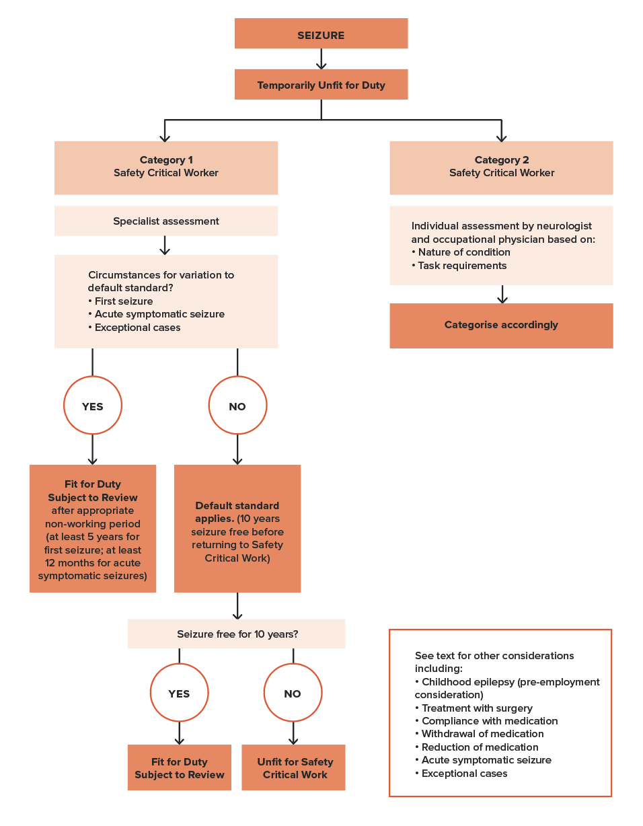

Acute symptomatic seizures
Acute symptomatic seizures are caused by a transient brain disorder or metabolic disturbance (for example, encephalitis, hyponatraemia, head injury, or drug or alcohol withdrawal) in patients without previous epilepsy. Acute symptomatic seizures can be followed by further seizures weeks, months or years after resolution of the transient brain disorder. This may occur because of permanent changes to the brain caused by the process underlying the acute symptomatic seizures (for example, seizures may return years after a resolved episode of encephalitis) or because the transient brain disorder has recurred (for example, benzodiazepine withdrawal).
People who have experienced a seizure only during and because of a transient brain disorder or metabolic disturbance should not perform Safety Critical Work for a sufficient period to allow the risk of recurrence to fall to an acceptably low level – for Category 1 Safety Critical Workers this period is at least 12 months (refer to Table 16 for details). Return to Safety Critical Work requires input from a specialist in epilepsy. The risk of seizure recurrence varies greatly, depending on the cause.
The management of seizures associated with hypoglycaemia is discussed in Section 4.3. Diabetes.
If seizures occur after the causative acute illness has resolved, whether or not due to a second transient brain disorder or metabolic disturbance, the acute symptomatic seizures criteria no longer apply. For example, if a person has a seizure during an episode of encephalitis and then, after recovery from the encephalitis, has another seizure and begins treatment for epilepsy, the default criteria apply.
Similarly, if a person experiences seizures during two separate episodes of benzodiazepine withdrawal, the default criteria apply. The management of late post-traumatic epilepsy is discussed under Head injury.

Exceptional cases
In addition to the reduction for particular circumstances or seizure types, there is also an allowance for ‘exceptional cases’ in which Fit for Duty Subject to Review may be considered for a Category 1 Safety Critical Worker on the recommendation of a medical specialist with specific expertise in epilepsy, and in consultation with the Authorised Health Professional and the rail transport operator’s Chief Medical Officer, if they have one, or another occupational physician experienced in rail. This enables individualisation of cases where the person does not meet the Standard but may be considered safe to perform their job.

Other situations relevant to both Category 1 and 2 Safety Critical Workers
The following information describes additional circumstances that may present for workers experiencing seizures. These circumstances do not result in a reduced seizure-free period for Category 1 Safety Critical Workers. The information may guide the individual assessment and management of Category 2 Safety Critical Workers.

Epilepsy treated by surgery
Resection of epileptogenic brain tissue may eliminate seizures completely, allowing performance of Safety Critical Work. For Category 1 Safety Critical Workers, the default non-working seizure-free period of 10 years applies, thus incumbent workers will be Permanently Unfit for Duty following such surgery. The vision standard may also apply if there is a residual visual field defect. If medication is being considered, refer to Withdrawal of all antiseizure medication or reduction in dose of antiseizure medication (below).
Fitness for duty for Category 2 Safety Critical Workers will need to be individually assessed based on the nature of the task.

‘Safe’ seizures (including prolonged aura)
Some seizures do not impair consciousness; however, this must be well established without exceptions and corroborated by reliable witnesses or video-electroencephalography (EEG) recording because people may believe their consciousness is unimpaired when it is not. For example, some ‘auras’ are associated with impaired consciousness that the person does not perceive.
Seizures may begin with a subjective sensation (the ‘aura’) that precedes impairment of consciousness. If this lasts long enough, the person may have time to stop work. However, this can be relied upon only when this pattern has been well established without exceptions and corroborated by witnesses or video-EEG monitoring. Furthermore, it may be impractical to stop Safety Critical Work immediately and safely (for example, train driving).
For these reasons, such seizures require the application of the default non-working period for Category 1 Safety Critical Workers. Fitness for duty for Category 2 Safety Critical Workers will need to be individually assessed based on the nature of the task.

Sleep-only seizures
Some seizures occur only in sleep. The default criteria apply to all Category 1 Safety Critical Workers. Fitness for duty for Category 2 Safety Critical Workers will need to be individually assessed based on the nature of the task.

Seizure in a person whose epilepsy has been previously ‘well controlled’ including provoked seizures
In people with epilepsy, their seizures are often provoked by factors such as sleep deprivation, missed doses of anti-epileptic medication, over-the-counter medications, alcohol or acute illnesses. If the provoking factor is avoided, the risk of subsequent seizures may be sufficiently low to allow Category 2 work to be resumed after a shorter seizure-free period than when following an unprovoked seizure. However, this applies only if the epilepsy has been well controlled until the provoked seizure, and careful consideration needs to be given to the nature of the work and whether the provoking factor can be reliably avoided. For the purpose of the Standard, sleep deprivation is not considered a provoking factor. There is no such allowance for Category 1 Safety Critical Workers, and the default criteria applies. Refer also to Medication noncompliance (below).

Medication noncompliance
Compliance with medical advice regarding medication intake is a requirement for fitness for duty. Where noncompliance with medication is suspected, the worker may be required to have drug-level monitoring. Where a person with a history of compliance with medication experiences a seizure because of a missed dose and there were no seizures in the 12 months leading up to that seizure, the situation can be considered a provoked seizure (refer to criteria for Seizure in a person whose epilepsy has been previously ‘well controlled’ including provoked seizures). Generally, there is no reduction in the non-working period for Category 1 Safety Critical Workers. Category 2 Safety Critical Workers should be individually assessed.

Withdrawal of all antiseizure medication or reduction in dose of antiseizure medication
Withdrawal of all anti-epileptic medication is incompatible with Category 1 Safety Critical Work. This also applies to a reduction in dose of anti-epileptic medication except if the dose reduction is due only to the presence of dose-related side effects, and the dose reduction is unlikely to result in a seizure. Category 2 Safety Critical Workers should be individually assessed.

Seizure causing a crash, incident or near miss
Not all seizures carry the same risk of causing a crash, incident or near miss on the network. People who have been involved in a crash, incident or near miss within the preceding 12 months as a result of a seizure are likely to have a higher risk of further incidents. For a Category 1 Safety Critical Worker who has experienced a crash or incident as a result of a seizure, the default seizure-free non-working period applies, even if they fall into one of the categories that allow a reduction. Category 2 Safety Critical Workers should be individually assessed.

Concurrent conditions
Where epilepsy is associated with other impairments or conditions, the relevant sections covering those disorders should also be consulted.

Other conditions with risk of seizure
Seizures can occur in association with many brain disorders. Some of these disorders may also impair safe working because of an associated neurological deficit. Both the occurrence of seizures, as well as the effect of any neurological deficit, must be taken into account when determining fitness for duty (refer to Section 4.8. Neurological conditions: other).

Advice to Safety Critical Workers
All Safety Critical Workers with epilepsy should be advised of the following general principles for safety if continuing Safety Critical Work:
- The worker must continue to take anti-epileptic medication regularly when and as prescribed.
- The worker should ensure they get adequate sleep and should not work when sleep deprived.
- The worker should avoid circumstances or the use of substances (for example, alcohol) that are known to increase the risk of seizures.
If a Safety Critical Worker refuses to follow a treating doctor’s recommendation to take anti-epileptic medication, the worker should be assessed as not fit for safety critical work (refer also to Medication noncompliance).

4.7.3. Fitness for duty criteria for Safety Critical Workers
Fitness for duty criteria are outlined in Table 16. These mainly apply to Category 1 Safety Critical Workers. Category 2 Safety Critical Workers should be individually assessed and the Category 3 standard should be applied if working on or near the track.
All Safety Critical Workers who need active management of epilepsy should be under review, including, where necessary, at least annual specialist appraisal. The use of an independent specialist may be considered.
It is important that health professionals familiarise themselves with both the general information above and the tabulated fitness for duty criteria before assessing a person’s fitness for duty.

Table 16. Seizures and epilepsy: Fitness for duty criteria for Safety Critical Workers
Condition | Criteria
Category 2
All cases Category 2 Safety Critical Workers (Refer also to text) | Category 2 Safety Critical Workers  A person should be categorised Temporarily Unfit for Duty following a seizure.  A person is not Fit for Duty Unconditional:  - if the person has ever experienced a seizure.  Fit for Duty Subject to Review may be determined, based on a consideration of the nature of the task and subject to annual review if:  - in the opinion of the treating specialist and in consultation with the Authorised Health Professional and the rail transport operator’s Chief Medical Officer (or an occupational physician experienced in rail), the risk to the network caused by a seizure is acceptably low; and  - the person follows medical advice, including adherence to medication if prescribed.  Category 2 Safety Critical Workers who work around the track should be assessed as per the Category 3 worker criteria – refer Part 5.
Unreliable or doubtful clinical information | Where the reliability of relevant clinical information is not clear (for example, unreported seizures likely due to the person not recognising the occurrence of seizures or deliberately not reporting seizures), the person is not fit for duty.
Category 1 – Default criteria
All cases Category 1 (default criteria)  Applies to all Category 1 Safety Critical Workers who have experienced a seizure  Exceptions may be considered only if the situation matches one of those listed below | Category 1 Safety Critical Workers  A person should be categorised Temporarily Unfit for Duty following a seizure.  A person is not Fit for Duty Unconditional:  - if the person has ever experienced a seizure.  Fit for Duty Subject to Review may be determined, subject to at least annual review*, taking into account information provided by a specialist in epilepsy as to whether the following criteria are met:  - there have been no seizures for at least 10 years**; and  - an EEG conducted in the last 6 months has shown no epileptiform activity and no other EEG conducted in the last 12 months has shown epileptiform activity***; and  - the person follows medical advice, including adherence to medication if prescribed or recommended.  * If a worker undergoing treatment for epilepsy has experienced an extended seizure-free period (more than 20 years) consideration may be given to reduce review requirements based on independent specialist advice.  ** Shorter seizure-free periods may be considered if the worker’s situation matches one of those in the tables that follow.  *** This is only required for initial review and not for subsequent annual review.
Category 1 - Possible reductions in the non-working seizure-free periods for Fit for Duty Subject to Review
History of a benign seizure or epilepsy syndrome limited to childhood  (for example, febrile seizures, benign focal epilepsy, childhood absence epilepsy) | A history of a benign seizure or epilepsy syndrome limited to childhood does not disqualify the person from performing Category 1 Safety Critical Work, as long as there have been no seizures after 11 years of age.  If a seizure has occurred after 11 years of age, there is no reduction. The default criteria apply unless the situation matches one of those listed below.
First seizure (of any type)  Note: 2 or more seizures in a 24-hour period are considered a single seizure | A Category 1 Safety Critical Worker should be categorised Temporarily Unfit for Duty following a first seizure (see definition in text).  A person is not Fit for Duty Unconditional:  - if the person has ever experienced a seizure.  Fit for Duty Subject to Review may be determined, subject to at least annual review, taking into account information provided by a specialist in epilepsy as to whether the following criteria are met:  - the seizure met the definition of ‘first seizure’; and  - there have been no seizures for at least 5 years (with or without medication); and  - an EEG conducted in the last 6 months shows no epileptiform activity and no other EEG conducted in the last 12 months has shown epileptiform activity.*  Resumption of Fit for Duty Unconditional may be considered, taking into account information provided by a specialist in epilepsy as to whether the following criteria are met:  - antiseizure medication has not been prescribed in the last 12 months; and  - there have been no seizures for at least 10 years; and  - an EEG conducted in the last 6 months has shown no epileptiform activity and no other EEG conducted in the last 12 months has shown epileptiform activity.  * This is only required for initial review and not for subsequent annual review.
Acute symptomatic seizures  Seizures occurring only during a temporary brain disorder or metabolic disturbance in a person without previous seizures. This includes head injuries, and withdrawal from drugs or alcohol. This is not the same as provoked seizures in a person with epilepsy | A Category 1 Safety Critical Worker should be categorised Temporarily Unfit for Duty following an acute symptomatic seizure (see detailed definition in text).  The minimum non-working seizure-free period is 12 months.  A person is not Fit for Duty Unconditional:  - if the person has ever experienced an acute symptomatic seizure.  Fit for Duty Subject to Review may be determined, subject to annual review, taking into account information provided by a specialist in epilepsy as to whether the following criteria are met:  - there have been no further seizures for at least 12 months; and  - an EEG conducted in the last 6 months has shown no epileptiform activity and no other EEG conducted in the last 12 months has shown epileptiform activity.*  If there have been 2 or more separate transient disorders causing acute symptomatic seizures, the default criteria apply (refer above).  Resumption of Fit for Duty Unconditional may be considered, taking into account information provided by a specialist in epilepsy as to whether the following criteria are met:  - antiseizure medication has not been prescribed in the last 12 months; and  - there have been no seizures for at least 10 years; and  - an EEG conducted in the last 6 months has shown no epileptiform activity and no other EEG conducted in the last 12 months has shown epileptiform activity.*  * This is only required for initial review and not for subsequent annual review.
Exceptional cases | Where a person with seizures or epilepsy does not meet the above criteria, Fit for Duty Subject to Review may be determined, based on consideration of the nature of the task and subject to annual review if:  - in the opinion of a medical specialist with specific expertise in epilepsy, and in consultation with the Authorised Health Professional and the rail transport operator’s Chief Medical Officer (or an occupational physician experienced in rail), the risk to the network caused by a seizure is acceptably low; and  - the person follows medical advice, including adherence to medication if prescribed.
Category 1 – other factors, conditions or circumstances that may influence fitness for duty status
Unreliable or doubtful clinical information | Where the reliability of relevant clinical information is not clear (for example, unreported seizures likely due to the person not recognising the occurrence of seizures or deliberately not reporting seizures), the person is not fit for duty.
Psychogenic nonepileptic seizures | Refer to Section 4.10. Psychiatric conditions.
Epilepsy treated by surgery (Where the primary goal of surgery is the elimination of epilepsy) | A person is not Fit for Duty Unconditional:  - if they have had surgery aimed at eliminating epilepsy.  Fit for Duty Subject to Review may be determined, subject to annual review, taking into account information provided by a specialist in epilepsy as to whether the following criteria are met:  - there have been no seizures for at least 10 years; and  - an EEG conducted in the last 6 months has shown no epileptiform activity and no other EEG conducted in the last 12 months has shown epileptiform activity*; and  - the person follows medical advice with respect to medication adherence.  The vision criteria may also apply if there is a visual field defect.  Withdrawal of any anti-epileptic medication is incompatible with performing Safety Critical Work.  * This is only required for initial review and not for subsequent annual review.
Recommended reduction in dosage of anti-epileptic medication in a person who satisfies the criteria for Fit for Duty Subject to Review | Safety Critical Work may continue (Fit for Duty Subject to Review):  - if the dose reduction is due only to the presence of dose-related side effects and is unlikely to result in a seizure; or  - if the dose is being reduced after an increase due to a temporary situation that has now resolved (for example, pregnancy) to the dose that was effective before the increase.  In circumstances other than the above, the person will no longer meet the criteria for fitness for duty.

Temporary illnesses. The Standard does not deal with the many conditions that may affect health on a short-to-medium-term basis and for which a Safety Critical Worker may be referred for assessment regarding fitness to resume duty. Clinical judgement is usually required on a case-by-case basis, although the text in each section gives some advice on the clinical issues to be considered.
Undifferentiated illness. A Safety Critical Worker may present with symptoms that could have implications for their job, but the diagnosis is not clear. Referral and investigation of the symptoms will mean that there is a period of uncertainty before a definitive diagnosis is made, and before the worker and employer can be confidently advised. Each situation will need to be assessed individually, with due consideration being given to the probability of a serious disease that will affect Safety Critical Work. Generally, workers presenting with symptoms of a potentially serious nature should be categorised as Temporarily Unfit for Duty until their condition can be adequately assessed. However, they may be suitable for alternative duties, including duties at a lower risk category (for example, Category 2 or Category 3). Workers who are fit to continue work while being investigated should be categorised as Fit for Duty Subject to Review.
Specialist review. The Standard generally requires Safety Critical Workers who are assessed as Fit for Duty Subject to Review to be seen by a specialist leading up to their review appointment with the Authorised Health Professional. Exceptions are specifically described in the Standard where appropriate.

References and further reading – Seizures and epilepsy
Annegers JF, Hauser WA, Coan SP and Rocca WA (1998) ‘A population-based study of seizures after traumatic brain injuries’, The New England Journal of Medicine, 338(1):20-4.
Austroads Ltd and NTC (2022) Assessing Fitness to Drive 2022: for commercial and private vehicle drivers.
Berger JT, Rosner F, Kark P and Bennett AJ. (2000) ‘Reporting by physicians of impaired drivers and potentially impaired drivers’, Journal of General Internal Medicine, 15(9):667-72.
Black AB (2001) ‘Epilepsy and driving: The perspective of an Australian neurologist’, Medicine and Law, 20:553-68.
Brown JW, Lawn ND, Lee J and Dunne JW (2015) ‘When is it safe to return to driving following first-ever seizure?’ Journal of Neurology, Neurosurgery and Psychiatry, 86(1):60-4.
Charlton JL, Di Stefano M, Dow J, Rapoport MJ, O’Neill D, Odell M, Darzins P and Koppel S (2021) Influence of chronic illness on crash involvement of motor vehicle drivers: 3rd Edition, Monash University Accident Research Centre.
Classen S, Crizzle AM, Winter SM, Silver W and Eisenschenk S (2012) ‘Evidence-based review on epilepsy and driving’, Epilepsy & Behavior, 23(2):103-12.
Drazkowski JF, Fisher RS, Sirven JI, Demaerschalk BM, Uber-Zak L, Hentz JG and Labiner D (2003) ‘Seizure-related motor vehicle crashes in Arizona before and after reducing the driving restriction from 12 to 3 months’, Mayo Clinic Proceedings, 78(7):819-25.
Driving Licence Committee of the European Union (2005) Epilepsy and driving in Europe: A report of the Second European Working Group on Epilepsy and Driving, Driving Licence Committee of the European Union.
Engel J, Fisher RS, Krauss GL, Krumholz A and Quigg MS (2007) Expert Panel Recommendations: Seizure disorders and commercial motor vehicle driver safety, Federal Motor Carrier Safety Administration.
Fisher RS, Parsonage M, Beaussart M, Bladin P, Masland R, Sonnen AE and Rémillard G (1994) ‘Epilepsy and driving: an international perspective’, Epilepsia, 35(3):675–84.
Gastaut H and Zifkin BG (1987) ‘The risk of automobile accidents with seizures occurring while driving’, Neurology, 37(10):1613-6.
Hansotia P and Broste SK (1991) ‘The effects of epilepsy or diabetes mellitus on the risk of automobile accidents’, The New England Journal of Medicine, 324:22-6.
Lawden M (2000) ‘Epilepsy surgery, visual fields, and driving’, Journal of Neurology, Neurosurgery and Psychiatry, 68(01):6.
Naik PA, Fleming ME, Bhatia P and Harden CL (2015) ‘Do drivers with epilepsy have higher rates of motor vehicle accidents than those without epilepsy?’, Epilepsy & Behavior, 47:111-4.
Somerville ER, Black AB and Dunne JW (2010) ‘Driving to distraction - certification of fitness to drive with epilepsy’, The Medical Journal of Australia, 192(6):342-4.
Taylor J, Chadwick D and Johnson T (1996) ‘Risk of accidents in drivers with epilepsy’, Journal of Neurology, Neurosurgery and Psychiatry, 60(6):621-7.
Zoer I, Sluiter JK and Frings-Dresen MHW (2014) ‘Psychological work characteristics, psychological workload and associated psychological and cognitive requirements of train drivers’, Ergonomics, 57(10):1473-1487.

4.8. Neurological conditions: other

4.8.1. Relevance to Safety Critical Work
Neurological disorders may affect the ability to perform Safety Critical Work due to their effect on cognitive function, vision, sensation, motor function or balance.
Although evidence of accident or incident risk is limited, it is very likely that symptoms that are common to many neurological conditions, such as potential spontaneous loss of consciousness, confusional states and impairment of muscular power and coordination, are deleterious to Safety Critical Work.
Balance is required for rail safety work in various situations, including walking (and, in an emergency, running) on ballast, or climbing ladders into cabs, on to rolling stock or up to signals. Balance may be affected by a range of neurological conditions, including disorders of the cerebellum, spinal cord and central or peripheral vestibular systems. Chronic intermittent conditions with acute onset are of main concern due to their potential for unexpected impact on Safety Critical Work. Vertigo resulting from vestibular disorders may also affect the ability to perform Safety Critical Work. Vertigo can occur suddenly and, with sufficient severity, performing Safety Critical Work can be impossible. It may be accompanied by oscillopsia (the illusion that the environment is moving), which compounds the disability in regard to Safety Critical Work. Some vestibular disorders may also affect hearing.
Sudden incapacity, such as from an intracranial bleed, is particularly relevant to Category 1 Safety Critical Workers.
The fitness for duty criteria in this chapter generally apply to both Category 1 and Category 2 Safety Critical Workers, although individual assessment of impairments and tasks may be required.

4.8.2. General assessment and management guidelines
A worker with a neurological disorder should be examined to determine the impact on the functions required for safe working as listed below (Figure 23).
If the health professional is concerned about a person’s ability to work safely, the person may be referred for a functional or practical assessment (refer to Section 3.5.1. Functional and practical assessments).
Workplace reports may be a useful source of information regarding overall safe working skills. For progressive conditions, deterioration in work performance may be the basis for a triggered referral (refer to Figure 13).

Aneurysms (including unruptured intracranial aneurysms) and other vascular malformations
Sudden severe haemorrhage from an intracranial aneurysm or vascular malformation may cause acute incapacity and affect working safely. However, the risk of sudden severe haemorrhage from some unruptured intracranial aneurysms and vascular malformations may be low enough to allow working. Workers should be individually assessed for suitability for Category 1 Safety Critical Work.
If the vascular malformation has bled and produced a neurological deficit, the worker should be assessed to determine if any of the functions listed in Figure 23 are impaired of sufficient severity to affect Safety Critical Work.
If treated surgically, the advice regarding intracranial surgery applies (see Intracranial surgery, below). If the person has had a seizure, the seizures and epilepsy fitness for duty criteria also apply (refer to Section 4.7. Neurological conditions: seizures and epilepsy).
Figure 23. Checklist for neurological disorders
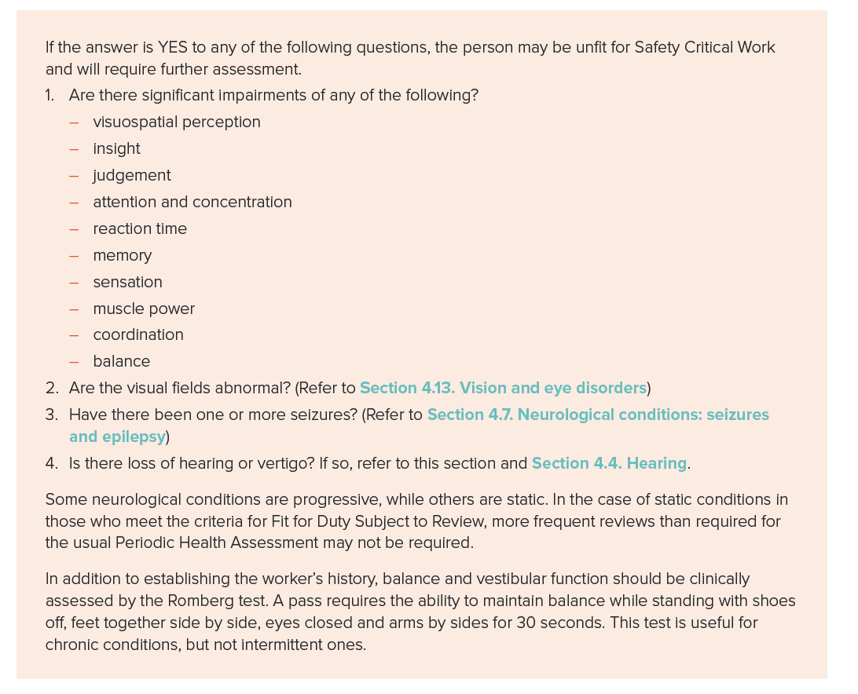

Cerebral palsy
Cerebral palsy may impair a worker’s ability to perform Safety Critical Work because of difficulty with motor control, or if it is associated with intellectual impairment or other disabilities. However, workers with mild cases may pass the necessary aptitude tests. As the disorder is usually static, more frequent review (in addition to that required for Period Health Assessment) is not normally required.

Head injury
There are various severities of head injury. Any person who has had a traumatic injury causing loss of consciousness should not perform Safety Critical Work for a minimum of 24 hours, and the effects on functions listed in the checklist in Figure 23 should be monitored. Minor head injuries involving a loss of consciousness of less than one minute with no complications do not usually result in any long-term impairment. Similarly, seizures that occur within 24 hours of a head injury (immediate post-traumatic seizures) are not considered to be epilepsy, but part of the acute process (refer to Acute symptomatic seizures). Long-term risk of seizures will also need to be considered in light of the nature and severity of the head injury.
More significant head injuries may impair any of the neurological functions listed in the checklist in Figure 23 and can impair long-term fitness for both Category 1 and Category 2 Safety Critical Work. There may be a focal neurological injury affecting motor or sensory tracts as well as the cranial nerves. Also, personality or behavioural changes may affect judgement and tolerance, and be associated with a psychiatric condition such as depression or post-traumatic stress disorder (PTSD). Clinical, neuropsychological or functional or practical assessments may be helpful in determining fitness for duty (refer to Section 3.5.1. Functional and practical assessments).
Neurological recovery from a traumatic brain injury may occur over a long period and some people who are initially unfit may recover sufficiently after many months such that Safety Critical Work can be resumed. Workers with appreciable impairments should initially be categorised as Temporarily Unfit for Duty and then managed according to their progress.
Risk of post-traumatic epilepsy (PTE): Persons with depressed skull fractures, traumatic intracranial haematoma or severe traumatic brain injury are at increased risk of epilepsy, especially in the first year. Category 1 Safety Critical Workers should be categorised Temporarily Unfit for Duty for 12 months after the injury. If one or more seizures have occurred, the symptomatic seizures criteria apply. PTE should be distinguished from immediate post-traumatic seizures occurring within 24 hours of a head injury, which are considered part of the acute process (refer to Acute symptomatic seizures). Category 2 Safety Critical Workers should be assessed individually based on the nature of their task.
Comorbidities such as drug or alcohol misuse and musculoskeletal injuries may also need to be considered (refer to Section 4.12. Substance misuse and dependenceand 4.1. Blackouts).

Intracranial surgery
Non-working periods are advised to allow for the risk of seizures occurring after certain types of intracranial surgery. Following supratentorial surgery or surgery requiring retraction of the cerebral hemispheres, the person should generally not perform Safety Critical Work for 12 months and should be categorised as Temporarily Unfit for Duty. There is no specific restriction after infratentorial or trans-sphenoidal surgery, however non-working periods may be advised by the treating specialist. This precautionary approach primarily applies to Category 1 Safety Critical Workers since, in the case of Category 2 Safety Critical Workers, sudden collapse is unlikely to lead to a serious incident. The non-working period may be varied from the recommended 12 months if, in the opinion of the treating specialist and in consultation with the Authorised Health Professional and the rail transport operator’s Chief Medical Officer (or an occupational physician experienced in rail), the risk to the network is acceptably low.
If one or more seizures occur, the fitness for duty criteria for seizures and epilepsy apply for Category 1 and Category 2 Safety Critical Workers (refer to Section 4.7. Neurological conditions: seizures and epilepsy). Similarly, if there is long-term impairment of any of the functions listed in the checklist in Figure 23, fitness for work will need to be assessed for Category 1 and Category 2 Safety Critical Workers.

Meniere’s disease
Meniere’s disease often results in recurrent vertigo, despite treatment. The natural history is of progression in the affected ear associated with increasing hearing loss until, in the extreme, total loss of vestibular function and partial loss of cochlear function occurs in the affected ear. The attacks are often heralded by a sense of fullness in the affected ear that may enable the worker to cease work safely. However, this is not practical for most train or tram driving, and some other Safety Critical Work. Safe cessation of work may be possible for tasks such as train controlling. Safety of the worker around the track will also need to be considered. A risk assessment of the job may assist to determine the ability to cease work safely, both for Category 1 and Category 2 Safety Critical Workers. In addition, the worker, whether Category 1 or Category 2, must meet any required hearing criteria (refer to Section 4.4. Hearing).

Multiple sclerosis
Multiple sclerosis may produce a wide range of neurological deficits that may be temporary or permanent and impair the performance of Category 1 and Category 2 Safety Critical Workers. Possible deficits that may impair safe working include all of those listed in Figure 23. Where practical, job modifications may be made to assist with some of these impairments; the advice of an occupational therapist may be helpful in this regard (refer to Section 3.5.1. Functional and practical assessments).

Neuromuscular disorders
Neuromuscular disorders include diseases of the peripheral nerves, muscles or neuromuscular junction, and may impair the performance of Category 1 and Category 2 Safety Critical Workers. Peripheral neuropathy may impair safe working due to difficulties with sensation (particularly proprioception) or from severe weakness. Disorders of the muscles or neuromuscular junction may also interfere with the ability to control a train or machinery. A functional or practical assessment may be required (refer to Section 3.5.1. Functional and practical assessments).

Parkinson’s disease
Parkinson’s disease is a common, progressive disease that may affect safe working in the advanced stages due to motor manifestations (bradykinesia and rigidity) or cognitive impairments (deficits in executive function and memory, and visuospatial difficulties) and hence may impair the performance of Category 1 and Category 2 Safety Critical Workers. When assessing the response to treatment, the response over the whole dose cycle should be taken into account (for example, in patients with motor fluctuations, it would not be appropriate to assess fitness only on the basis of the best ‘on’ response). Most patients with severe motor fluctuations will be unfit for Safety Critical Work. A functional or practical assessment may be required (refer to Section 3.5.1. Functional and practical assessments).
There may also be disturbances of sleep with episodes of sleepiness when working (refer to Section 4.11. Sleep disorders).

Stroke (cerebral infarction or intracerebral haemorrhage)
Stroke may impair safe working ability due to long-term neurological deficit, or due to the risk of a recurrent stroke or transient ischaemic attack (TIA) (see below). However, stroke and TIA rarely cause loss of consciousness. (It is uncommon for undiagnosed strokes or TIA to result in motor vehicle crashes. When they do, it is usually due to an unrecognised visual field deficit).
The risk of recurrent stroke is probably highest in the first month after the initial stroke but is still sufficiently low (about 10 per cent in the first year) that it does not on its own require suspension of Safety Critical Work. However, fatigue and impairments in concentration and attention are common after stroke (even in those with no persisting neurological deficits) and may impair the ability to perform Safety Critical Work. For this reason, there should be a non-working period after stroke for Category 1 and Category 2 Safety Critical Workers, even in those with no detectable persisting neurological deficit.
For those with a persistent neurological deficit, subsequent fitness for duty will depend on the extent of impairment of the functions listed in the checklist in Figure 23. A functional or practical assessment may be required (refer to Section 3.5.1. Functional and practical assessments). The vision criteria may also apply (refer to Section 4.13. Vision and eye disorders). If the person has had a seizure, the seizures and epilepsy fitness for duty criteria also apply (refer to Section 4.7. Neurological conditions: seizures and epilepsy).

Transient ischaemic attack
TIAs can be single or recurrent and may be followed by stroke. They may impair safe working if they occur while at work. This is particularly relevant to Category 1 Safety Critical Workers. The risk of a further TIA or stroke is about 15 per cent in the first 3 months and about half of that risk occurs in the first week. In view of the low risk of TIA or stroke affecting safe working, Category 1 Safety Critical Workers should not work for 4 weeks after a TIA (Temporarily Unfit for Duty) and should be reassessed at that point.
The worker may then be categorised as Fit for Duty Subject to Review by an appropriate specialist if there is no long-term impairment and risk of recurrence is low (refer to Section 3.4.5. Temporary conditions). A shorter non-working period of 2 weeks applies for Category 2 Safety Critical Workers, who may then be categorised as Fit for Duty Subject to Review. Requirements for periodic review should be determined based on the advice of the treating specialist.

Subarachnoid haemorrhage
Category 1 Safety Critical Workers should not perform Safety Critical Work for at least 6 months, and Category 2 for at least 3 months, following a subarachnoid haemorrhage. Fit for Duty Subject to Review may be determined after this non-working period, taking into account the presence of neurological disabilities as described in Figure 23. The vision criteria may also apply (refer to Section 4.13. Vision and eye disorders). If the person has had one or more seizures, the seizures and epilepsy fitness for duty criteria also apply (refer to Section 4.7. Neurological conditions: seizures and epilepsy). If a craniotomy has been performed, the advice for intracranial surgery also applies (refer to Intracranial surgery above). A functional or practical assessment may be considered (refer to Section 3.5.1. Functional and practical assessments).
Minor non-aneurysmal subarachnoid haemorrhage restricted to the cerebral convexity is associated with a range of underlying neurovascular conditions (for example, cerebral amyloid angiopathy and reversible cerebral vasoconstriction syndrome) with differing symptom associations and risks. For such workers, assessment of fitness for duty will depend on the underlying aetiology and presence of neurological impairments as described in Figure 23. The vision criteria may apply (refer to Section 4.13. Vision and eye disorders). If the person has had one or more seizures, the seizures and epilepsy fitness for duty criteria also apply (refer to Section 4.7. Neurological conditions: seizures and epilepsy). If a craniotomy has been performed, the advice for intracranial surgery also applies (refer to Intracranial surgery above). A practical or functional assessment may be considered (refer to Section 3.5.1. Functional and practical assessments).

Space-occupying lesions, including brain tumours
Brain tumours and other space-occupying lesions (for example, abscesses, chronic subdural haematomas and cysticercosis) may cause diverse effects depending on their location and type. They may impair any of the neurological functions listed in Figure 23 and hence affect both Category 1 and Category 2 Safety Critical Work. If the person has had one or more seizures, the seizures and epilepsy fitness for duty criteria also apply (refer to Section 4.7. Neurological conditions: seizures and epilepsy).
If a craniotomy has been performed, the advice regarding intracranial surgery also applies (refer to Intracranial surgery above).

4.8.3. Fitness for duty criteria for Safety Critical Workers
Fitness for duty criteria are outlined in Table 17 (in alphabetical order), including fitness for duty criteria for:
- aneurysms (unruptured intracranial aneurysms and other vascular malformations)
- cerebral palsy
- head injury
- intracranial surgery
- Meniere’s disease
- multiple sclerosis
- neuromuscular conditions
- Parkinson’s disease
- stroke
- transient ischaemic attacks
- space-occupying lesions, including brain tumours
- subarachnoid haemorrhage.
It is important that health professionals familiarise themselves with both the general information above and the tabulated fitness for duty criteria before assessing a person’s fitness for duty. Unless otherwise specified, the criteria generally apply to both Category 1 and Category 2 Safety Critical Workers, although individual assessment of impairments and tasks may be required.

Table 17. Neurological disorders: Fitness for duty criteria for Safety Critical Workers
Condition | Criteria
Aneurysms (Unruptured intracranial aneurysms) and other vascular malformations of the brain  (Refer also to Subarachnoid haemorrhage) | Category 1 Safety Critical Workers  A person is not Fit for Duty Unconditional:  - if the person has an unruptured intracranial aneurysm or other vascular malformation.  Fit for Duty Subject to Review may be determined, subject to at least annual review, taking into account:  - information provided by an appropriate specialist regarding the risk of symptomatic haemorrhage; and  - the response to treatment.  If there is any neurological deficit, the worker should be assessed to determine if there is impairment of any of the following: visuospatial perception, insight, judgement, attention, reaction time, sensation, memory, muscle power, balance, coordination or vision (including visual fields).  If treated surgically, the Intracranial surgery advice applies (see below).  The non-working period (Temporarily Unfit for Duty) should be based on the advice of the treating specialist if treated intra-arterially.  If the person has had a seizure, the seizure and epilepsy fitness for duty criteria apply (refer to Section 4.7. Neurological conditions: seizures and epilepsy).  * Where the condition is considered stable and there are minimal symptoms likely to affect safety critical tasks, the requirement for periodic review may be reduced or waived based on the advice of the treating specialist.
Cerebral palsy (Refer also to Neuromuscular disorders (peripheral neuropathy, muscular dystrophy, and the like)) | Category 1 and Category 2 Safety Critical Workers  A person is not Fit for Duty Unconditional:  - if the person has cerebral palsy producing significant impairment of any of the following: visuospatial perception, insight, judgement, attention, reaction time, sensation, muscle power, balance, coordination or vision (including visual fields).  Fit for Duty Subject to Review may be considered, taking into account:  - the nature of the work and reports on work performance; and  - information provided by an appropriate specialist regarding the level of impairment.  * Where the condition is considered stable or static and there are minimal symptoms likely to affect safety critical tasks, the requirement for periodic review may be reduced or waived based on the advice of the treating specialist.
Head injury (Refer also to Intracranial surgery) | Category 1 and Category 2 Safety Critical Workers  A person is not Fit for Duty Unconditional:  - if the person has traumatic brain injury producing significant impairment of any of the following: visuospatial perception, insight, judgement, attention, reaction time, sensation, muscle power, balance, coordination or vision (including visual fields).  Fit for Duty Subject to Review may be considered, taking into account:  - the nature of the work and reports on work performance; and  - information provided by an appropriate specialist regarding the level of impairment and the presence of other disabilities that may impair Safety Critical Work according to the Standard; and  - the results of neuropsychological testing, as appropriate.  Periodic review is not required if the condition is static.  A person is not Fit for Duty Unconditional:  - if they have a high risk of post traumatic epilepsy (penetrating brain injury, brain contusion, subdural haematoma, loss of consciousness or alteration of consciousness or post traumatic amnesia greater than 24 hours).  Fit for Duty Subject to Review may be considered, if the person has had no seizures for at least 12 months. If a seizure has occurred, refer to Section 4.7. Neurological conditions: seizures and epilepsy.
Intracranial surgery | Category 1 Safety Critical Workers  A person should be categorised Temporarily Unfit for Duty for 12 months* following supratentorial surgery or surgery that involves retraction of the cerebral hemispheres.  * The non-working period may be varied on the advice of the treating neurosurgeon if the risk to the network is acceptably low.  Category 1 and 2 Safety Critical Workers  If there are seizures or long-term neurological deficits, refer to Section 4.7. Neurological conditions: seizures and epilepsy, or Other neurological conditions below.
Meniere’s disease | Category 1 Safety Critical Workers  A person is not Fit for Duty Unconditional:  - if the person has Meniere’s disease.  Fit for Duty Subject to Review may be determined, subject to annual review, taking into account the nature of the work and workplace reports, and information provided by the treating neurologist or ear, nose and throat specialist as to whether the following criteria are met:  - if, in the opinion of a relevant specialist, the risk to the network caused by an attack is acceptably low; and  - the person follows medical advice, including adherence to medication if prescribed; and  - the appropriate hearing criteria are met.  Category 2 Safety Critical Workers  - Category 2 Safety Critical Workers require an individual risk assessment of their job. They may be categorised Fit for Duty Subject to Review or Fit for Duty Unconditional if acute incapacity is not detrimental to safety. They may require good hearing, refer to Section 4.4. Hearing. Restrictions in relation to work around the track may need to apply (refer to Part 5).
Multiple sclerosis | Category 1 and Category 2 Safety Critical Workers  A person is not Fit for Duty Unconditional:  - if the person has multiple sclerosis.  Fit for Duty Subject to Review may be determined, subject to at least annual review, taking into account:  - the nature of the work and reports on work performance; and  - information provided by an appropriate specialist regarding the level of impairment of any of the following: visuospatial perception, insight, judgement, attention, reaction time, memory, sensation, muscle power, balance, coordination or vision (including visual fields).
Neuromuscular disorders (peripheral neuropathy, muscular dystrophy, and the like) | Category 1 and Category 2 Safety Critical Workers  A person is not Fit for Duty Unconditional:  - if the person has peripheral neuropathy, muscular dystrophy or any other neuromuscular disorder that significantly impairs muscle power, sensation or coordination.  Fit for Duty Subject to Review may be determined, subject to at least annual review, taking into account:  - the nature of the work and reports on work performance; and  - information provided by an appropriate specialist regarding the level of impairment of muscle power, sensation, balance or coordination.
Parkinson’s disease | Category 1 and Category 2 Safety Critical Workers  A person is not Fit for Duty Unconditional:  - if the person has Parkinson’s disease.  Fit for Duty Subject to Review may be determined, subject to at least annual review, taking into account:  - the nature of the work and reports on work performance; and  - information provided by an appropriate specialist regarding the level of motor and cognitive impairment, and the response to treatment.
Stroke (Cerebral infarction or intracerebral haemorrhage) (also refer to Transient ischaemic attack (TIA) below) | Category 1 and Category 2 Safety Critical Workers  A person should be categorised Temporarily Unfit for Duty for at least 3 months following a stroke.  A person is not Fit for Duty Unconditional:  - if the person has had a stroke.  Following the prescribed non-working period, Fit for Duty Subject to Review may be determined subject to at least annual review, taking into account:  - the nature of the work and reports on work performance; and  - information provided by an appropriate specialist regarding the level of impairment of any of the following: visuospatial perception, insight, judgement, attention, reaction time, memory, sensation, muscle power, balance, coordination or vision (including visual fields).  If the worker has recovered or if the condition is considered stable or static and there are minimal symptoms likely to affect safety critical tasks, the requirement for periodic review may be reduced or waived based on the advice of the treating specialist.
Space-occupying lesions (including brain tumours) (Refer also to Intracranial surgery) | Category 1 and Category 2 Safety Critical Workers  A person is not Fit for Duty Unconditional:  - if the person has a space-occupying lesion.  Fit for Duty Subject to Review may be determined, subject to at least annual review, taking into account:  - the nature of the work and reports on work performance; and  - information provided by an appropriate specialist about the level of impairment of any of the following: visuospatial perception, insight, judgement, attention, reaction time, sensation, memory, muscle power, balance, coordination or vision (including visual fields).  If seizures occur, the fitness for duty criteria for seizures and epilepsy apply (refer to Section 4.7. Neurological conditions: seizures and epilepsy).  If surgically treated, the criteria for Intracranial surgery apply.
Subarachnoid haemorrhage (Refer also to Aneurysms (abdominal and thoracic)) | Category 1 Safety Critical Workers  A Category 1 Safety Critical Worker should be categorised Temporarily Unfit for Duty for at least 6 months following a subarachnoid haemorrhage.  A person is not Fit for Duty Unconditional:  - if the person has had a subarachnoid haemorrhage*.  Following the prescribed non-working period, Fit for Duty Subject to Review may be determined, taking into account:  - the nature of the work and reports on work performance; and  - information provided by an appropriate specialist about the level of impairment of any of the following: visuospatial perception, insight, judgement, attention, reaction time, sensation, memory, muscle power, balance, coordination or vision (including visual fields).  Category 2 Safety Critical Workers  A Category 2 Safety Critical Worker should be categorised Temporarily Unfit for Duty for at least 3 months following a subarachnoid haemorrhage.  A person is not Fit for Duty Unconditional:  - if the person has had a subarachnoid haemorrhage*.  Following the prescribed non-working period, Fit for Duty Subject to Review may be determined, taking into account:  - the nature of the work and reports on work performance; and  - information provided by an appropriate specialist about the level of impairment of any of the following: visuospatial perception, insight, judgement, attention, reaction time, sensation, memory, muscle power, balance, coordination or vision (including visual fields).  * This does not include a minor non-aneurysmal subarachnoid haemorrhage restricted to the cerebral convexity unless impairments are present – refer to Subarachnoid haemorrhage in the text.
Transient ischaemic attack (TIA) | Category 1 Safety Critical Workers  A person should be categorised Temporarily Unfit for Duty for at least 4 weeks following a TIA.  Following the prescribed non-working period, Fit for Duty Subject to Review may be determined taking into account information provided by an appropriate specialist if there is no long-term impairment and the risk of recurrence is low. Requirements for periodic review should be determined based on the advice of the treating specialist  Category 2 Safety Critical Workers  A person should be categorised Temporarily Unfit for Duty for at least 2 weeks following a TIA.  Following the prescribed non-working period, Fit for Duty Subject to Review may be determined taking into account information provided by an appropriate specialist if there is no long-term impairment and risk of recurrence is low. Requirements for periodic review should be determined based on the advice of the treating specialist.
Other neurological conditions (Refer also to Section 4.9. Neurodevelopmental disorders) | Category 1 and Category 2 Safety Critical Workers  A person is not Fit for Duty Unconditional:  - if the person has a neurological disorder that significantly impairs any of the following: visuospatial perception, insight, judgement, attention, reaction time, sensation, memory, muscle power, coordination, balance or vision (including visual fields).  Fit for Duty Subject to Review may be determined subject to at least annual review*, taking into account:  - the nature of the work and reports on work performance; and  - information provided by an appropriate specialist about the likely impact of the neurological impairment on Safety Critical Work.  - * Where the condition is considered stable or static and there are minimal symptoms likely to affect safety critical tasks, the requirement for periodic review may be reduced or waived based on the advice of the treating specialist.

Temporary illnesses. The Standard does not deal with the many conditions that may affect health on a short-to-medium-term basis and for which a Safety Critical Worker may be referred for assessment regarding fitness to resume duty. Clinical judgement is usually required on a case-by-case basis, although the text in each section gives some advice on the clinical issues to be considered.
Undifferentiated illness. A Safety Critical Worker may present with symptoms that could have implications for their job, but the diagnosis is not clear. Referral and investigation of the symptoms will mean that there is a period of uncertainty before a definitive diagnosis is made, and before the worker and employer can be confidently advised. Each situation will need to be assessed individually, with due consideration being given to the probability of a serious disease that will affect Safety Critical Work. Generally, workers presenting with symptoms of a potentially serious nature should be categorised as Temporarily Unfit for Duty until their condition can be adequately assessed. However, they may be suitable for alternative duties, including duties at a lower risk category (for example, Category 2 or Category 3). Workers who are fit to continue work while being investigated should be categorised as Fit for Duty Subject to Review.
Specialist review. The Standard generally requires Safety Critical Workers who are assessed as Fit for Duty Subject to Review to be seen by a specialist leading up to their review appointment with the Authorised Health Professional. Exceptions are specifically described in the Standard where appropriate.

References and further reading – Other neurological conditions
Austroads Ltd and NTC (2022) Assessing Fitness to Drive 2022: for commercial and private vehicle drivers.
Charlton JL, Di Stefano M, Dow J, Rapoport MJ, O’Neill D, Odell M, Darzins P and Koppel S (2021) Influence of chronic illness on crash involvement of motor vehicle drivers: 3rd Edition, Monash University Accident Research Centre.
Hawley, CA (2001) ‘Return to driving after head injury’, Journal of Neurology, Neurosurgery and Psychiatry, 70(6):761-6.
Heikkila VM, Turkka J, Korpelainen J, Kallanranta T and Summala H (1998) ‘Decreased driving ability in people with Parkinson’s disease’, Journal of Neurology, Neurosurgery and Psychiatry, 64(3):325-30.
Mckiernan D and Jonathon D (2001) ‘Driving and vertigo’, Clinical Otolaryngology, 26(1):1-2.
Wood JM, Worringham C, Kerr G, Mallon K and Silburn P (2005) ‘Quantitative assessment of driving performance in Parkinson’s disease’, Journal of Neurology, Neurosurgery and Psychiatry, 76(2):176-80.
Zoer I, Sluiter JK and Frings-Dresen MHW (2014) ‘Psychological work characteristics, psychological workload and associated psychological and cognitive requirements of train drivers’, Ergonomics, 57(10):1473-1487.

4.9. Neurodevelopmental disorders
Neurodevelopmental disorders (neurodevelopmental divergence) encompasses a number of conditions, the most prominent being attention deficit hyperactivity disorder (ADHD) and autism spectrum disorder (ASD), which are the focus of this section. People with disorders of intellectual development, particularly those who may have difficulties with learning, communicating, making timely judgments and planning, are also covered by this section, unless better covered by the neurological or psychiatric sections of the Standard.
While defined as mental, behavioural or developmental disorders under the International Classification of Diseases, these disorders are separated from the neurological and psychiatric conditions section in the Standard due to their non-episodic nature and the approach necessary for their assessment and management.
For the purposes of the Standard, the term 'neurodevelopmental disorder' applies to disorders that typically first manifest in childhood but may not be diagnosed until adulthood, as distinct from disorders acquired in adulthood. It also applies to individuals with behavioural traits or neurocognitive function which lie towards the extreme of the spectrum of neurodiversity and which may impair safety critical functioning in safety sensitive and/or teamwork settings.

4.9.1. Relevance to Safety Critical Work
Neurodevelopmental disorders may be associated with various symptoms including disturbances of attention, behaviour, language, social communication, cognition and perception, as well as inappropriate responses to unexpected change. They therefore have the potential to affect Safety Critical Work. Social and time-sensitive communication can impact understanding of nuance, tone and facial expression, as well as the ability to comprehend and infer, thus influencing any group response to safety critical scenarios.
ADHD and ASD are separate disorders, but they can share symptoms and a person can have both conditions at the same time. People with neurodevelopmental disorders also commonly experience comorbid psychiatric conditions.
ADHD is characterised by inattention, hyperactivity and impulsivity. This may have important implications for their work such as responding to emergency situations. Relevant to the conduct of rail safety work, people with ADHD may have difficulty with:
- planning, organising and prioritising
- sustaining or shifting focus
- managing frustration, modulating emotions and self-regulation
- being prone to angry, aggressive or risky behaviours
- restlessness and agitation
- managing distraction (internal and external).
The stimulant medications prescribed to treat ADHD are unlikely to result in impairment unless there is abuse. They will, however, likely be detected on a drug test.
People with ASD can have differences in social communication and interaction, with restricted and repetitive patterns of behaviour, interests and activities. This may have important implications for their work such as their ability to respond to emergency situations. Relevant to the conduct of rail safety work, people with ASD may have difficulty with:
- managing attention and distraction
- understanding non-verbal communication
- planning and organising
- adapting to unexpected change
- sensory sensitivities (for example, glare and sound)
- emotional regulation
- input overload and reduced tolerance
- repetitive behaviours such as rocking or hand flapping.
Functional impacts can be beneficial or challenging, depending on specific role requirements. The impacts will depend on factors such as the person’s adaptive coping strategies, insight and compliance with treatment, and the stability of their environment. Insight is a key feature of their interaction with workgroup activity.

Evidence of crash risk
There are no specific data on the impact of neurodevelopmental disorders on the rates of incidents in rail, but there is evidence of impacts on safety more generally and in relation to road safety, particularly among young drivers.
For people with ASD, shortcomings in tactical driving skills have been observed, while rule-following aspects of driving are improved. For people with ADHD, there is increased risk of involvement in motor accidents in all ages compared to those without ADHD, with inattention and hyperactivity or impulsivity predicting accident risk. ADHD medication appears to be effective at reducing accident risk (motor vehicle and other) across all age groups.

4.9.2. General assessment and management guidelines
Neurodevelopmental disorders may be self-declared by rail safety workers at Pre-placement or Periodic Health Assessments (Health Questionnaire). If not declared at the beginning of employment, disorders may become evident during a health assessment. The existence of a neurodevelopmental disorder may be revealed during a Triggered Health Assessment initiated by either the Safety Critical Worker or by the rail transport operator in association with behavioural or performance issues, or other incidents observed in the workplace.
As for other psychiatric and neurological conditions, assessment of the impact of neurodevelopmental disorders on Safety Critical Work should be individualised. A person needs to be assessed regarding the specific pattern of disorder, potential impairments, insight, and severity, together with the skills needed to work safely and the impact of the working environment, as well as any comorbid conditions such as psychiatric conditions or substance misuse. Consideration should also be given to the person’s social circumstances and coping strategies, which will influence the impact of the condition on their working performance.
The assessment may include a clinical assessment (for example, neuropsychological testing) or consideration of work performance or training reports, or both (refer to Figure 13).
The presence of a severe condition is unlikely to be compatible with being able to sustain Safety Critical Work and will usually result in the person being categorised Permanently or Temporarily Unfit for Duty.
If a person is prescribed stimulants for treating ADHD (for example, dexamphetamine) this should be declared by the worker and documented by the Authorised Health Professional in case the person is subject to drug testing in the future.

4.9.3. Fitness for duty criteria for Safety Critical Workers
Fitness for duty criteria are outlined in Table 18.
It is important that health professionals familiarise themselves with both the general information above and the tabulated fitness for duty criteria before assessing a person’s fitness for duty.

Table 18. Neurodevelopmental disorders: Fitness for duty criteria for Safety Critical Workers
Condition | Criteria
Neurodevelopmental disorders (Including ADHD, ASD, learning and intellectual development disorders) | Category 1 and Category 2 Safety Critical Workers  A person is not Fit for Duty Unconditional:  - if the person has a neurodevelopmental disorder that significantly impairs any of the following: insight, judgment, behaviour, attention, concentration, language, social communication, planning, organisation or responsiveness (including in an emergency situation).  Fit for Duty Subject to Review may be determined subject to periodic review*, taking into account the nature of the work, workplace reports and information provided by a psychiatrist or other appropriate specialist as to whether the following criteria are met:  - the diagnosis has been confirmed by an appropriate specialist; and  - the person has insight into their condition and the potential impacts on safe working; and  - the condition and any comorbidities are well controlled and unlikely to affect Safety Critical Work.  * Where the condition is considered stable or static and there are minimal symptoms likely to affect safety critical tasks, the requirement for periodic review may be reduced or waived, based on the advice of the treating specialist.

Temporary illnesses. The Standard does not deal with the many conditions that may affect health on a short-to-medium-term basis and for which a Safety Critical Worker may be referred for assessment regarding fitness to resume duty. Clinical judgement is usually required on a case-by-case basis, although the text in each section gives some advice on the clinical issues to be considered.
Undifferentiated illness. A Safety Critical Worker may present with symptoms that could have implications for their job, but the diagnosis is not clear. Referral and investigation of the symptoms will mean that there is a period of uncertainty before a definitive diagnosis is made, and before the worker and employer
can be confidently advised. Each situation will need to be assessed individually, with due consideration being given to the probability of a serious disease that will affect Safety Critical Work. Generally, workers presenting with symptoms of a potentially serious nature should be categorised as Temporarily Unfit for Duty until their condition can be adequately assessed. However, they may be suitable for alternative duties, including duties at a lower risk category (for example, Category 2 or Category 3). Workers who are fit to continue work while being investigated should be categorised as Fit for Duty Subject to Review.
Specialist review. The Standard generally requires Safety Critical Workers who are assessed as Fit for Duty Subject to Review to be seen by a specialist leading up to their review appointment with the Authorised Health Professional. Exceptions are specifically described in the Standard where appropriate.

References and further reading – Neurodevelopmental disorders
Australasian ADHD Professionals Association (2022) Australian evidence-based clinical practice guideline for attention deficit hyperactivity disorder (ADHD).
Brooks J, Kellett J, Seeanner J, Jenkins C, Buchanan C, Kinsman A, Kelly D and Pierce S (2016) ‘Training the motor aspects of pre-driving skills of young adults with and without autism spectrum disorder’, Journal of Autism and Developmental Disorders, 46(7):2408-26.
Brunkhorst-Kanaan N, Libutzki B, Reif A, Larsson H, McNeill RV and Kittel-Schneider S (2021) ‘ADHD and accidents over the life span – A systematic review’, Neuroscience & Biobehavioral Reviews, 125:582-91.
Chee DY, Lee HC, Patomella AH and Falkmer T (2017) ‘Driving behaviour profile of drivers with autism spectrum disorder (ASD)’, Journal of Autism and Developmental Disorders, 47(9):2658-70.
Cox NB, Reeve RE, Cox SM and Cox DJ (2012) ‘Brief report: driving and young adults with ASD – parents’ experiences’, Journal of Autism and Developmental Disorders, 42(10):2257-62.
Curry AE, Metzger KB, Pfeiffer MR, Elliott MR, Winston FK and Power TJ (2017) ‘Motor vehicle crash risk among adolescents and young adults with attention-deficit/hyperactivity disorder’, JAMA Pediatrics, 171(8):756-63.
Doyle N and Medhurst B (2022) Evaluating and supporting neurodifferences at work.
Jacob KS (2010) 'The assessment of insight across cultures’, Indian Journal of Psychiatry, Oct;52(4):373-7.
Lindsay S (2017) ‘Systematic review of factors affecting driving and motor vehicle transportation among people with autism spectrum disorder’, Disability and Rehabilitation, 39(9):837-46.
Roy A, Garner AA, Epstein JN, Hoza B, Nichols JQ, Molina BSG, Swanson JM, Arnold LE and Hechtman L (2020) ‘Effects of Childhood and Adult Persistent Attention-Deficit/Hyperactivity Disorder on Risk of Motor Vehicle Crashes: Results From the Multimodal Treatment Study of Children With Attention-Deficit/Hyperactivity Disorder’, Journal of the American Academy of Child & Adolescent Psychiatry, 59(8):952-963.
Wilson NJ, Lee HC, Vaz S, Vindin P and Cordier R (2018) ‘Scoping review of the driving behaviour of and driver training programs for people on the autism spectrum’, Behavioural Neurology.
World Health Organization (2022) International Classification of Disease, 11th revision.
Zoer I, Sluiter JK and Frings-Dresen MHW (2014) ‘Psychological work characteristics, psychological workload and associated psychological and cognitive requirements of train drivers’, Ergonomics, 57(10):1473-1487.

4.10. Psychiatric conditions
(Refer also to Section 4.6.2. Dementia, Section 4.8. Neurological conditions: other, Section 4.9. Neurodevelopmental disorders and Section 4.12. Substance misuse and dependence).
Psychiatric conditions encompass a range of cognitive, emotional and behavioural disorders such as schizophrenia, depression, anxiety disorders and personality disorders. Related conditions such as dementia and substance misuse disorders are addressed elsewhere in the Standard (refer to Section 4.6.2. Dementia and Section 4.12. Substance misuse and dependence). Neurodevelopmental disorders are covered in Section 4.9. Neurodevelopmental disorders.

4.10.1. Relevance to Safety Critical Work
Safety Critical Work is a complicated psychomotor performance that depends on fine coordination between the sensory and motor systems. It is influenced by factors such as arousal, perception, learning, memory, attention, concentration, emotion, reflex speed, time estimation, auditory and visual functions, decision-making ability and personality. Complex feedback systems interact to produce the appropriate coordinated behavioural response. Anything that interferes with any of these factors to a significant degree may impair the ability to perform Safety Critical Work.
Specifically, train drivers are required to stay aware, perceive, interpret, recognise, anticipate and act on environmental signals in specific situations. They should have the ability to concentrate and to perform their work accurately. Selective, divided and sustained attention (for example, vigilance) is required. Train drivers are also required to memorise relevant information. They must be capable of coping with emotional demands, low decision latitude and a solitary work environment. They should also be able to respond appropriately to emergency situations.
Psychiatric conditions may be associated with disturbances of behaviour, cognitive abilities and perception, and therefore have the potential to affect performance of Safety Critical Work. They do, however, differ considerably in their aetiology, symptoms and severity, and may be episodic or persistent.
The impact of mental illness also varies depending on a person’s social circumstances, job and coping strategies. Assessment of fitness for duty must therefore be individualised, and should rely on evaluation of the specific pattern of illness and potential impairments, as well as severity, rather than the diagnosis per se. The range of potential impairments for various conditions is described below. These impairments are difficult to determine precisely because impairment differs at various phases of the illness and may vary markedly between individuals.
Table 19 summarises the potential impacts of various psychiatric conditions on Safety Critical Work.

Effects of Safety Critical Work on mental health
Frontline rail workers such as train drivers also have a unique risk in the course of their work due to people suiciding on railways. These incidents are usually managed through a rail transport operator’s critical event management program. However, such events, particularly when recurrent, may lead to depression, anxiety (in the form of PTSD) and substance misuse.

Table 19. Potential impairments associated with various psychiatric conditions
Condition | Impairments
Depression | - Disturbance of attention, information processing and judgement, including reduced ability to anticipate situations  - Psychomotor retardation and reduced reaction times  - Sleep disturbance and fatigue  - Suicidal ideation that may result in reckless conduct
Anxiety disorders | - Preoccupation or distraction  - Decreased working memory  - Panic attacks  - Obsessional behaviours, including obsessional slowness, which impairs the ability to work efficiently and safely
Post-traumatic stress disorder | - Avoidance of certain situations related to traumatic experience  - Increased startle response  - Poor sleep and nightmares  - Recurrent intrusive memories  (There may be overlap with depression and substance misuse)
Bipolar affective disorder | - Depression and suicidal ideation  - Mania or hypomania, with impaired judgement about working safely, skill and associated recklessness  - Delusional beliefs that may directly affect work  - Grandiose beliefs that may result in extreme risk-taking
Personality disorders | - Aggressive or impulsive behaviour  - Resentment of authority or reckless behaviour  - Disordered interpersonal relationships  - Impaired decision-making
Schizophrenia | - Reduced ability to sustain concentration or attention  - Reduced cognitive and perceptual processing speeds, including reaction time  - Reduced ability to perform in complex situations such as when there are multiple distractions  - Abnormalities of perceptions such as hallucinations, which are distracting and preoccupying  - Delusional beliefs that interfere with working, for example, persecutory beliefs may include being followed and result in erratic working  - Current antipsychotic medications do not have powerful beneficial effects on cognition
Psychogenic non-epileptic seizures | - Impaired consciousness  - Impaired awareness  - Impaired motor control

Evidence of crash risk
There is no specific data on the impact of psychiatric illness on the incidence of crashes or incidents in rail, but by extrapolation information may be derived from road accident data. Some studies have shown that drivers with a psychiatric illness have an increased crash risk compared with drivers without a psychiatric illness. There is also specific evidence for increased risk among those with schizophrenia and personality disorders.

Impairments associated with medication
Medications prescribed for treating psychiatric conditions may impair performance of Safety Critical Work. There is, however, little evidence that medication, if taken as prescribed, contributes to road crashes; in fact, it may help reduce the risk of a crash (refer to Section 3.4.8. Drugs and rail safety work).
The assessment of medication effects should be individualised and rely upon self-report, observation, clinical assessment and collateral information to determine if particular medications might affect Safety Critical Work. Authorised Health Professionals should have heightened concern when sedative medications are prescribed but should also consider the need to treat psychiatric conditions effectively (also refer to Section 4.12. Substance misuse and dependence).

4.10.2. General assessment and management guidelines

Identifying psychological health problems
Unlike chronic degenerative disease where the incidence increases with age, common psychiatric conditions show a relatively constant incidence across working age. Such conditions may therefore arise between Periodic Health Assessments, relying on the worker or manager to initiate a Triggered Health Assessment.
Triggered referral for assessment is therefore an important mechanism of identifying and managing Safety Critical Workers with psychiatric conditions, underpinned by a positive organisational culture of reporting and confidence in the process. For example, new onset of forgetfulness, inability to pass competency assessments that were previously passed, or inability to learn and retain new information, or poor behaviour may indicate the need for a Triggered Health Assessment. Refer to Section 2.6.5. Communicating with Authorised Health Professionals.
While identification of psychiatric conditions via screening at a Periodic Health Assessment remains important, the limitations of self-administered screening tools are acknowledged and the value of establishing a rapport with the worker is emphasised.

Screening for anxiety or depression at recruitment and Periodic Health Assessment
Substantial anxiety or depression affects up to 10 per cent of the adult population. This has led to the introduction of the K10 questionnaire, a well-validated tool for screening for anxiety and depression (refer to Figure 24).
While the tool is well-validated in community settings, its limitations as a self-administered questionnaire in the occupational context is acknowledged. Note also that the K10 is a screening instrument, not a diagnostic tool; thus, Authorised Health Professionals should apply clinical judgement in the interpretation of the score and the action required. A detailed explanation of the tool and scoring is provided in Section 6.1.2. K10 questionnaire for anxiety and depression. If the person appears unduly familiar with the K10, other validated questionnaires such as the DASS-21 may be applied after consultation with the rail transport operator’s Chief Medical Officer or equivalent. Psychiatric referral or neuropsychological testing may be helpful to forming an overall opinion of fitness for duty.

Figure 24. K10 questionnaire
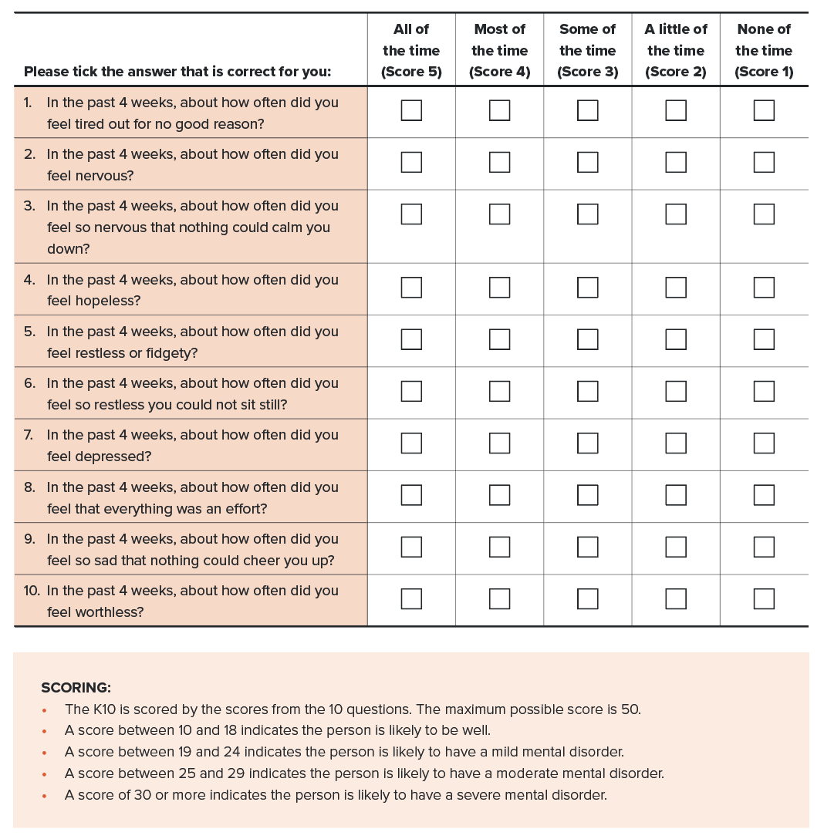

Assessment for psychiatric conditions during a Triggered Health Assessment
Screening tools such as the K10 are less likely to be useful in a triggered situation, where specific concerns may have been raised regarding possible psychological ill-health.
The nature of the assessment will depend on the circumstances and the clinical presentation and be orientated towards psychiatric conditions, substance misuse or neurological disorders and possibly other medical conditions.
Further assessments may include relevant questionnaires, psychiatric or neuropsychological assessment. Workplace reports may be a useful source of information regarding overall safe working skills. Reports of critical incidents, such as suicides on railways, should also be considered (refer to Figure 13).
A dual diagnosis with substance misuse is often a consideration. Referral to specialists will be appropriate to the working diagnosis.
In the event of a worker being uncooperative in the conduct of the assessment, they should be assessed as Temporarily Unfit for Duty and the rail transport operator notified.

General assessment and mental state examination
When assessing the impact of a mental illness on the ability to work safely, the focus should be on assessing the severity and significance of likely functional effects, rather than the diagnosis of a mental illness per se.
The mental state examination can be usefully applied in identifying areas of impairment that may affect fitness for duty.
- Appearance – Appearance is suggestive of general functioning (for example, attention to personal hygiene, grooming, sedation, indications of substance use).
- Attitude – This may, for example, be described as cooperative, uncooperative, hostile, guarded or suspicious. Although subjective, it helps to evaluate the quality of information gained in the rest of the assessment and may reflect personality attributes.
- Behaviour – This may include observation of specific behaviours or general functioning, including ability to function in normal work and social environments.
- Mood and affect – This includes elevated mood (increase in risk-taking) and low mood (suicidal ideation).
- Thought form, stream and content – This relates to the logic, quantity, flow and subject of thoughts, which may be affected by mania, depression, schizophrenia or dementia. Delusions with specific related content may impact on safe working ability.
- Perception – This relates to the presence of disturbances, such as hallucinations, that may interfere with attention or concentration, or may influence behaviour.
- Cognition – This relates to alertness, orientation, attention, memory, visuospatial functioning, language functions and executive functions. Evidence from formal testing, screening tests and observations related to adaptive functioning may be sought to determine if a psychiatric condition is associated with deficits in these areas that are relevant to safe working.
- Insight – This relates to self-awareness of the effects of the condition on behaviour and thinking. Assessment requires exploration of the person’s awareness of the nature and impacts of their condition and has major implications for management.
- Judgement – The person’s ability to make sound and responsible decisions has obvious implications for safety.
Mild mental illness does not usually have a significant impact on functioning. Moderate levels of mental illness commonly affect functioning, but many people will be able to manage usual activities, often with some modification. Severe mental illness often impairs multiple domains of functioning, and it is this category that is most likely to impact on the functions and abilities required for Safety Critical Work. A person’s medication requirements should not be used as the only measure of disease severity.
The person with insight may recognise when they are unwell and self-limit their working. Limited insight may be associated with reduced awareness of deficits and may result in markedly impaired judgement or self-appraisal. Workers with lack of insight should be categorised as Temporarily Unfit for Duty or even Permanently Unfit for Duty as required.
Mental illness, particularly if accompanied by paranoid beliefs or lack of insight, may lead to noncompliance with requests to attend medical reviews or take prescribed medication, and may lead to difficulty obtaining a full picture of the worker's condition and functioning. In cases where the Authorised Health Professional is not satisfied that they have a complete picture of the worker’s condition, the worker should be categorised Temporarily Unfit for Duty until adequate information can be obtained.

Acute psychotic episodes
A person suffering an acute severe episode of mental illness (for example, psychosis, moderate to severe depression or mania) may pose a significant risk. They should be categorised as Temporarily Unfit for Duty.

Severe chronic conditions
A person with a severe chronic or relapsing psychiatric condition (including neurodevelopmental disorders – refer to Section 4.9. Neurodevelopmental disorders) needs to be assessed regarding the impairments associated with the condition and the skills needed to work safely. This may include a clinical assessment (for example, neuropsychological) or consideration of work performance reports, or both (refer to Figure 13). The presence of a severe or relapsing psychiatric condition is unlikely to be compatible with being able to sustain Safety Critical Work in the long run and will usually result in the person being categorised Permanently Unfit for operational duties.

Psychogenic nonepileptic seizures,
Some transient episodes of apparently impaired consciousness, awareness or motor control resemble epileptic seizures or syncope, yet have a psychological cause. These episodes are usually termed psychogenic nonepileptic seizures (PNES), although they are sometimes known as dissociative, functional or pseudo seizures. Most people diagnosed with PNES report loss of responsiveness or loss of awareness. This may impact safety on the network, particularly for Category 1 Safety Critical Workers and Category 2 Safety Critical Workers working around the track.
People with active PNES should generally be assessed as unfit for duty if they lose awareness or responsiveness with their psychogenic seizures, have a history of seizure-related injuries, or if the symptoms suggest that their ability to undertake Safety Critical Work would be impaired during a psychogenic seizure. The safety risk may be sufficiently low after a 3-month period with no further psychogenic seizures, to allow a return to work on the recommendation of a specialist.
Diagnosis of PNES must establish that such episodes are psychogenic only. This may require recording an episode with video or video-EEG. Approximately 20 per cent of people with PNES have a history of epilepsy. In such cases, it is important to distinguish between the two types of attack and to establish whether an epileptic seizure has occurred. The seizure and epilepsy fitness for duty criteria may apply in these cases (refer to Section 4.7. Neurological conditions: seizures and epilepsy). If there is uncertainty regarding the type of attack, the blackouts of uncertain mechanism (refer to Section 4.1. Blackouts) fitness for duty criteria may apply. If more than one standard applies, the longer non-working period applies.

Substance misuse (refer also to Section 4.12. Substance misuse and dependence)
People with a dual diagnosis of a psychiatric condition, and drug or alcohol misuse are likely to be at higher risk and warrant careful consideration. The assessment should seek to identify the potential relevance of:
- problematic alcohol consumption
- use of illicit substances
- prescription drug abuse (for example, increased use of sedatives or painkillers).

Treatment and management
Treatments of psychiatric conditions, including medication and ‘talking therapies’, should be considered in terms of the likely impact on fitness for duty, including the benefits and possible adverse side effects. Compliance with treatment should also be considered and may depend on a number of factors including the nature of the condition and insight by the worker.
The effects of prescribed medication should be considered, including:
- how medication may help to control or overcome aspects of the condition that may impact on working safely; and
- whether medication side effects may affect working safely, including risk of sedation, impaired reaction time, impaired motor skills, blurred vision, hypotension or dizziness.
Information about the potential effects of various medications is summarised in Section 3.4.8. Drugs and rail safety work.
Talking therapies and online therapy may be useful alternatives or supplements to medication in order to lessen the risk of impairment.
Workers who are already being treated for psychiatric conditions should have a mental health plan which should be discussed at assessment. The plan should reference the need for cognitive and communication skills and responsiveness in emergency situations. Good liaison with the treating doctor or psychologist is important to ensure they understand the implications for the worker’s Safety Critical Work and the need to work shift rosters.
The presence or absence of insight has implications for management. The person with insight may recognise when they are unwell and self-limit their Safety Critical Work. Limited insight may be associated with reduced awareness of deficits and may result in markedly impaired judgement or self-appraisal.
The review period should be tailored to the likely prognosis or pattern of progression of the disorder in an individual with a conservative approach to Safety Critical Work.

Interfacing programs
There may be a number of support programs that are available to workers to which an Authorised Health Professional may refer as required, for example, an Employee Assistance Program or peer support (refer to Section 1.3. Legislative basis and interfaces).

4.10.3. Fitness for duty criteria for Safety Critical Workers
Fitness for duty criteria are outlined in Table 20.
It is important that health professionals familiarise themselves with both the general information above and the tabulated fitness for duty criteria before assessing a person’s fitness for duty.
Table 20. Psychiatric conditions: Fitness for duty criteria for Safety Critical Workers
Condition | Criteria
K10 score  The scores are a guide and should be interpreted in conjunction with clinical assessment | Category 1 and Category 2 Safety Critical Workers  If the person has a K10 score of greater than or equal to 19, the person may be categorised as Temporarily Unfit for Duty or Fit for Duty Subject to Review while the causes are being assessed and managed (refer to Section 6.1.2. K10 questionnaire for anxiety and depression):  - For scores of 19 to 24, the worker may be categorised Fit for Duty Subject to Review without external referral if the examining doctor feels the issues can be managed within the consultation.  - For scores of 25 to 29, the worker must be referred back to their treating doctor for further management.  If the score is greater than or equal to 30, the worker must be categorised Temporarily Unfit for Duty pending further management.
Psychiatric conditions | Category 1 and Category 2 Safety Critical Workers  A person is not Fit for Duty Unconditional:  - if the person has a psychiatric condition of sufficient severity that it may impair behaviour, cognitive ability or perception required for Safety Critical Work (refer to Section 4.10.1. Relevance to Safety Critical Work); or  - if the Authorised Health Professional believes that there is a significant risk of a previous psychiatric condition relapsing.  Fit for Duty Subject to Review may be determined, subject to at least annual* review, taking into account the nature of the work, workplace reports and information provided by a psychiatrist as to whether the following criteria are met:  - the person has the psychological capacities to undertake their safety critical role; and  - the condition is well controlled, and the person is compliant with treatment over a substantial period, and the person has insight into the potential effects of their condition on safe working; and  - there are no adverse medication effects that may impair their capacity for safe working; and  - the impact of comorbidities has been considered (for example., substance abuse).  * If the worker has a demonstrated history of good control over many years and there are minimal symptoms likely to affect safety critical tasks, the requirement for periodic review may be reduced based on the advice of the treating specialist.
Psychogenic nonepileptic seizures (Refer also to Section 4.7. Neurological conditions: seizures and epilepsy) | Category 1 Safety Critical Workers  A person should be categorised Temporarily Unfit for Duty following a psychogenic nonepileptic seizure.  A person is not Fit for Duty Unconditional:  - if the person has ever experienced a psychogenic nonepileptic seizure.
Psychogenic nonepileptic seizures  (continued) | Fit for Duty Subject to Review may be considered subject to at least annual review, taking into account information provided by the treating neurologist or psychiatrist as to whether the following criteria are met:  - seizures are identified as psychogenic only with no epileptic seizures*; and  - there have been no further psychogenic seizures for at least 3 months.  * The seizure and epilepsy criteria also apply in cases where there is coexistent epilepsy (refer to Section 4.7. Neurological conditions: seizures and epilepsy). If psychogenic and epileptic seizures cannot be differentiated, the criteria for blackouts of uncertain mechanism apply (refer to Section 4.1. Blackouts). If more than one standard applies, the standard with the longer non-working period prevails.

Temporary illnesses. The Standard does not deal with the many conditions that may affect health on a short-to-medium-term basis and for which a Safety Critical Worker may be referred for assessment regarding fitness to resume duty. Clinical judgement is usually required on a case-by-case basis, although the text in each section gives some advice on the clinical issues to be considered.
Undifferentiated illness. A Safety Critical Worker may present with symptoms that could have implications for their job, but the diagnosis is not clear. Referral and investigation of the symptoms will mean that there is a period of uncertainty before a definitive diagnosis is made, and before the worker and employer can be confidently advised. Each situation will need to be assessed individually, with due consideration being given to the probability of a serious disease that will affect Safety Critical Work. Generally, workers presenting with symptoms of a potentially serious nature should be categorised as Temporarily Unfit for Duty until their condition can be adequately assessed. However, they may be suitable for alternative duties, including duties at a lower risk category (for example, Category 2 or Category 3). Workers who are fit to continue work while being investigated should be categorised as Fit for Duty Subject to Review.
Specialist review. The Standard generally requires Safety Critical Workers who are assessed as Fit for Duty Subject to Review to be seen by a specialist leading up to their review appointment with the Authorised Health Professional. Exceptions are specifically described in the Standard where appropriate.

References and further reading – Psychiatric conditions
Asadi-Pooya AA and Sperling MR (2015) 'Epidemiology of psychogenic nonepileptic seizures', Epilepsy & Behavior, 46:60-5.
Asadi-Pooya AA, Nicholson TR, Pick S, Baslet G, Benbadis SR, Beghi M, Brigo F, Buchhalter J, D'Alessio L, Dworetzky B, Gigineishvili D, Kanaan RA, Kozlowska K, LaFrance WC Jr, Lehn A, Perez DL, Popkirov S, Pretorius C, Szaflarski JP, Tolchin B, Valente K, Stone J and Reuber M (2020) ‘Driving a motor vehicle and psychogenic nonepileptic seizures: ILAE Report by the Task Force on Psychogenic Nonepileptic Seizures’, Epilepsia Open, 5(3):371-85.
Austroads Ltd and NTC (2022) Assessing Fitness to Drive 2022: for commercial and private vehicle drivers.
Charlton JL, Di Stefano M, Dow J, Rapoport MJ, O’Neill D, Odell M, Darzins P and Koppel S (2021) Influence of chronic illness on crash involvement of motor vehicle drivers: 3rd Edition, Monash University Accident Research Centre.
Zoer I, Sluiter J and Frings-Dresen MHW (2014) ‘Psychological work characteristics, psychological workload and associated psychological and cognitive requirements of train drivers’, Ergonomics, 57(10):1473-87.

4.11. Sleep disorders

4.11.1. Scope and interfaces
This chapter focuses on sleep disorders, particularly sleep apnoea, as they present a significant risk to safety through impaired judgment and increased sleepiness. They are also associated with comorbidities that may impact Safety Critical Work.
The interface with fatigue is acknowledged. Many chronic illnesses can cause fatigue, which may or may not be associated with increased sleepiness. A Safety Critical Worker may therefore be referred for a health assessment (Triggered Health Assessment) with symptoms of fatigue in association with poor work performance or incidents. They should be assessed for a broad range of medical conditions and related factors, including the following:
- medical conditions, including anaemia, diabetes, hypothyroidism, cardiac disease, chronic obstructive pulmonary disease, sleep disorders
- psychological conditions, including depression, anxiety, post-traumatic stress disorder (PTSD)
- occupational factors, including rosters, shift work and sleeping arrangements, bullying and conflict
- social factors, including family and relationship problems.
Such workers should be assessed, categorised appropriately regarding fitness for duty as per the Standard, and referred to their general practitioner as required.
This chapter also interfaces with fatigue risk management (refer to Section 1.4.2. Fatigue management). The ONRSR Guideline: Safety Management System identifies that rail transport operators must:
- develop a fatigue risk management program
- provide education and information
- manage risks associated with hours of work.

4.11.2. Relevance to Safety Critical Work

Effects of sleep disorders on Safety Critical Work
A number of sleep disorders may cause excessive daytime sleepiness, which manifests itself as a tendency to doze at inappropriate times when required to stay awake, and which has obvious implications for Safety Critical Work. Also relevant to rail safety are the impacts on executive functions, attentiveness and memory. These effects are relevant to both Category 1 and Category 2 Safety Critical Workers.
Relevant disorders include:
- sleep-related breathing disorders
- apnoeas and hypopneas (refer to Figure 25) – obstructive sleep apnoea (OSA), obstructive sleep apnoea syndrome (OSAS), central sleep apnoea and nocturnal hypoventilation, obesity hypoventilation
- insomnias – problems getting to sleep or staying asleep
- other sleep disorders relevant to rail safety:
  - hypersomnolence – for example, narcolepsy
  - circadian rhythm sleep-wake disorders – for example, shift work sleep disorder
  - sleep-related movement disorders and parasomnias – for example, restless legs and sleepwalking
  - other disorders – sleep-related gastroesophageal reflux, sleep-related myocardial ischaemia.
Sleep disorders are common and underdiagnosed. An Australian study of middle-aged adults aged 45 to 65, using a combination of survey, clinical assessment and in-laboratory polysomnography, found a prevalence of clinically significant OSA in 24 per cent of females and 47 per cent of males. Insomnia was found in 16 per cent of females and 9 per cent of males; and restless legs syndrome in 4 per cent of females and 2 per cent of males. At least one sleep disorder was present in 43 per cent of the 895 people studied. Some studies have suggested a higher prevalence of OSA and OSAS in transport vehicle drivers associated with risk factors such as obesity, age and male gender. This may have implications for rail.
OSA is frequently associated with comorbidities including metabolic, cardiovascular, renal, pulmonary and neuropsychiatric. There is considerable evidence that OSA is an independent risk factor for many of these comorbidities and there is also evidence that some of these comorbidities may predispose to the development of OSA. Sleep apnoea may also worsen conditions relevant to Safety Critical Work such as hypertension, anxiety and depression and is associated with type 2 diabetes. Attention to and management of comorbidities is an important consideration for fitness for duty and general health management of Safety Critical Workers.
Increased sleepiness during the daytime may also occur in otherwise normal people and may be due to:
- prior sleep deprivation (restricting the time for sleep)
- poor sleep hygiene habits
- irregular sleep-wake schedules (for example, rosters)
- the influence of sedative medications including alcohol.
These factors may increase the severity of sleep disorders and result in more severe cognitive impairment and sleepiness in workers with otherwise mild or moderately severe sleep disorders.

Effects of rail safety work on sleep
Safety Critical Worker roles often involve shift work, which uncommonly may be associated with shift work disorder, a circadian rhythm sleep disorder characterised by excessive sleepiness, insomnia, or both. The disorder may also be associated with poor mental health, including anxiety and depression.

Evidence of safety risk
Up until recently, information about the risk of accidents due to sleep disorders has come from road crash data, which demonstrate an increased rate of motor vehicle accidents of between 2 and 7 times that of control subjects in those with sleep apnoea, as well as increased objectively measured sleepiness while driving (electroencephalography and eye closure measurements). Impaired performance is also demonstrated in driving simulator studies.
Performance impairment is similar to that seen due to illegal alcohol impairment or sleep deprivation.
Drivers with severe sleep-disordered breathing may have a much higher rate of accidents than those with a less severe sleep disorder. Drivers with a high Epworth Sleepiness Scale (ESS) score have a higher crash risk (see below). Those with self-reported episodes of dozing, or frequent sleepiness while driving, are also at a higher crash risk, irrespective of sleep apnoea severity.
A recent Australian study of rail incidents among safety critical workers found that the likelihood of an incident increased in those with severe untreated OSA compared with those receiving treatment (OR 1.75, 95% CI 1.16-2.64).
People with narcolepsy present with excessive sleepiness can have periods of sleep with little or no warning of sleep onset. Other symptoms include cataplexy, sleep paralysis and vivid hypnagogic hallucinations, which present a significant risk for Safety Critical Work. Those with narcolepsy perform worse than control subjects on simulated driving tasks and are more likely to have (motor vehicle) accidents.

4.11.3. General assessment and management guidelines

Definitions
Figure 25 outlines the definitions of OSA and OSAS applied in the Standard. In general terms, OSAS occurs when the pathophysiological process of disordered breathing is accompanied by symptoms such as daytime sleepiness, neurocognitive impairment and mood disturbance. In other words, OSA can occur (even in severe forms) without the person being aware of symptoms.

Figure 25. Definitions applied in the Standard – obstructive sleep apnoea and obstructive sleep apnoea syndrome
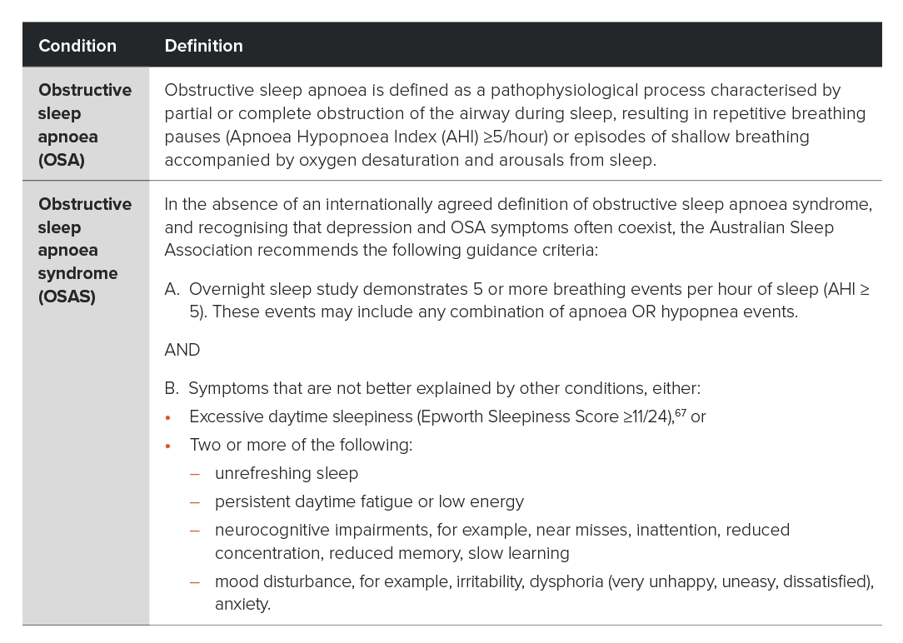

Initial assessment and management
Consistent with the overall risk management approach of the Standard and the management of other chronic conditions such as cardiovascular disease, the assessment and management of sleep disorders and sleep disorder risk, focuses on the most common disorder of sleep (obstructive sleep apnoea) and aims to:
- identify workers with severe impairment or disease that may have immediate implications for safety on the network
- identify workers with moderate impairment or disease for whom early management will likely prevent disease progression and support ongoing fitness for duty.

Figure 26. Sleep disorders - Initial assessment and management for Safety Critical Workers (Category 1 and 2)
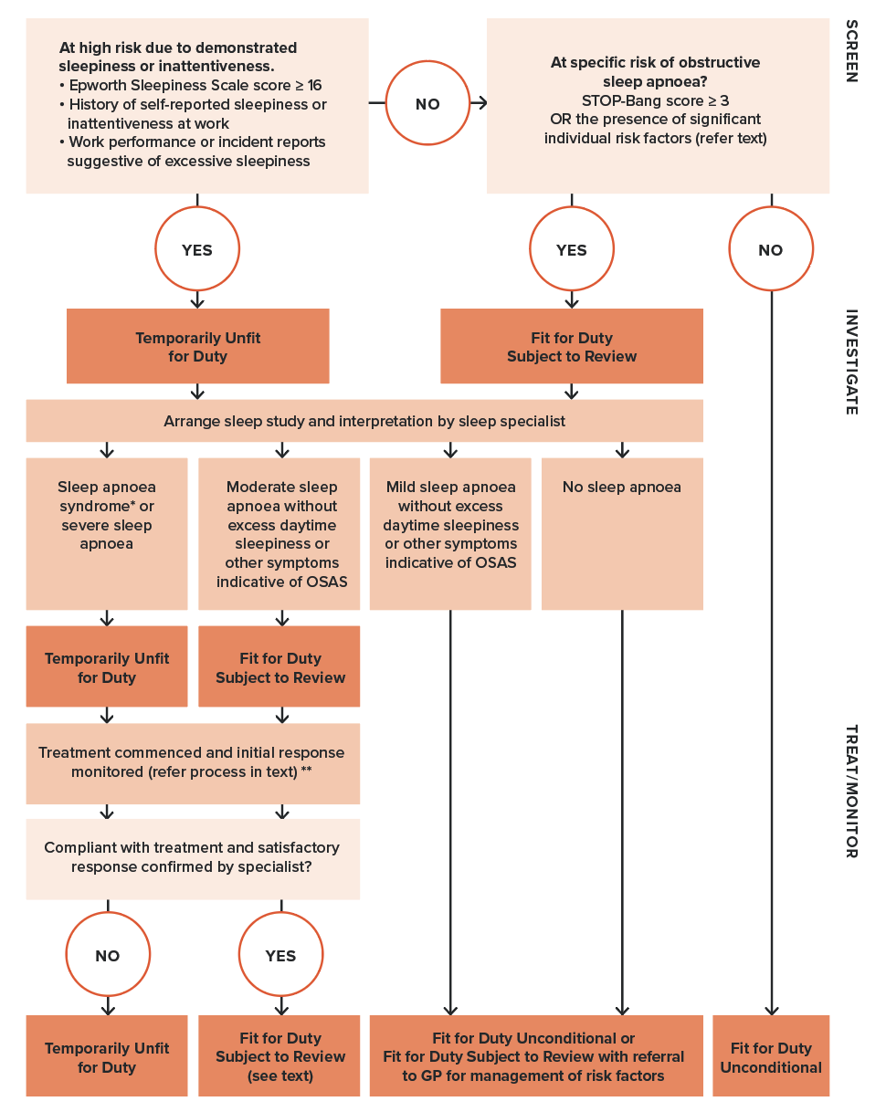
* See definition of OSAS (Figure 25)
** Review will be required while the treatment is being established and appropriate response is determined

The approach to the initial assessment and management of sleep disorders is summarised in Figure 26 and described below.
It involves:
- screening for excessive daytime sleepiness (relevant to all sleep disorders) using the self-reported ESS (refer to Figure 28), and considering safety incidents
- screening for specific risk of OSA using the STOP-Bang score (refer to Figure 29)
- referring as appropriate for a sleep study to confirm sleep disorder or otherwise (refer to page 233)
- referring those with a positive sleep study for specialist assessment and management (refer to page 234)
- monitoring to confirm compliance and appropriate response to treatment (refer to page 235).

Assessing for high risk of excessive daytime sleepiness and inattentiveness
The priority in terms of safety on the network is to determine whether the worker experiences excessive sleepiness or inattentiveness while working.
Witnessed episodes of dozing at work, unsatisfactory work performance or the occurrence of incidents may be indicative of these impacts and may prompt a Triggered Health Assessment, during which the patterns of sleepiness and other impacts can be explored with the worker in terms of possible causes, both medical and lifestyle related, or work related, such as shift work. Figure 27 provides examples of the possible concerns that could be considered and requested in a workplace report.
Figure 27. Workplace reports relevant to assessment and management of sleep disorders
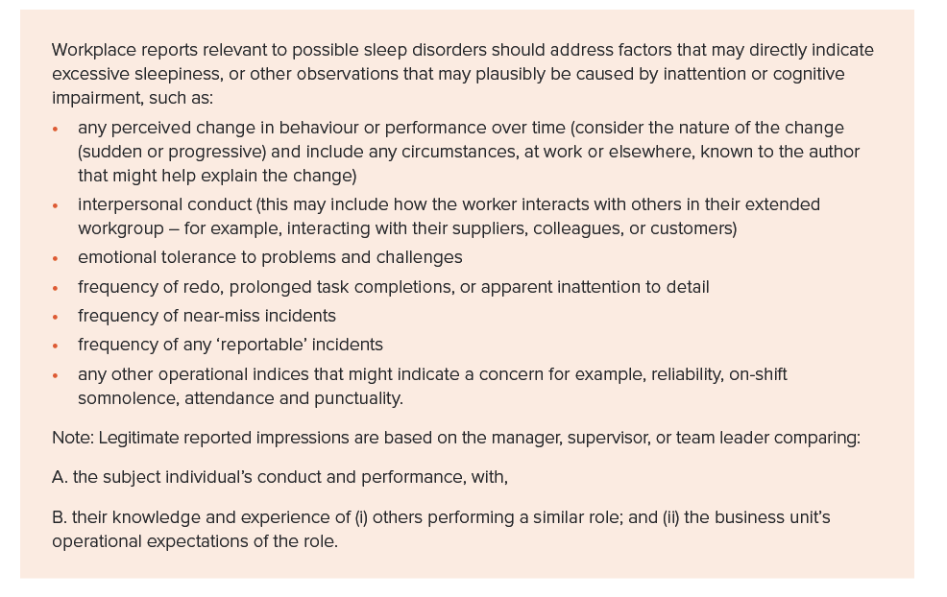
For Pre-placement and Change of grade Health Assessments and Periodic Health Assessments, the worker is asked to self-report sleepiness at work, declare any existing sleep disorders and respond to questions from the ESS, a subjective tool that asks about the likelihood of dozing in various circumstances, irrespective of the cause (refer to Figure 28). These aspects are included in the Health Questionnaire or administered by the Authorised Health Professional.
A feature of the syndromes of disordered sleep is lack of awareness of both the presence and severity of their condition. It is recognised that tests such as the ESS rely on the cognitive awareness and honest completion by the worker, hence incorrect reporting can occur. This is acknowledged, along with the role of such screening tools as just one aspect of a comprehensive assessment. The Authorised Health Professional may choose to administer or validate the questionnaire responses verbally.
Evidence of sleepiness at work, sleepiness-related incidents or a raised ESS (16 or more) warrant referral for a sleep study (see page 233). In most cases, the worker will need to be immediately categorised Temporarily Unfit for Duty pending further assessment.
It is noted that when the ESS is used in someone known to have OSA (AHI of 5 or greater) then a score of 11 or greater is evidence of a syndrome of disordered sleep. Similarly, when the ESS is used to monitor response to treatment, a score of less than 11 is a useful indicator that the syndrome of disordered sleep is improving.
Additional information on the use, administration and scoring of the ESS is available in Section 6.1.3. Epworth Sleepiness Scale.
Unexplained episodes of ‘sleepiness’ also require consideration of the causes of blackouts (refer to Section 4.1. Blackouts).

Figure 28. Epworth Sleepiness Scale questionnaire (included in Safety Critical Worker Health Questionnaire)

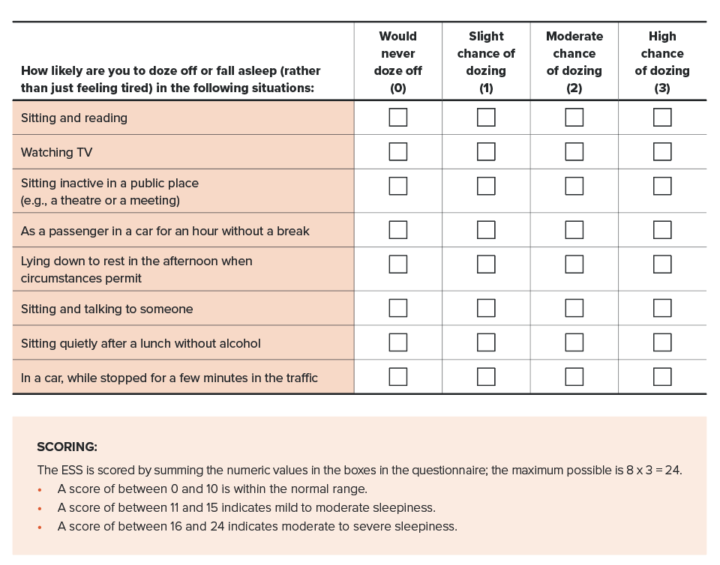
* The Epworth Sleepiness Scale is under copyright to Dr Murray Johns 1991, 1997. It may be used by individual doctors without permission, but its use on a commercial basis must be negotiated. https://epworthsleepinessscale.com/

Establishing the risk of obstructive sleep apnoea
Periodic Health Assessments (and Triggered Health Assessments, if indicated) also include assessment of the risk of OSA using the STOP-Bang questionnaire to identify workers who should undergo a sleep study (Figure 29).
This validated screening tool consists of 8 yes or no questions including age, gender, history of snoring, body mass index (BMI), neck circumference, self-reported tiredness, observed breathing problems during sleep and the presence of hypertension in its variety of forms. The questionnaire is administered by the Authorised Health Professional. A moderate to high risk of OSA is defined as a positive response to 3 or more items. It reflects the fact that all males over the age of 50 are at increased risk if they have just one other risk factor. Additional information on the use, administration and scoring of the STOP-Bang questionnaire is available in Section 6.1.4. STOP-Bang questionnaire.

Figure 29. STOP-Bang questionnaire
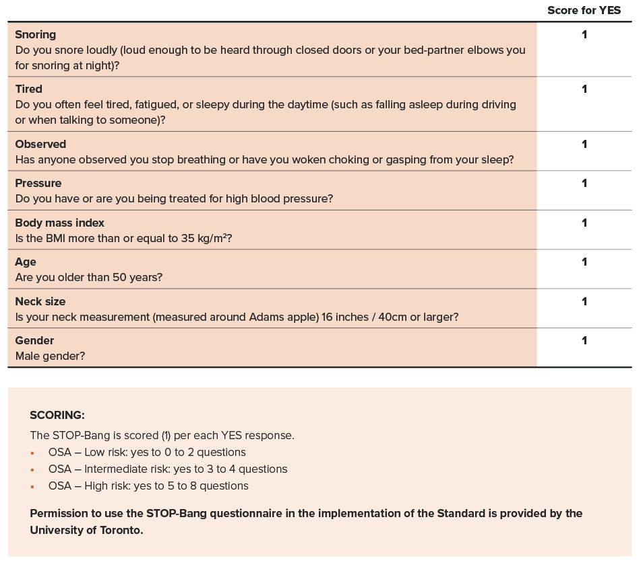

Significant individual risk factors
The presence of specific risk factors should also be considered. For example, treatment-resistant hypertension (defined as blood pressure requiring at least 3 medications to control) is associated with a very high risk for OSA, as is a BMI greater than 40. Workers with these features should be referred to for a sleep study irrespective of their STOP-Bang score.
While not included in the STOP-Bang, a diagnosis of type 2 diabetes adds to the suspicion of OSA, being strongly associated with the condition. The presence of atrial fibrillation (treated with reversion to sinus rhythm, or persistent despite treatment) is a further risk factor. Poor memory and concentration, morning headaches and insomnia may also be presenting features of a disordered sleep syndrome that are not included in the STOP-Bang instrument. Consequently, any history suggestive of a syndrome of disordered sleep should be referred for further investigation.

Polysomnography – referral, interpretation and repeat studies

Referral for polysomnography
Safety Critical Workers with confirmed or suspected daytime sleepiness or a raised STOP-Bang score (3 or greater), or other high-risk features should be referred for a sleep study (polysomnography). The results of the sleep study should be interpreted and reported by a sleep physician who has established quality assurance procedures for the data acquisition.
The worker may be categorised Fit for Duty Subject to Review or Temporarily Unfit for Duty (refer to Figure 26) depending on their circumstances and clinical risk profile.
While the gold standard test for diagnosing OSA is with in-laboratory full polysomnography with a sleep technician in attendance (Type 1), unattended home polysomnography (Type 2) is also adequate for diagnosis. Initial screening may be conducted using polysomnography packages that are available for home assessment (refer to Table 21).
Type 3 and Type 4 assessments are screening tests only and are not suitable for assessing Safety Critical Workers unless there is limited access to Type 2 studies. Home studies in general, and Type 3 studies in particular, underestimate severity. Consequently, if such a test demonstrates severely disordered breathing, then it can be considered diagnostic for the purposes of the Standard.
Table 21. Types of polysomnography (PSG) packages
Recommended for Safety Critical Worker assessment | Type 1 | Attended, in-laboratory, full PSG with ≥ 7 recording channels measuring sleep stage, breathing and cardiac parameters, and limb movements
 | Type 2 | Unattended, home, full PSG with ≥ 7 recording channels
Screening tests only and NOT recommended for Safety Critical Worker assessment | Type 3 | Limited (≥ 4 channel) monitoring of breathing parameters without sleep phase assessment
 | Type 4 | Limited channel monitoring of only 1–2 channels (for example, oximetry)

Interpretation of polysomnography results (OSA severity)
The severity of OSA is usually determined by the frequency of obstructive respiratory events and defined by the apnoea hypopnoea index (AHI), which is the average number of respiratory disturbances per hour of sleep. Variations to the AHI exist depending on the method employed by the sleep study, and there can be night-to-night variability of the number of breathing events per hour recorded.
OSA is generally defined as an AHI of 5 or more events per hour. In turn, moderate OSA is defined as an AHI of 15 to 29 events per hour and severe OSA is defined as an AHI of 30 or more events per hour. Significant sleep fragmentation may be important to note, and the oxygen desaturation nadir (SpO2 nadir) and the Oxygen Desaturation Index (ODI) are also markers of severity. The latter has been shown to correlate with cardiac risk.
The results of the sleep study, including the AHI value (or its equivalent), the ODI and the SpO2 nadir should be documented in the worker’s medical record, together with their weight and neck circumference at the time of the study, so that this information is available for consideration at subsequent health assessments.
Safety Critical Workers with a result consistent with moderate or greater severity (AHI of 15 or more) should be examined by a sleep specialist (video consultation is acceptable) to explain the diagnosis and treatment options and advise any ongoing monitoring requirements (see below). If the workplace report describes features of concern, this should be provided to the sleep physician (refer to Figure 27).

Repeat studies and management of risk factors
If a worker is found not to have OSAS or moderate to severe OSA but carries high-risk features that are likely to be present at subsequent assessments, the specialist should be asked to advise relevant triggers for the worker’s next sleep study.
Workers with untreated mild or moderate OSA with risk factors that deteriorate at subsequent health assessments, such as weight gain of 10 per cent or more, should be referred for specialist review, preceded by a repeat sleep study as appropriate
Safety Critical Workers found to have risk factors such as high BMI, high blood pressure or diabetes should be directed to their treating general practitioner for continuing care and, if applicable, their organisation’s health promotion program.
The Authorised Health Professional should determine the periodicity of subsequent (triggered) reviews based on their overall clinical assessment of the rail worker.

Treatment and monitoring of OSA and OSAS

Initial treatment
In all cases, initial determination of the diagnosis should be based on a report from a suitably qualified sleep specialist.
Treatment may be initiated prior to the worker being seen by a treating sleep specialist. There are various treatment options that might be recommended, a description of which is beyond the scope of the Standard.
Category 1 or 2 Safety Critical Workers who are diagnosed with OSAS or severe OSA should be categorised Temporarily Unfit for Duty while a satisfactory response to treatment is established. Timing of their return to work is individualised and may be managed by the Authorised Health Professional. As a guide, return to Safety Critical Work may be possible after one to two weeks of treatment when CPAP (continuous positive airway pressure) usage reports demonstrate satisfactory compliance and response (see below). Once adherence and adequate response to treatment is evident (as per Table 22), annual review may be all that is required (see below). The treating specialist must ratify response to treatment before ongoing Fit for Duty Subject to Review (at least annual) is established.
Safety Critical Workers diagnosed with moderate OSA (that is, without self-reported sleepiness or workplace reports suggesting OSAS), may be categorised Fit for Duty Subject to Review while awaiting specialist advice. Once specialist treatment recommendations are identified and established, the Authorised Health Professional may determine the frequency of review, including to monitor the modifiable risk factors associated with the disorder.

Ongoing monitoring and review
For Category 1 and Category 2 Safety Critical Workers with OSAS or severe OSA, at least annual review by a suitably qualified specialist is the general requirement of the Standard.
The Chief Medical Officer of a rail transport operator, may, however establish a policy whereby reviews can be carried out by workers’ treating general practitioners or the organisation’s contracted Authorised Health Professionals. Such a policy should only apply to Safety Critical Workers who demonstrate an established pattern of adherence and a satisfactory response to treatment.
Those treated with CPAP should use a CPAP machine with a usage meter to allow objective assessment and recording of treatment compliance and satisfactory response to treatment. A report of usage for at least the 3 months immediately prior to the review, should be reviewed at each annual review. Minimally acceptable compliance with treatment recommendations is defined as use for 4 hours or more per day of use on 70 per cent or more of days in the reporting period.
Post-marketing experience has revealed there are currently no reliable usage detection devices available for those patients choosing to be treated with mandibular splints. While potentially appropriate for less severe conditions, they are not appropriate for first line therapy of Category 1 or Category 2 Safety Critical Workers with severe OSA or confirmed OSAS. These patients should be closely monitored by a sleep physician. Mandibular advancement splints (or other therapies) may potentially be deemed appropriate by the sleep physician in cases where CPAP is not tolerated. In this situation, a repeat sleep study on treatment and MWT is likely to be required.
Monitoring should include an assessment of symptoms, including sleepiness and impacts on cognitive performance. Measurements of wakefulness, such as the 4 by 40-minute Maintenance of Wakefulness Test (MWT) (see below) may assist in understanding the worker’s treatment needs and support clinical decision-making by the assessing specialist.
For a worker who has been diagnosed with OSA (of any severity), a repeat sleep study may be recommended by a sleep physician to re-evaluate the management needs of the diagnosed disorder. For example, if the worker has lost substantial weight, they may no longer require CPAP to manage their OSA, and other treatment options may be suitable. In such cases a validated sleep study and MWT may support the reduction in therapeutic requirements. Consequently, the worker may no longer need to provide their CPAP usage reports and undergo annual review by their sleep specialist. However, they should continue to undergo annual review to monitor their modifiable risk factors.

Unable to tolerate treatment or refusal of treatment
Due to the limitations of the test and the risks to rail safety, Safety Critical Workers with OSAS or severe OSA are not exempt from treatment even if they have a normal MWT result. Such workers may be offered non-safety critical work until such time effective treatment can be established.
Safety Critical Workers with OSA who refuse or are unable to comply with recommended treatment options may choose to discuss with their sleep specialist the role of the MWT. However, while this test may objectively assess daytime sleepiness, it does not assess the impact that severely disordered sleep may have on cognitive function and higher executive functions such as reasoning and judgement. Furthermore, although the MWT may be used to assist the sleep specialist to monitor the response to therapy, or assess workers with lesser severities of OSA who are not on treatment, the MWT may not be used instead of therapy in workers with severe OSA or OSAS.
The conduct of the MWT should comply with the following requirements:
- It should include drug and alcohol testing (with laboratory confirmation testing of any non-negative testing results).
- It should comprise four 40-minute test periods.
- In the case of non-CPAP treatments, such as a mandibular advancement device, the worker should use their current treatment in order to control their sleep apnoea before the MWT.
- If the worker is not planning on using any treatment for their sleep apnoea (not applicable to severe OSA or OSAS), then the MWT should be conducted after a non treatment period of at least 2 weeks.
Under these conditions of refusal or unable to tolerate CPAP treatment, concerning the MWT, a worker demonstrating a normal MWT may be categorised as Fit for Duty Subject to Review, only if all the following criteria are met:
- Where applicable, the treating sleep physician can attest that their patient is adherent to their recommended non-CPAP treatment strategies (for example, mandibular advancement splint, there is evidence of progressive weight loss).
- The workplace report indicates an acceptable safety record (the worker does not have incidents associated with inattentiveness).
- The worker has no evidence of obesity hypoventilation syndrome.
Those with an abnormal MWT or a workplace report that records safety incidents associated with inattentiveness, should remain Temporarily Unfit for Duty until appropriate treatment is shown to be effective.
Any documented deterioration in risk factors, symptoms or change in safety record should trigger a review by the treating sleep physician.
A repeat sleep study and further MWT (where applicable) should otherwise be conducted at least every 3 years even if age is the only change in the risk factor profile.

Narcolepsy and other disorders of hypersomnolence
Diagnosis of narcolepsy, idiopathic hypersomnia and other central disorders of hypersomnolence is made on the combination of clinical features, HLA (human leukocyte antigen) typing and multiple sleep latency test (MSLT), with a diagnostic sleep study on the previous night to exclude other sleep disorders and aid interpretation of the MSLT.
Narcolepsy is present in 0.05 per cent of the population and usually starts in the second or third decade of life. There are two types of narcolepsy – type 1 and 2.
In narcolepsy type 1, sufferers present with excessive sleepiness and can have periods of sleep with little or no warning of sleep onset. Other symptoms include cataplexy (sudden loss of muscle tone precipitated by an emotional stimulus), sleep paralysis and vivid hypnagogic hallucinations. The majority of sufferers of narcolepsy type 1 are HLA-DQB1*06:02 (a serotype) positive.
Narcolepsy type 2 and other central disorders of hypersomnolence, such as idiopathic hypersomnia, often share similar features and are more common than narcolepsy type 1. Sufferers present with excessive daytime sleepiness or an excessive need for sleep, or both. Cataplexy is not present.
Subjects suspected of having narcolepsy or another central disorder of hypersomnolence should be referred to a sleep physician or neurologist for assessment (including a MSLT) and management. If the diagnosis is suspected and supported by a workplace report, they should be categorised Temporarily Unfit for Duty until there have been no symptoms for 6 months. They should have a review at least annually by their specialist.
Sleepiness in narcolepsy and other hypersomnolence disorders may be managed effectively with scheduled naps and wakefulness promoting medication. Cataplexy is usually treated either with anti-depressants (for example, venlafaxine, tricyclic antidepressants) or sodium oxybate.
The MWT is a test that measures a person’s ability to stay awake in a quiet, dark and non-stimulating room. In narcolepsy, the MWT is given to people who are receiving treatment, in order to assess the effectiveness of treatment and to quantify daytime sleepiness in those who need to stay awake throughout the day.

Advice to workers
All workers suspected of having, or found to have, sleep apnoea or other sleep disorders should be advised about the potential impact on Safety Critical Work and strategies for maintaining fitness for duty. General advice should include:
- minimising unnecessary activity at times when normally asleep
- allowing adequate time for sleep
- avoiding working after having missed a large portion of their normal sleep
- avoiding alcohol and sedative medications
- resting if sleepy
- ensuring the sleep environment is cool, dark and quiet.
Safety Critical Workers are responsible for:
- notifying management if they are sleepy so they do not carry out rail safety work while impaired by fatigue, or if they may become so impaired
- complying with treatment, including management of lifestyle factors
- maintaining their treatment device
- attending review appointments
- honestly reporting their condition to their treating physician and the Authorised Health Professional.

4.11.4. Fitness for duty criteria for Safety Critical Workers
Fitness for duty criteria are outlined in Table 22.
It is important that health professionals familiarise themselves with both the general information above and the tabulated fitness for duty criteria before assessing a person’s fitness for duty.

Table 22. Sleep disorders: Fitness for duty criteria for Safety Critical Workers
Condition | Criteria
Sleep disorder risk assessment (sleepiness)  (refer to Figure 27, Figure 28) | Category 1 and Category 2 Safety Critical Workers  A person is not Fit for Duty Unconditional:  - if there is evidence of excessive daytime sleepiness such as one or more of the following:  - an ESS score of 16 or greater  - a history of self-reported sleepiness at work  - workplace reports indicating excessive sleepiness  - incident reports plausibly caused by inattention or sleepiness.  They should be categorised Temporarily Unfit for Duty and promptly assessed by a specialist in relation to a possible sleep disorder.  If a sleep disorder is diagnosed, see relevant criteria below.
Obstructive sleep apnoea risk assessment (STOP-Bang)  (refer to Figure 29) | Category 1 and Category 2 Safety Critical Workers  A person is not Fit for Duty Unconditional:  - if they are assessed as being at intermediate risk or higher of OSA, as evidenced by a STOP-Bang score greater than or equal to 3, or a combination of other high-risk features (refer to text).  They should be categorised Fit for Duty Subject to Review and promptly referred for overnight sleep study.  If a sleep disorder is diagnosed, see relevant criteria below.
Obstructive sleep apnoea | Category 1 and Category 2 Safety Critical Workers  Obstructive sleep apnoea syndrome (OSAS) (irrespective of severity of sleep apnoea)  A person is not Fit for Duty Unconditional:  - if the person has been diagnosed with OSAS (refer to text for definition); or  - if the person has a STOP-Bang score greater than or equal to 3 and self-reported excessive daytime sleepiness (ESS ≥ 11/24); or  - if the person has self-reported excessive daytime sleepiness (ESS ≥ 11/24 and AHI ≥ 5); or  - if the person has AHI greater than or equal to 5 and their workplace report is consistent with a syndrome of disordered sleep.  They should be categorised Temporarily Unfit for Duty until a satisfactory response to treatment is observed.  Fit for Duty Subject to Review may be determined, taking into account the nature of the work and information provided by an appropriate specialist* in sleep disorders as to whether the following criteria are met:  - the person is compliant with treatment**; and  - the response to treatment is satisfactory.  The person should be subject to at least annual review by a sleep specialist.*  Severe sleep apnoea (without excessive daytime sleepiness or other syndrome features)  A person is not Fit for Duty Unconditional:  - if the person has severe sleep apnoea on a diagnostic sleep study (AHI greater than 30 events per hour) without self-reported excessive daytime sleepiness or other features of OSAS.  They should be categorised Temporarily Unfit for Duty until a satisfactory response to treatment is observed.  Fit for Duty Subject to Review may be determined taking into account the nature of the work and information provided by an appropriate specialist* in sleep disorders as to whether both the following criteria are met:  - the person is compliant with treatment**; and  - the response to treatment is satisfactory.  The person should be subject to at least annual review by a sleep specialist*.  Moderate sleep apnoea (without excessive daytime sleepiness or other syndrome features)  A person is not Fit for Duty Unconditional:  - if the person has moderate sleep apnoea on a diagnostic sleep study (AHI of 15 to 29 events per hour) without self-reported excessive daytime sleepiness or other features of OSAS.  They may be initially categorised Fit for Duty Subject to Review unless excessive daytime sleepiness or cognitive impairment is suspected, in which case they should be categorised Temporarily Unfit for Duty while treatment is established (as above).  Fit for Duty Subject to Review may be determined, taking into account the nature of the work and information provided by an appropriate specialist* in sleep disorders as to whether the following criteria are met:  - the person is compliant with treatment if prescribed**; and  - the response to treatment is satisfactory.  The period of review may be determined by the Authorised Health Professional taking into consideration advice from the treating health professional.  * The initial granting of Fit for Duty Subject to Review must be based on information provided by a specialist. The Chief Medical Officer of a rail transport operator may establish a policy whereby subsequent reviews may be carried out by the worker's treating general practitioners or the operator’s contracted Authorised Health Professionals. Such a policy would apply only to Safety Critical Workers who demonstrate an established pattern of compliance and good response to treatment.  ** If a person does not tolerate or refuses treatment, they must discuss their options with their treating sleep specialist and follow any recommendations of the sleep specialist (including any special tests). The specialist must provide a satisfactory report and the worker must demonstrate a satisfactory safety record. Refer to text for details.
Narcolepsy and idiopathic hypersomnia | Category 1 and Category 2 Safety Critical Workers  A person is not Fit for Duty Unconditional:  - if narcolepsy or another central disorder of hypersomnolence is confirmed.  Fit for Duty Subject to Review may be determined, subject to annual review, taking into account the nature of the work and information provided by a specialist in sleep disorders as to whether the following criteria are met:  - a clinical assessment has been made by a sleep physician; and  - cataplexy has not been a feature in the past; and  - medication is taken regularly; and  - symptoms have been appropriately controlled for 6 months; and  - normal sleep latency is present on MWT (on or off medication).
Other causes of excessive daytime sleepiness | Refer to guidelines in the text.

Temporary illnesses. The Standard does not deal with the many conditions that may affect health on a short-to-medium-term basis and for which a Safety Critical Worker may be referred for assessment regarding fitness to resume duty. Clinical judgement is usually required on a case-by-case basis, although the text in each section gives some advice on the clinical issues to be considered.
Undifferentiated illness. A Safety Critical Worker may present with symptoms that could have implications for their job, but the diagnosis is not clear. Referral and investigation of the symptoms will mean that there is a period of uncertainty before a definitive diagnosis is made, and before the worker and employer can be confidently advised. Each situation will need to be assessed individually, with due consideration being given to the probability of a serious disease that will affect Safety Critical Work. Generally, workers presenting with symptoms of a potentially serious nature should be categorised as Temporarily Unfit for Duty until their condition can be adequately assessed. However, they may be suitable for alternative duties, including duties at a lower risk category (for example, Category 2 or Category 3). Workers who are fit to continue work while being investigated should be categorised as Fit for Duty Subject to Review.
Specialist review. The Standard generally requires Safety Critical Workers who are assessed as Fit for Duty Subject to Review to be seen by a specialist leading up to their review appointment with the Authorised Health Professional. Exceptions are specifically described in the Standard where appropriate.

References and further reading – Sleep disorders
Abeyaratne M, Casolin A and Luscombe GM (2023) ‘Safety incidents and obstructive sleep apnoea in railway workers’, Occupational Medicine, 73(2):97-102
Adams RJ, Appleton SL, Taylor AW, Gill TK, Lang C, McEvoy RD and Antic NA (2017) ‘Sleep health of Australian adults in 2016: results of the 2016 Sleep Health Foundation national survey’, Sleep Health, 3(1):35-42.
Aldrich MS, Chervin RD and Malow BA (1997) ‘Value of the multiple sleep latency test (MSLT) for the diagnosis of narcolepsy’, Sleep, 20(8):620-9.
Amra B, Javani M, Soltaninejad F, Penzel T, Fietze I, Schoebel C and Farajzadegan Z (2018) ‘Comparison of Berlin Questionnaire, STOP-Bang, and Epworth Sleepiness Scale for Diagnosing Obstructive Sleep Apnea in Persian Patients’, International Journal of Preventative Medicine, 9(1):28.
Amra B, Rahmati B, Soltaninejad F and Feizi A (2018) ‘Screening Questionnaires for Obstructive Sleep Apnea: An Updated Systematic Review’, Oman Medical Journal, 33(3):184-92.
Andrews G and Slade T (2001) ‘Interpreting scores on the Kessler Psychological Distress Scale (K10)’, Australian and New Zealand Journal of Public Health, 25(6):494-7.
Appleton SL, Gill TK, Lang CJ, Taylor AW, McEvoy RD, Stocks NP, González-Chica DA and Adams RJ (2018) ‘Prevalence and comorbidity of sleep conditions in Australian adults: 2016 Sleep Health Foundation national survey’, Sleep Health, 4(1):13-19.
Austroads Ltd and NTC (2022) Assessing Fitness to Drive 2022: for commercial and private vehicle drivers.
Berger M, Varvarigou V, Rielly A, Czeisler CA, Malhotra A and Kales SN (2012) ‘Employer-mandated sleep apnea screening and diagnosis in commercial drivers’, Journal of Occupational Environmental Medicine, 54(8):1017-25.
Boynton G, Vahabzadeh A, Hammoud S, Ruzicka DL and Chervin RD (2013) ‘Validation of the STOP-BANG Questionnaire among Patients Referred for Suspected Obstructive Sleep Apnea’, Journal of Sleep Disorders: Treatment and Care, 2(4).
Chakrabarti S, Singh M, Kumar R, Gupta N, Rathi,V and Ish P (2019) ‘Comparison of Epworth Sleepiness Scale and STOP-BANG Questionnaire for Diagnosing Obstructive Sleep Apnea at a Tertiary Care Centre in North India: A Retrospective Study’, Indian Journal of Sleep Medicine, 14(3):46-50.
Chung F and University Health Network, STOP-Bang questionnaire, http://www.stopbang.ca/osa/screening.php
Charlton JL, Di Stefano M, Dow J, Rapoport MJ, O’Neill D, Odell M, Darzins P and Koppel S (2021) Influence of chronic illness on crash involvement of motor vehicle drivers: 3rd Edition, Monash University Accident Research Centre.
Chung F, Yegneswaran B, Liao P, Chung SA, Vairavanathan S, Islam S, Khajehdehi A and Shapiro CM (2008) ‘STOP questionnaire: a tool to screen patients for obstructive sleep apnea’, Anesthesiology, 108(5):812-21.
Chung F, Subramanyam R, Liao P, Sasaki E, Shapiro C, Sun Y (2012) ‘High STOP-Bang score indicates a high probability of obstructive sleep apnoea’, British Journal of Anaesthesia, 108(5):768-75.
Chung F, Yang Y, Brown R and Liao P (2014) ‘Alternative scoring models of STOP-bang questionnaire improve specificity to detect undiagnosed obstructive sleep apnea’, Journal of Clinical Sleep Medicine, 10(9):951-8.
Colquhoun CP and Casolin A (2016) ‘Impact of rail medical standard on obstructive sleep apnoea prevalence', Occupational Medicine, 66(1):62-8.
Dorrian J, Chapman J, Bowditch L, Balfe N and Naweed A (2022) ‘A survey of train driver schedules, sleep, wellbeing, and driving performance in Australia and New Zealand’, Scientific Reports, 12(1):3956.
Douglas JA, Chai-Coetzer CL, McEvoy D, Naughton MT, Neill AM, Rochford P, Wheatley J and Worsnop C (2017) ‘Guidelines for sleep studies in adults – a position statement of the Australasian Sleep Association’, Sleep Medicine, 36(1):S2–S22.
Ellender CM, Jones C, Duce B, Winter S and Hukins C (2022) ‘Conducting CPAP review appointment – timing, tips and troubleshooting’, Medicine Today, 23(1-2):23-28.
Farney RJ, Walker BS, Farney RM, Snow GL and Walker JM (2011) ‘The STOP-Bang equivalent model and prediction of severity of obstructive sleep apnea: relation to polysomnographic measurements of the apnea/hypopnea index’, Journal of Clinical Sleep Medicine, 7(5):459-65.
Findley LJ, Fabrizio MJ, Knight H, Norcross BB, LaForte AJ and Suratt PM (1989) ‘Driving simulator performance in patients with sleep apnea’, American Review of Respiratory Diseases, 140(2):529-30.
George CF (2001) ‘Reduction in motor vehicle collisions following treatment of sleep apnoea with nasal CPAP’, Thorax, 56(7):508-12.
Hartenbaum N, Collop N, Rosen IM, Phillips B, George CF, Rowley JA, Freedman N, Weaver TE, Gurubhagavatula I, Strohl K, Leaman HM, Moffitt GL and Rosekind MR (2006) ‘Sleep apnea and commercial motor vehicle operators: statement from the Joint Task Force of the American College of Chest Physicians, American College of Occupational and Environmental Medicine, and the National Sleep Foundation’, Journal of Occupational and Environmental Medicine, 48(9).
Howard M and O’Donoghue F (2016) ‘The hidden burden of OSA in Safety Critical Workers: how should we deal with it?’, Occupational Medicine, 66(1):2-4.
Howard M, Desai AV, Grunstein RR, Hukins C, Armstrong JG, Joffe D, Swann P, Campbell DA and Pierce RJ (2004) ‘Sleepiness, sleep-disordered breathing, and accident risk factors in commercial vehicle drivers’, American Journal of Respiratory and Critical Care Medicine, 170(9):1014-21.
International Diabetes Federation (2001) Consensus statement on sleep apnoea and type 2 diabetes.
Jonas DE, Amick HR, Feltner C, Weber RP, Arvanitis M, Stine A, Lux L, Middleton JC, Voisin C and Harris RP (2017) ‘Screening for Obstructive Sleep Apnea in Adults: An Evidence Review for the U.S. Preventive Services Task Force’, Rockville (MD): Agency for Healthcare Research and Quality (US), Report No. 14-05216.
Krysta K, Bratek A, Zawada K and Stepańczak R (2017) ‘Cognitive deficits in adults with obstructive sleep apnea compared to children and adolescents’, Journal of Neural Transmission, 124(Suppl 1):187-201.
Lechat B, Naik G, Reynolds A, Aishah A, Scott H, Loffler KA, Vakulin A, Escourrou P, McEvoy RD, Adams RJ, Catcheside PG and Eckert DJ (2022) ‘Multinight prevalence, variability, and diagnostic misclassification of obstructive sleep apnoea’, American Journal of Respiratory and Critical Care Medicine, 205(5):563-9.
Lloberes P, Levy G, Descals C, Sampol G, Roca A, Sagales T and de la Calzada MD (2000) ‘Self-reported sleepiness while driving as a risk factor for traffic accidents in patients with obstructive sleep apnoea syndrome and in non-apnoeic snorers’, Respiratory Medicine, 94(10):971-6.
Masa JF, Rubio M and Findley LJ (2000) ‘Habitually sleepy drivers have a high frequency of automobile crashes associated with respiratory disorders during sleep’, American Journal of Respiratory and Critical Care Medicine, 162(4 pt 1):1407-12.
McArdle N, Reynolds AC, Hillman D, Moses E, Maddison K, Melton P and Eastwood P (2022) ‘Prevalence of common sleep disorders in a middle-aged community sample’, Journal of Clinical Sleep Medicine, 18(6):1503-14.
McArdle N and Eastwood PR (2022) ‘Shift work, clinically significant sleep disorders and mental health in a representative, cross-sectional sample of young working adults’, Scientific Reports, 12(1):16255.
Mehta A, Qian J, Petocz P, Darendeliler MA and Cistulli PA (2000) ‘A randomized, controlled study of a mandibular advancement splint for obstructive sleep apnea’, American Journal of Respiratory and Critical Care Medicine, 163(6):1457-61.
Nagappa M, Liao P, Wong J, Auckley,D, Ramachandran SK, Memtsoudis S, Mokhlesi B and Chung F (2015) ‘Validation of the STOP-Bang Questionnaire as a Screening Tool for Obstructive Sleep Apnea among Different Populations: A Systematic Review and Meta-Analysis’, PLOS ONE, 10(12):e0143697.
Oscullo G, Torres G, Campos-Rodriguez F, Posadas T, Reina-González A, Sapiña-Beltrán E, Barbé F and Martinez-Garcie A (2019) ‘Resistant/refractory hypertension and sleep apnoea: current knowledge and future challenges’, Journal of Clinical Medicine, 8(11):1872.
Office of the National Rail Safety Regulator (2019) ONRSR Guideline Safety Management System (SMS), https://nraspricms01.blob.core.windows.net/assets/documents/Guideline/Safety-Management-System-Guideline-updated-1-July-2022.pdf
Philip P, Guichard K, Strauss M, Léger D, Pepin E, Arnulf I, Sagaspe P, Barateau L, Lopez R, Taillard J, Micoulaud-Franchi JA and Dauvilliers Y (2021) ‘Maintenance of wakefulness test: how does it predict accident risk in patients with sleep disorders.’ Sleep Medicine, 77:249-255.
Popević MB, Milovanović A, Nagorni-Obradović L, Nešić D, Milovanović J and Milovanović APS (2017) ‘Screening commercial drivers for obstructive sleep apnea: Validation of STOP-Bang questionnaire’, International Journal of Occupational Medicine and Environmental Health, 30(5):751-61.
Sarkissian L, Kitipornchai L, Cistulli,P and Mackay SG (2019) ‘An update on the current management of adult obstructive sleep apnoea’, Australian Journal of General Practice, 48(4):182-6.
Wickwire E, Geiger-Brown J, Scharf S, and Drake C (2017) ‘Shift Work and Shift Work Sleep Disorder, Clinical and Organizational Perspectives’, Chest, 151(5):1156–1172.
Wilson J, Morgan S, Magin PJ and van Driel ML (2014) ‘Fatigue – a rational approach to investigation’, Australian Family Physician, 43(7):457-61.

4.12. Substance misuse and dependence
(Refer also to Section 1.4.1. Drug and alcohol management programs)

4.12.1. Scope and definitions
This section focuses on diagnosis and management of Category 1 and Category 2 Safety Critical Workers who have substance misuse or substance dependence. It is concerned with all substances that can impair cognition in regard to safety.

Substance misuse
Substance misuse may be seen as a continuum ranging from mild or occasional use to severe or dependence.
For the purposes of the Standard, the term 'substance misuse' refers to the use of any substance, whether legal or illegal, which causes the individual social, psychological, physical or legal problems related to intoxication, binge use or dependence. This includes:
- chronic heavy consumption of alcohol
- misuse of prescription and over-the-counter medication
- use of illicit drugs
- use of natural unregulated intoxicants, for example, Datura, mushrooms, and the like.

Substance dependence
Substance dependence is a condition that falls within the substance misuse definition and, for the purposes of the Standard, is characterised by several of the following features:
- There is tolerance, as defined by either a need for markedly increased amounts of the substance to achieve intoxication or the desired effect, or a markedly diminished effect with continued use of the same amount of substance.
- There is withdrawal, as manifested by either the characteristic withdrawal syndrome for the substance, or the same (or a closely related) substance is taken to relieve or avoid withdrawal symptoms.
- The substance is often taken in larger amounts or during a longer period of time than was intended.
- There is a persistent desire or unsuccessful efforts to cut down or control substance use.
- A great deal of time is spent in activities to obtain the substance, use the substance or recover from its effects.
- Important social, occupational or recreational activities are given up or reduced because of substance use; and the substance use is continued despite knowledge of having a persistent or recurrent physical or psychological problem that is likely to have been caused or exacerbated by the substance (for example, continued drinking despite worsening a peptic ulcer; single or multiple convictions for drug and alcohol vehicle driving offences; marital discord and domestic violence, and so on).

Remission
For the purpose of the Standard, remission or recovery is attained when there is abstinence from use of illicit drugs or where the use of other substances, such as alcohol, has reduced in frequency to the point where it is unlikely to cause impairment of Safety Critical Work or to result in a positive test at work. Remission must be confirmed by biological monitoring (for example, urine drug testing, alcohol breath testing, liver function tests (LFT), carbohydrate deficient transferrin (CDT), urinary ethyl glucuronide (EtG), hair analysis for drugs) over a period of at least 6 months. At the conclusion of any monitoring a worker with remission may be certified Fit for Duty Subject to Review on a long-term basis (refer Section 4.12.4. General assessment and management guidelines).

4.12.2. Interface with drug and alcohol management programs
This section should be read in conjunction with the requirements of the RSNL and National Regulations regarding drug and alcohol management program requirements, as well as the ONRSR Safety Management System Guideline. Regulation 28 identifies a number of requirements, including that rail transport operators identify workers who have alcohol or other drug related problems and, where appropriate, refer those workers to be assessed and treated, counselled or rehabilitated.
The health assessment system for Safety Critical Workers described in this chapter is integral to a rail transport operator’s drug and alcohol management program. For example, it provides a mechanism by which a Safety Critical Worker may be referred for a Triggered Health Assessment if they are found to test positive to a drug or alcohol test (random or for cause) or there are other circumstances that indicate a potential problem such as recurrent drink driving convictions. The assessment may result in specialist referral and more regular review as part of a rehabilitation or return to work process.
Periodic Health Assessments conducted under the Standard do not routinely include drug and alcohol testing, however the assessment incorporates a behavioural screen for heavy alcohol use (Alcohol Use Disorders Identification Test (AUDIT)) and a clinical assessment, with specialist referral if indicated.
Pre-placement or Change of Risk Category Health Assessments may include a drug test, depending on the jurisdiction’s legislation and the rail transport operator’s requirements.
For all assessments conducted under the Standard, if a person is suspected of being intoxicated by alcohol or drugs at the time of an assessment, the Authorised Health Professional should assess them and enquire about possible reasons for their condition. Under these specific circumstances the doctor may conduct a drug and alcohol test in accordance with relevant legislation. If drug or alcohol intoxication is suspected or confirmed, the Authorised Health Professional should categorise the worker as Temporarily Unfit for Duty and notify the employer.
The presence of certain illicit drugs is an offence under the RSNL and will be managed accordingly. Working restrictions (that is, suspension of rail safety duties) following a positive drug test are imposed as determined by operational procedures governed by the RSNL. Medical fitness for duty may only be determined as a result of a medical review process (refer to flow chart in Figure 30 and Section 3.4.8. Drugs and rail safety work).

4.12.3. Relevance to Safety Critical Work
Both the acute and chronic effects of substance misuse are relevant to Safety Critical Work.

Alcohol
The acute effects of alcohol are well established; its use is incompatible with the conduct of Safety Critical Work as reflected in the RSNL as described above.
Chronic heavy alcohol use carries a risk of neurocognitive deficits (Wernicke–Korsakoff syndrome) relevant to safe working capability, including:
- short-term memory and learning impairments, which become more evident as the task difficulty increases
- impaired perceptual–motor speed
- impairment of visual search and scanning strategies
- deficits in executive functions, such as mental flexibility and problem-solving skills; difficulty in planning, organising and prioritising tasks; difficulty focusing attention, sustaining focus, shifting focus from one task to another, or filtering out distractions; difficulty monitoring and regulating self-action; or impulsivity.

Figure 30. Organisational and medical management of drug and alcohol misuse or dependence in Safety Critical Workers
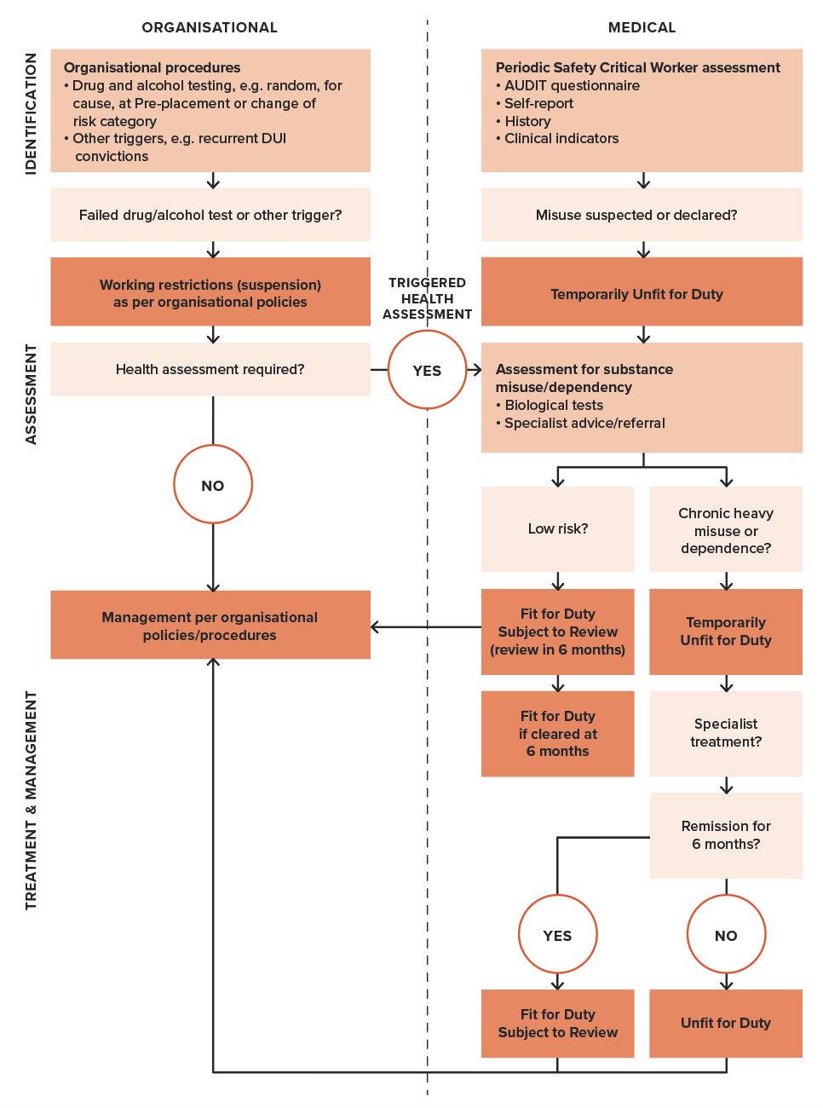
Peripheral neuropathies experienced as numbness or paraesthesia of the hands or feet may also occur, as well as lack of muscle coordination (ataxia).
In the event of the above end-organ effects relevant to safe working, the appropriate requirements should be applied as set out elsewhere in the Standard.
Alcohol-dependent people may experience a withdrawal syndrome (delirium tremens) on cessation or significant reduction of intake, which carries some risk of generalised seizure (refer to Acute symptomatic seizures), confusional states and hallucinations.
Of relevance to the management of Safety Critical Workers with alcohol dependence is that individuals with alcohol dependence have approximately twice the risk of (motor vehicle) crash involvement as controls. In addition, (vehicle) drivers with alcohol dependency are more likely to drive while intoxicated.

Other substances
Substances (prescribed, over the counter and illicit drugs) can be misused for their intoxicating, sedative or euphoric effects. Workers who are under the acute influence of these drugs, or craving for them or withdrawing from them, are more likely to behave in a manner incompatible with safe working. This may involve, but not be limited to, risk taking, aggression, feelings of invulnerability, narrowed attention, altered arousal states and poor judgement. Acute cannabis consumption is associated with increased road trauma.
The chronic effects of these substances vary and are not as well understood as those of alcohol. Some evidence suggests cognitive impairment is associated with chronic stimulant, opioid and benzodiazepine use. Those misusing these substances may be at risk of brain injury through hypoxic overdose, trauma or chronic illness. Withdrawal seizures may occur (refer to Acute symptomatic seizures).
Withdrawal symptoms can also vary and may include restlessness, insomnia, anxiety, aggression, anorexia, muscle tremor and autonomic effects.
End-organ damage, including cardiac, neurological and hepatic damage, may be associated with some forms of illicit substance use, particularly injection drug use. Cocaine and other stimulant misuse have been linked with cardiovascular pathology. In the event of end-organ effects relevant to Safety Critical Work, the appropriate requirements should be applied as set out elsewhere in the Standard.

Opioid analgesics for pain management
The long-term use of opioid analgesics is generally not accepted as an appropriate approach for chronic musculoskeletal pain management and therefore should be questioned. Workers using these agents or being treated with buprenorphine and methadone for opioid dependency should be referred for assessment by an appropriate specialist such as an addiction medicine specialist or addiction psychiatrist.

Effects of alcohol or drugs on other diseases
People who are frequently intoxicated and who also suffer from certain other medical conditions are often unable to give their other medical problems the careful attention required, which has implications for safe working.

Epilepsy
Many people with epilepsy are quite likely to have a seizure if they miss their prescribed medication even for a day or two, particularly when this omission is combined with inadequate rest, emotional turmoil, irregular meals, and alcohol or other substances. Patients under treatment for any kind of epilepsy are not fit for duty if they are frequently intoxicated.

Diabetes
People with insulin-dependent diabetes have a special problem if they are frequently intoxicated. Not only might they forget to inject their insulin at the proper time and in the proper quantity, but their food intake can also get out of balance with the insulin dosage. This may result in a hypoglycaemic reaction or the slow onset of diabetic coma. Such workers would not be fit for duty.

4.12.4. General assessment and management guidelines
The key consideration is to ensure workers with suspected or confirmed substance misuse problems do not present a risk to safety on the network, either from being acutely affected, or affected by the consequences of chronic use or withdrawal.
The flow chart in Figure 30 shows the steps of identification, assessment and treatment in the management of substance misuse and dependence, and also shows the interface between organisational approaches and Safety Critical Worker health assessments.

Identification
Triggered Health Assessments are an important mechanism of identifying and managing Safety Critical Workers with substance misuse disorders, as workers may not be inclined to self-report at Periodic Health Assessments. Substance misuse may be considered, for example, if a worker is referred by the rail transport operator as a result of poor performance or concerns about psychological ill-health.
Biological (urine, blood, saliva or breath) testing for drug or alcohol is not required as part of routine Periodic Health Assessments. However, in the course of the health assessment clinical examination the Authorised Health Professional should be alert for indications in the history of substance misuse, such as psychological problems.
For all assessments conducted under the Standard, if a person is suspected of being intoxicated by alcohol or drugs at the time of an assessment, the Authorised Health Professional should assess them and enquire about possible reasons for their condition. Under these specific circumstances the doctor may conduct a drug and alcohol test in accordance with relevant legislation. If drug or alcohol intoxication is suspected or confirmed, the Authorised Health Professional should categorise the worker as Temporarily Unfit for Duty and notify the employer.
Screening tests may be useful for identifying substance misuse and dependence disorders. For example, the Alcohol Use Disorders Identification Test (AUDIT) questionnaire is used to screen for risky of hazardous alcohol use, high-risk or harmful alcohol use and alcohol dependence, and is included in the Health Questionnaire (refer to Figure 31 and Table 23). The AUDIT relies on accurate responses to the questionnaire and should be interpreted in the context of a global assessment that includes other clinical evidence.
If the person appears unduly familiar with the AUDIT, other validated questionnaires may be applied (after consultation with the rail transport operator’s Chief Medical Officer or equivalent) and clinical judgement may be needed. Additional information on the use, administration and scoring of the AUDIT questionnaire is available in Section 6.1.5. Alcohol Use Disorders Identification Test questionnaire.

Figure 31. Alcohol Use Disorders Identification Test (AUDIT) questionnaire
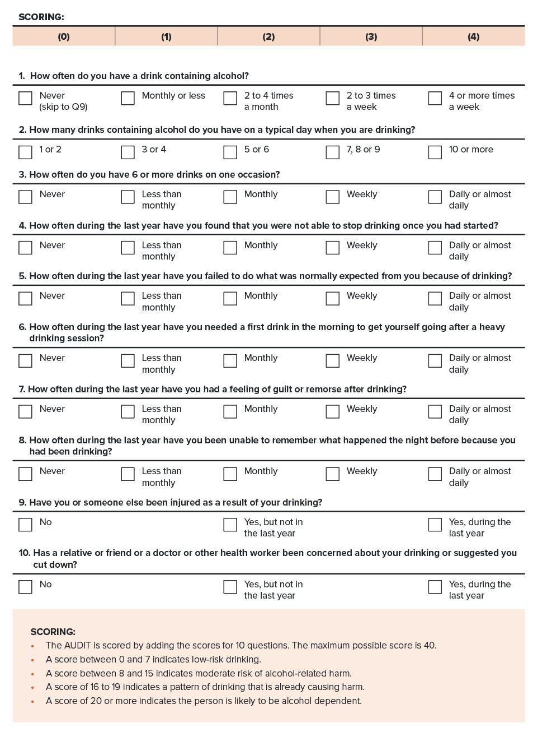

Assessment
Careful individual assessment must be made of workers who misuse or are suspected of misusing alcohol or other substances (prescribed or illicit), even if drug use is occasional. Assessment will require consideration of the worker’s substance use history, work attendance and performance records, response to any previous treatment and their level of insight.
During clinical assessment, patients may understate or deny substance use for fear of consequences of disclosure. In addition, the acute and chronic cognitive effects of some substance use also contribute to difficulty in obtaining an accurate history and identification of substance use. Assessment should therefore incorporate a range of indicators of substance use in addition to self-reporting, including, for example, CDT and LFT for alcohol misuse, or drug metabolites and hair analysis for drug misuse.
Authorised Health Professionals should be mindful that misuse may not be confined to a single drug class, and people may use multiple substances in combination. In addition, people who misuse substances may change from one substance to another. They should also be alert to the complex course of substance misuse; periods of abstinence of a number of months are a feature of dependence and should not be interpreted as sustainable recovery or as evidence that ongoing professional help is not required. Both dependence and recovery are best viewed as fluid rather than fixed states, thus underscoring the need for sustained and assertive recovery management.
Workers who are found to be misusing or are suspected of misusing alcohol or drugs should be categorised as Temporarily Unfit for Duty while their condition is being investigated.
Where dependence or chronic, heavy misuse is suspected by the Authorised Health Professional, the worker should be referred to (or discussed with) a doctor experienced in managing substance misuse disorders, for example a psychiatrist specialised in alcohol and drug misuse or an addiction medicine specialist, to assist in determining the level of substance use and the level of safety risk. People with a combined substance misuse disorder and mental illness (‘dual diagnosis’) often have a level of complexity requiring specialist assessment.

Management and treatment
If the risk of further substance misuse has been assessed as low, a worker should be categorised as Fit for Duty Subject to Review in 6 months’ time and subject to ongoing monitoring as per rail transport operator policy. If there is no evidence of substance misuse at the 6-month review, they may not require more frequent review subsequently, but their risk of substance misuse should be specifically addressed at subsequent Periodic Health Assessments.
Those assessed as having chronic or heavy substance misuse or dependence, should be categorised Temporarily Unfit for Duty. A strong response to treatment and well-documented abstinence and recovery (remission) may enable determination of Fit for Duty Subject to Review. Remission must be confirmed by biological monitoring (for example, urine drug testing, LFT, CDT, urinary EtG, hair analysis for drugs) over a period of at least 6 months. At the conclusion of any monitoring a worker with remission may be certified Fit for Duty Subject to Review on a long-term basis.
Patients with severe substance misuse problems or dependence who have had previous high rates of relapse and fluctuation in stabilisation would not be considered fit to return to Safety Critical Work.

4.12.5. Fitness for duty criteria for Safety Critical Workers
Fitness for duty criteria are outlined in Table 23.
It is important that health professionals familiarise themselves with both the general information above and the tabulated fitness for duty criteria before assessing a person’s fitness for duty.

Table 23. Substance misuse and dependence: Fitness for duty criteria for Safety Critical Workers
Condition | Criteria
AUDIT questionnaire | Category 1 and Category 2 Safety Critical Workers  If the person has an AUDIT score of greater than 8, the person may be categorised as Fit for Duty Subject to Review or Temporarily Unfit for Duty while causes are being assessed and managed (refer to Section 6.1.5. Alcohol Use Disorders Identification Test questionnaire):  - Workers with scores of 8 to 15 may be managed within the consultation by providing simple advice and information on the alcohol guidelines and risk factors. If the risk is assessed as being low, they should be categorised as Fit for Duty Subject to Review.  - Workers with scores of 16 to 19 should be managed by a combination of simple advice, brief counselling and continued monitoring. Follow-up and referral to the worker’s general practitioner is necessary. They should be categorised as Fit for Duty Subject to Review or Temporarily Unfit for Duty pending further assessment.  - Workers with scores of 20 or more should be referred to specialist services to consider withdrawal, pharmacotherapy and other more intensive treatments. They should be assessed as Temporarily Unfit for Duty pending further assessment.
Substance misuse (Continued overleaf) | Category 1 and Category 2 Safety Critical Workers  A person is not Fit for Duty Unconditional:  - if there is evidence of substance misuse.  The person should be categorised Temporarily Unfit for Duty while being assessed and managed.  Fit for Duty Subject to Review may be determined, with review in 6 months:  - if the risk of further substance misuse is assessed as being low.  If there is no evidence of substance misuse at the 6-month review, they may not require more frequent review, but their risk of substance misuse should be specifically addressed at subsequent Periodic Health Assessments.  In the case of chronic or heavy substance misuse or substance dependence, Fit for Duty Subject to Review may be determined, subject to at least annual review, taking into account the nature of the work and information provided by an appropriate specialist (such as an addiction medicine specialist or addiction psychiatrist) as to whether the following criteria are met:  - the person is involved in a treatment program and has been in remission* for at least 6 months as confirmed by biological monitoring; and  - there is an absence of cognitive impairments relevant to safe working; and  - there is absence of end-organ effects that impact on safe working (as described elsewhere in the Standard); and  - the risk of further substance misuse is assessed as being low.  * For the purpose of the Standard, remission or recovery is attained when there is abstinence from use of illicit drugs or where the use of other substances, such as alcohol, has reduced in frequency to the point where it is unlikely to cause impairment of Safety Critical Work or to result in a positive test at work.  Remission must be confirmed by biological monitoring (for example, urine drug testing, LFT, CDT, urinary EtG, hair analysis for drugs) over a period of at least 6 months. At the conclusion of any monitoring a worker with remission may be certified Fit for Duty Subject to Review on a long-term basis.

Temporary illnesses. The Standard does not deal with the many conditions that may affect health on a short-to-medium-term basis and for which a Safety Critical Worker may be referred for assessment regarding fitness to resume duty. Clinical judgement is usually required on a case-by-case basis, although the text in each section gives some advice on the clinical issues to be considered.
Undifferentiated illness. A Safety Critical Worker may present with symptoms that could have implications for their job, but the diagnosis is not clear. Referral and investigation of the symptoms will mean that there is a period of uncertainty before a definitive diagnosis is made, and before the worker and employer can be confidently advised. Each situation will need to be assessed individually, with due consideration being given to the probability of a serious disease that will affect Safety Critical Work. Generally, workers presenting with symptoms of a potentially serious nature should be categorised as Temporarily Unfit for Duty until their condition can be adequately assessed. However, they may be suitable for alternative duties, including duties at a lower risk category (for example, Category 2 or Category 3). Workers who are fit to continue work while being investigated should be categorised as Fit for Duty Subject to Review.
Specialist review. The Standard generally requires Safety Critical Workers who are assessed as Fit for Duty Subject to Review to be seen by a specialist leading up to their review appointment with the Authorised Health Professional. Exceptions are specifically described in the Standard where appropriate.

References and further reading – Substance misuse and dependence
Ashton CH (2001) ‘Pharmacology and effects of cannabis: a brief review’, British Journal of Psychiatry, 178:101–6.
Australian and New Zealand College of Anaesthetists (2020) Faculty of Pain Management: Statement regarding the use of opioid analgesics in patients with chronic non- cancer pain.
Berghaus G, Sticht G, Grellner W, Lenz D, Naumann T and Wiesenmüller S (2011) Meta-analysis of empirical studies concerning the effects of medicines and illegal drugs including pharmacokinetics on safe driving. Druid.
Borkenstein R, Crowther R and Shumate R (1974) ‘The role of the drinking driver in traffic accidents’, Blutalkohol, 11:1–131.
Broyd SJ, van Hell HH, Beale C, Yücel M and Solowij N (2016) ‘Acute and chronic effects of cannabinoids on human cognition – a systematic review’, Biological Psychiatry, 79:557–67.
Brust JCM. (2014) ‘Neurologic complications of illicit drug abuse’, CONTINUUM: Lifelong Learning in Neurology, 20:642–56.
Bush K, Kivlahan DR, McDonell MB, Fihn SD and Bradley KA (1998) ‘The AUDIT alcohol consumption questions (AUDIT-C): an effective brief screening test for problem drinking’, Archives of Internal Medicine, 158:1789–95.
Charlton JL, Di Stefano M, Dow J, Rapoport MJ, O’Neill D, Odell M, Darzins P and Koppel S (2021) Influence of chronic Illness on crash involvement of motor vehicle drivers: 3rd edition. Monash University Accident Research Centre Reports 353. Melbourne, Australia: Monash University Accident Research Centre.
Coffey C, Carlin JB, Degenhardt L, Lynskey M, Sanci L and Patton GC (2002) ‘Cannabis dependence in young adults: an Australian population study’, Addiction, 97:187–94.
Drummer OH (2009) ‘Epidemiology and traffic safety: culpability studies’, in Drugs, Driving and Traffic Safety, 93–106 (Birkhäuser Basel). doi:10.1007/978-3- 7643-9923-8_7.
Drummer OH and Yap S (2016) ‘The involvement of prescribed drugs in road trauma’, Forensic Science International, 265:17–21.
Drummer OH, Gerostamoulos D, Di Rago M, Woodford NW, Morris C, Frederiksen T, Jachno K and Wolfe R (2020) ‘Odds of culpability associated with use of impairing drugs in injured drivers in Victoria, Australia’, Accident Analysis and Prevention, 135:105389.
Elvik R. (2013) ‘Risk of road accident associated with the use of drugs: a systematic review and meta-analysis of evidence from epidemiological studies’, Accident Analysis and Prevention, 60:254–67.
EMCDDA (2014) Drug use, impaired driving and traffic accidents – 2nd edition. European Monitoring Centre for Drugs and Drug Addiction http://bookshop.europa.eu doi:10.2810/26821.
Frishman WH, Del Vecchio A, Sanal S and Ismail A (2003) ‘Cardiovascular manifestations of substance abuse: Part 2: Alcohol, amphetamines, heroin, cannabis, and caffeine’, Heart Disease, 5:253–71.
Garrisson H, Scholey A, Ogden E and Benson S (2021) ‘The effects of alcohol intoxication on cognitive functions critical for driving: a systematic review’, Accident Analysis and Prevention, 154:106052.
Hartman RL and Huestis MA (2013) ‘Cannabis effects on driving skills’, Clinical Chemistry, 59:478–92.
Ogden EJD, Verster JC, Hayley AC, Downey LA, Hocking B, Stough CK, Scholey AB and Bonomo Y (2018) ‘When should the driver with a history of substance misuse be allowed to return to the wheel? A review of the substance misuse section of the Australian national guidelines’, Internal Medicine Journal, 48:908–15.
Panenka WJ, Procyshyn RM, Lecomte T, MacEwan GW, Flynn SW, Honer WG and Barr AM (2013) ‘Methamphetamine use: a comprehensive review of molecular, preclinical and clinical findings’, Drug and Alcohol Dependence, 129:167–79.
Parekh V (2019) ‘Psychoactive drugs and driving’, Australian Prescriber, 42:182–5.
Ramaekers JG (2018) ‘Driving under the influence of cannabis an increasing public health concern’, Journal of the American Medical Association, 319:1433–4.
Rogeberg O (2019) ‘A meta-analysis of the crash risk of cannabis-positive drivers in culpability studies: avoiding interpretational bias’, Accident Analysis and Prevention, 123:69–78.
Royal Australian College of General Practitioners (2015) Prescribing drugs of dependence in general practice, Part A: Clinical governance framework.
Royal Australian College of General Practitioners (2017) Prescribing drugs of dependence in general practice, Part C1: Opioids. www.racgp.org.au.
Royal Australian College of General Practitioners (2017) Prescribing drugs of dependence in general practice, Part C2: The role of opioids in pain management.
Royal Australian College of Physicians (2009) Prescription Opioid Policy: improving management of chronic non-malignant pain and prevention of problems associated with prescription opioid use.
Schnabel E, Hargutt V and Krüger HP (2010) Meta-analysis of empirical studies concerning the effects of alcohol on safe driving. Druid.
Schumann J, Perkins M, Dietze P, Nambiar D, Mitra B, Gerostamoulos D, Drummer OH, Cameron P, Smith K and Beck B (2021) ‘The prevalence of alcohol and other drugs in fatal road crashes in Victoria, Australia’, Accident Analysis and Prevention, 153:105905.
Seppala K, Korttila K, Häkkinen S and Linnoila M (1976) ‘Residual effects and skills related to driving after a single oral administration of diazepam, medazepam or lorazepam’, British Journal of Clinical Pharmacology, 3:831–41.
Silber BY, Papafotiou K, Croft RJ, Ogden E, Swann P and Stough C. (2005) ‘The effects of dexamphetamine on simulated driving performance’, Psychopharmacology, 179:536–43.
Skegg DCG, Richards SM and Doll R (1979) ‘Minor tranquillisers and road accidents’, British Medical Journal, 1:917–9.
Stough C, Downey LA, King R, Papafotiou K, Swann P and Ogden E (2012) ‘The acute effects of 3,4-methylenedioxymethamphetamine and methamphetamine on driving: a simulator study’, Accident Analysis and Prevention, 45:493–7.

4.13. Vision and eye disorders
(Refer also to Section 4.3. Diabetes, Section 4.6. Neurological conditions: general and dementia)

4.13.1. Relevance to Safety Critical Work
Good vision is essential for Safety Critical Work, including the tasks of driving trains and trams, operating other machinery, train controlling and working on or near the track. A worker with significant impairment of visual acuity or visual fields may fail to detect another train or member of the public and will take appreciably longer to perceive and react to signals or a potentially hazardous situation. The predictability of the track and route, as well as the height of seating above ground, provide some compensation for borderline cases with mild visual field loss, depending on the nature of the role.
Progressive eye conditions are a particular safety concern as changes can occur gradually, and the worker may not appreciate the extent or impact of visual impairment. Detection and regular monitoring of such conditions (for example cataract, glaucoma and diabetic retinopathy) are therefore important. Most inherited or acquired optic neuropathies (other than glaucoma), retinal degenerations and retinopathies are likely to be incompatible with Safety Critical Work as these involve substantial and (usually) progressive loss of visual acuity, visual field and colour discrimination.
Colour vision is also important for some safety critical tasks. For example, the identification of red, green and other coloured signals, flags and lights is necessary for the safe operation of trains (refer to Section 4.13.2. Colour vision risk assessment for Safety Critical Workers).

4.13.2. Colour vision risk assessment for Safety Critical Workers
Not all safety critical tasks require the ability to differentiate colours, and not all tasks require the same degree of colour differentiation. Generally, workers such as train drivers who need to distinguish red signals under all conditions, such as at high speed, at distance and in poor visibility, are required to have Normal Colour Vision as defined in Table 24. Where speed or distance is not crucial for signal recognition, a degree of colour vision impairment may be accommodated if the worker can distinguish red and green sufficiently accurately with time (Colour Defective Safe A). If colour differentiation is required only on flat surfaces such as flags and screens and is not time critical, then a further degree of impairment may be accommodated (Colour Defective Safe B). The categories of colour vision requirements are defined based on the nature of the tasks and testing outcomes as per Table 24.
The colour vision criteria should be applied on the basis of the colour vision risk assessment irrespective of the worker’s overall risk category. The risk assessment should be undertaken by the rail transport operator as per Figure 32 and communicated to the Authorised Health Professional in the health assessment request.
Assessment of a job requires consideration of:
- whether there is a need for colour differentiation
- if there is a need for colour differentiation, whether there is redundancy of information that obviates the need for red-green colour differentiation (for example, semaphore arms)
- if there is no redundancy, whether the job can be redesigned to eliminate the need for red-green colour differentiation
- if red colour differentiation is required, whether the task requires seeing colour as point sources (typically signals) or flat surfaces (typically flags or screens)
- if seeing point sources is required, what viewing conditions might be experienced, with the most adverse conditions requiring Normal Colour Vision (typically drivers) and lesser conditions requiring Colour Defective Safe A vision.
Table 25 includes examples of rail safety workers’ jobs and describes typical colour vision requirements. These are illustrative only and are not necessarily correct for any one network.
Table 24. Categories of colour vision
Colour vision category | Functional definition | Testing definition
Normal Colour Vision | Worker is required to differentiate red in point sources at high speed, far distance, and in poor light or weather conditions. | - Ishihara’s Pseudoisochromatic Plate Test - fewer than 3 errors OR  - Railway LED Lantern Test (RLLT) at 6 metres - PASS
Colour Defective Safe A | Worker is required to differentiate red in point sources but not under conditions such as high speed, long distance or poor light or weather conditions. | - RLLT at 3 metres - PASS
Colour Defective Safe B | Worker is required to differentiate red on flat surfaces such as flags or screens. | - If fail the above tests, pass two out of three applications of the Farnsworth D15 test.
Table 25. Examples of colour vision requirements for rail safety workers
Job | Example colour vision risk assessment | Colour vision requirements (Category) Example only
Training driver | Train drivers must be able to recognise colour signals. Positional cues are not always available because: red-green lights often operate from a single lens signal; lights from a signal might have no background or; illumination at night to help their identification; there might be dazzle from a low sun behind the signal; and red lights might be presented by a lantern in emergency situations, requiring rapid reaction.Combinations of red-yellow-green signals are used to inform the train driver of a safe speed and routing. | Normal Colour Vision
Tram driver | Tram drivers usually have to use traffic lights similarly to vehicle drivers. Road traffic lights have positional cues and hence redundancy of information. | No colour vision requirements  Colour vision testing not required
Heritage and tourist train drivers | Heritage and tourist train drivers who are not on a main line may have a semaphore arm on a signal that gives a positional cue (redundancy) as well as a red-green light. This only applies for daylight driving. The trains usually travel at low speed. | Colour Defective Safe A
Shunter | Shunters may need to identify all colours, including purple in some cases, although the trains they are guiding are generally moving slowly. They may work at night and be required to see red-green signals and use red-green lanterns for signalling. | Colour Defective Safe A
Signal repairer | Signal repairers need to recognise red and green at a distance from a single lens signal to check correctness of their repairs and to ensure safety of the network. However, they are not under time pressure to read the signal. | Colour Defective Safe A
Signaller | Signallers are required to identify panel lights. Older signal panels use LED lights whereas modern panels use LCD screens. | Colour Defective Safe B
Train controller | Train controllers who work with multicolour screen-based equipment may need to distinguish colours such as red, magenta, blue and green. | Colour Defective Safe B
Around the Track Personnel | Around the Track Personnel do not require colour vision testing under the Standard but may require it for other aspects of their role. | Colour vision requirements dependent on other tasks

Figure 32. Colour vision risk assessment
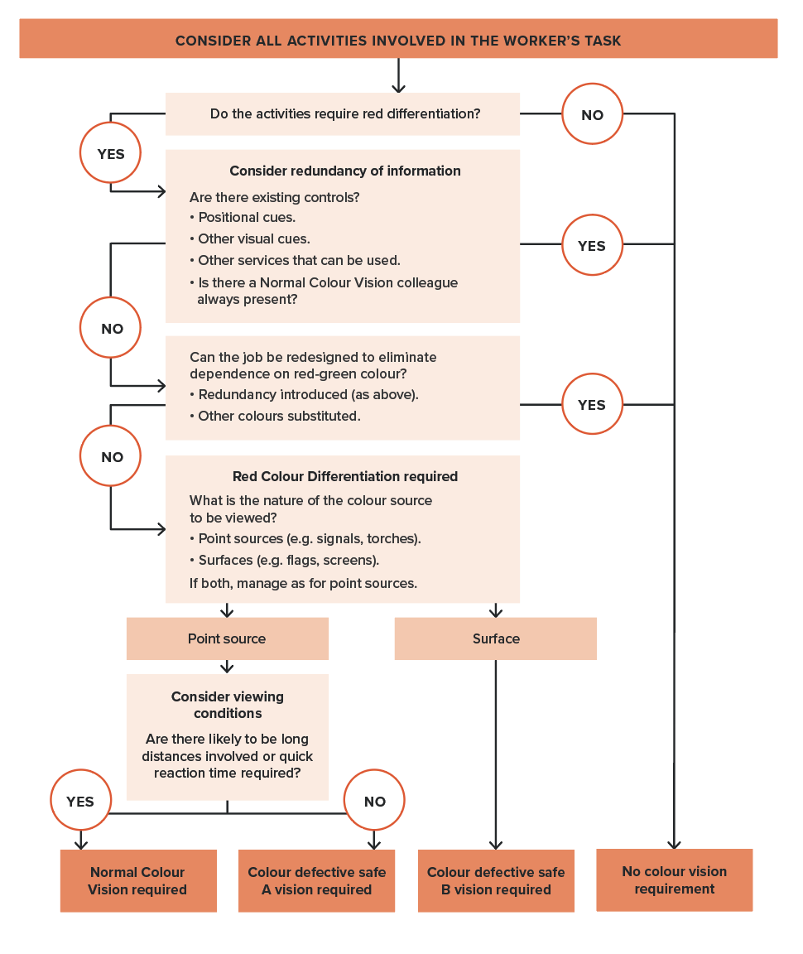

4.13.3. General assessment and management guidelines
History of visual impairment and vision disorders is established via the Health Questionnaire and previous health assessment records as appropriate. Findings should be discussed with the worker to determine the nature and cause of any vision disorders and the likelihood of progression. This in turn informs screening, management and monitoring.
Assessment is in relation to the three main visual attributes – acuity, visual fields and colour vision as described below. The fitness for duty criteria for visual acuity and visual fields are applicable to workers performing both Category 1 and Category 2 Safety Critical Work. Colour vision is assessed as per the outcome of the risk assessment described in Section 4.13.2. Colour vision risk assessment for Safety Critical Workers.
As noted above, most inherited or acquired optic neuropathies (other than glaucoma), or retinal degenerations and retinopathies are likely to be incompatible with Safety Critical Work as these involve substantial and (usually) progressive loss of visual acuity, visual field and colour discrimination.
People with other progressive eye conditions, such as (but not limited to) cataract, glaucoma and diabetic retinopathy, should be monitored regularly and should be advised in advance regarding the potential future impact on their working ability within this sector. Depending on the condition and the rate of its progression, and subject to at least annual review, they may be categorised as Fit for Duty Subject to Review if they meet the vision fitness for duty criteria.
People with cataracts might experience loss of contrast sensitivity and greater sensitivity to glare. Visual acuity tends not to be a good measure of functional ability in those with cataract and careful consideration should be made for those who might be working in low or changing ambient light.
Workers with diabetes are categorised Fit for Duty Subject to Review and will have an eye assessment at their annual review (refer to Section 4.3. Diabetes). Vision will also be amongst the attributes considered for workers with a range of neurological conditions (refer relevant sections).

Visual acuity
For the purposes of the Standard, visual acuity is defined as a person’s clarity of vision with or without glasses or contact lenses. A person who does not meet the visual acuity criteria at initial assessment, may be referred for further assessment by an optometrist or ophthalmologist.

Assessment method
Visual acuity should be measured for each eye separately and without optical correction in the first instance. If optical distance correction is needed, vision should be retested with appropriate corrective lenses.
Acuity should be tested using a standard visual acuity chart (Snellen or LogMAR chart, or equivalent, with 5 letters on the 6/12 line). Standard charts should be placed 6 metres from the person tested; otherwise, a reverse chart can be used and viewed through a mirror from a distance of 3 metres. More than two errors in reading the letters of any line are regarded as a failure to read that line.
Fitness for duty categorisation will depend on the extent of any impairment and the stability of the condition as summarised below:
- If a person’s uncorrected or corrected visual acuity is at least 6/9 in the better eye and at least 6/18 in the worse eye:
  - Fit for Duty Unconditional applies if the impairment is stable.
  - Fit for Duty Subject to Review applies if the condition is unstable or progressive. The person should be subject to at least annual review, including a report from an appropriate specialist (optometrist or ophthalmologist).
- If the person’s best corrected visual acuity in the better eye is at least 6/9 but worse than 6/18 in the worse eye:
  - Fit for Duty Subject to Review applies if the condition is stable and is not likely to progress. The person may not require more frequent review, but their condition should be specifically reviewed at their Periodic Health Assessments, including a specialist report if appropriate.
  - If the condition is unstable or progressive, the person should be individually assessed by an appropriate specialist.
- If the acuity of the worse eye is worse than 6/60, the criteria for monocular vision apply.
The person must wear the appropriate aids when undertaking Safety Critical Work. The suitability of these aids in meeting the fitness for duty requirements may be monitored by the Authorised Health Professional without reference to an ophthalmologist, optometrist or general practitioner. In appropriate circumstances, a referral may be made.
It is not required that workers carry spare sets of glasses at work. However, people who wear contact lenses should carry glasses in case of any event that requires removal of a contact lens - for example, red eye or foreign body. For contact lens wearers, visual acuity with these glasses in place should also be measured to ensure the criteria are met.

Visual fields
For the purpose of the Standard, visual fields are defined as a measure of the extent of the peripheral (side) vision. Visual fields may be reduced as a result of many neurological or ocular diseases or injuries.
As for visual acuity, categorisation of workers depends on the extent and the stability of conditions affecting their visual fields. For example, a person who has a stable visual field loss that is not associated with a progressive condition may be categorised Fit for Duty Unconditional if their vision meets the stated criteria. Progressive conditions affecting visual fields will need to be monitored and will be categorised Fit for Duty Subject to Review if the extent of their visual fields meets the stated criteria.
The visual field criteria apply to both Category 1 and Category 2 Safety Critical Workers, however some flexibility is allowed for those who do not work on track, such as train controllers, whose work is not so reliant on full visual fields.

Screening and assessment
Workers are required to self-declare vision or eye problems in the Health Questionnaire.
In the absence of any known visual disorder or visual field loss, visual fields may be initially screened by confrontation. The tester should sit close to and directly opposite the person and instruct them to cover one eye. They should occlude their opposite eye like a mirror image. The tester then asks the person to fixate the non-occluded eye and to count the number of fingers held up in each of the four corners of the tester’s visual field. Other extreme upper, lower and side points may also be tested. This process should be repeated for the other eye.
Confrontation is an inexact test. Any person who has, or is suspected of having, a previously undiagnosed visual field defect should be referred for formal assessment, including perimetry.
Monocular automated static thresholding perimetry is required to quantify and monitor central field loss.
Workers with any significant field defect or a progressive eye condition affecting visual fields require a binocular Esterman visual field assessment with fixation. This is usually conducted using a Humphrey Field Analyser, but any machine that can be shown to be equivalent is acceptable. The test must be performed with fixation monitoring (conducted manually) and appropriate reliability indices (below 20 per cent) must be applied.

Horizontal extent of the binocular visual field
The binocular visual field must have an extent of at least 140 degrees within 10 degrees above and below the horizontal midline.
A single cluster of up to 3 adjoining missed points, unattached to any other area of defect, lying on or across the horizontal meridian will be disregarded when assessing the horizontal extension of the visual field. A vertical defect of only a single point width but of any length, unattached to any other area of defect, which touches or cuts through the horizontal meridian may be disregarded.
There should be no significant defect in the binocular field which encroaches within 20 degrees of fixation above or below the horizontal meridian. This means that homonymous or bitemporal defects that come close to fixation, whether hemianopic or quadrantanopic, are not normally accepted.

Central field loss
Scattered single missed points or a single cluster of up to 3 adjoining points is acceptable binocular central field loss for a person to be fit for duty.
A significant or unacceptable central field loss is defined as any of the following:
- A cluster of 4 or more adjoining points that is either completely or partly within the central 20-degree area.
- Loss consisting of both a single cluster of three adjoining missed points up to and including 20 degrees from fixation, and any additional separate missed points within the central 20-degree area.
- Any central loss that is an extension of a hemianopia or quadrantanopia of size greater than 3 missed points.

Monocular vision (one-eyed workers)
People with monocular vision have reduced visual fields compared to binocular viewers. They also have impaired depth perception, limited to monocular cues to depth.
Train and tram drivers often have a good view of the track or road due to the elevation of their seat, as well as large windscreens and wing mirrors (in the case of tram drivers) that may help compensate for reduced visual fields. Their work safety record and driving record should also be considered.
Train controllers, and other Safety Critical Workers who do not work on track, usually require only a limited field of vision and may be exempted from this criterion.
Monocularity in either a Category 1 or Category 2 Safety Critical Worker does not meet the criteria for Fit for Duty Unconditional; however, Fit for Duty Subject to Review may be recommended if the remaining eye has a horizontal extent of at least 140 degrees within 10 degrees above and below the horizontal midline, no other significant visual field loss and visual acuity of 6/9 or better. The period of review should be determined by the appropriate specialist based on the health and stability of vision in the remaining eye.
In exceptional circumstances, the Chief Medical Officer may categorise a worker with less than the required visual field in the remaining eye as Fit for Duty Subject to Review if an ophthalmologist or optometrist with expertise in visual fields assesses that the person is safe for Safety Critical Work. Good rotation of the neck is also necessary to ensure adequate overall fields of vision, particularly for people with monocular vision (refer to Section 4.5. Musculoskeletal disorders).
See also Sudden loss of unilateral vision below.

Colour vision
Colour vision defects are usually inherited and these mostly affect the red and green cones in the retina. This leads to reds, greens and browns being difficult to discriminate along with confusion between purples, blues, pinks and greys.
Inherited colour vision defects affect about 5 per cent of men.

Assessment method
Figure 33 summarises the testing procedures for colour vision. No coloured lenses or sunglasses may be worn when testing. If red colour differentiation is required for the task, colour vision should be screened using Ishihara’s plates under good illumination. The worker should be shown the trial plate, and the test should be explained to them. The 12 colour plates with numbers should then be shown in a random order, noting any errors. Three or more errors out of 12 plates is a fail.
Workers who fail the Ishihara and are required to see point sources may be further tested with the Railway LED Lantern Test. If they pass the test at 6 metres, they may be categorised as fit to perform Normal Colour Vision duties. If they pass the test at 3 metres, the worker may be categorised as fit to perform Colour Defective Safe A duties.
Workers who fail the Ishihara and are required to see red-green colours on flat surfaces (for example, controllers and workers using screen-based equipment) may be further tested using the Farnsworth D15 test. The Farnsworth D15 test should be applied 3 times. A pass is 2 or more correct trials, and this identifies Colour Defective Safe B. An incorrect trial is 2 or more crossing errors on the test.
Figure 33. Colour vision clinical assessment*
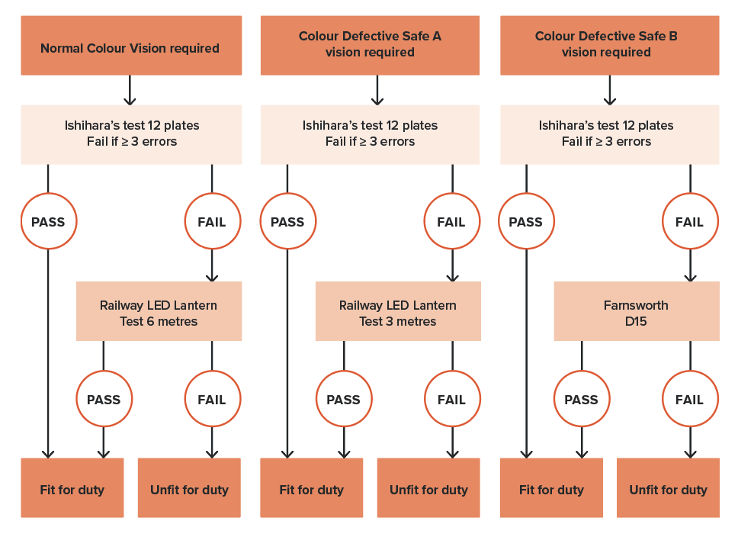
* Note: Workers who were previously assessed by a rail transport operator under the former Standard using the Farnsworth Lantern, or who were assessed prior to 2012 with a practical test and have been working safely in the same role, may continue to perform their duties. However, if such a worker applies for a position with different colour vision demands or if the colour vision demands of the role change, they should be assessed against the Standard.

Other eye conditions and treatments

Diplopia
People with diplopia (double vision) are generally not fit for Safety Critical Work. Any person who reports or is suspected of experiencing diplopia should be referred for assessment by an optometrist or ophthalmologist. They should be categorised as Temporarily Unfit for Duty pending this assessment. Fit for Duty Subject to Review may be determined if the criteria are met with suitable treatment.

Congenital and acquired nystagmus
Nystagmus might be associated with reduced visual acuity. Safety Critical Workers with nystagmus must meet the visual acuity standard. Any underlying condition must be fully assessed to ensure there is no other issue that relates to fitness for duty. Those with congenital nystagmus may have developed coping strategies that are compatible with safe working and should be individually assessed by an appropriate specialist.

Sudden loss of unilateral vision
A person who experiences any substantial and sudden loss of vision, such as loss of an eye, or loss associated with stroke or intraocular vein or artery occlusion should be assessed as Temporarily Unfit for Duty for an appropriate period (usually 3 months).

Ocular surgery
Symptoms such as sensitivity to glare, halos, starbursts and double vision are often experienced following ocular surgeries and might impact short-term fitness for duty. Reduction in contrast sensitivity and difficulty seeing in low light might also occur after refractive surgery. Dry eye is another well-published symptom with impacts on visual clarity. These symptoms might be relevant to tasks such as train driving, particularly at dawn, dusk or night. Advice regarding non-working periods (Temporarily Unfit for Duty) should be sought from the treating doctor.

Telescopic lenses (bioptic telescopes) and electronic aids
Bioptic telescopes are devices used to compensate for reduced visual acuity but do so at the expense of visual fields. These devices are not suitable for use by Safety Critical Workers.

4.13.4. Fitness for duty criteria for Safety Critical Workers
Fitness for duty criteria are outlined in Table 26.
It is important that health professionals familiarise themselves with both the general information above and the tabulated fitness for duty criteria before making an assessment of a person’s fitness for duty.

Table 26. Vision and eye disorders: Fitness for duty criteria for Safety Critical Workers
Condition | Criteria
Acuity | Category 1 and Category 2 Safety Critical Workers  Category 1 and Category 2 Safety Critical Workers are required to meet the following visual acuity criteria (uncorrected or corrected):  - better than or equal to 6/9 in the better eye; and  - better than or equal to 6/18 in the worse eye.  Categorisation will depend on the stability of the condition (see below).  Stable conditions  A person who has a stable visual impairment that is not associated with a progressive condition may be categorised Fit for Duty Unconditional if their corrected vision meets the above criteria.  If the person’s best corrected visual acuity in the better eye is at least 6/9 but worse than 6/18 in the worse eye, the person will be Fit for Duty Subject to Review. The person may not require more frequent review, but their condition should be specifically reviewed at Periodic Health Assessment, including a specialist report if appropriate.  If the acuity of the worse eye is worse than 6/60, the criteria for monocular vision apply.  The person must wear the appropriate aids when undertaking rail safety work. The suitability of these aids in meeting the fitness for duty requirements will be monitored by the Authorised Health Professional at each Periodic Health Assessment.  Progressive conditions  A person is not Fit for Duty Unconditional:  - if the person has a progressive eye condition that may affect visual acuity.  Fit for Duty Subject to Review may be determined subject to at least annual review, and taking into account the nature of the work and the opinion of the treating optometrist or ophthalmologist as to:  - the progression of the condition and the response to treatment; and  - whether the visual acuity criteria are met, with or without corrective lenses; and  - whether other criteria are met per this section, including visual fields.
Visual fields | Category 1 and Category 2 Safety Critical Workers  Category 1 and Category 2 Safety Critical Workers are required to meet the following visual field criteria:  - the binocular visual field must have an extent of at least 140 degrees within 10 degrees above and below the horizontal midline; and  - they must have no significant central scotoma defined as any of the following:  - A cluster of 4 or more adjoining points that is either completely or partly within the central 20-degree area.  - Loss consisting of both a single cluster of 3 adjoining missed points up to and including 20 degrees from fixation, and any additional separate missed points within the central 20-degree area.  - Any central loss that is an extension of a hemianopia or quadrantanopia of size greater than 3 missed points.  NOTE: Safety Critical Workers who do not work on or around the track (for example, train controllers) usually require only a limited field of vision and may be exempted from these criteria.  Stable conditions  A person who has a stable visual field loss that is not associated with a progressive condition may be categorised Fit for Duty Unconditional if their vision meets the above criteria.  Progressive conditions  A person is not Fit for Duty Unconditional:  - if the person has a progressive eye condition that may affect visual fields.  Fit for Duty Subject to Review may be determined subject to at least annual review, and taking into account the nature of the work and the opinion of the treating optometrist or ophthalmologist as to whether:  - the person meets the visual field criteria as stated above; and  - the visual field loss is unlikely to progress rapidly.
Monocular vision | A person is not Fit for Duty Unconditional:  - if the person is monocular.  Fit for Duty Subject to Review may be determined, subject to periodic review, taking into account the nature of the work and information provided by the treating optometrist or ophthalmologist, as to whether the following criteria are met:  - the visual acuity in the remaining eye is 6/9 or better, with or without correction; and  - the visual field in the remaining eye has a horizontal extent of at least 140 degrees within 10 degrees above and below the horizontal midline; and  - there is no other significant visual field loss that is likely to impede Safety Critical Work (as above).  In exceptional circumstances, the Chief Medical Officer may categorise a worker with less than that visual field in the remaining eye as Fit for Duty Subject to Review if an ophthalmologist or optometrist with expertise in visual fields assesses that the person may be safe for Safety Critical Work.  Safety Critical Workers who do not work on or around the track (for example, train controllers) usually require only a limited field of vision and may be exempted from these criteria.
Colour vision | Colour vision requirements are determined by a risk assessment and communicated by the rail transport operator to the Authorised Health Professional.  No coloured lenses or sunglasses may be worn when testing colour vision.  Colour vision should be screened using Ishihara’s plates; 3 or more errors out of 12 plates is a fail.  In the event of a fail, further assessment may be conducted as per the text and flow chart in Figure 33.
Diplopia | Category 1 and Category 2 Safety Critical Workers  A person is not Fit for Duty Unconditional:  - if the person experiences any diplopia (other than physiological diplopia) within 20 degrees from central fixation.  Fit for Duty Subject to Review may be determined, taking into account the nature of the work and the opinion of the treating optometrist or ophthalmologist as to whether the following criteria are met:  - the criteria can be met with suitable treatment; and  - other criteria are met as per this section, including visual fields.

Temporary illnesses. The Standard does not deal with the many conditions that may affect health on a short-to-medium-term basis and for which a Safety Critical Worker may be referred for assessment regarding fitness to resume duty. Clinical judgement is usually required on a case-by-case basis, although the text in each section gives some advice on the clinical issues to be considered.
Undifferentiated illness. A Safety Critical Worker may present with symptoms that could have implications for their job, but the diagnosis is not clear. Referral and investigation of the symptoms will mean that there is a period of uncertainty before a definitive diagnosis is made, and before the worker and employer can be confidently advised. Each situation will need to be assessed individually, with due consideration being given to the probability of a serious disease that will affect Safety Critical Work. Generally, workers presenting with symptoms of a potentially serious nature should be categorised as Temporarily Unfit for Duty until their condition can be adequately assessed. However, they may be suitable for alternative duties, including duties at a lower risk category (for example, Category 2 or Category 3). Workers who are fit to continue work while being investigated should be categorised as Fit for Duty Subject to Review.
Specialist review. The Standard generally requires Safety Critical Workers who are assessed as Fit for Duty Subject to Review to be seen by a specialist leading up to their review appointment with the Authorised Health Professional. Exceptions are specifically described in the Standard where appropriate.

References and further reading – Vision
ARTC (Australian Rail Track Corporation) (2023) Colourlight Signals and indicators.
Austroads Ltd and NTC (2022) Assessing Fitness to Drive 2022: for commercial and private vehicle drivers.
Bailey KGH and Carter T (2016) ‘Consistency of secondary colour vision tests in transport industries’, Occupational Medicine, 66(4):268-75.
Bowers A, Peli E, Elgin J, McGwin G Jr and Owsley C (2005) ‘On-road driving with moderate visual field loss’, Optometry and Vision Science, 82(8):657-67.
Casolin A, Katalinic PL, Yuen GS-Y and Dain SJ (2011) 'The RailCorp Lantern test', Occupational Medicine, 61(3):171-7.
Charlton JL, Di Stefano M, Dow J, Rapoport MJ, O’Neill D, Odell M, Darzins P and Koppel S (2021) Influence of chronic illness on crash involvement of motor vehicle drivers: 3rd Edition, Monash University Accident Research Centre.
CIE (International Commission on Illumination) (2001) CIE technical report: recommendations for colour vision requirements for transport.
Dain SJ, Casolin A and Long J (2015) ‘Color Vision and the Railways: Part 3. Comparison of FaLant, OPTEC 900, and Railway LED Lantern Tests’, Optometry and Vision Science, 92(2):152-6.
DeLaey JJ and Colenbrander A (2006) Visual Standards: Vision Requirements for Driving Safety with Emphasis on Individual Assessment.
Hanna S and The Optometry Australia Diabetes Guidelines Working Group (2016) ‘Optometry Australia – Guidelines on the examination and management of patients with diabetes’, Clinical and Experimental Optometry, 99(2):120-126.
Hansraj R (2007) ‘Night vision of the post-LASIK myope’, The South African Optometrist, 66(4):141-149.
Hovis JK and Oliphant D (2000) ‘A lantern colour vision test for the rail industry’, American Journal of Industrial Medicine, 38(6):681-96.
International Standards Organization (ISO) ISO 12866:1999 Ophthalmic instruments — Perimeters.
Koefoed VF, Miles T, Cason JB and Troche R (2020) ‘Colour vision classification – comparing CAD and CIE 143:2001 International recommendations for colour vision requirements in transport’, Acta Ophthalmologica, 98(7):726-735
McGwin G, Wood J, Huisingh C and Owsley C (2016) ‘Motor vehicle collision involvement among persons with hemianopia and quadrantanopia’, Geriatrics (Switzerland), 1(19).
McKnight AJ, Shinar D and Hilburn B (1991) ‘The visual and driving performance of monocular and binocular heavy-duty truck drivers’, Accident Analysis & Prevention, 23(4):225-37.
Owsley C, Wood JW and McGwin G (2015) ‘A roadmap for interpreting the literature on vision and driving’, Survey of Ophthalmology, 60(3):250-62.
Parkes J (2007) Risk assessment of safety critical tasks for rail safety workers involving colour vision, National Transport Commission (internal report).
Patterson G, Howard C, Hepworth L and Rowe F (2019) ‘The Impact of Visual Field Loss on Driving Skills: A Systematic Narrative Review’, British and Irish Orthoptic Journal, 15:53-63 doi: 10.22599/bioj.129
Sample P, Dannheim F, Artes PH, Dietzsch J, Henson D, Johnson C, Ng M, Schiefer U and Wall M (2011) ‘Imaging and Perimetry Society Standards and Guidelines’, Optometry and Vision Science, 88(1):4-7.
Wood J (2002) ‘Aging, driving and vision’, Clinical and Experimental Optometry, 85(4):214-20.
Wood JM and Black AA (2016) ‘Ocular disease and driving’. Clinical and Experimental Optometry, 99: 395–401.
Wood JM, Atchison DA, Black AA and Larue GD (2022) ‘Low levels of refractive blur increase the risk of colour misperception of red train signals’, Ophthalmic and Physiological Optics, 42(4):872-878.
Wood JM, Black AA, Dingle K, Rutter C, DiStefano M, Koppel S, Charleton JL and Bentley SA (2021) ‘Impact of vision disorders and vision impairment on motor vehicle crash risk and on-road driving performance: A systematic review’, Acta Ophthalmologica, 100(2):e339-e367.
Wood JM, McGwin G Jr, Elgin J, Vaphiades MS, Braswell RA, DeCarlo DK, Kline LB, Meek, GC, Searcey K and Owsley C (2009) ‘On-road driving performance by people with hemianopia and quadrantanopia’, Investigative Ophthalmology and Visual Science, 50(2):577-85.

5. Assessment and management of health conditions – Category 3 workers
This section of the Standard applies to Category 3 workers and explains:
- the rail safety risks associated with specific medical conditions and their treatments
- the approach to assessment and management of these conditions, including screening tools and investigations
- the fitness for duty criteria and review requirements.
Note that it is impossible to cover all conditions or combinations of conditions that may affect safety. A generic approach may be applied in situations where conditions or symptoms are not covered in the Standard or where there are concerns about the net effect of multiple minor conditions (refer to Section 3.4.7. Multiple medical conditions).

5.1. Introduction
Rail safety workers who work on or near the track but not in a Controlled Environment (Category 3 workers) require a Track Safety Health Assessment.
These workers also receive track safety awareness training on a regular basis, which is another key aspect of their ability to protect their own safety and that of fellow workers.
The health requirements for Category 3 work are based on the principle of a worker being able to:
- see a train
- hear a train
- move out of the way for their own safety.
These workers are therefore required to undergo clinical assessment that includes hearing, vision and mobility at Pre-placement and periodically during their employment. This section provides detailed guidance for Authorised Health Professionals in relation to the clinical assessment, management and determination of fitness for duty for these aspects. The clinical assessment includes audiometry, testing of visual acuity and visual fields and a general musculoskeletal assessment (refer to Section 5.2. Hearing, Section 5.3. Vision, and Section 5.4. Musculoskeletal function).
It is also acknowledged that health conditions that cause loss of attention or loss of consciousness can prevent a person from seeing, hearing and moving out of the path of an oncoming train. These are also addressed in this section and include:
- blackouts
- cardiovascular conditions
- diabetes
- neurological conditions, including cognitive impairment, seizures and epilepsy and other neurological conditions
- psychiatric conditions
- substance misuse.
Identification of these conditions at Pre-placement and Periodic Health Assessment is generally by worker self-report via the Health Questionnaire. Unlike Category 1 Safety Critical Workers, there is no active screening for these conditions other than by self-report.
These conditions may arise between Periodic Health Assessments. Rail transport operators should ensure that workers are advised to notify their supervisor or request a Triggered Health Assessment if they do any of the following:
- develop a condition that could lead to collapse on track, for example cardiovascular conditions
- incur serious injury or illness to their eyes, hearing or limbs
- suffer a serious brain injury
- develop a cognitive or serious psychiatric condition.
Substance abuse should also be declared in accordance with the rail transport operator’s drug and alcohol management program. Workers making such notifications should be referred for a Triggered Health Assessment to assess implications for safety around the track and action taken should be taken accordingly, including job modification as required.

Who may conduct health assessments for Category 3 workers?
There are two types of Authorised Health Professional:
- Those who are authorised to conduct all health assessments, including assessments for Safety Critical Workers (Category 1, Category 2) and Track Safety Health Assessments (Category 3).
- Those who are authorised to conduct Track Safety Health Assessments (Category 3) only.
Authorised Health Professionals who are authorised to conduct Category 3 assessments only (i.e., non-medically trained health professionals) should conduct assessments under the supervision of medically trained Authorised Health Professionals.
Determination of fitness for duty for workers who declare or are diagnosed with medical conditions that may impact track safety (for example epilepsy, diabetes, cardiovascular disease, substance misuse as per Part 5), should be made with direct oversight by a medically trained Authorised Health Professional, who should review reports from treating doctors and sign off the fitness for duty report (refer to Section 2.5. Authorising health professionals).

Determining review periods for Category 3 workers
Review periods for Category 3 workers who are diagnosed with conditions described in this part of the Standard are generally not specifically prescribed. This includes impairments of hearing, vision and mobility, as well as conditions that might impact these attributes. The Authorised Health Professional should advise on requirements for more frequent review based on a consideration of the stability of the condition, the job requirements and the potential risks to rail safety.

5.2. Hearing

5.2.1. Relevance to safety around the track
There are appreciable risks from moving trains, which can be surprisingly quiet even at high speed, so the ability to hear a train horn is important. A horn is intended to emit about 88 dB at 200 metres in the country and 85 dB at 100 metres in towns. The fitness for duty criteria have been set with a margin of safety to allow for adverse environmental conditions and the worker facing away from the train. The need is to hear (warning) sounds, rather than speech, in noise.
Note: The Standard is designed to identify and manage workers with hearing loss that may affect safety on the network and should be distinguished from audiometric monitoring required for workers who frequently use personal hearing protectors as a control measure for noise that exceeds the exposure standard. The interface between these programs should however be managed by the rail transport operator and, as appropriate, by the examining Authorised Health Professional to optimise hearing conservation.
When working with hearing protection, the worker should not be expected to hear warning sounds but should be communicated with by gesture by the gang supervisor.

5.2.2. General assessment and management guidelines
Pure tone audiometry may be performed with or without hearing aids, and the threshold for fitness for duty applies to the better ear. If the hearing criterion is not met with hearing aids, the audiogram may be repeated once the aids have been upgraded. Fit for Duty Subject to Review may also be recommended if a sound discrimination in noise test has been passed. Practical onsite tests are not recommended due to issues with validity and reproducibility.
Fit for Duty Subject to Review (Job Modification) may also be recommended, for example, if the worker is to be escorted at all times when around the track. Workers who meet the criteria with hearing aids should undergo periodic review of their hearing and function of their hearing aid. Frequency of review should be determined based on the nature and degree of hearing loss, the potential impact of noise exposure and the advice of the treating audiologist.
The prescription and fitting of hearing aids for Category 3 workers should be undertaken by the audiologist with due consideration to the individual needs of the worker, the nature of their work and the nature of the working environment.
Use in noisy environments or where warning sounds need to be heard warrants particular consideration. An initial report from the audiologist should demonstrate specific understanding of the circumstances of use and the mitigation of any risks to the worker or the rail environment.
Workers who use hearing aids should be advised of the following requirements:
- They should wear the aid at all times at the recommended settings.
- They should report the development of any medical condition that may temporarily worsen hearing or reduce efficient function of the hearing aid (for example, severe middle ear infection), or if a hearing aid fails or is lost. Monaural aid use, when binaural hearing loss is present, results in reduced ability to localise warning sounds.
- They should have their hearing assessed and their hearing aid serviced annually.
- In the event of replacement or upgrading of hearing aids, or further deterioration in hearing, speech discrimination in noise or quiet should be re-examined.
- They are encouraged to carry a supply of batteries or ensure their hearing aid is recharged overnight.

5.2.3. Fitness for duty criteria for Category 3 workers
Fitness for duty criteria are outlined in Table 27. It is important that health professionals familiarise themselves with both the general information above and the tabulated fitness for duty criteria before assessing a person’s fitness for duty.

Table 27. Hearing: Fitness for duty criteria for Category 3 workers
Condition | Criteria
Hearing | Compliance with the Standard should be initially assessed by audiometry with or without hearing aids.  A person is not Fit for Duty Unconditional:  - if hearing loss is greater than or equal to 40 dB averaged over 0.5 KHz, 1 KHz and 2 KHz in the better ear.  Fit for Duty Subject to Review may be determined if the criterion is met with hearing aids.  If a rail safety worker requires hearing aids, the aids should be fitted by an audiologist with due consideration to the individual needs of the worker, the nature of their work and the nature of the working environment.  Fit for Duty Subject to Review (Job Modification) may be considered, for example, if the worker is to be escorted at all times when around the track.  Workers who meet the above criteria but in whom noise-induced hearing loss is suspected should be referred to the rail operator's hearing conservation program.

5.3. Vision

5.3.1. Relevance to safety around the track
Good visual acuity and fields are important to sense an oncoming train.
There are no requirements for colour vision for Category 3 workers under the Standard. If colour vision is required for other aspects of the worker’s role, the protocols outlined in Section 4.13. Vision and eye disorders may be applied.

5.3.2. General assessment and management guidelines

Visual acuity
The criterion for visual acuity relates to the better eye. This includes workers who are monocular. Visual acuity should be measured for each eye separately and without optical correction. If optical correction is needed, vision should be retested with appropriate corrective lenses.
Acuity should be tested using a standard visual acuity chart (Snellen or LogMAR chart or equivalent) with 5 letters on the 6/12 line. Standard charts should be placed 6 metres from the person tested, or a reverse chart can be used and viewed through a mirror from a distance of 3 metres. Other calibrated charts can be used at a minimum distance of 3 metres. More than two errors in reading the letters of any line are regarded as a failure to read that line. The visual acuity criteria can be met with or without corrective spectacle lenses or contact lenses.
A person who has a stable visual impairment that is not associated with a progressive condition may be categorised Fit for Duty Unconditional if their corrected vision meets the criterion. The person must wear the appropriate aids when working.
If workers meet the criteria with corrective lenses, they should be able to be passed by the Authorised Health Professional without reference to an ophthalmologist, optometrist or general practitioner. In appropriate circumstances, a referral may be made.
It is not required that workers carry spare sets of glasses at work. However, people who wear contact lenses should carry a spare set of glasses in case a foreign body enters the eye (requiring removal of the lens).
People with progressive eye conditions, such as cataract, glaucoma and diabetic retinopathy, optic neuropathy and retinitis pigmentosa, should be monitored regularly and should be advised in advance regarding the potential future impact on their working ability and possible alternative employment. Depending on the condition and the rate of progression, and subject to periodic review, they may be categorised Fit for Duty Subject to Review if they meet the vision fitness for duty criteria.
Because persons with cataract suffer loss of contrast sensitivity and greater sensitivity to glare, they may have more difficulty seeing when working than is indicated by their visual acuity.

Visual fields
Visual fields may be initially screened by confrontation. The tester should sit close to, and directly opposite, the person and instruct them to cover one eye. They should occlude their opposite eye like a mirror image. They then ask the person to fixate on the non-occluded eye and to count the number of fingers held up in each of the 4 corners of the tester’s visual field. Other extreme upper, lower and side points may also be tested. This process should be repeated for the other eye. Confrontation is an inexact test. Any person who has, or is suspected of having, a visual field defect should have a formal perimetry-based assessment.
Monocular automated static thresholding perimetry is required to quantify and monitor central field loss.
Subjects with any significant field defect or a progressive eye condition require a binocular Esterman visual field for assessment. This is classically done on a Humphrey visual field analyser but any machine that can be shown to be equivalent is accepted. This must be performed with fixation monitoring. Alternative devices must have the ability to monitor fixation and to stimulate the same spots as the standard binocular Esterman. For an Esterman binocular chart to be considered reliable for fitness for duty, the false positive score must be no more than 20 per cent.

Monocular vision (one-eyed worker)
People with monocular vision have reduced visual fields compared to binocular viewers. They also have impaired depth perception, which they may adapt to depending on monocular cues to depth, but the loss of binocular cues remains unchanged.
Fit for Duty Subject to Review may be recommended if the visual field and acuity in the remaining eye meets the Standard. In borderline cases, the Chief Medical Officer may categorise a worker with less than that visual field in the remaining eye as Fit for Duty Subject to Review if an ophthalmologist or optometrist assesses that the person is safe to work around the track with periodic review of the remaining eye. Good rotation of the neck is also necessary to ensure adequate overall fields of vision particularly for people with monocular vision.

5.3.3. Fitness for duty criteria for Category 3 workers
Fitness for duty criteria are outlined in Table 28. It is important that health professionals familiarise themselves with both the general information above and the tabulated fitness for duty criteria before assessing a person’s fitness for duty.
Table 28. Vision and eye disorders: Fitness for duty criteria for Category 3 workers
Condition | Criteria
Visual acuity | A Category 3 worker is required to meet the following visual acuity criteria (uncorrected or corrected):  - better than or equal to 6/12 in the better eye.  Categorisation will depend on the stability of the condition (see below).  Stable conditions  A person who has a stable visual impairment that is not associated with a progressive condition may be categorised Fit for Duty Unconditional if their corrected vision meets the above criteria.  The person must wear the appropriate aids when undertaking rail safety work. The suitability of these aids in meeting the fitness for duty requirements will be monitored by the Authorised Health Professional at each Periodic Health Assessment.  Progressive conditions  A person is not Fit for Duty Unconditional:  - if the person has a progressive eye condition that may affect visual acuity.  Fit for Duty Subject to Review may be determined subject to periodic review, and taking into account the nature of the work and the opinion of the treating optometrist or ophthalmologist as to:  - the progression of the condition and the response to treatment  - whether the visual acuity criteria are met, with or without corrective lenses  - whether other criteria are met per the Standard, including visual fields.
Visual fields | A Category 3 worker is required to meet the following criteria for visual fields:  - the binocular visual field (or the visual field in the remaining eye in the case of monocular vision) must have an extent of at least 110 degrees within 10 degrees above and below the horizontal midline; and  - they must have no significant visual field loss (scotoma) within a central radius of 20 degrees of the foveal fixation or other scotoma likely to affect work performance); and  - they must have no significant visual field loss (scotoma) with more than four contiguous spots within a 20-degree radius from fixation.  Stable conditions  A person who has a stable visual field loss that is not associated with a progressive condition may be categorised Fit for Duty Unconditional if their vision meets the above criteria.  Progressive conditions  A person is not Fit for Duty Unconditional:  - if the person has a progressive eye condition that may affect visual fields.  Fit for Duty Subject to Review may be determined subject to periodic review, and taking into account the nature of the work and the opinion of the treating optometrist or ophthalmologist as to whether:  - the person meets the visual field criteria as stated above; and  - the visual field loss is unlikely to progress rapidly.  Fit for Duty Subject to Review (Job Modification) may be considered, for example, if the worker is to be escorted at all times when around the track.

5.4. Musculoskeletal function

5.4.1. Relevance to safety around the track
Track safety requires sufficient soundness of limb function to permit rapid movement away from an oncoming train.

5.4.2. General assessment and management guidelines
The musculoskeletal criteria only relate to a person’s ability to move quickly from the path of an oncoming train; it is not intended to cover all of the inherent job requirements and job demands that individuals may undertake on track as part of their jobs. Where a rail transport operator or contracting company wish for advice in relation to such issues, a more comprehensive assessment would need to be requested.
Moving rapidly from the path of an oncoming train may require a worker to negotiate steep and unstable ballast shoulders in order to reach a safe area. The Standard relates to any rheumatological, neurological or chronic pain condition that affects musculoskeletal function. Acute and chronic pain associated with musculoskeletal disorders may also impact the cognitive aspects of rail safety work, with evidence that it affects attention and concentration, as well as emotional responses. This should also be considered for the overall management of the workers with musculoskeletal disorders.

5.4.3. Fitness for duty criteria for Category 3 workers
Fitness for duty criteria are outlined in Table 29. It is important that health professionals familiarise themselves with both the general information above and the tabulated fitness for duty criteria before assessing a person’s fitness for duty.
Table 29. Musculoskeletal function: Fitness for duty criteria for Category 3 workers
Condition | Criteria
Musculoskeletal function | A person is not Fit for Duty Unconditional:  - if pain, weakness, instability or other impairment from a musculoskeletal or medical condition results in interference with the ability to walk on coarse ballast or move rapidly from the path of an oncoming train.  Fit for Duty Subject to Review may be determined, taking into consideration the opinion of the treating doctor and the nature of the work, if the condition is adequately treated and function is restored.  Fit Duty Subject to Review (Job Modification) may be considered, for example, if the person is to be accompanied at all times when around the track.

5.5. Other conditions that may impact safety around the track

5.5.1. Relevance to safety around the track
Conditions that cause loss of attention or loss of consciousness can prevent a person from seeing, hearing or moving out of the path of an oncoming train and are therefore addressed in the Standard. They include:
- blackouts
- cardiovascular conditions
- diabetes
- neurological conditions, including cognitive impairment, seizures and epilepsy and other neurological conditions
- psychiatric conditions
- substance misuse.

5.5.2. General assessment and management guidelines
Identification of these conditions at Pre-placement and Periodic Health Assessment is generally by worker self-report via the Health Questionnaire. Between Periodic Health Assessments, where a worker declares a condition or symptoms that are likely to impact on their safety around the track, they will be subject to a Triggered Health Assessment as described earlier. The rail transport operator may also initiate a Triggered Health Assessment if concerned about a worker’s safety.
Review periods for Category 3 workers who are diagnosed with conditions identified in this section of the Standard are generally not prescribed and should be determined by the Authorised Health Professional. They should take into consideration the severity and degree of instability of a condition when determining if a worker should be reviewed earlier than 5 years.
In the case of younger workers, who may not otherwise be reviewed until age 40, consideration should be given to an earlier Triggered Health Assessment if a serious medical condition is present. Where an earlier review is assessed as being necessary, the Triggered Health Assessment should focus on the condition as opposed to repeating the entire Track Safety Health Assessment (Category 3). A Triggered Health Assessment can involve a review of documents obtained from the treating doctor and need not necessarily require a face-to-face assessment of the worker.

5.5.3. Fitness for duty criteria for Category 3 workers
It is important that health professionals familiarise themselves with both the general information above and the tabulated fitness for duty criteria before assessing a person’s fitness for duty.
Table 30 contains fitness for duty criteria and guidance regarding fitness for duty worker categorisation.
Determination of fitness for duty for workers who declare or are diagnosed with any of these medical conditions should be made with direct oversight by a medically trained Authorised Health Professional, who should review reports from treating doctors and sign off the fitness for duty report (refer to Section 2.5. Authorising health professionals).
Table 30. Fitness for duty criteria for Category 3 workers: other conditions likely to impact safety around the track
Condition | Criteria
Blackouts: episodes of impaired consciousness of uncertain nature  (For blackouts associated with a known cause see criteria below) | A person is not Fit for Duty Unconditional:  - if the person has experienced blackouts of an unknown cause that cannot be diagnosed as syncope, seizures or other recognised medical causes of loss of consciousness.  Fit for Duty Subject to Review may be determined taking into account the opinion of the treating doctor and the nature of the work:  - if the blackouts were confined to a single 24-hour period and there have been no further blackouts for at least 6 months; or  - if there were 2 or more blackouts separated by at least 24 hours and there have been no further blackouts for at least 12 months.  Fit for Duty Subject to Review following a lesser period without further blackouts may be considered on a case-by-case basis following discussion with the Chief Medical Officer of the rail transport operator and consideration of the duties that will be performed and the need for any job modification.
Cardiovascular conditions | Unstable angina, angina on mild exertion or heart failure  A person is not Fit for Duty Unconditional:  - if the person has a history of unstable angina, angina on mild exertion or heart failure that could interfere with their capacity to move quickly from the path of an oncoming train.  Fit for Duty Subject to Review may be determined taking into consideration the opinion of the treating doctor and the nature of the work if:  - satisfactory treatment has been instituted; and  - the person’s exercise tolerance has improved such that they can reliably move from the path of an oncoming train.  Syncope  A person is not Fit for Duty Unconditional:  - if the person has a history of episodes of syncope without warning due to any medical condition.  Fit for Duty Subject to Review may be determined taking into consideration the nature of the work and the opinion of the treating doctor as to whether the following criteria have been met:  - the underlying cause has been identified; and  - satisfactory treatment has been instituted; and  - the person has been symptom-free for at least 4 weeks.
Diabetes | A person is not Fit for Duty Unconditional:  - if the person has had a recent ‘severe hypoglycaemic event’ (within 6 weeks) or is subject to recurrent episodes of severe hypoglycaemia.  Fit for Duty Subject to Review may be determined taking into consideration the nature of the work and the opinion of the treating doctor as to whether the following criteria have been met:  - any recent ‘severe hypoglycaemic event’ has been satisfactorily treated; and  - the person is following a treatment regimen that minimises the risk of recurrent hypoglycaemia; and  - the person experiences early warning symptoms (awareness) of hypoglycaemia or has a documented management plan for lack of early warning symptoms.
Neurological conditions – cognitive impairment | A person is not Fit for Duty Unconditional:  - if the person has cognitive impairment.  Fit for Duty Subject to Review may be determined taking into consideration information provided by the treating doctor regarding the level of impairment of visuospatial perception, insight, judgement, attention, reaction time and memory, and the likely impact of any impairments on the person’s capacity to reliably detect and move rapidly from the path of an oncoming train.
Neurological conditions – seizures and epilepsy | A person should be categorised Temporarily Unfit for Duty following a seizure.  A person is not Fit for Duty Unconditional if they have ever experienced a seizure.  Fit for Duty Subject to Review may be determined following an appropriate seizure-free period and provided the person follows medical advice, including adherence to medication if prescribed or recommended.  The default non-working seizure-free period is 12 months.  The default non-working seizure free period applies except in the circumstances described below. For each of these circumstances, Fit for Duty Subject to Review may be determined taking into consideration the nature of the work and the opinion of the treating doctor as to whether the criteria are met.  - In the case of a first seizure, there have been no further seizures (with or without medication) for at least 6 months.  - In the case of epilepsy treated for the first time, the person has been treated for at least 6 months, there have been no seizures in the preceding 6 months, if any seizures occurred after the start of treatment, they happened only in the first 6 months after starting treatment and not in the last 6 months, and the person follows medical advice including adherence to medication.  - In the case of acute symptomatic seizures, there have been no further seizures for at least 6 months. If there have been 2 or more separate transient disorders causing acute symptomatic seizures the default criteria apply.  - In the case of safe seizures, with no loss of consciousness, ‘safe’ seizures have been present for at least 2 years, there have been no seizures of any other type for at least 2 years, and the person follows medical advice with respect to medication if prescribed.  - In the case of sleep only seizures, either:  - There have been no previous seizures while awake, the first sleep-only seizure was at least 12 months ago, and the person follows medical advice including adherence to medication if prescribed; or  - There have been previous seizures while awake but not in the preceding 2 years, sleep-only seizures have been occurring for at least 2 years, and the person follows medical advice including adherence to medication if prescribed.  - In the case of a seizure in a person whose epilepsy was previously well controlled, either:  - The seizure was caused by an identified provoking factor that can be reliably avoided and that has not caused previous seizures, there have been no seizures for at least 4 weeks, and the person follows medical advice including adherence to medication; or  - No cause was identified, there have been no seizures for at least 3 months and the person follows medical advice including adherence to medication.  If the person has experienced one or more seizures during the 12 months leading up to the last seizure, there is no reduction, and the default criteria apply.  Exceptional circumstances: Fit for Duty Subject to Review following a lesser seizure-free period may be considered on a case-by-case basis following discussion with the Chief Medical Officer of the rail transport operator and consideration of the duties that will be performed and the need for any job modification.
Psychiatric conditions | A person is not Fit for Duty Unconditional:  - if the person has a psychiatric condition that is likely to impair insight, judgement, perception, behaviour or cognitive function and affect the person’s capacity to move rapidly from the path of an oncoming train.  Fit for Duty Subject to Review may be determined taking into consideration the nature of the work and the opinion of the treating doctor as to whether the following criteria are met:  - the condition is well controlled; and  - the person has been compliant with treatment; and  - there are no adverse medication effects that may affect the person’s ability to move rapidly from the path of an oncoming train: and  - the impact of comorbidities has been considered (for example, substance abuse).
Substance misuse | A person is not Fit for Duty Unconditional:  - if there is evidence of substance misuse.  The person should be categorised Temporarily Unfit for Duty while being assessed.  Fit for Duty Subject to Review may be determined, taking into account the nature of the work and the opinion of the assessing practitioner as to whether the risk of further substance misuse is low.  In the case of chronic or heavy substance misuse or substance dependence, a period of demonstrated remission* should be considered prior to return to work (Fit for Duty Subject to Review). The review period should be defined in consultation with the treating practitioner.  * Remission is attained when there is abstinence from use of illicit drugs or where the use of other substances, such as alcohol, has reduced in frequency to the point where it is unlikely to cause impairment or to result in a positive test at work. The worker’s substance use history, response to treatment and level of insight should be considered, as well as the drug and alcohol management program and rehabilitation policies of the rail transport operator. Remission must be confirmed by biological monitoring.

6. Clinical tools, forms and transition arrangements
This section of the Standard includes:
- explanations and templates for screening questionnaires used in the Standard,
- model forms to support implementation of the Standard by rail transport operators, including information about what aspects of the forms represent standardised content and should not be modified
- information about transition arrangements for the Standard based on a risk management approach.

6.1. Clinical tools

6.1.1. Clarke hypoglycaemia awareness questionnaire

Background
The Clarke hypoglycaemia awareness questionnaire was developed by a team of researchers at the Department of Pediatrics and Psychiatric Medicine at the University of Virginia Health Sciences Center in 1995. The original study was designed to evaluate prospectively the frequency, severity and consequences of reduced awareness of hypoglycaemia. The study found that subjects who believed they had reduced hypoglycaemia awareness were generally correct.
The questionnaire comprises 8 questions characterising the person’s exposure to episodes of moderate to severe hypoglycaemia (refer to Figure 34). It also examines the glycaemic threshold for, and symptomatic responses to, hypoglycaemia. A score of four or more implies impaired awareness of hypoglycaemia.

Use of the Clarke hypoglycaemia awareness questionnaire for screening Safety Critical Workers
The purpose of the Clarke hypoglycaemia awareness questionnaire in the Standard is to screen for impaired hypoglycaemic awareness in workers with existing diabetes.
This questionnaire is useful to administer to assess hypoglycaemia awareness including:
- for people who have been on insulin for many years
- after a severe hypoglycaemic event
- after a crash.
The Clarke hypoglycaemia awareness questionnaire is scored by counting the ‘U’, ‘R’ and ‘A’ responses.
- A ‘U’ response to question 4 indicates hypoglycaemia unawareness.
- Four or more ‘R’ responses imply reduced hypoglycaemia awareness.
- Two or fewer R responses implies awareness.
- ‘A’ responses imply hypoglycaemia awareness.
The Authorised Health Professional will confirm and record the scores in the Record for Health Professional for Category 1 and Category 2 Safety Critical Workers (refer to Section 6.2.4. Record for Health Professional) and act accordingly.

Figure 34. Clarke hypoglycaemia awareness questionnaire
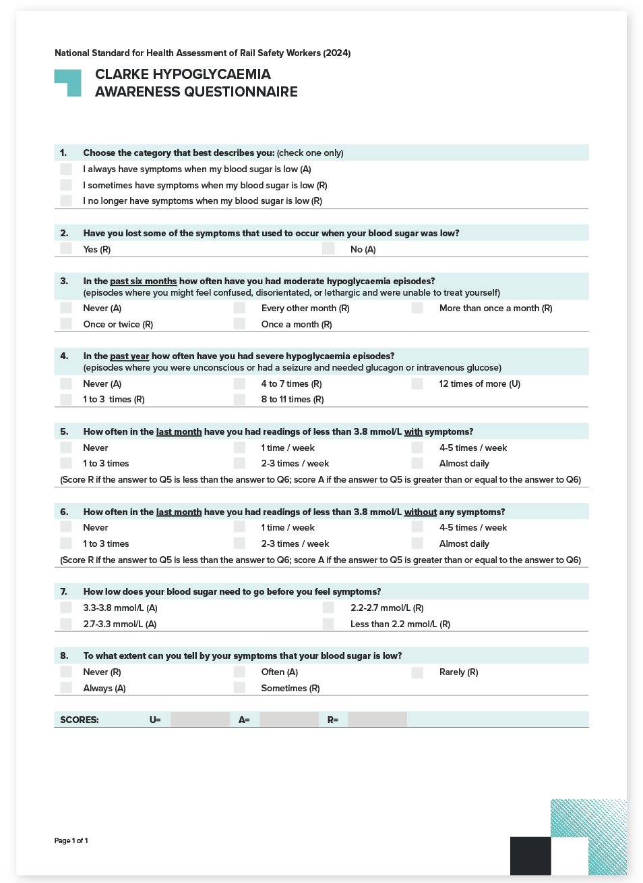
To download this form visit: ntc.gov.au.

6.1.2. K10 questionnaire for anxiety and depression

Background
The K10 scale is based on 10 questions about negative emotional states experienced during the 4-week period leading up to the assessment (refer to Figure 35). For each item, there is a 5-level response scale based on the amount of time the respondent reports experiencing the particular problem.
Research has shown a strong association between high scores on the K10 and the diagnosis of anxiety and affective disorders. There is a lesser but significant association between the K10 and other mental disorder categories, and with the presence of any current mental disorder.
Sensitivity and specificity data analysis also supports the K10 as an appropriate screening instrument to identify likely cases of anxiety and depression in the community, and to monitor treatment outcomes. Thus, the K10 is widely recommended as a simple measure of psychological distress and as a means to monitor progress following treatment for common mental health disorders such as anxiety and depression.

Use of the K10 for screening Safety Critical Workers
The purpose of applying the K10 is to screen for mental health disorders that may affect attentiveness and thus the ability to safely perform Safety Critical Work.
The K10 may be administered by interview to improve the likelihood of a considered response. Questions 3 and 6 do not need to be asked if the response to the preceding question was ‘None of the time’. In such cases, questions 3 and 6 will automatically receive a score of 1.
The K10 is a screening instrument; thus, Authorised Health Professionals are required to apply clinical judgement in the interpretation of the score and the action required.

Scoring the K10 and managing Safety Critical Workers
A total score of 50 is possible. Low scores indicate low levels of psychological distress, and high scores indicate high levels of psychological distress. The table in Figure 36 provides a guide for managing workers according to their K10 score.
The Authorised Health Professional evaluates the responses to the questionnaire in conjunction with supporting information provided by the operator, such as absenteeism and accident history, which may provide indications of a mental health problem. The Authorised Health Professional should also form a clinical impression of the worker and consider if this is consistent with the score on the K10.
The Authorised Health Professional may also feel it is appropriate to contact a worker’s general practitioner to discuss their history. Based on these inputs, the Authorised Health Professional will form a view as to whether they believe there is a significant current risk that the worker might be impaired at work.
As a general rule, workers who rate most commonly ‘Some of the time’ or ‘All of the time’ categories are in need of a more detailed assessment and may not be fit to continue Safety Critical Work. Workers who rate most commonly ‘A little of the time’ or ‘None of the time’, generally do not require further assessment, however, the clinical examination may indicate otherwise and will guide the final decision in this regard.
It is important to note that high scores may be the result of acute distress brought on by domestic or work stress or may be due to endogenous causes. Interventions appropriate to the particular situation will therefore need to be identified.
Where work stress is identified as a factor in a raised score, the Authorised Health Professional is in a good position to constructively intervene and advise on remedial steps regarding workload, job reorganisation, training, conflict resolution and so on.
Figure 35. K10 questionnaire
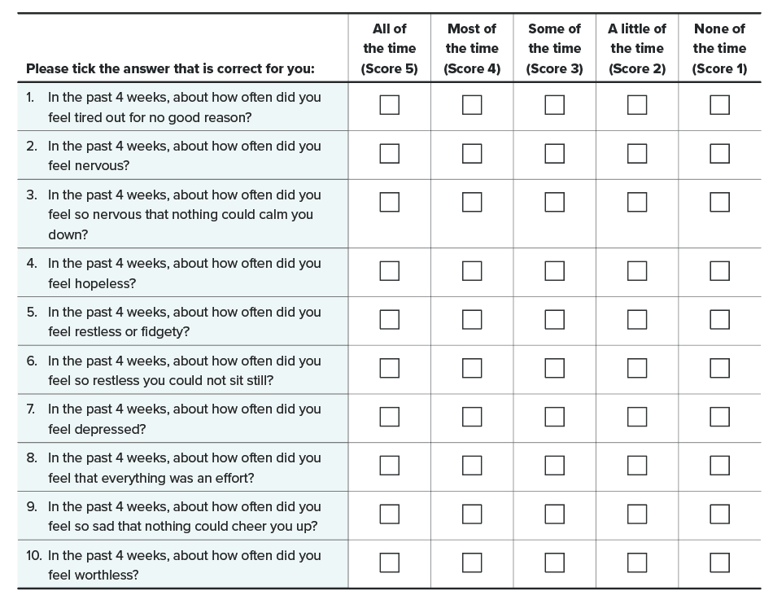

Risk Zone I — K10 scores between 10 and 18
Scores below 19 indicate that the worker is likely to be well but should be considered in the context of the overall clinical impression of the worker. Although no formal intervention is required, reference to the importance of mental health for Safety Critical Work is appropriate. Information and resources may also be provided to highlight symptoms and sources of support.

Risk Zone II — K10 scores between 19 and 24
Scores in this zone indicate that the worker is likely to have a mild disorder (specificity greater than 90 per cent). The Authorised Health Professional should explore possible reasons including domestic or work stress, and provide brief counselling as required. The Authorised Health Professional should identify sources of support or guidance that may be helpful to the worker, including work-based employee assistance programs, community support services or the worker’s general practitioner. The Authorised Health Professional may assess the worker as Fit for Duty Subject to Review to flag the issue for attention at subsequent assessments. The period of review may be earlier or in line with normal periodic frequencies, depending on the clinical assessment and other indicators.

Risk Zone III — K10 scores between 25 and 29
This zone indicates the worker is likely to suffer from a moderate mental disorder (specificity greater than 98 per cent). Again, the Authorised Health Professional should explore possible reasons and consider the supporting information and clinical picture. Workers in this zone should be managed by a combination of brief counselling, referral to the worker’s general practitioner and continued monitoring. The Authorised Health Professional may assess the worker as Fit for Duty Subject to Review and should refer for external assessment via the worker’s general practitioner. Alternatively, the Authorised Health Professional may categorise the worker as Temporarily Unfit for Duty if there are immediate concerns for safe working.

Risk Zone IV — K10 scores equal to or greater than 30
Scores in this zone indicate that the worker is likely to have a severe mental disorder (specificity greater than 99 per cent). They should be assessed as Temporarily Unfit for Duty pending further assessment and referred to their general practitioner in the first instance.
Figure 36. K10 scoring and management of Safety Critical Workers
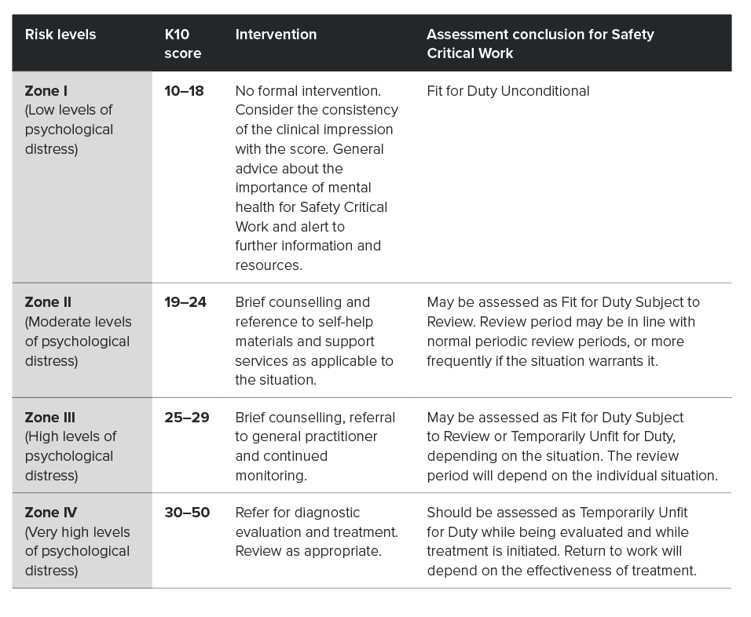

6.1.3. Epworth Sleepiness Scale

Background
The Epworth Sleepiness Scale (ESS) was developed by the Sleep Disorders Unit at the Epworth Hospital in Melbourne in 1991 to measure daytime sleepiness in adults. It is an 8-item questionnaire that asks the person about the likelihood of dozing in various circumstances during the day, irrespective of the cause (refer to Figure 37). The original and subsequent studies reported a reasonably high level of reliability for ESS scores in measuring persistent daytime sleepiness in adults.

Use of the ESS for screening Safety Critical Workers
The ESS is used in the Standard to help identify high risk workers who might be experiencing sleepiness at work. The ESS may be administered by interview to improve the likelihood of a considered response.
It is used in conjunction with the STOP-Bang Questionnaire (refer to Section 6.1.4. STOP-Bang questionnaire), which determines risk of obstructive sleep apnoea (OSA). It may be best administered after the STOP-Bang questionnaire, in the context of known risk factors for OSA.
It is noted that when the ESS is used in someone known to have OSA (AHI of 5 or greater) then a score of 11 or greater is evidence of a syndrome of disordered sleep. Similarly, when the ESS is used to monitor response to treatment, a score of less than 11 is a useful indicator that the syndrome of disordered sleep is improving.

Figure 37. Epworth Sleepiness Scale questions and scoring
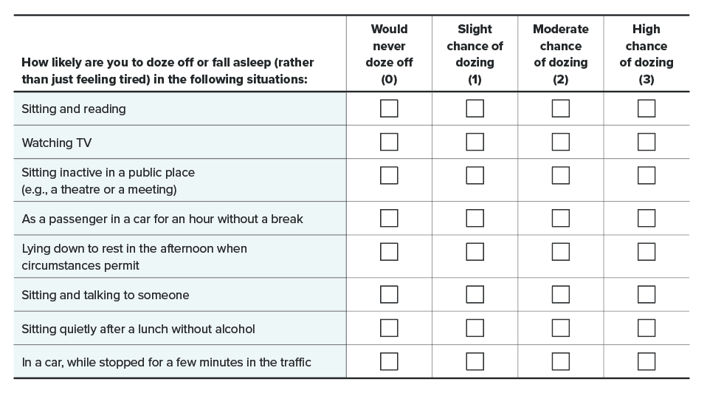

Scoring the ESS and managing Safety Critical Workers
The ESS is scored by summing the numeric values in the boxes in the questionnaire; the maximum possible is 8 x 3 = 24.
- A score of between 0 and 10 is within the normal range.
- Mild to moderate self-reported sleepiness (ESS score of 11 to 15) may be associated with a significant sleep disorder, although the degree of increased risk of sleepiness-related (motor vehicle) accidents is unknown.
- Scores of 16 to 24 are consistent with moderate to severe sleepiness and are associated with an increased risk of sleepiness-related accidents.
If a worker receives a score of greater than or equal to 16 they will be categorised as Temporarily Unfit for Duty until a sleep study is arranged (refer to Figure 26).

6.1.4. STOP-Bang questionnaire

Background
The STOP-Bang questionnaire was developed by professors at the University of Toronto as an OSA screening tool. It is a validated 8-item screening tool comprising 4 questions (STOP) and 4 objective criteria (Bang), with the questions and criteria scored (refer to Figure 38). In the surgical setting, for which it was first developed, the sensitivity of a STOP-Bang score greater than or equal to 3 is 84 per cent, 93 per cent and 100 per cent to predict all OSA (apnea-hypopnea index (AHI) greater than or equal to 5), moderate to severe OSA (AHI greater than or equal to 15) and severe OSA (AHI greater than or equal to 30), respectively.
Figure 38. STOP-Bang questionnaire
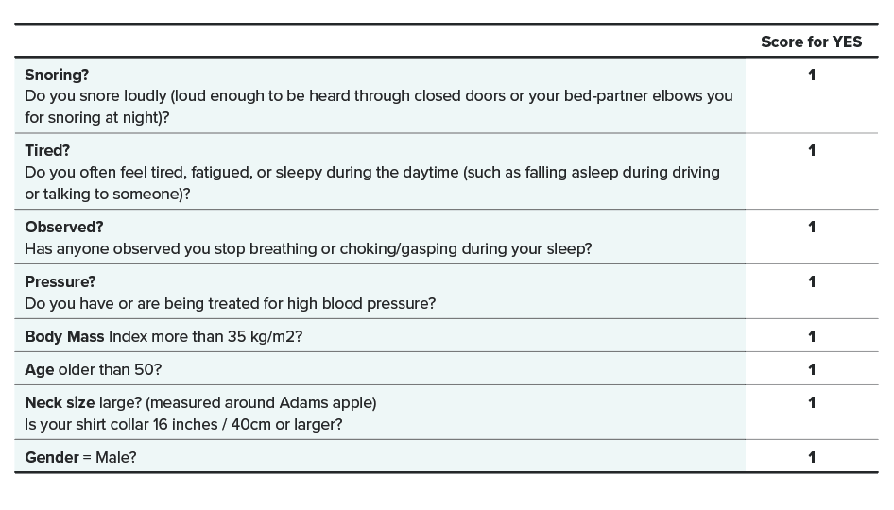

Use of the STOP-Bang questionnaire for screening Safety Critical Workers
The STOP-Bang questionnaire is used in the Standard to screen for potential OSA in Safety Critical Workers. The STOP-Bang questionnaire is a new screening tool under the 2024 Standard and has been included to reduce reliance on self-reported sleepiness (via the Epworth Sleepiness Scale).
The STOP-Bang questionnaire is administered by the Authorised Health Professional and recorded in Section 9.3 of the Record for Health Professional for Category 1 and 2 workers (refer to Section 6.2.4. Record for Health Professional).

Scoring the STOP-Bang questionnaire and managing Safety Critical Workers
The STOP-Bang questionnaire is scored by summing the numeric values in the boxes in the questionnaire; the maximum possible is 8.
- A score of between 0 and 2 indicates low risk of OSA and the worker will be categorised as Fit for Duty Unconditional.
- A score greater than or equal to 3 indicates medium to high risk of OSA and the worker will be categorised as Fit for Duty Subject to Review until a sleep study is arranged (refer to Section 6.2.4. Record for Health Professional).
If the worker is diagnosed with OSA and requires treatment, they will be categorised as Temporarily Unfit for Duty until they can demonstrate compliance with treatment.

6.1.5. Alcohol Use Disorders Identification Test questionnaire

Background
The Alcohol Use Disorders Identification Test (AUDIT) was developed by the World Health Organisation as a method of screening for excessive alcohol consumption. It provides a framework for intervention to help at-risk or high-risk drinkers to reduce or cease their alcohol consumption. It also helps to identify alcohol dependence.
The AUDIT has 10 questions to which there is a choice of up to 5 answers in a tick-a-box format (refer to Figure 39).
The questions are designed to seek information in 3 domains: risky or hazardous alcohol use, dependence symptoms and high risk or harmful alcohol use (refer to Figure 40). A total score of 40 is possible. Higher scores indicate a greater likelihood of hazardous or harmful drinking and reflect a greater severity of alcohol problems and dependence, as well as a greater need for more intensive treatment.

Definitions

Risky or hazardous alcohol use
Hazardous drinking is a pattern of alcohol consumption that increases the risk of harmful consequences for the user or others, including the risk of accidents, injuries and social problems.

High-risk or harmful alcohol use
Harmful use refers to alcohol consumption that results in long-term consequences to physical and mental health (for example, gastritis, liver damage or depression).

Alcohol dependence
Alcohol dependence is a cluster of behavioural, cognitive and physiological phenomena that may develop after repeated alcohol use. Typically, these include a strong desire to consume alcohol, impaired control over use, persistent drinking despite harmful consequences, a higher priority given to drinking than to other activities and obligations, increased alcohol tolerance and physical withdrawal reaction.

Use of the AUDIT questionnaire for screening Safety Critical Workers
The AUDIT questionnaire is used to identify patterns of alcohol use that may impact on Safety Critical Work. It aims to ensure that individuals are not impaired at work, either by the direct effects of alcohol or the health and social problems associated with alcohol use.
The Periodic Health Assessment also provides an opportunity to counsel Safety Critical Workers about hazardous drinking patterns.
While the AUDIT is included in the Health Questionnaire for self-administration, the responses may be validated verbally as required. It may be helpful to reassure the worker that all responses are confidential and are not forwarded to the operator.
AUDIT results are categorised into particular risk levels (or ‘zones’) to guide the appropriate intervention (refer to Figure 41).
The Authorised Health Professional should evaluate the responses to the questionnaire in conjunction with results of the clinical examination and form a view as to whether they believe there is a significant current risk that the worker might be impaired at work, either by the direct effects of alcohol, or by associated health or social problems.
Note that it is possible to accumulate 8 or more points as a result of binge drinking on days off, or highlight excessive drinking in the past, without necessarily being at risk of being impaired at work. The health assessment does, however, provide a valuable opportunity to provide brief advice about risky alcohol consumption.
Also note that through separate drug and alcohol policies and procedures, workers may be subject to random testing. Workers are also subject to testing following incidents.

Figure 39. AUDIT questionnaire
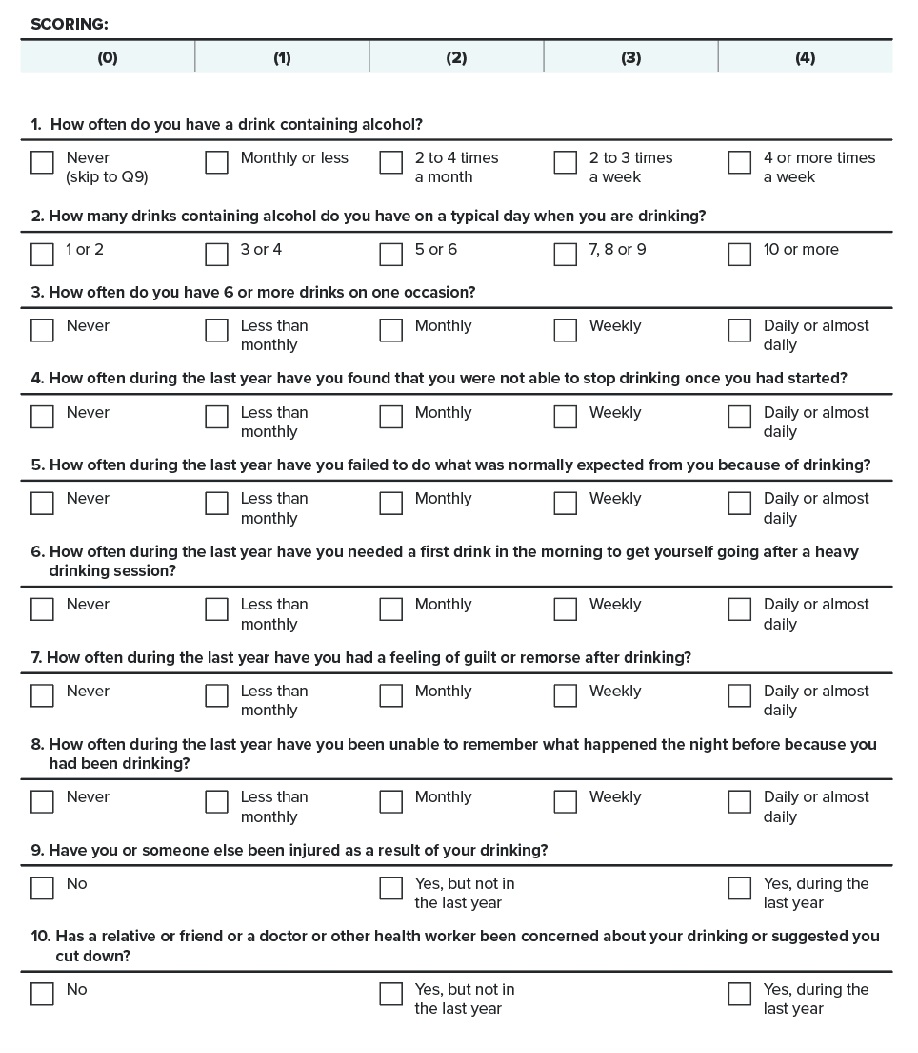

Figure 40. Domains and item content of the AUDIT
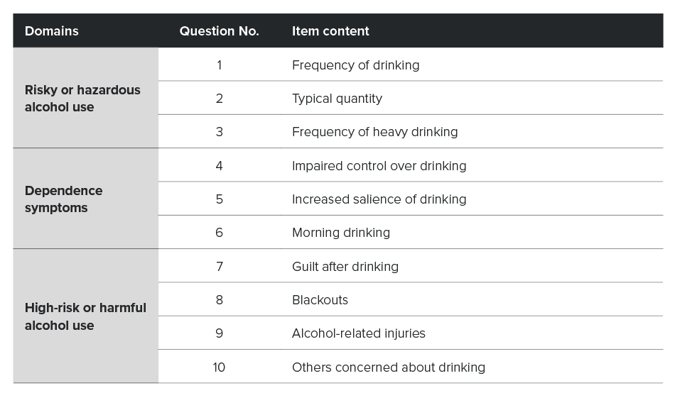
Figure 41. AUDIT risk levels
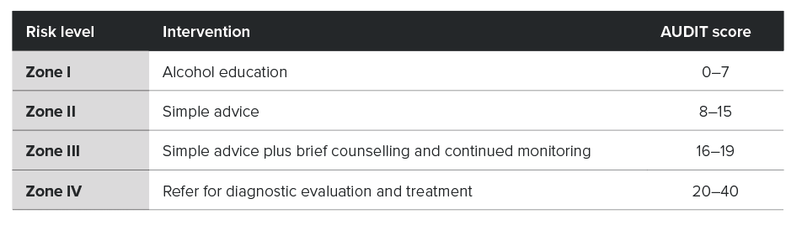

Risk Zone I — AUDIT scores between 0 and 7
This score generally indicates low-risk drinking. Although no formal intervention is required, alcohol education is appropriate for the following reasons:
- It contributes to the general awareness of alcohol risks and the relevance to Safety Critical Work.
- It may be effective for workers who have experienced alcohol problems but who have already reduced their drinking levels, or whose circumstances may change.
- It could be effective for those workers who have minimised the extent of their drinking on the AUDIT questions.

Risk Zone II — AUDIT scores between 8 and 15
Scores in this zone are likely to be recorded by a significant proportion of workers. They indicate alcohol use in excess of the low-risk guidelines.
People in Zone II would generally be drinking at risky or hazardous levels and would be at moderate risk of alcohol-related harm. This zone, however, may also include workers experiencing actual harm and low levels of dependence. Generally, simple advice and information on the alcohol guidelines and risk factors, and the importance of attentiveness for Safety Critical Work, would be an appropriate intervention.
The Authorised Health Professional may assess the worker as Fit for Duty Subject to Review to flag the issue for attention at subsequent assessments. The period of review may be earlier than or in line with normal periodic frequencies, depending on the clinical assessment and other indicators.

Risk Zone III — AUDIT scores between 16 and 19
This zone indicates risky drinking and problems related to higher levels of consumption. This score indicates a pattern of consumption that is already causing harm to the drinker who may also have symptoms of dependence. Workers in this zone should be managed by a combination of simple advice, brief counselling and continued monitoring. Follow-up and referral to the worker’s general practitioner is necessary.
The Authorised Health Professional should assess the worker as Fit for Duty Subject to Review and should refer for external assessment via the worker’s general practitioner. They may also categorise as Temporarily Unfit for Duty if there are immediate concerns for safe conduct of safety critical tasks.

Risk Zone IV — AUDIT scores in excess of 20, and where combined scores on questions 4, 5 and 6 are greater than or equal to 4
Scores in this zone indicate that the person falls into the high-risk category of alcohol-related harm. Workers in this zone are likely to be alcohol dependent and require more intensive intervention. Authorised Health Professional should note that dependence varies along a continuum of severity and might be clinically significant at lower AUDIT scores.
Workers in this zone should be referred to specialist services to consider withdrawal, pharmacotherapy, and other more intensive treatments. They should be assessed as Temporarily Unfit for Duty pending further assessment and referred in the first instance to their general practitioner.

Steps in identifying a drinking problem
If a person has a total score of greater than or equal to 8 on the AUDIT questionnaire, the following additional steps are recommended:
- Check the accuracy of the high scoring questions with the worker.
- Ask some additional questions to help determine the person’s potential for alcohol dependence. The following question may be helpful to confirm accuracy and obtain more information: for example, How many drinks did you have on your last drinking day—and on the previous occasion? (this is a good guide to the usual intake).

6.2. Model forms
This section contains the model forms and explanations for completion.
The fillable forms for conducting the health assessments may be downloaded from the NTC website.
Note that the forms are model forms and may be modified by rail transport operators to suit their circumstances provided that the content relevant to the implementation of the Standard is preserved.

6.2.1. Risk categorisation and health assessment requirements template
This template may be used to guide conduct of the risk assessment, which guides determination of the worker’s risk category and health assessment requirements.
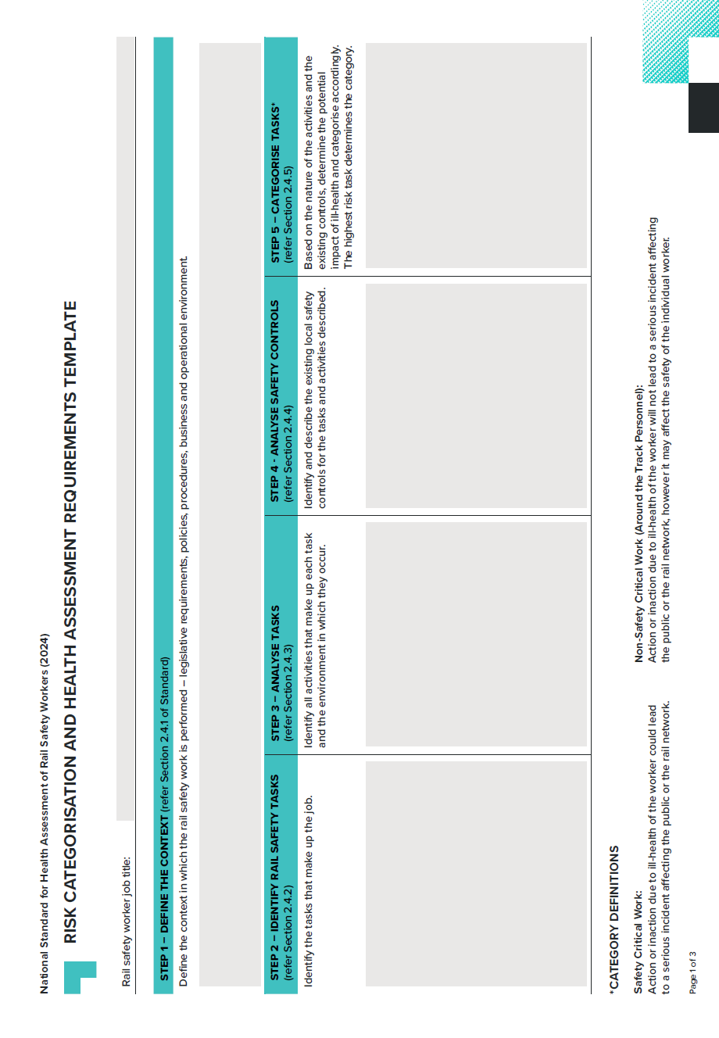
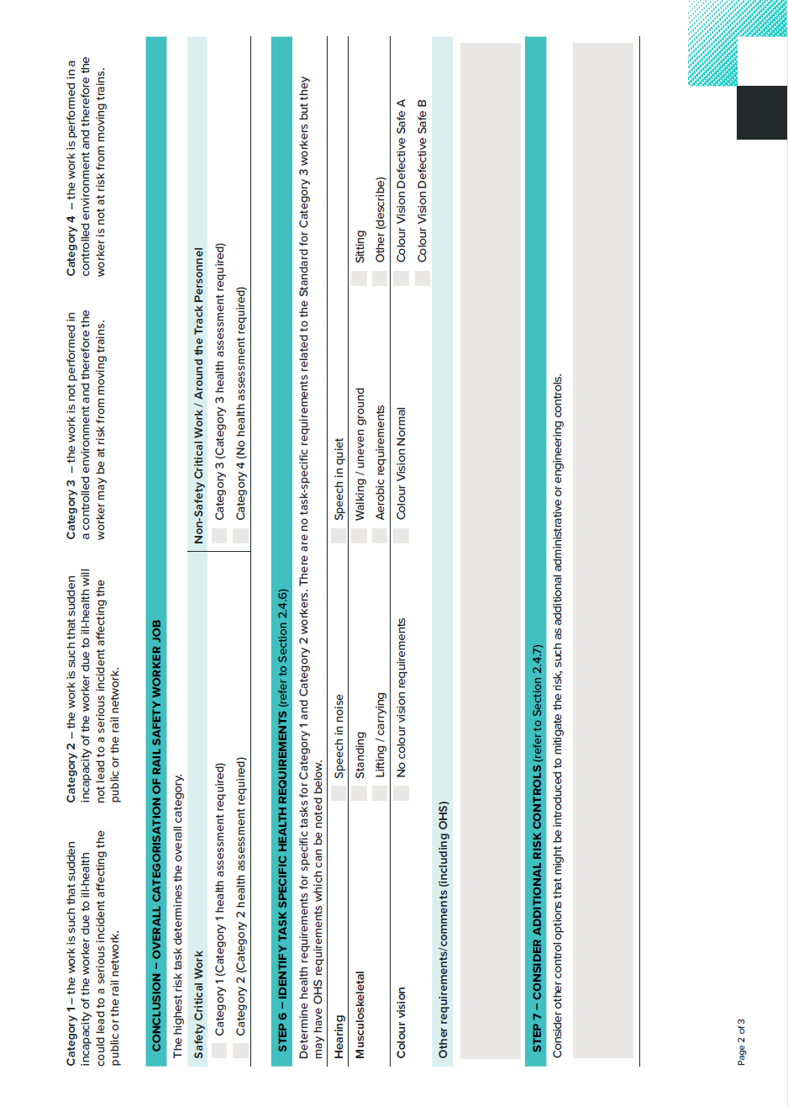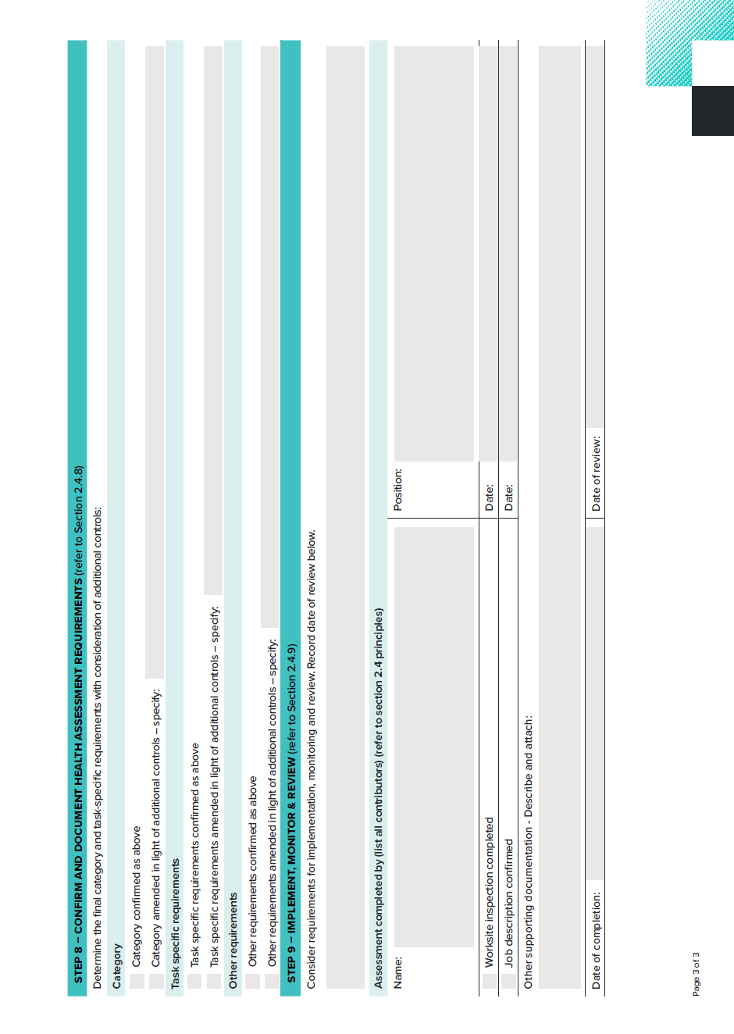
To download this form visit: ntc.gov.au.

6.2.2. Request and Report Form
The Request and Report Form is the key means of communication between the rail transport operator and the Authorised Health Professional.
The form is used as follows:
- Part A – Health Assessment Request – The rail transport operator completes Part A, encloses copies of relevant supporting information (for example, a previous health assessment report, sick leave summary, relevant workers compensation reports or critical incident reports) and a blank copy of the Record for Health Professional, and forwards them to the Authorised Health Professional. This section also accommodates workers' informed consent for portability of the health assessment report as required.
- Part B – Health Assessment Report – Upon completion of the assessment, the Authorised Health Professional completes Part B of the form.
The original form is sent to the rail transport operator. The Authorised Health Professional retains a copy on file and a further copy is provided to the worker or applicant.
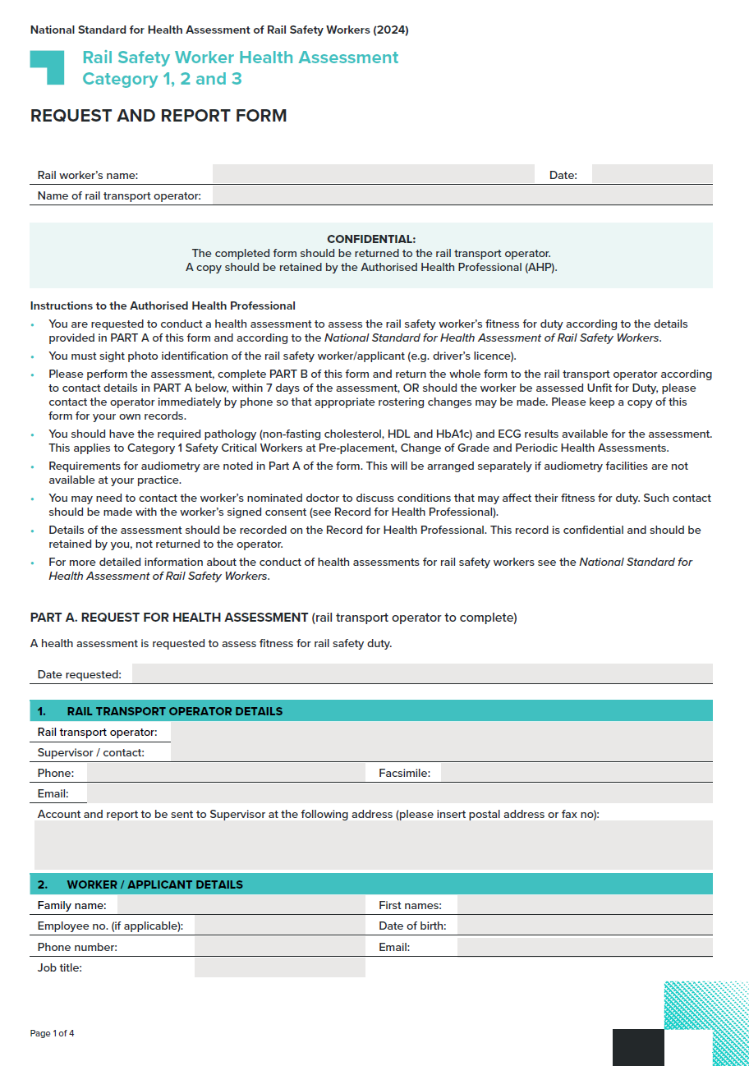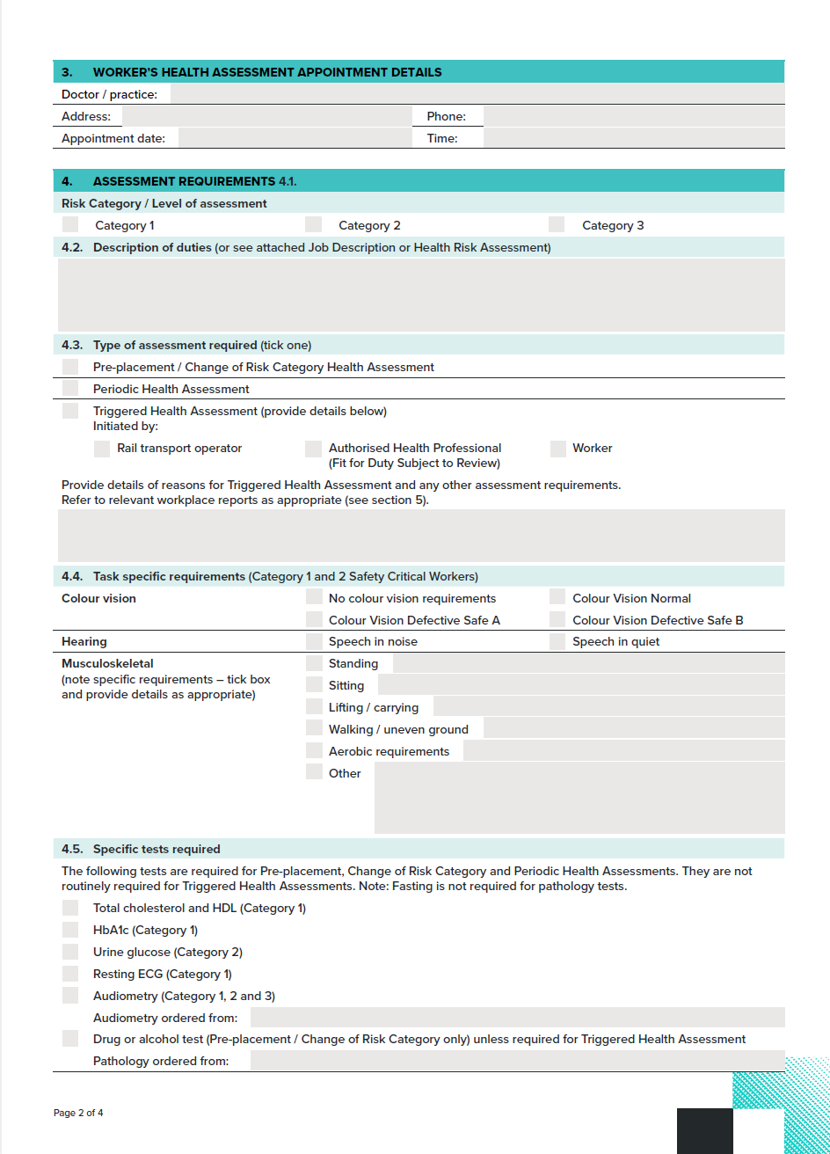
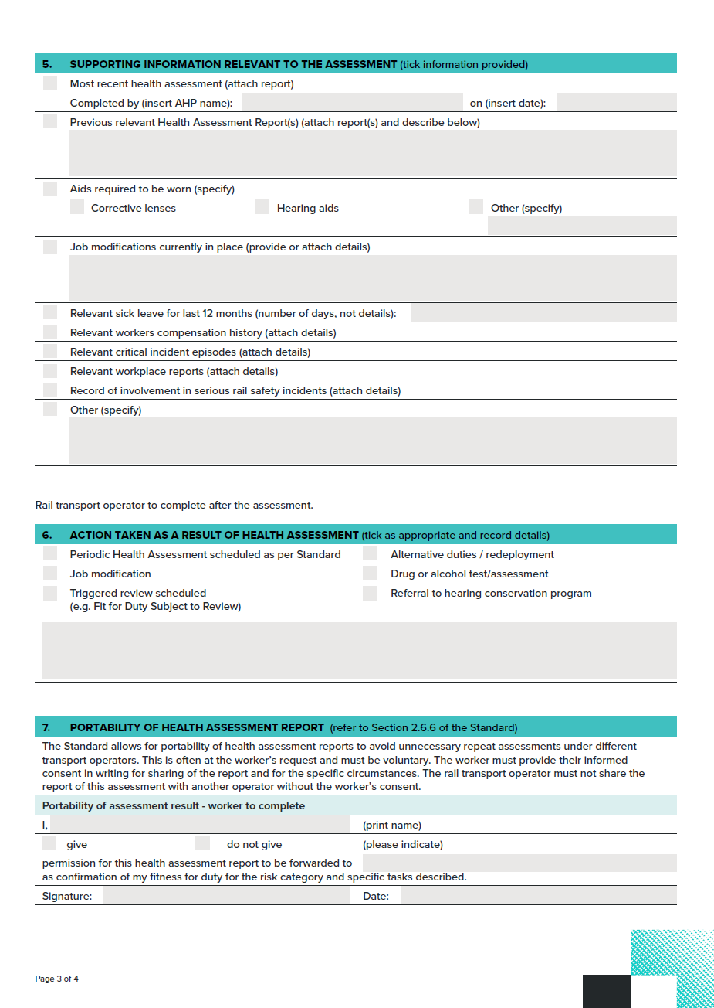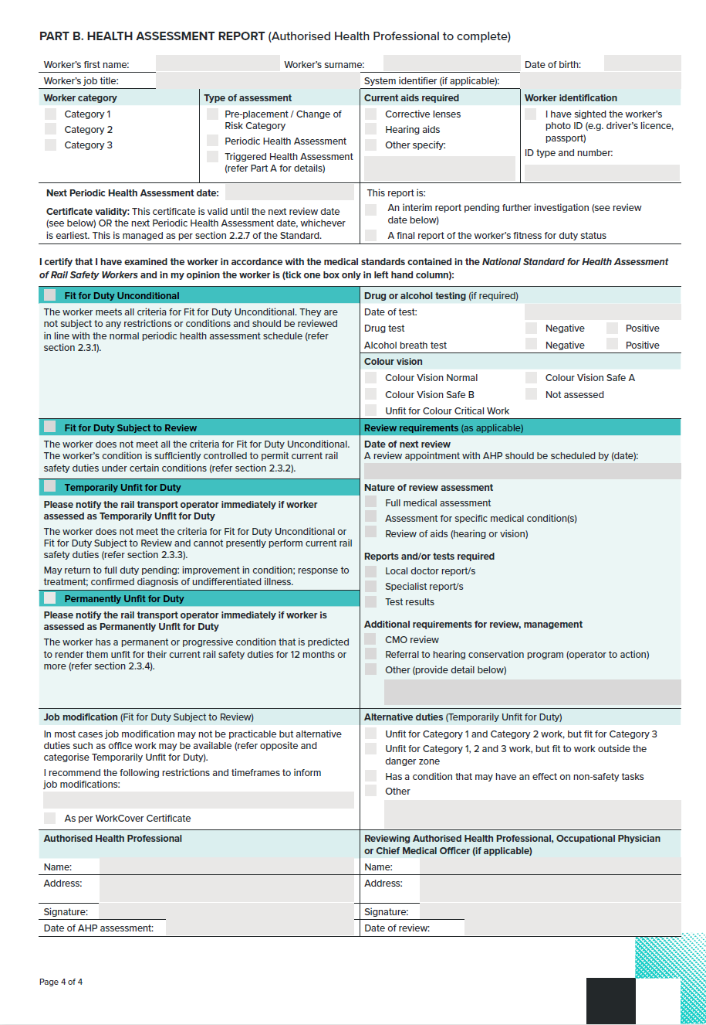
To download this form visit: ntc.gov.au.

6.2.3. Worker Notification and Health Questionnaire
This form contains the Worker Notification and Health Questionnaire. There is a version of this form for Category 1 and Category 2 Safety Critical Workers, and a version for Category 3 workers.
The self-administered questionnaire in the Category 1 and Category 2 form is a screening tool to help identify conditions that might affect the performance of Safety Critical Work. The questionnaire is not a diagnostic tool, and no decision can be made regarding the worker’s fitness for duty until the full assessment is performed.
The Authorised Health Professional may need to guide or assist with completion of the questionnaire if literacy or cultural background are barriers to self-administration by the worker. The health professional will also need to review the answers with the worker to determine relevant detail. There is space on the form for the health professional to make relevant notations.
Dishonest completion of the questionnaire may be an issue. Workers are required to sign the completed questionnaire in the presence of the Authorised Health Professional and the Authorised Health Professional should countersign. The clinical assessment provides an opportunity to validate responses as appropriate.
The form is used as follows:
- Part A – The rail transport operator completes PART A including appointment details and instructions to the worker or applicant.
- Part B – The worker or applicant completes PART B and presents it to the Authorised Health Professional.
- Part C – The rail transport operator requests that the worker or applicant sign the end of the form to indicate that they have read and understood the statements concerning the health information to be provided at the beginning of the form. The worker or applicant signs the form as a true statement and the Authorised Health Professional countersigns.
The rail transport operator discusses the results with the worker or applicant. The form is retained by the Authorised Health Professional and filed in the worker’s medical record.
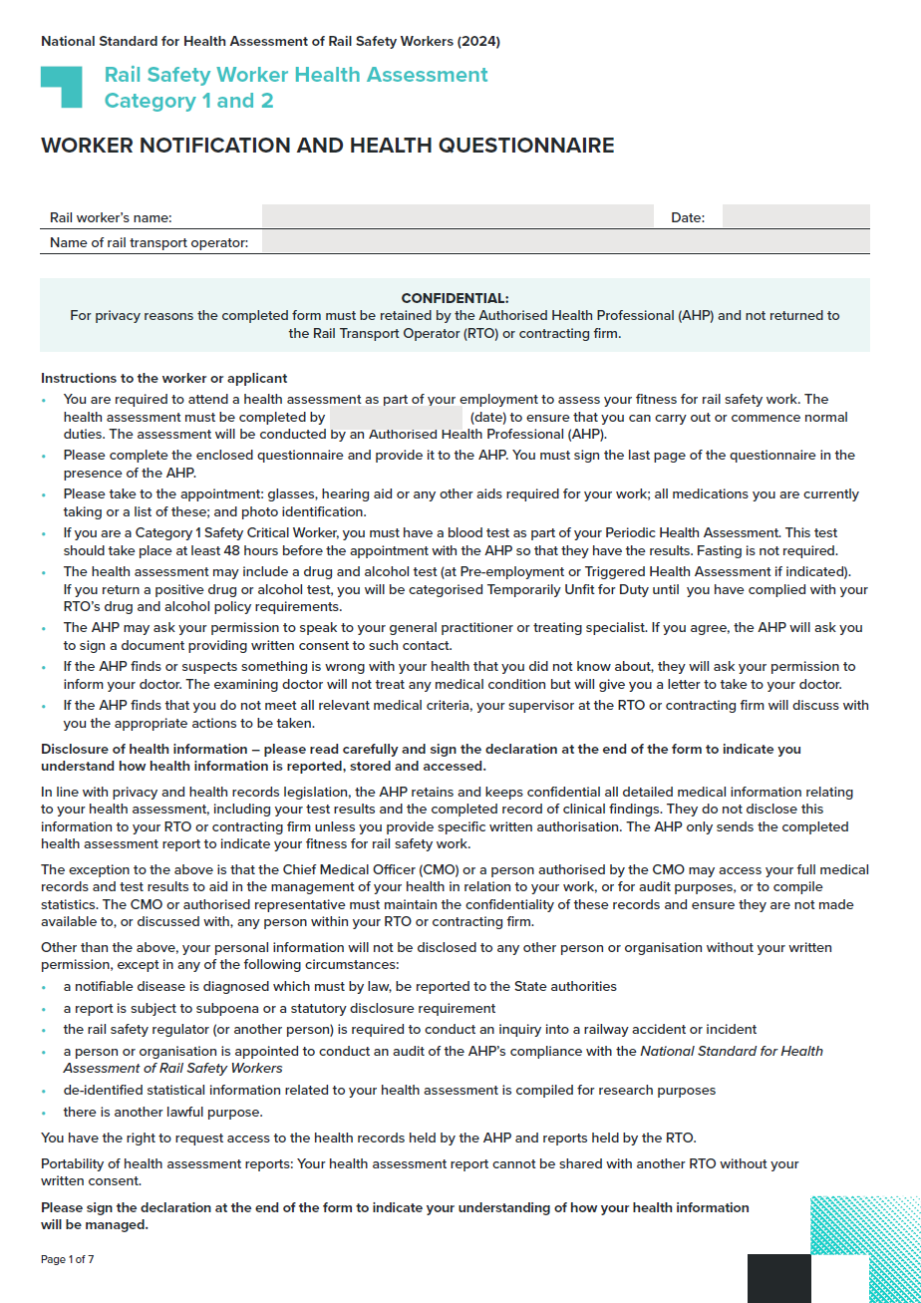
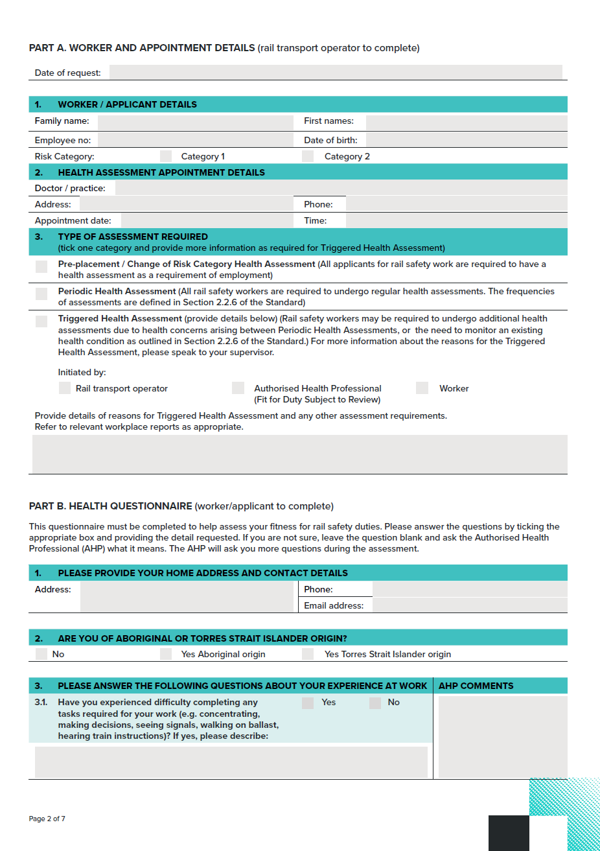
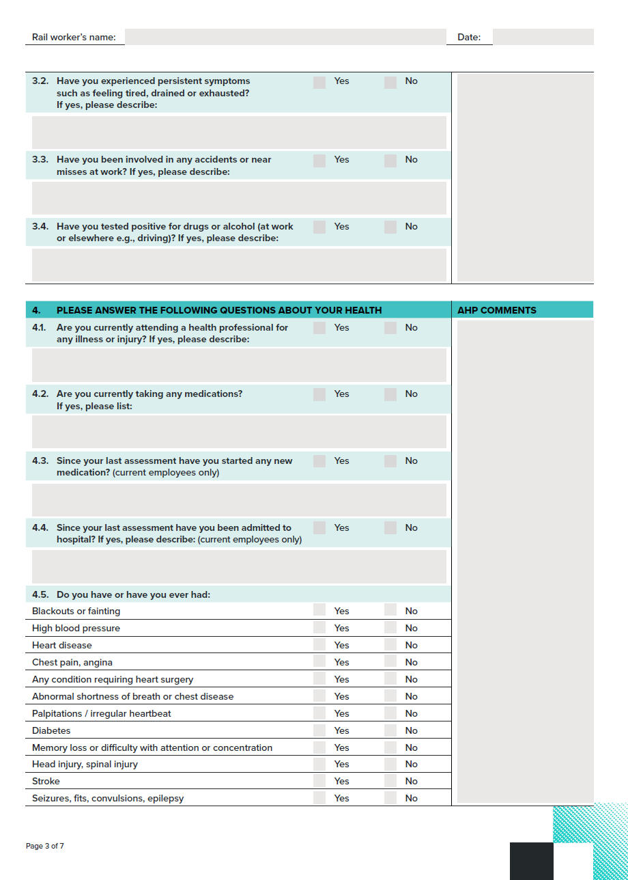
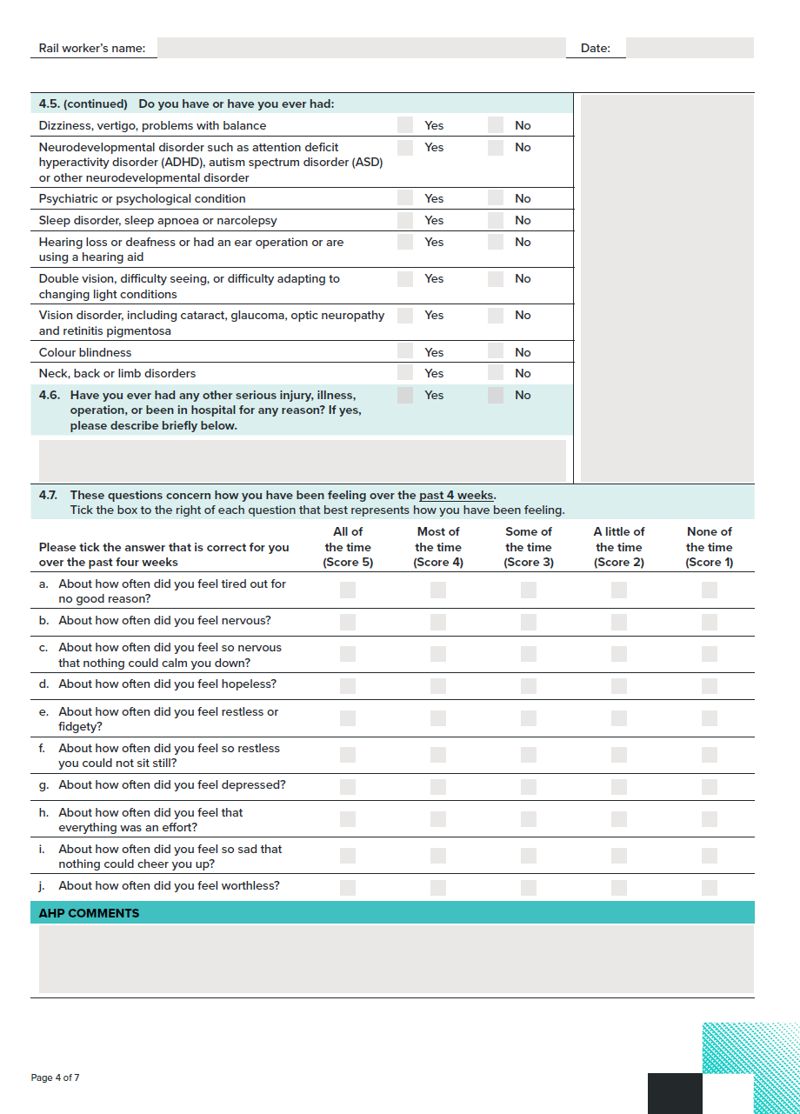
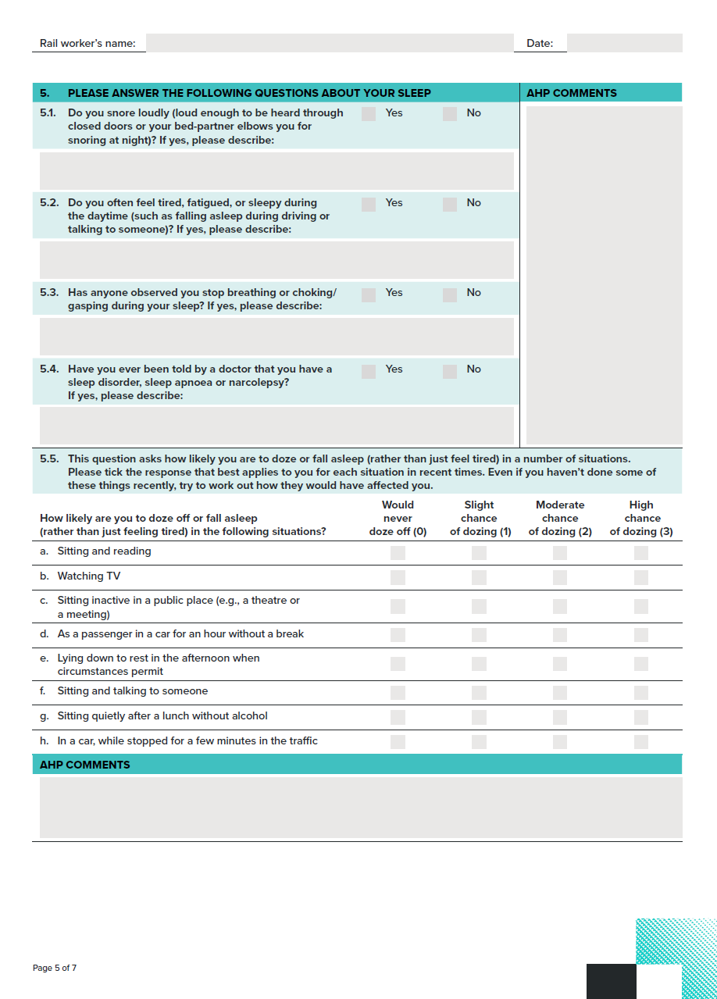
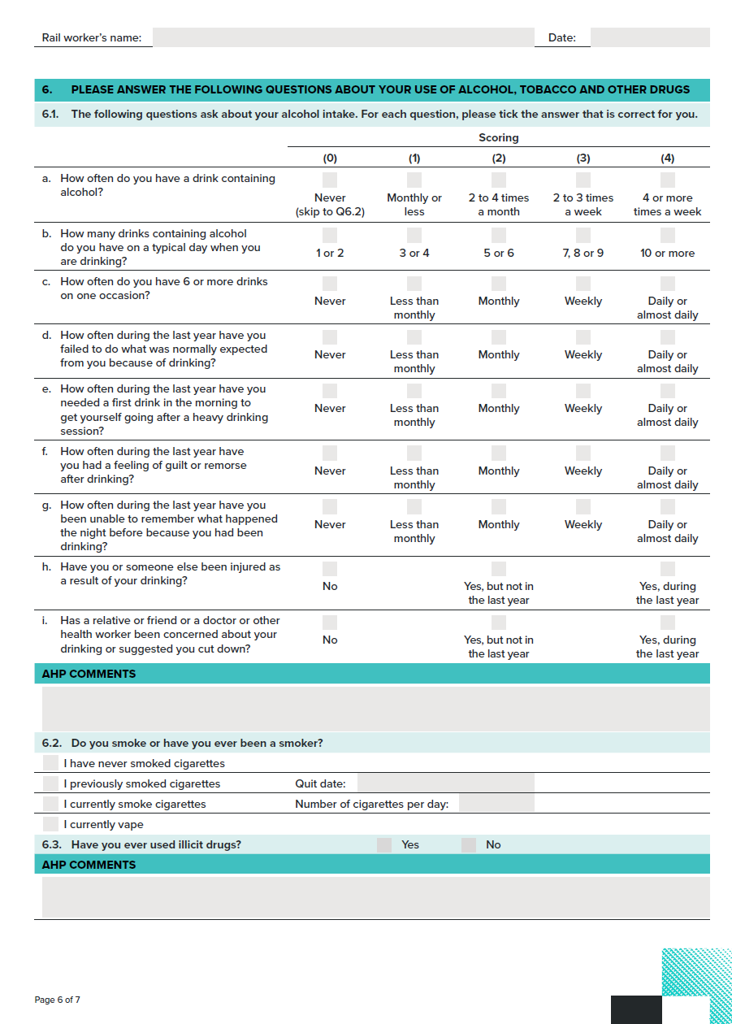
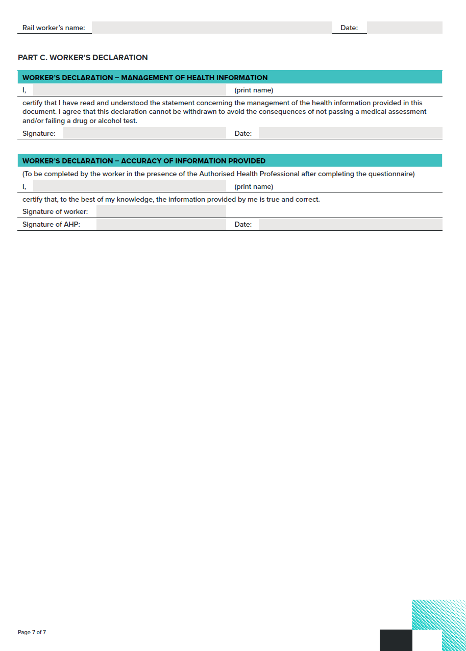
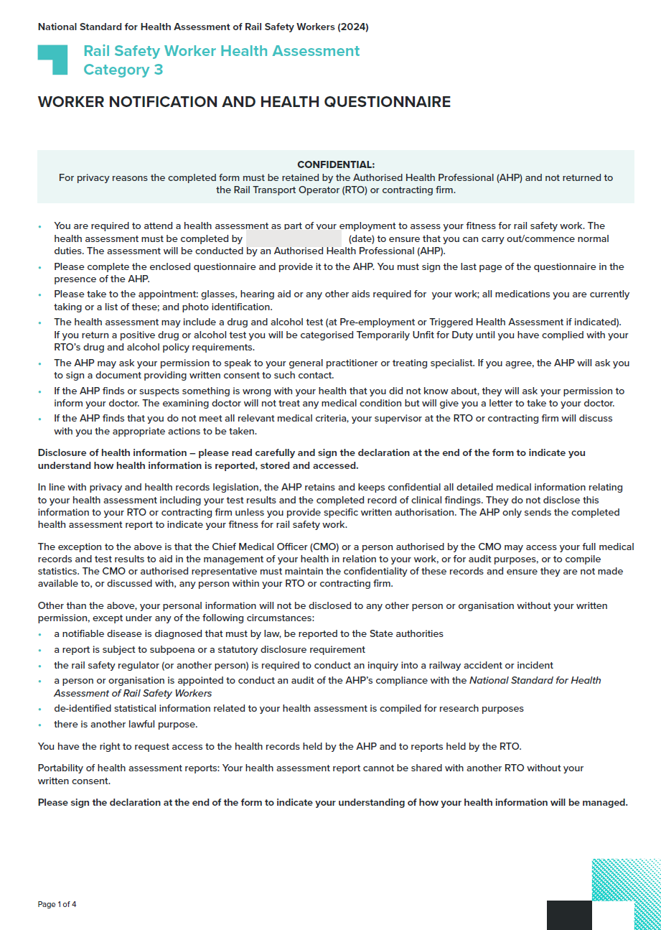
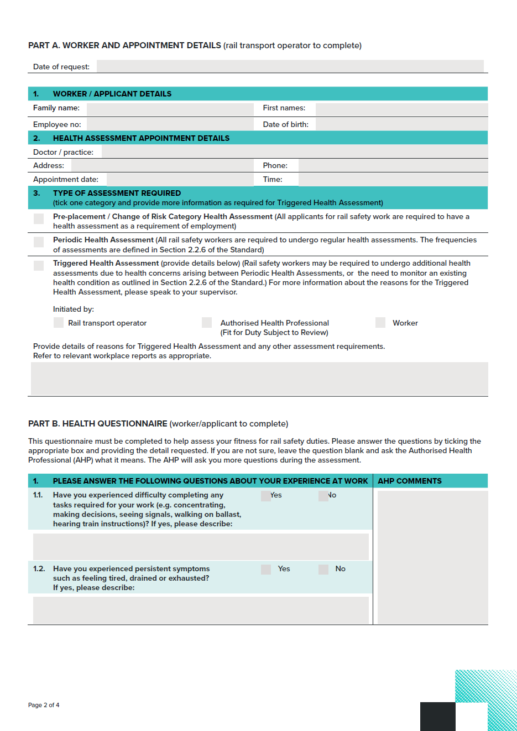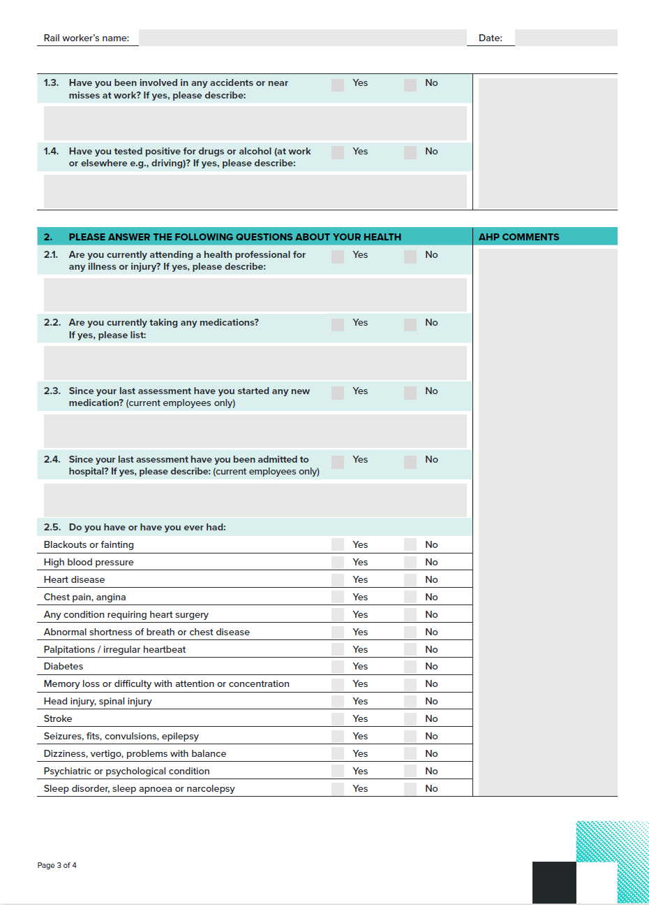
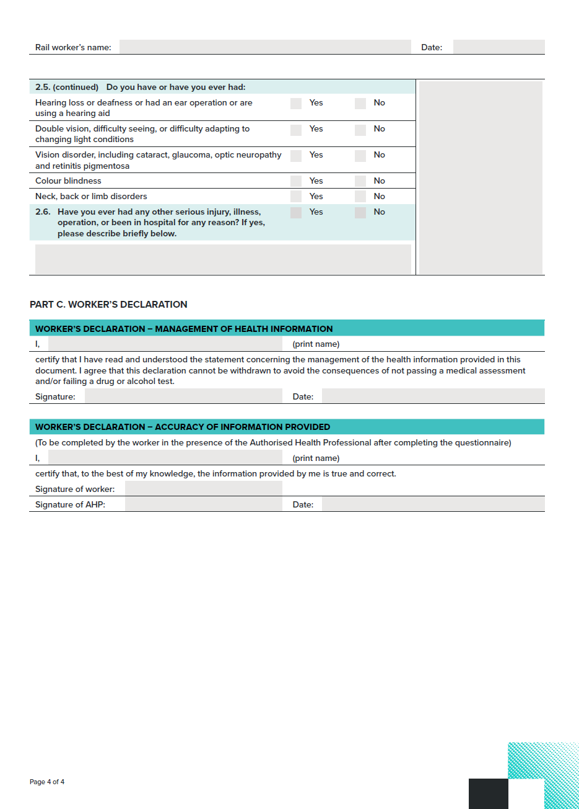

To download this form visit: ntc.gov.au.

6.2.4. Record for Health Professional
The Record for Health Professionals is a tool that guides the health assessment process. It provides a standard format for recording the results of the assessment, which should then be filed by the Authorised Health Professional in the worker or patient’s medical history. There is a version of this form for Category 1 and Category 2 Safety Critical Workers, and a version for Category 3 workers.
The form should be used as follows:
- Part A – The rail transport operator completes Part A and includes the form with the Request and Report Form (Section 6.2.2. Request and Report Form) and forwards it to the Authorised Health Professional.
- Part B – The worker or patient is able to provide signed consent for the Authorised Health Professional to contact their treating doctor.
- Parts C and D – The Authorised Health Professional records the results of the clinical examination.
- Part D summarises the findings and actions.
The completed Record for Health Professionals is not to be forwarded to the rail transport operator for reasons of privacy. The Authorised Health Professional should summarise the results in terms of fitness for duty on the Request and Report Form (Section 6.2.2. Request and Report Form).
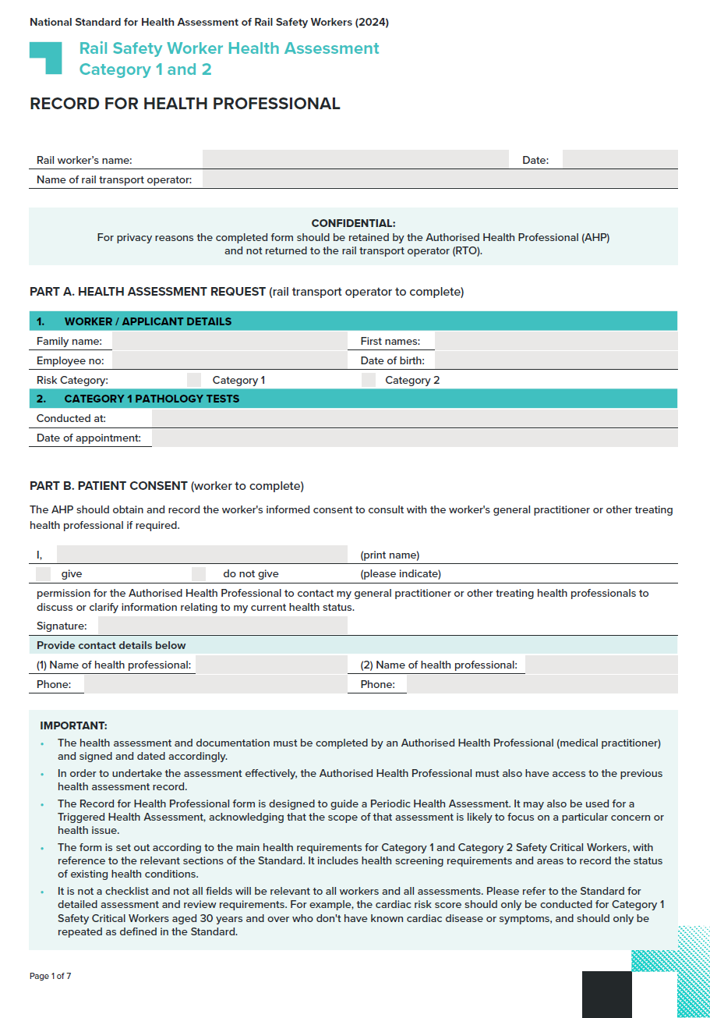
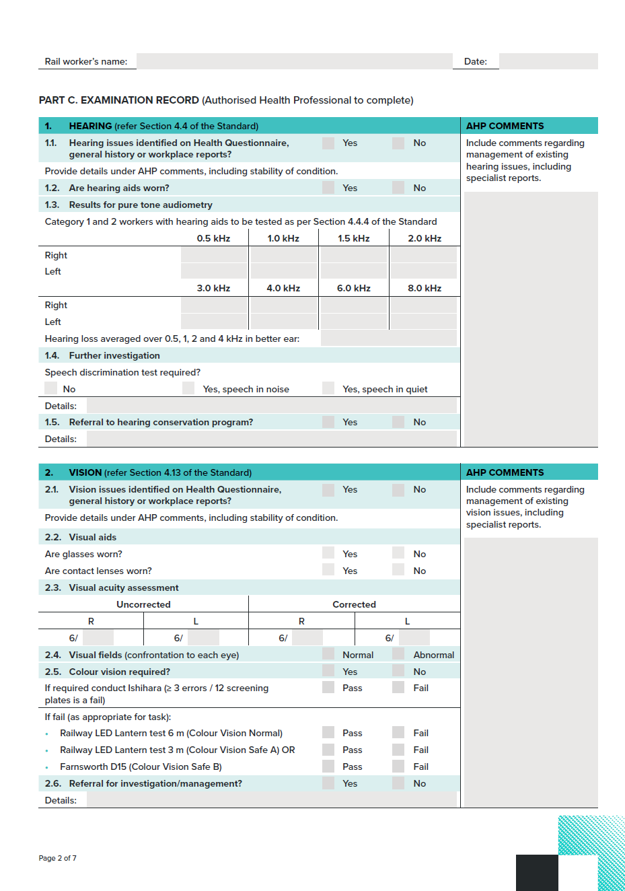

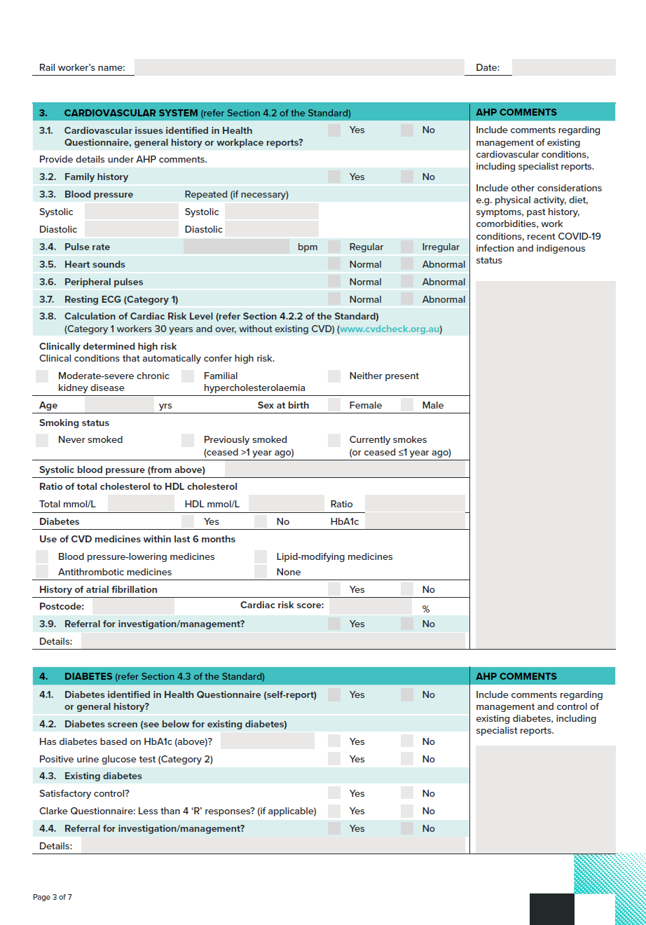
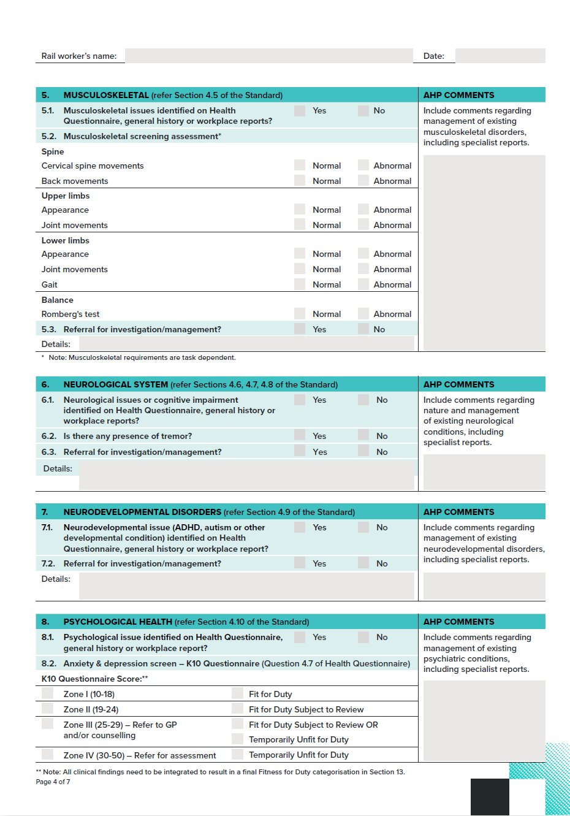
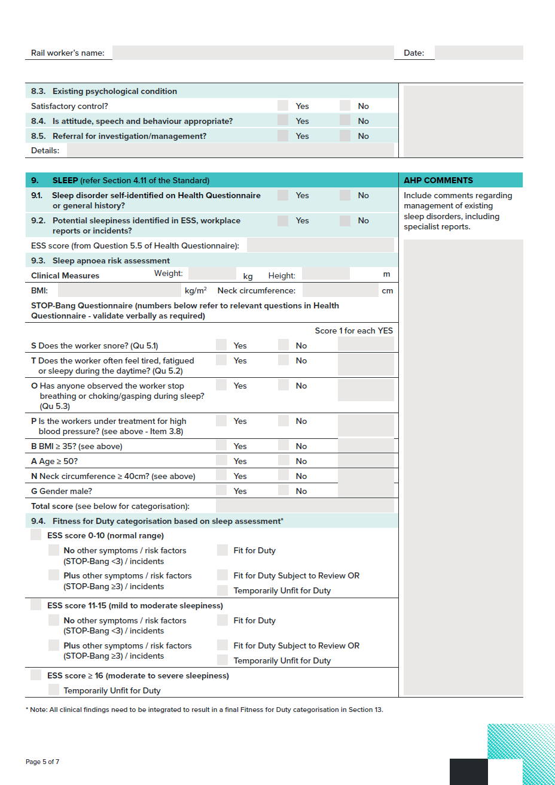
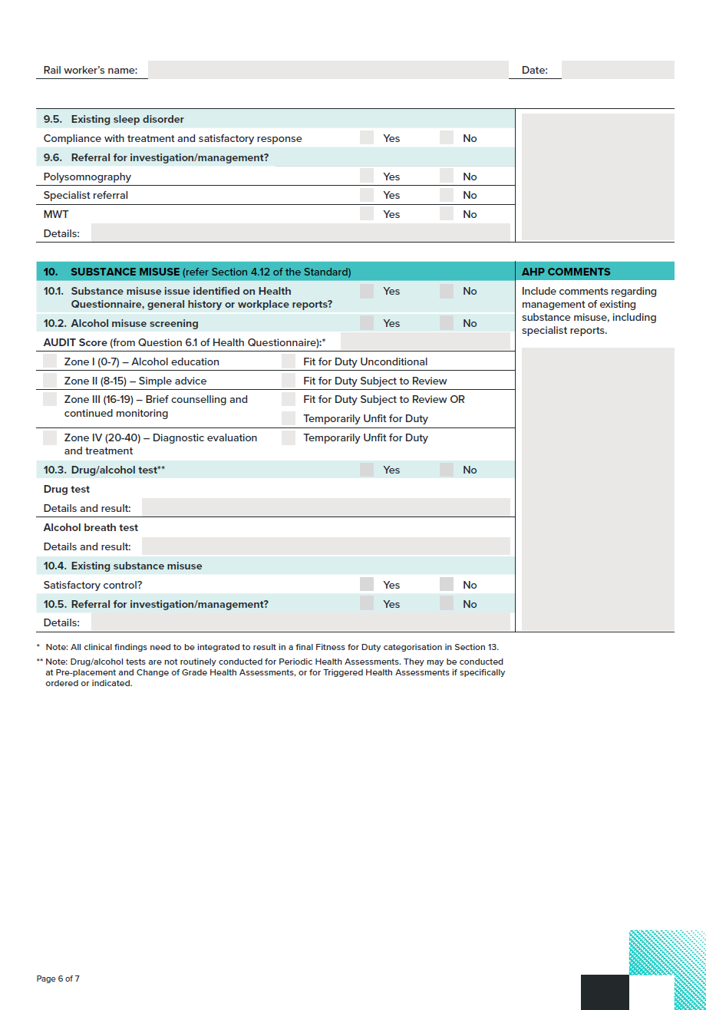
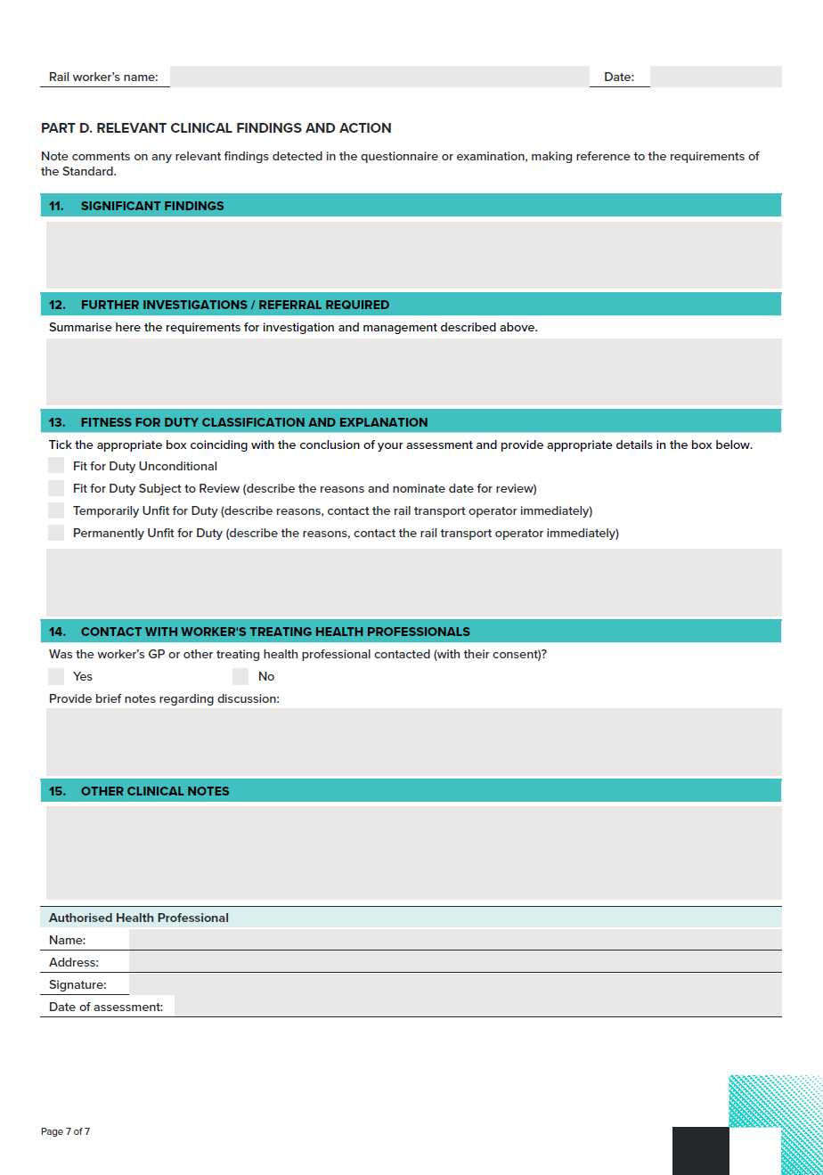
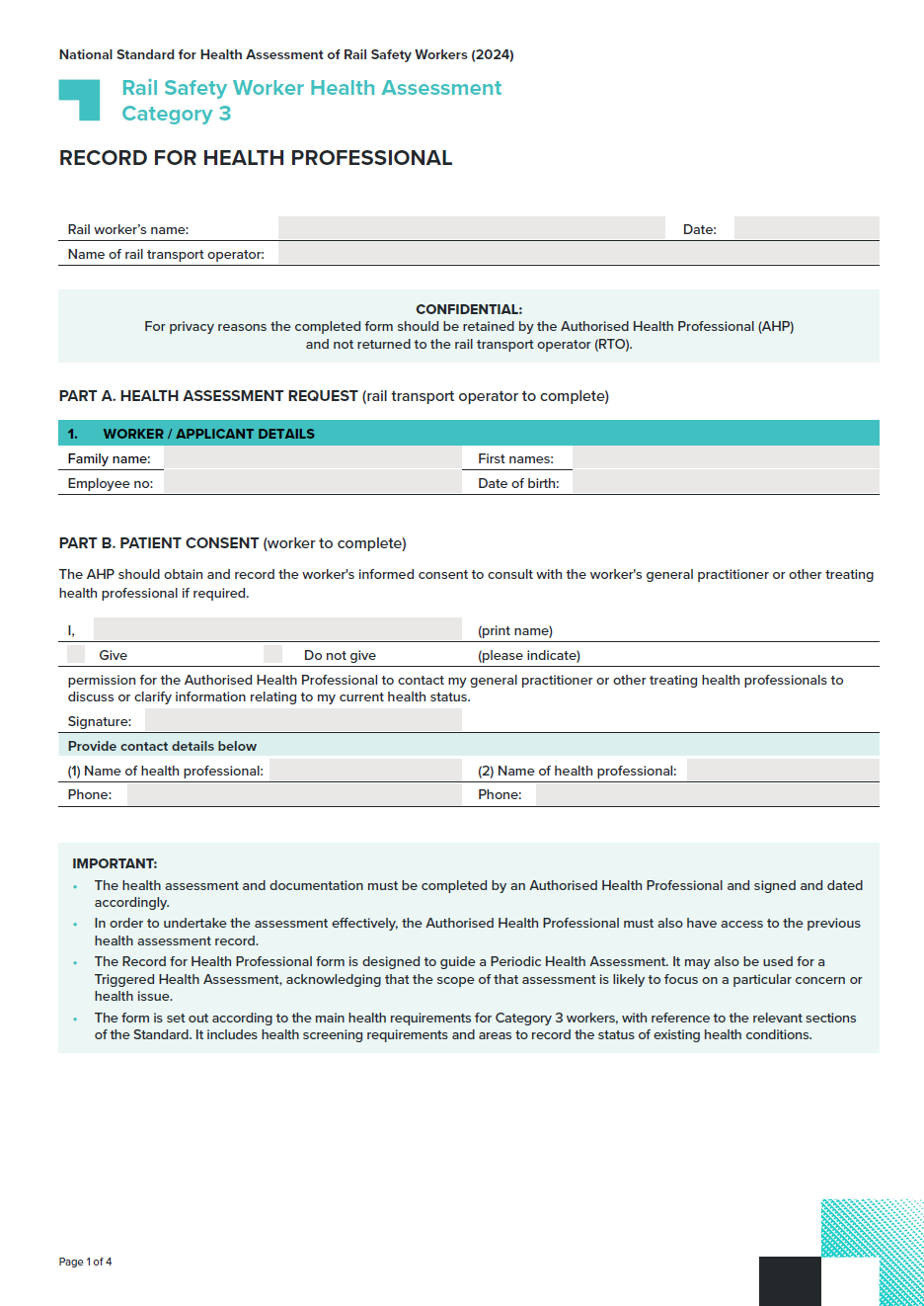
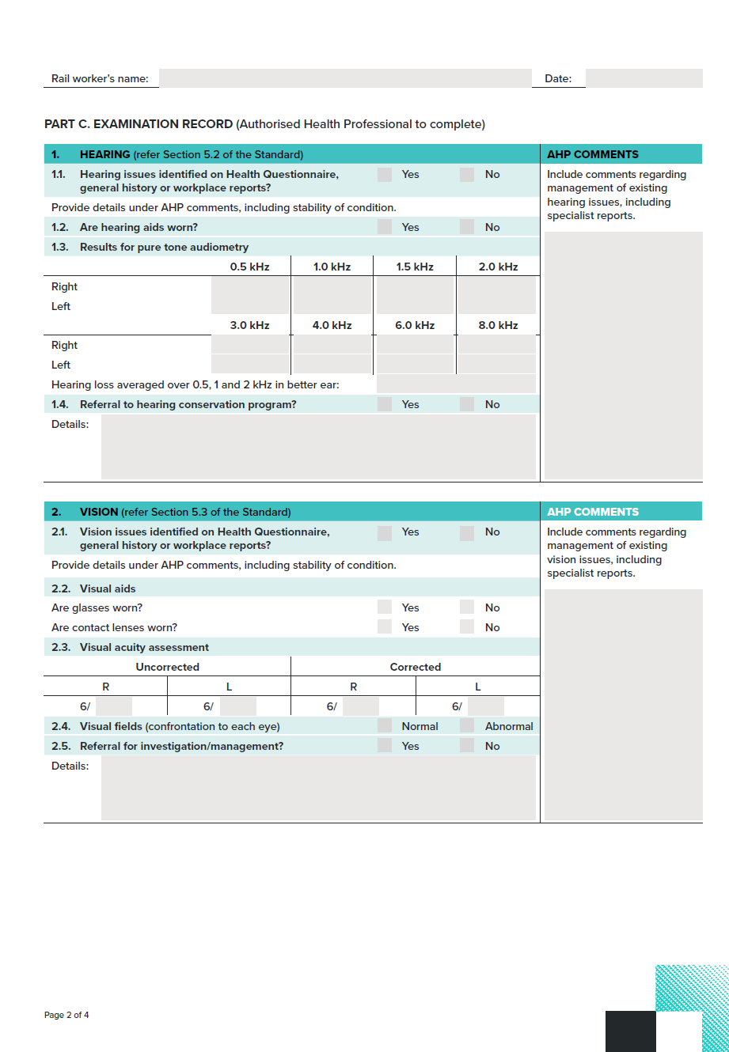
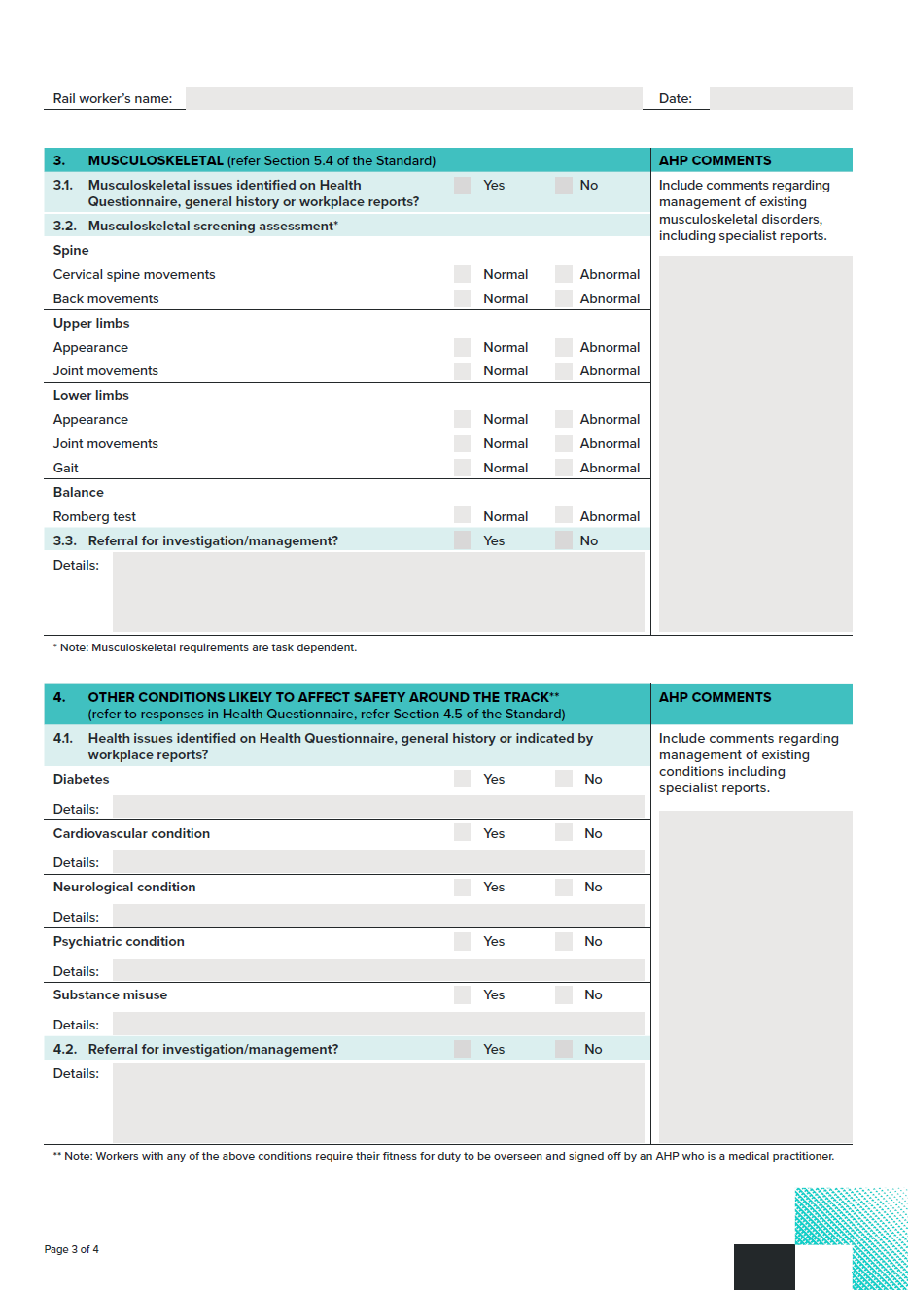
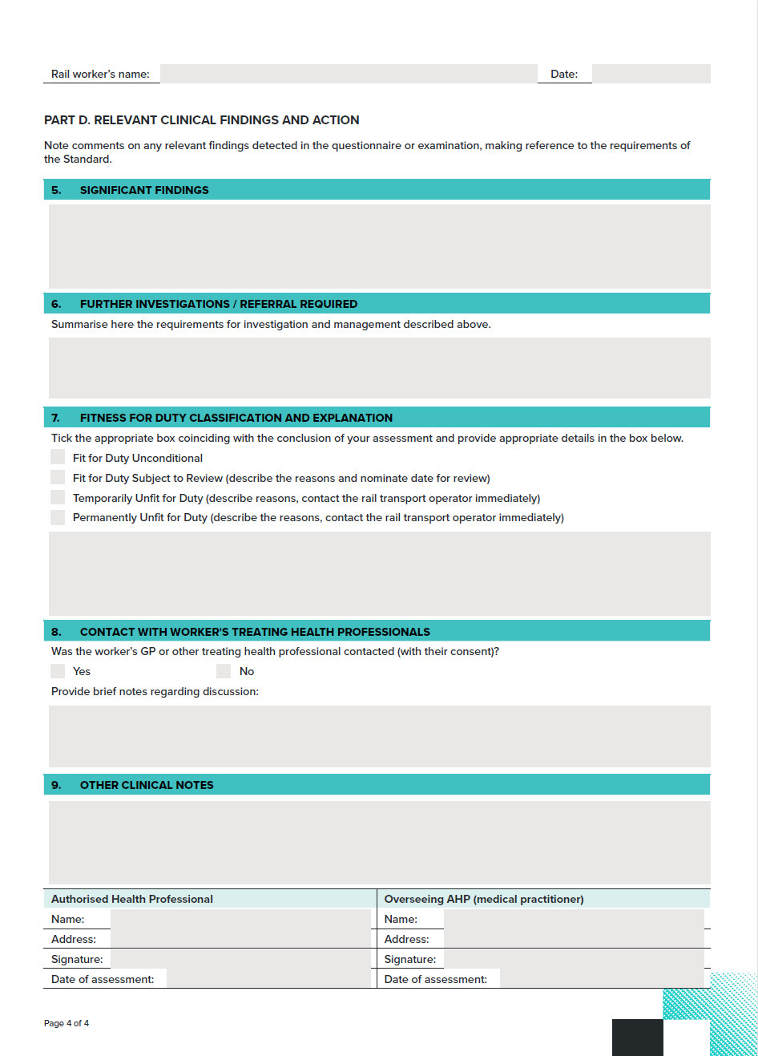
To download this form visit: ntc.gov.au.

6.3. Transition arrangements

6.3.1. Purpose of this section
This section sets out how it is intended that the Standard is to take effect.

6.3.2. Definitions
In this section, the commencement date is Monday 11 November 2024 [This is the date the Standard takes effect – see Section 1.2. Scope of the Standard of the Standard]. In this section, the former Standard is the National Standard for Health Assessment of Rail Safety Workers, 2017.

6.3.3. Assessments according to the Standard
All health assessments required under the National Standard for Health Assessment of Rail Safety Workers must be conducted according to this version of the Standard from the date of commencement.
The requirement that blood tests for Category 1 Safety Critical Workers no longer require fasting, is already effective as approved by the Infrastructure and Transport Senior Officials’ Committee on 31 October 2022.
Workers will be assessed under the new Standard as their assessments fall due. Individuals with known health concerns may be triggered for an earlier assessment if needed.

6.3.4. Requirements for meeting the colour vision standard
Workers who were previously assessed by a rail transport operator under the former Standard using the Farnsworth Lantern, or who were assessed prior to 2012 with a practical test and have been working safely in the same role, may continue to perform their duties. However, if such a worker applies for a position with different colour vision demands or if the colour vision demands of the role change, they should be assessed against the Standard (refer to Section 4.13. Vision and eye disorders).
National Transport Commission
Level 3/600 Bourke Street
Melbourne VIC 3000
Ph: (03) 9236 5000
Email: enquiries@ntc.gov.au
www.ntc.gov.au

Office of the National Rail Safety Regulator (2019) ONRSR Guideline Safety Management System (SMS), https://nraspricms01.blob.core.windows.net/assets/documents/Guideline/Safety-Management-System-Guideline-updated-1-July-2022.pdf
Rail Safety National Law https://www.onrsr.com.au/publications/rail-safety-national-law-related-legislation
Rail Safety National Law National Regulations 2012, https://www.onrsr.com.au/publications/rail-safety-national-law-related-legislation
Australian Human Rights Commission (2014) A quick guide to Australian discrimination laws, https://www.humanrights.gov.au/sites/default/files/GPGB_quick_guide_to_discrimination_laws_0.pdf
Office of the Australian Information Commissioner, Australian Privacy Principles, https://www.oaic.gov.au/privacy-law/privacy-act/australian-privacy-principles
Office of the Australian Information Commission, State and territory privacy legislation, https://www.oaic.gov.au/privacy/privacy-in-your-state
Office of the National Rail Safety Regulator (2019) ONRSR Guideline Safety Management System (SMS), https://nraspricms01.blob.core.windows.net/assets/documents/Guideline/Safety-Management-System-Guideline-updated-1-July-2022.pdf
Under section 203 of the RSNL the Minister may, by notice in the Gazette grant exemptions from this Law. Under section 203A of the RSNL, the Regulator may, in the event of an emergency, by notice in the South Australian Government Gazette, exempt rail transport operators or rail transport operators of a class, from the operation of section 114 in respect of the railway operations, or specified railway operations, of the operator.
Charlton, JL et al. (2021) Influence of chronic illness on crash involvement of motor vehicle drivers: 3rd Edition, Monash University Accident Research Centre. https://www.monash.edu/__data/assets/pdf_file/0008/2955617/Chronic-illness-and-MVC-risk_Report-MUARC-report-no-353_JUNE2022.pdf
Safe Work Australia (2018) How to manage work health and safety risks Code of Practice, https://www.safeworkaustralia.gov.au/system/files/documents/1901/code_of_practice_-_how_to_manage_work_health_and_safety_risks_1.pdf.
The ACT, NSW and Victoria require medical records for adults to be retained for at least seven years from the date of the provision of the last health service.
Information and Privacy Commission NSW (2023), Fact Sheet – Consent, https://www.ipc.nsw.gov.au/fact-sheet-consent
Office of the Australian Information Commissioner, Access your health information, https://www.oaic.gov.au/privacy/your-privacy-rights/health-information/access-your-health-information
Office of the Australian Information Commissioner, Part 4: Notifiable Data Breach (NDB) Scheme, https://www.oaic.gov.au/privacy/privacy-guidance-for-organisations-and-government-agencies/preventing-preparing-for-and-responding-to-data-breaches/data-breach-preparation-and-response/part-4-notifiable-data-breach-ndb-scheme
Under section 203 of the RSNL the Minister may, by notice in the Gazette grant exemptions from this Law. Under section 203A of the RSNL, the Regulator may, in the event of an emergency, by notice in the South Australian Government Gazette, exempt rail transport operators or rail transport operators of a class, from the operation of section 114 in respect of the railway operations, or specified railway operations, of the operator.
Section 128(5) of the Rail Safety National Law.
Sections 123, 126, 127 of the Rail Safety National Law.
Section 52(2)(c) of the Rail Safety National Law.
Xie Y, Xu E, Bowe B, Al-Aly Z. (2022) Long-term cardiovascular outcomes of COVID-19, Nature Medicine 28:583-590.
Rowe SL, Leder K, Dyson K, Sundaresan L, Wollersheim D, Lynch BM, Abdullahi I, Cowie BC. Stephens N, Nolan T, Sullivan S, Sutton B, Cheng AC (2022) Complications Following SARS-CoV-2 Infection in Victoria, Australia: A Record Linkage Study. Available at SSRN: https://ssrn.com/abstract=4025054 or http://dx.doi.org/10.2139/ssrn.4025054
Heart Foundation and Australian Chronic Disease Prevention Alliance (2023) Australian Guideline and calculator for assessing and managing cardiovascular disease risk. https://www.cvdcheck.org.au
Note: This varies from the age stratification for testing outlined in the Australian guideline for assessing and managing cardiovascular disease risk.
Jennings GLR, Audehm R, Bishop W, Chow CK, Liaw S, Liew D and Linton SM (2021) ‘National Heart Foundation of Australia: position statement on coronary artery calcium scoring for the primary prevention of cardiovascular disease in Australia’, The Medical Journal of Australia, 214(9): 434-439.
Redelmeier DA, Kenshole AB and Ray JG (2009) ‘Motor vehicle crashes in diabetic patients with tight glycemic control: a population-based case control analysis’, PLOS Medicine, 6(12).
Australian Diabetes Society Position Statement (May 2023) Guidance concerning the use of glycated haemoglobin for the diagnosis of diabetes mellitus.
d’Emden MC et al. (2012) ‘The role of HbA1c in the diagnosis of diabetes mellitus in Australia’, The Medical Journal of Australia, 197(4):220-221.
Australian Diabetes Society Position Statement (May 2023) Guidance concerning the use of glycated haemoglobin for the diagnosis of diabetes mellitus, https://www.diabetessociety.com.au/guideline/hba1c-for-diagnosis-of-diabetes-mellitus-may-2023/
http://www.onlineconversion.com/blood_sugar.htm
Rail Industry Safety and Standards Board (RISSB) (2021) Code of Practice - Safety Critical Communications.
RISSB (2018) Safety Critical Communications Guideline.
Safe Work Australia (2020) Managing noise and preventing hearing loss at work: Code of Practice.
Humes LE (2018) 'The World Health Organization’s hearing-impairment grading system: an evaluation for unaided communication in age-related hearing loss', The International Journal of Audiology.
World Health Organization (2021) World report on hearing.
Olusanya BO, Neumann KJ, and Saunders JE (2014) ‘The Global Burden of Disabling Hearing Impairment: A Call to Action’, Bulletin of the World Health Organization, 92( 5):367–373.
Safe Work Australia (2020).
RISSB (2021).
RISSB (2018).
Audiology Australia (2022) Australian Teleaudiology Guidelines.
For the purposes of this document, an audiologist is a person accredited as such by Audiology Australia (refer to www.audiology.asn.au) or the Australian College of Audiology (refer to www.acaud.com.au) or the New Zealand Audiological Society (refer to www.audiology.org.nz).
For the purposes of this document, an audiometrist is a person accredited as such by the Australian College of Audiology (refer to www.acaud.com.au) or the Hearing Aid Audiology Society of Australia (refer to www.haasa.org.au) or the New Zealand Audiological Society (refer to http://www.audiology.org.nz/).
The speech discrimination in noise and quiet protocols described above are indicative. Other industry approved protocols for speech in noise and quiet can be applied.
Zoer I, Sluiter JK and Frings-Dresen MHW (2014) ‘Psychological work characteristics, psychological workload and associated psychological and cognitive requirements of train drivers’, Ergonomics, 57(10):1473-1487.
Charlton JL, et al. (2021) Influence of chronic illness on crash involvement of motor vehicle drivers: 3rd Edition, Monash University Accident Research Centre.
Zoer I, Sluiter JK and Frings-Dresen MHW (2014) ‘Psychological work characteristics, psychological workload and associated psychological and cognitive requirements of train drivers’, Ergonomics, 57(10):1473-1487.
Zoer I, Sluiter JK and Frings-Dresen MHW (2014) ‘Psychological work characteristics, psychological workload and associated psychological and cognitive requirements of train drivers’, Ergonomics, 57(10):1473-1487.
World Health Organization (2022) International Classification of Disease, 11th Revision.
Zoer I, Sluiter JK, Frings-Dresen MHW (2014) ‘Psychological work characteristics, psychological workload and associated psychological and cognitive requirements of train drivers’, Ergonomics, 57(10):1473-1487.
Jacob KS (2010) 'The assessment of insight across cultures’, Indian Journal of Psychiatry, Oct;52(4):373-7.
Wilson NJ, Lee HC, Vaz S, Vindin P and Cordier R (2018) ‘Scoping review of the driving behaviour of and driver training programs for people on the autism spectrum’, Behavioural Neurology.
Roy A et al. (2020) ‘Effects of childhood and adult persistent attention-deficit/hyperactivity disorder on risk of motor vehicle crashes: results from the multimodal treatment study of children with attention-deficit/hyperactivity disorder’, Journal of the American Academy of Child & Adolescent Psychiatry, 59(8):952-963.
Brunkhorst-Kanaan N et al. (2021) ‘ADHD and accidents over the life span – a systematic review’, Neuroscience & Biobehavioral Reviews, 125:582-91.
Zoer I, Sluiter JK, Frings-Dresen MHW (2014) ‘Psychological work characteristics, psychological workload and associated psychological and cognitive requirements of train drivers’, Ergonomics, 57(10):1473-1487.
Charlton JL et al. (2021) Influence of chronic illness on crash involvement of motor vehicle drivers: 3rd Edition, Monash University Accident Research Centre.
Australian Bureau of Statistics (2018) National Health Survey: First results, Australian Bureau of Statistics website https://www.abs.gov.au/statistics/health/health-conditions-and-risks/national-health-survey-first-results/latest-release
Psychology Foundation of Australia, Depression Anxiety Stress Scales (DASS), University of New South Wales website. http://www2.psy.unsw.edu.au/groups/dass/
Asadi-Pooya AA and Sperling MR (2015) ‘Epidemiology of psychogenic nonepileptic seizures’, Epilepsy & Behavior, 46:60-5.
Asadi-Pooya AA et al. (2020) ‘Driving a motor vehicle and psychogenic nonepileptic seizures: ILAE Report by the Task Force on Psychogenic Nonepileptic Seizures’, Epilepsia Open, 5(3):371-85.
Royal Australian College of General Practitioners (2018) e-Mental health: A guide for GPs, https://www.racgp.org.au/clinical-resources/clinical-guidelines/key-racgp-guidelines/view-all-racgp-guidelines/e-mental-health-a-guide-for-gp
Office of the National Rail Safety Regulator (2019) ONRSR Guideline: Safety Management System https://nraspricms01.blob.core.windows.net/assets/documents/Guideline/Safety-Management-System-Guideline-updated-1-July-2022.pdf
Krysta K, Bratek A, Zawada K and Stepańczak R (2017) ‘Cognitive deficits in adults with obstructive sleep apnea compared to children and adolescents’, Journal of Neural Transmission, 124(Suppl 1):187-201.
McArdle N, Reynolds AC, Hillman D, Moses E, Maddison K, Melton P and Eastwood P (2022) ‘Prevalence of common sleep disorders in middle-aged community sample’, Journal of Clinical Sleep Medicine, 18(6):1503-14.
Clinically significant OSA was defined as apnea-hypopnea index (AHI) ≥ 5 events/h with excessive sleepiness (Epworth Sleepiness Scale ≥ 11) or AHI ≥ 15 events/h (even in the absence of symptoms).
Bonsignore MR, Balamonte P, Mazzuca E, Castrogiovanni A and Marrone O (2019) ‘Obstructive sleep apnea and comorbidities: a dangerous liaison’, Multidisciplinary Respiratory Medicine, 14(8).
Wickwire EM, Geiger-Brown J, Scharf SM and Drake CL (2017) ‘Shift Work and Shift Work Sleep Disorder, Clinical and Organizational Perspectives’, Chest, 151(5):1156–1172.
Reynolds A et al. (2022) ‘Shift work, clinically significant sleep disorders and mental health in a representative, cross-sectional sample of young working adults’, Scientific Reports, 12(1):16255.
Abeyaratne M, Casolin A and Luscombe GM (2023) ‘Safety incidents and obstructive sleep apnoea in railway workers’, Occupational Medicine, 73(2):97-102.
McArdle N et al. (2022).
Chung F and University Health Network, STOP-Bang questionnaire, http://www.stopbang.ca/osa/screening.php
Oscullo G et al. (2019) ‘Resistant/refractory hypertension and sleep apnoea: current knowledge and future challenges’, Journal of Clinical Medicine, 8(11):1872.
Ellender CM, Jones C, Duce B, Winter S, Hukins C (2022) ‘Conducting CPAP review appointment – timing, tips and troubleshooting’, Medicine Today, 23(1-2): 23-28.
Expert advice - Australasian Sleep Association, March 2023.
Philip P et al. (2021) ‘Maintenance of wakefulness test: how does it predict accident risk in patients with sleep disorders.’ Sleep Medicine,77:249-255.
Charlton JL et al. (2021) Influence of chronic illness on crash involvement of motor vehicle drivers: 3rd Edition, Monash University Accident Research Centre.
Australian and New Zealand College of Anaesthetists. Faculty of Pain Medicine (2021) Statement regarding the use of opioid analgesics in patients with chronic non-cancer pain.
Safe Work Australia (2020).
Clarke W, Cox DJ, Gonder-Frederick LA, Julian D, Schlundt D and Polonsky W (1995) ‘Reduced Awareness of Hypoglycemia in Adults With IDDM: A prospective study of hypoglycemic frequency and associated symptoms’, Diabetes Care, 18(4):517–522. https://doi.org/10.2337/diacare.18.4.517
ibid.
Online Conversion website, http://www.onlineconversion.com/blood_sugar.htm
Johns M (1991) ‘A new method for measuring daytime sleepiness: the Epworth sleepiness scale’, American Sleep Disorders Association and Sleep Research Society, 14(6):540-5. https://pubmed.ncbi.nlm.nih.gov/1798888/
Johns M (1992) ‘Reliability and Factor Analysis of the Epworth Sleepiness Scale’, American Sleep Disorders Association and Sleep Research Society, 15(4):376-81. https://academic.oup.com/sleep/article-pdf/15/4/376/13659687/sleep-15-4-376.pdf
McArdle N, Reynolds AC, Hillman D et al. (2022) ‘Prevalence of common sleep disorders in middle-aged community sample’, Journal of Clinical Sleep Medicine, 18(6):1503-14.
Used with permission of the University of Toronto to reproduce the STOP-Bang questionnaire content in the Standard.
Chung F, Yegneswaran B, Liao P, Sharon C, Vairavanathan S, Islam S, Khajehdehi A and Shapiro CM (2008) ‘STOP Questionnaire: a tool to screen patients for obstructive sleep apnea’, Anesthesiology: The Journal of the American Society of Anesthesiologists, 108(5):812–821.
www.ntc.gov.au

